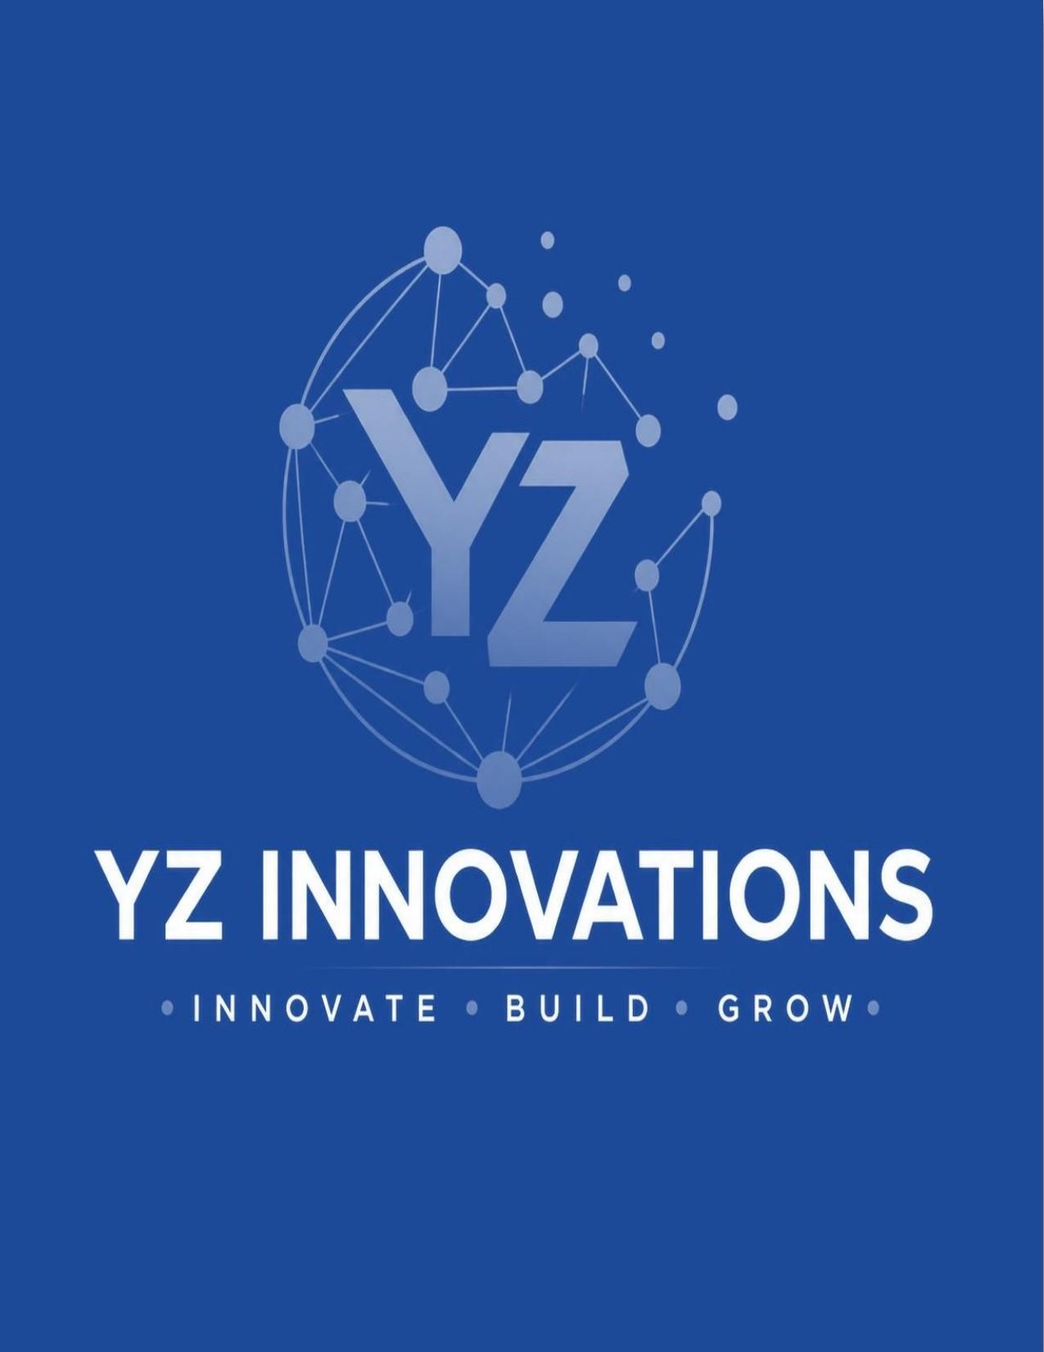
FINANCIAL PROPOSAL
Smart Tea/Coffee IoT Vending Machines &
Electric Vehicle Transport Service

Prepared for Brainmachine.AI

chine.ai
Dhaka, Bangladesh
Submitted by

Project Initiator, YZ Innovations
Zi 30th April, 2026

30th April, 2026
To,
Brainmachine.ai
Dhaka, Bangladesh
Subject: Financial Proposal for Smart Tea/Coffee IoT Vending Machines and Electric Vehicle Transport Service at CUET Campus
Dear Sir,
Greetings from Yeasir Mohammed Zihan.
We are pleased to submit our financial proposal for the introduction of Smart Tea/Coffee IoT Vending Machines and Electric Vehicle (EV) Transport Services across the Chittagong University of Engineering and Technology (CUET) campus.
This project aims to develop a modern, smart campus ecosystem by combining automated beverage solutions with eco-friendly transportation services for students, faculty, staff, and visitors. The smart vending machine network will provide convenient access to tea and coffee through cashless payments, real-time monitoring, and IoT-enabled operations.
In addition, the electric vehicle service will offer safe, affordable, and sustainable internal campus transportation — helping reduce travel time, improve mobility, and support environmental sustainability.
With strong daily demand, a high-traffic academic environment, and growing interest in smart technologies, CUET presents excellent potential for sustainable revenue generation and future expansion. We believe this combined initiative can become a scalable model for universities, institutions, and smart campuses across Bangladesh.
Should you require any further details or discussion, we would be honored to connect with you. Thank you for your time and consideration.
Sincerely,
Yeasir Mohammed Zihan
Project Initiator
YZ Innovations, Bangladesh

About Us
YZ Innovations is an innovation-driven technology company specializing in artificial intelligence, smart automation, IoT integration, and scalable digital solutions. Our focus is on transforming traditional industries into efficient, technology-enabled systems through practical and commercially viable innovations.
We develop intelligent platforms and automated ecosystems that enhance productivity, convenience, and data driven decision-making across sectors such as retail, education, transport, and enterprise services.
With a strong technical team and a commitment to innovation, we deliver reliable, high-performance solutions tailored to modern business needs. Our vision is to lead the development of next-generation smart infrastructure in Bangladesh and beyond — enabling AI-powered commerce and connected digital ecosystems.
We aim to build impactful, scalable solutions such as smart vending networks, automated service systems, and
integrated business platforms that create real-world value and sustainable growth.

Smart Infrastructure Overview
Our integrated smart vending and electric vehicle ecosystem is built on a reliable IoT-based connectivity framework and cloud-driven management platform to ensure uninterrupted service, real-time monitoring, and efficient automated operations.

Smart Vending Machine Network
Each smart tea and coffee vending machine is connected through a stable internet network (mobile/FTTH) with optional backup connectivity to minimize downtime. This enables seamless beverage transactions, live sales reporting, remote diagnostics, and centralized inventory management.
The vending system integrates with a cloud-based dashboard providing real-time tracking of sales, ingredient consumption, stock levels, machine performance, and maintenance alerts. Automated notifications ensure timely refilling, fault detection, and operational continuity.

Electric Vehicle Fleet Management
All electric vehicles are equipped with IoT-enabled GPS and monitoring devices connected to the same centralized platform. This enables live vehicle tracking, route monitoring, battery status updates, charging schedules, trip analytics, and fleet performance management.
The EV system supports optimized route planning, driver monitoring, and predictive maintenance alerts — maximizing operational efficiency and passenger service quality.

Payment & Reliability
- Fully digital payment solutions including mobile financial services (bKash, Nagad), QR-based payment cards, and future wallet integration.
- Fail-safe offline functionality with automatic data synchronization upon connectivity restoration.
- 99% service uptime guaranteed with 24/7 technical support and real-time network monitoring.

Section 1 — Smart Tea/Coffee Vending Machines

Proposed Installation Locations — 15 Smart Vending Machines
The 15 vending machines will be strategically placed across the CUET campus to maximize foot traffic coverage, including academic buildings, residential halls, the library, canteen areas, and administrative zones.
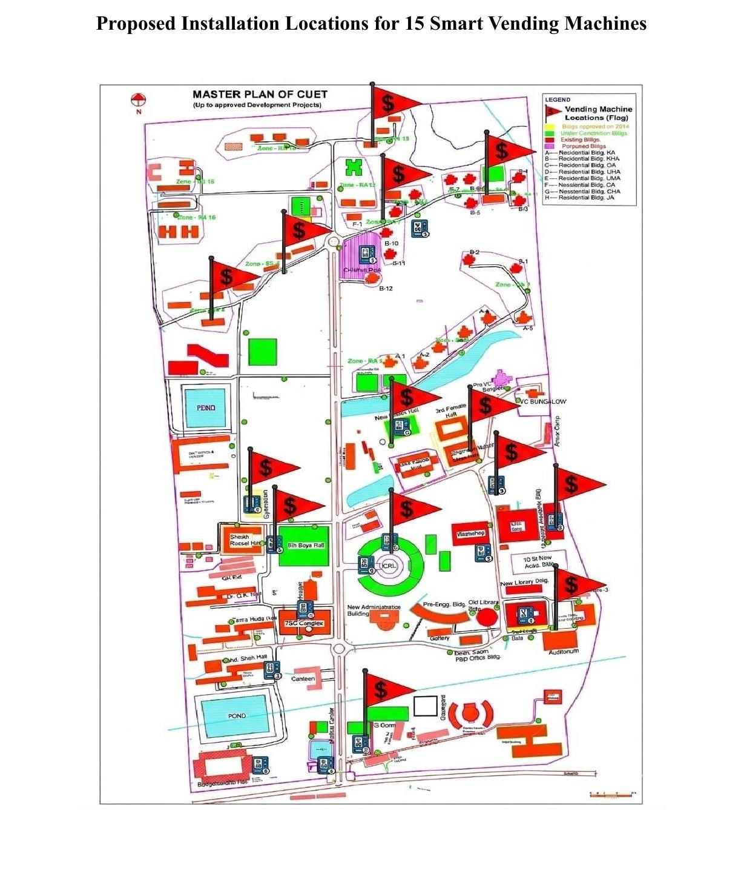

Tea/Coffee vending machine:
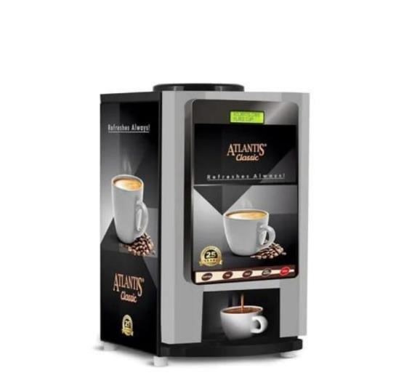

Machine Specifications

Machine Cost | 70,000 Taka per unit
Drink Options | 2  —  Tea & Coffee
Dispensing Speed | – 12 seconds per cup
Power Consumption | 1.5  –  2.0  kW
Canister Capacity | kg Tea Mix + 1 kg Coffee Mix
Startup Time | – 5 minutes

Competitive Comparison
Feature | Our Smart Vending Machine | Traditional Vending Machine
Machine Cost | 70,000 Taka (low-cost, scalable) | High (expensive imported systems)
Drink Options | 2 (Tea & Coffee — focused efficiency) | 6–20+ options (complex systems)
Dispensing Speed | 8–12 seconds per cup | 15–30+ seconds per cup
Power Consumption | 1.5–2.0 kW (efficient) | Higher power usage
Startup Time | 3–5 minutes (fast boot) | 10–20 minutes or more
Maintenance | Simple, low breakdown risk | Complex, higher maintenance cost
Scalability | Easy to deploy multiple units | Costly to scale
Durability | Long-term design, longer operational life | Moderate lifespan, higher wear
System Focus | Optimized for campus use | General-purpose system

Daily Profit Calculation (20 Cups Coffee + 20 Cups Tea per Machine)
Category |  | Details | Calculation | Amount  (Taka)
Coffee Revenue | 20 cups × 15 Taka |  | 20 × 15 | 300
Tea Revenue | 20 cups × 10 Taka |  | 20 × 10 | 200
Total  Revenue |  |  |  | 500
Coffee  Ingredient Cost | 20 cups × 8 Taka |  | 20 × 8 | 160
Tea  Ingredient Cost | 20 cups × 6.67 Taka |  | 20 × 6.67 | 133
Total  Ingredient Cost |  |  |  | 293
Net Daily Profit | Revenue – Ingredient Cost |  | 500 – 293 | 207

Return on Investment — Per Vending Machine

70,000 Tk 6,198 Tk 74,376 Tk ~11.3 months
The return on investment (ROI) is approximately 106% per year, meaning the initial investment can be recovered in approximately 11 to 12 months under stable daily sales conditions. With 15 machines deployed across the CUET campus, the annual revenue potential is substantial and highly scalable.
Initial Investment | Monthly Profit | Yearly Profit | Payback Period

Section 2 — Electric Vehicle Transport Service
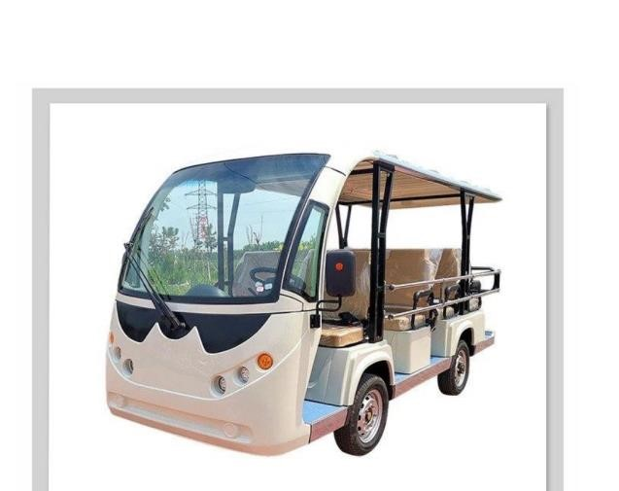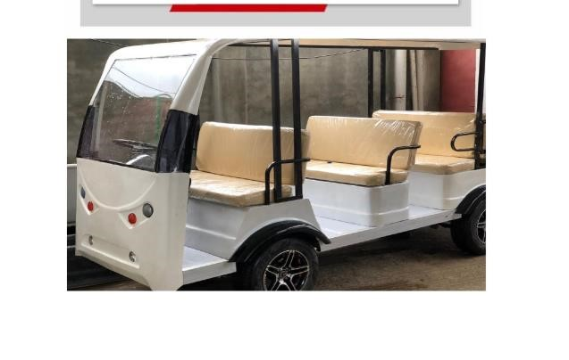

Vehicle Technical Specifications
Vehicle Type | Electric Campus Shuttle / E-Rickshaw
Vehicle Cost | 450,000  Taka per unit
Passenger Capacity | 10 passengers
Top Speed | 25  –  35  km/h
Charging Time | 6 – 8 hours
Battery Range | 80  –  100  km per charge
Power Source | Rechargeable Battery System
Operating Cost | Low (electricity  -  based)
Startup Time | Instant
Maintenance | Low — simplified mechanical design

Fare Structure & Assumptions
Passenger Category | Fare | Share of Passengers
Students / Faculty | 10 Taka | 70%
Visitors / Outsiders | 15 Taka | 30%
Daily capacity assumption: 10 passengers/trip × 12 trips × 5 EVs = 600 total passengers per day (420 students/faculty + 180 visitors)

Daily Profit Calculation — Per Electric Vehicle
Category | Details | Calculation | Amount (Taka)
Student/Faculty Revenue | 84 passengers × 10 Taka | 84 × 10 | 840
Visitor Revenue | 36 passengers × 15 Taka | 36 × 15 | 540
Total Revenue |  |  | 1,380
Electricity Cost | Per vehicle charging share | — | 160
Driver Cost | Per vehicle daily share | — | 500
Maintenance Cost | 10,000 Tk/month ÷ 30 days ÷ 5  EVs | 10,000÷30÷5 | 67
Total Operating Cost |  |  | 727
Net Daily Profit | Revenue – Operating Cost | 1,380 – 727 | 653

Return on Investment — Per Electric Vehicle
Initial Investment Monthly Profit Yearly Profit Payback Period

4,50,000 Tk 19,590 Tk 2,35,080 Tk ~23 months
The return on investment (ROI) is approximately 52% per year. The initial investment can be recovered in approximately 23 months under stable passenger demand and consistent campus operations. With a fleet of 5 EVs, the combined yearly profit potential is approximately 11,75,400 Taka — offering strong long-term commercial viability.

Terms & Conditions

General Terms
- The monthly subscription fee is on a post-paid basis.
- Upon receipt of the Purchase Order (PO), service deployment will be completed within 7 working days.
- Full technical support related to internet connectivity will be provided free of charge.
- The client will be responsible for internal LAN setup and ensuring adequate power backup.
- The client agrees to comply with all existing and future regulations, guidelines, and digital policies issuedby relevant regulatory authorities.
- All provided equipment shall remain the sole property of the service provider.
- This proposal remains valid for 30 days from the date of issuance.

Commercial Terms
- Quotation validity: 5 days from issuance date (subject to market price fluctuations).
- Prices are exclusive of VAT and applicable taxes.
- Payment terms: 50% advance upon issuance of Purchase Order (PO); 20% within 7 working days afterdelivery; 30% upon completion and system go-live.
- Warranty period: 1 year standard warranty.

Service Assurance
Bandwidth | Guaranteed dedicated bandwidth
Uptime | 99  % service uptime
Support | 24/7 technical support center
Monitoring | Real  -  time network monitoring system
Response | Fast response and on-site support when required

We look forward to the opportunity to partner with Brainmachine.ai and contribute to building a smarter, greener CUET campus. We are fully committed to delivering excellence in both execution and ongoing service.
Yeasir Mohammed Zihan
Project Initiator — YZ Innovations, Bangladesh

