Supporting Information S1- Genes classified as low or high H₂S producers in a genome-wide screen for cysteine catabolism
ORF | Name | PHENOTYPE
YNL141W | AAH1 | LOW
YOR239W | ABP140 | MODERATELY LOW
YLR144C | ACF2 | MODERATELY HIGH
YAR015W | ADE1 | LOW
YOR128C | ADE2 | LOW
YGL234W | ADE5,7 | LOW
YGR061C | ADE6 | LOW
YDR408C | ADE8 | LOW
YJR105W | ADO1 | LOW
YBL082C | ALG3 | MODERATELY LOW
YFL050C | ALR2 | MODERATELY LOW
YDR441C | APT2 | LOW
YGL148W | ARO2 | LOW
YPR060C | ARO7 | LOW
YJL115W | ASF1 | LOW
YGR124W | ASN2 | MODERATELY LOW
YFR021W | ATG18 | MODERATELY LOW
YIL088C | AVT7 | LOW
YKR099W | BAS1 | MODERATELY LOW
YLR399C | BDF1 | HIGH
YIL159W | BNR1 | HIGH
YGL007W | BRP1 | LOW
YCR063W | BUD31 | MODERATELY LOW
YDL099W | BUG1 | MODERATELY HIGH
YJL209W | CBP1 | LOW
YAL021C | CCR4 | LOW
YGL003C | CDH1 | MODERATELY LOW
YGL029W | CGR1 | LOW
YMR198W | CIK1 | MODERATELY HIGH
YGL223C | COG1 | LOW
YLR201C | COQ9 | HIGH
YBR036C | CSG2 | MODERATELY LOW
YBR131W | CVT16 | LOW
YGL078C | DBP3 | LOW
YKR024C | DBP7 | LOW
YER124C | DSE1 | MODERATELY LOW
YER176W | ECM32 | MODERATELY LOW
YNL084C | END3 | MODERATELY LOW
YNL280C | ERG24 | MODERATELY HIGH
YLR342W | FKS1 | LOW
YER182W | FMP10 | HIGH
YBR047W | FMP23 | LOW
YLL029W | FRA1 | HIGH
YGL220W | FRA2 | HIGH
YAL028W | FRT2 | MODERATELY LOW
YBR021W | FUR4 | LOW
YOR183W | FYV12 | MODERATELY LOW
YNL133C | FYV6 | MODERATELY LOW
YLR068W | FYV7 | LOW
YNL199C | GCR2 | MODERATELY LOW
YDR507C | GIN4 | LOW
YGR163W | GTR2 | MODERATELY LOW
YDL234C | GYP7 | LOW
YKL109W | HAP4 | MODERATELY HIGH
YOL095C | HMI1 | MODERATELY HIGH
YDR174W | HMO1 | LOW
YDR158W | HOM2 | LOW
YBR133C | HSL7 | LOW
YDR533C | HSP31 | LOW
YCR071C | IMG2 | MODERATELY HIGH
YIL002C | INP51 | MODERATELY LOW
YDR315C | IPK1 | LOW
YLL027W | ISA1 | HIGH
YPL135W | ISU1 | HIGH
YDL115C | IWR1 | MODERATELY HIGH
YGL173C | KEM1 | LOW
YAR018C | KIN3 | MODERATELY LOW
YOR322C | LDB1 | MODERATELY LOW
YFR001W | LOC1 | LOW
YFL018C | LPD1 | LOW
YOR084W | LPX1 | MODERATELY HIGH
YJL124C | LSM1 | LOW
YKL176C | LST4 | LOW
YAL024C | LTE1 | LOW
YCR020C-A | MAK31 | MODERATELY LOW
YKR007W | MEH1 | LOW
YOL064C | MET22 | MODERATELY LOW
YDL200C | MGT1 | LOW
YDR031W | MIC14 | LOW
YDR245W | MNN10 | LOW
YJL183W | MNN11 | LOW
YGL124C | MON1 | LOW
YNL284C | MRPL18 | HIGH
YKR085C | MRPL20 | HIGH
YMR193W | MRPL24 | LOW
YLR439W | MRPL4 | HIGH
YGR165W | MRPS35 | HIGH
YJL133W | MRS3 | HIGH
YGR257C | MTM1 | HIGH
YPL226W | NEW1 | MODERATELY LOW
YOR209C | NPT1 | MODERATELY LOW
YHL029C | OCA5 | LOW
YGL038C | OCH1 | LOW
YKL134C | OCT1 | HIGH
YOR036W | PEP12 | LOW
YDR079W | PET100 | HIGH
YBR168W | PEX32 | MODERATELY LOW
YOL136C | PFK27 | MODERATELY HIGH
YDL236W | PHO13 | LOW
YBR092C | PHO3 | MODERATELY HIGH
YBR106W | PHO88 | MODERATELY LOW
YGL023C | PIB2 | MODERATELY LOW
YHR034C | PIH1 | LOW
YDR490C | PKH1 | MODERATELY LOW
YGR123C | PPT1 | MODERATELY LOW
YML016C | PPZ1 | MODERATELY LOW
YOR323C | PRO2 | MODERATELY LOW
YML017W | PSP2 | MODERATELY LOW
YKL076C | PSY1 | MODERATELY LOW
YDR496C | PUF6 | MODERATELY LOW
YGL058W | RAD6 | MODERATELY LOW
YGL246C | RAI1 | LOW
YPL246C | RBD2 | MODERATELY HIGH
YOR107W | RGS2 | HIGH
YHL027W | RIM101 | MODERATELY HIGH
YGL046W | RIM8 | HIGH
YEL050C | RML2 | HIGH
YGL250W | RMR1 | LOW
YGR180C | RNR4 | MODERATELY LOW
YPL123C | RNY1 | LOW
YBR084C-A | RPL19A | MODERATELY LOW
YBL027W | RPL19B | LOW
YBL087C | RPL23A | LOW
YER117W | RPL23B | MODERATELY LOW
YGL031C | RPL24A | MODERATELY LOW
YHR010W | RPL27A | LOW
YFR032C-A | RPL29 | LOW
YFR031C-A | RPL2A | LOW
YDL191W | RPL35A | LOW
YDR500C | RPL37B | MODERATELY LOW
YLR448W | RPL6B | MODERATELY LOW
YGL076C | RPL7A | LOW
YHL033C | RPL8A | MODERATELY LOW
YGL147C | RPL9A | LOW
YDR382W | RPP2B | LOW
YMR230W | RPS10B | LOW
YGR027C | RPS25A | LOW
YOR182C | RPS30B | MODERATELY LOW
YBR181C | RPS6B | MODERATELY LOW
YBL072C | RPS8A | MODERATELY LOW
YHR021C | RPSD27B | LOW
YIL153W | RRD1 | LOW
YHR038W | RRF1 | LOW
YGL244W | RTF1 | HIGH
YOR014W | RTS1 | LOW
YKL212W | SAC1 | LOW
YOR184W | SER1 | MODERATELY LOW
YLR058C | SHM2 | LOW
YBL058W | SHP1 | LOW
YMR216C | SKY1 | LOW
YBL007C | SLA1 | LOW
YOR008C | SLG1 | LOW
YBR266C | SLM6 | LOW
YBR172C | SMY2 | LOW
YNR023W | SNF12 | LOW
YGL127C | SOH1 | HIGH
YCL048W | SPS22 | MODERATELY LOW
YBR081C | SPT7 | LOW
YHR066W | SSF1 | LOW
YLR362W | STE11 | HIGH
YLR372W | SUR4 | LOW
YHR009C | TDA3 | MODERATELY HIGH
YGR192C | TDH3 | MODERATELY LOW
YDR438W | THI74 | LOW
YPR074C | TKL1 | LOW
YER113C | TMN3 | MODERATELY LOW
YER090W | TRP2 | LOW
YOR006C | TSR3 | LOW
YLR425W | TUS1 | MODERATELY LOW
YOR344C | TYE7 | LOW
YDR207C | UME6 | MODERATELY LOW
YGL212W | VAM7 | LOW
YBR105C | VID24 | MODERATELY HIGH
YNL212W | VID24 | MODERATELY LOW
YLR410W | VIP1 | LOW
YGL212W | VAM7 | LOW
YHR039C-B | VMA10 | LOW
YPR036W | VMA13 | MODERATELY LOW
YGR105W | VMA21 | LOW
YHR060W | VMA22 | LOW
YEL027W | VMA3 | LOW
YKL080W | VMA5 | LOW
YEL051W | VMA8 | LOW
YKL119C | VPH2 | LOW
YKR001C | VPS1 | LOW
YDR495C | VPS3 | LOW
YGL095C | VPS45 | LOW
YDR484W | VPS52 | LOW
YOR359W | VTS1 | LOW
YDL224C | WHI4 | LOW
YPL239W | YAR1 | MODERATELY LOW
YBL100C | YBL100C | LOW
YBR074W | YBR074W | MODERATELY LOW
YBR206W | YBR206W | HIGH
YBR285W | YBR285W | LOW
YER123W | YCK3 | MODERATELY LOW
YCL007C | YCL007C | LOW
YCR102C | YCR102C | LOW
YDL199C | YDL199C | LOW
YDL237W | YDL237W | LOW
YDR010C | YDR010C | MODERATELY LOW
YDR266C | YDR266C | LOW
YDR417C | YDR417C | LOW
YER186C | YER186C | LOW
YER187W | YER187W | MODERATELY LOW
YFL034W | YFL034W | LOW
YGR102C | YGR102C | LOW
YJL188C | YJL188C | LOW
YJR096W | YJR096W | LOW
YKL118W | YKL118W | LOW
YLR225C | YLR225C | HIGH
YOL036W | YOL036W | MODERATELY LOW
YOR139C | YOR139C | MODERATELY HIGH
YOR309C | YOR309C | MODERATELY LOW
YPL102C | YPL102C | MODERATELY LOW
YPR117W | YPR117W | MODERATELY LOW
YBR264C | YPT10 | LOW
YIR026C | YVH1 | LOW

2.6.2 Go terms associated with low H₂S producers
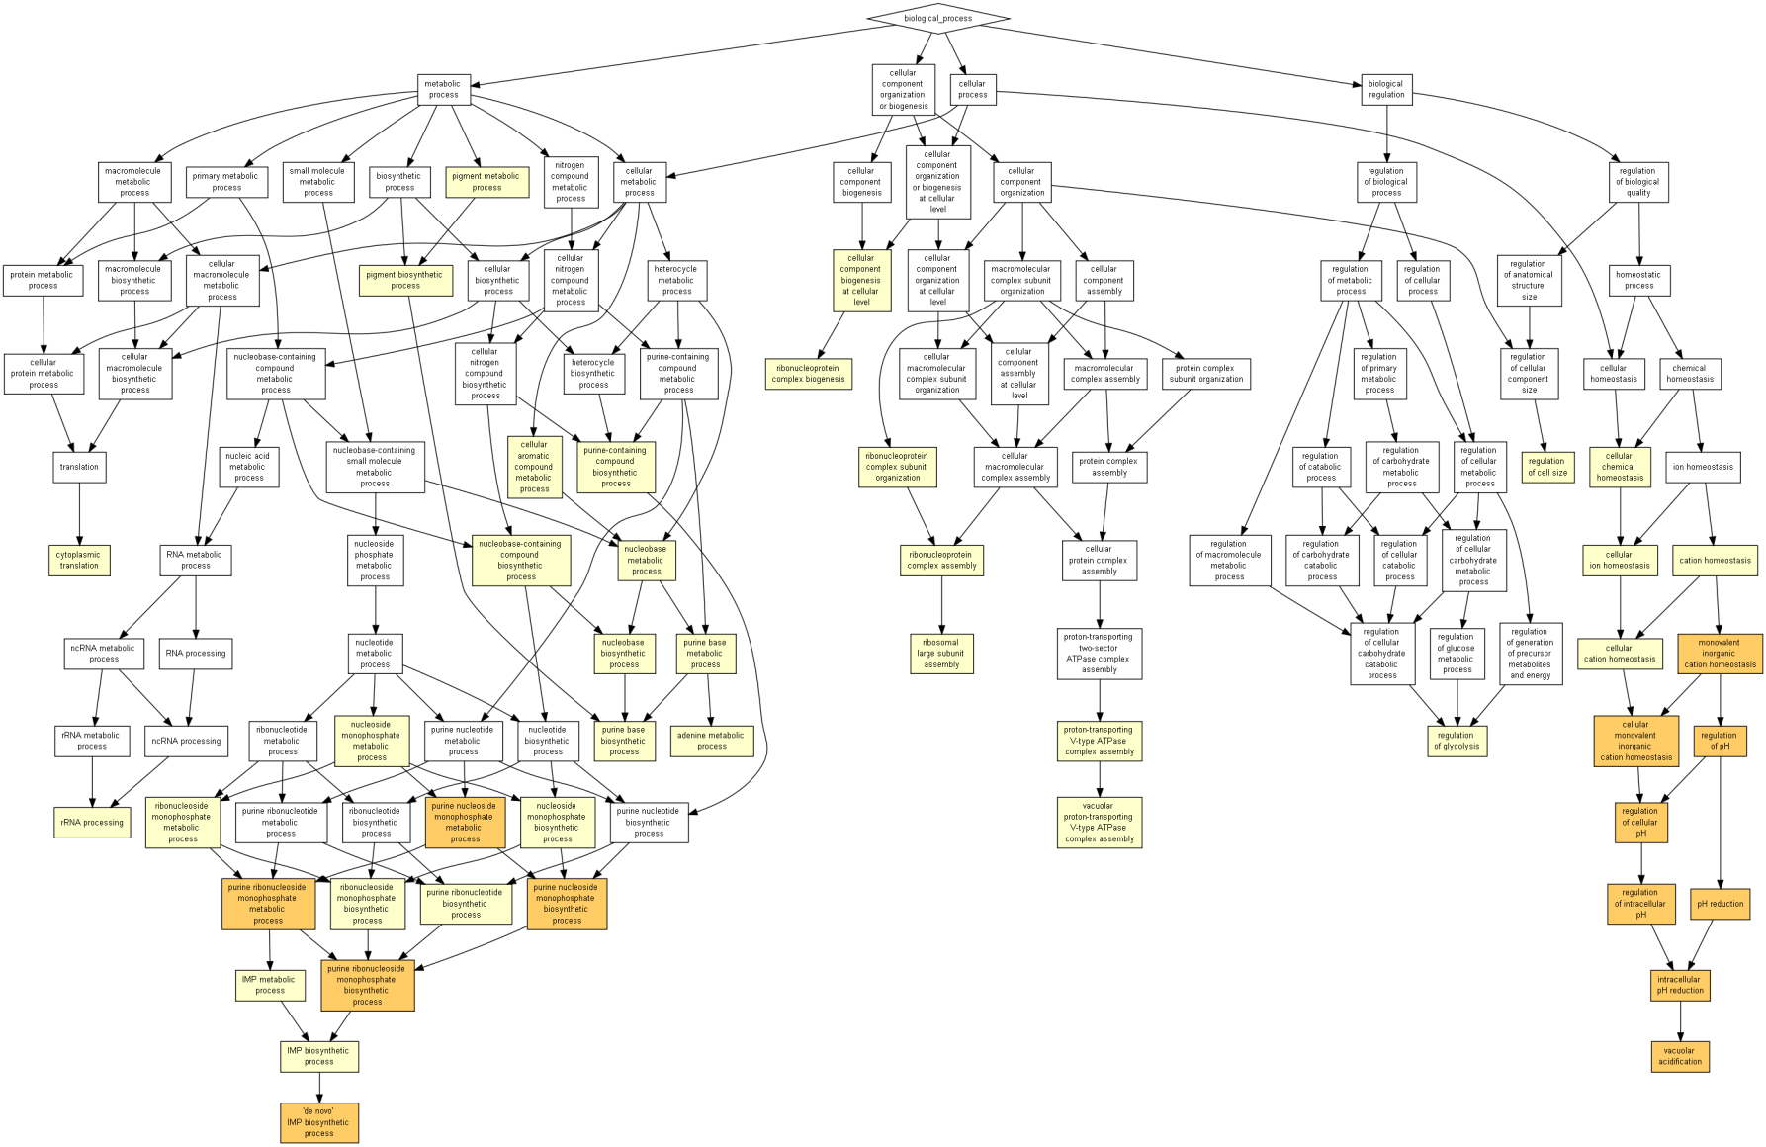
GO Term | Description | P-value
GO:0045851 | pH reduction | 2.12E-07
GO:0007035 | vacuolar acidification | 2.12E-07
GO:0051452 | intracellular pH reduction | 2.12E-07
GO:0030641 | regulation of cellular pH | 3.19E-07
GO:0051453 | regulation of intracellular pH | 3.19E-07
GO:0030004 | cellular monovalent inorganic cation homeostasis | 5.99E-07
GO:0006885 | regulation of pH | 9.69E-07
GO:0055067 | monovalent inorganic cation homeostasis | 1.43E-06
GO:0009168 | purine ribonucleoside monophosphate biosynthetic process | 3.85E-06
GO:0009167 | purine ribonucleoside monophosphate metabolic process | 3.85E-06
GO:0006189 | 'de novo' IMP biosynthetic process | 5.65E-06
GO:0009126 | purine nucleoside monophosphate metabolic process | 5.88E-06
GO:0009127 | purine nucleoside monophosphate biosynthetic process | 5.88E-06
GO:0002181 | cytoplasmic translation | 1.15E-05
GO:0006188 | IMP biosynthetic process | 1.23E-05
GO:0046040 | IMP metabolic process | 1.23E-05
GO:0006144 | purine base metabolic process | 2.49E-05
GO:0009161 | ribonucleoside monophosphate metabolic process | 3.39E-05
GO:0009156 | ribonucleoside monophosphate biosynthetic process | 3.39E-05
GO:0009113 | purine base biosynthetic process | 4.21E-05
GO:0009124 | nucleoside monophosphate biosynthetic process | 4.55E-05
GO:0009123 | nucleoside monophosphate metabolic process | 7.83E-05
GO:0030003 | cellular cation homeostasis | 9.02E-05
GO:0000027 | ribosomal large subunit assembly | 1.10E-04
GO:0022613 | ribonucleoprotein complex biogenesis | 1.57E-04
GO:0071843 | cellular component biogenesis at cellular level | 2.06E-04
GO:0006873 | cellular ion homeostasis | 2.59E-04
GO:0006725 | cellular aromatic compound metabolic process | 2.62E-04
GO:0070072 | vacuolar proton-transporting V-type ATPase complex assembly | 2.66E-04
GO:0070070 | proton-transporting V-type ATPase complex assembly | 2.66E-04
GO:0046083 | adenine metabolic process | 2.66E-04
GO:0009112 | nucleobase metabolic process | 3.05E-04
GO:0006364 | rRNA processing | 3.93E-04
GO:0055082 | cellular chemical homeostasis | 4.17E-04
GO:0072522 | purine-containing compound biosynthetic process | 4.78E-04
GO:0055080 | cation homeostasis | 4.99E-04
GO:0009152 | purine ribonucleotide biosynthetic process | 5.38E-04
GO:0022618 | ribonucleoprotein complex assembly | 5.57E-04
GO:0046148 | pigment biosynthetic process | 6.17E-04
GO:0046112 | nucleobase biosynthetic process | 6.17E-04
GO:0034654 | nucleobase-containing compound biosynthetic process | 6.27E-04
GO:0006110 | regulation of glycolysis | 6.45E-04
GO:0071826 | ribonucleoprotein complex subunit organization | 7.44E-04
GO:0008361 | regulation of cell size | 7.89E-04
GO:0042440 | pigment metabolic process | 8.10E-04

** Strains were grouped according to the gene ontology description of the encoded gene product, as defined in the Saccharomyces Genome Database (www.yeastgenome.org) using Gorilla (Eden, et al., 2009).

2.6.2 GO terms associated with high H₂S producers
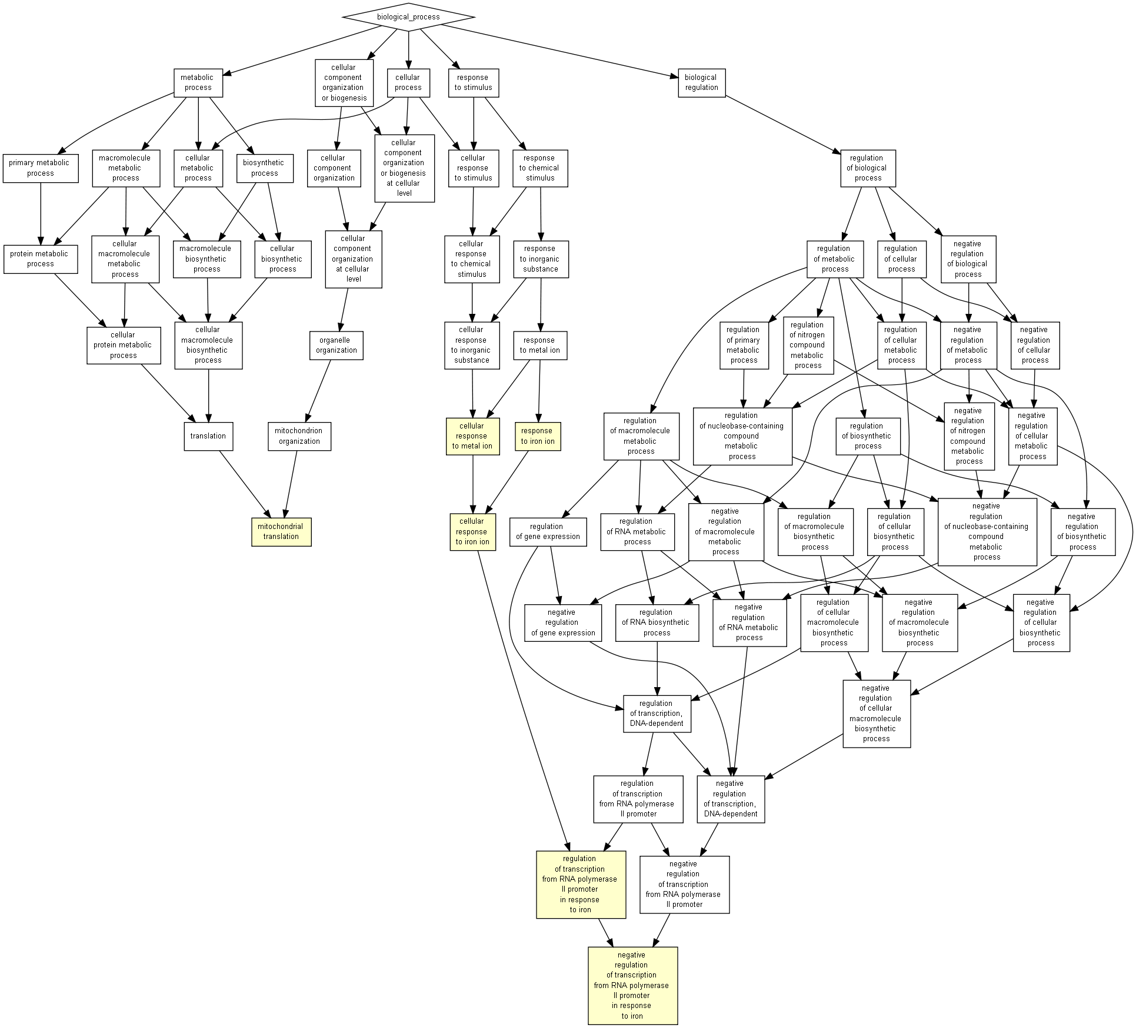
GO Term | Description | P-value
GO:0034396 | negative regulation of transcription from RNA polymerase II promoter in response to iron | 6.35E-05
GO:0010039 | response to iron ion | 1.90E-04
GO:0034395 | regulation of transcription from RNA polymerase II promoter in response to iron | 1.90E-04
GO:0071281 | cellular response to iron ion | 1.90E-04
GO:0032543 | mitochondrial translation | 3.75E-04
GO:0071248 | cellular response to metal ion | 6.26E-04

**Strains were grouped according to the gene ontology description of the encoded gene product, as defined in the Saccharomyces Genome Database (www.yeastgenome.org) using Gorilla (Eden, et al., 2009).

