I got the following error on ubuntu when using pytorch, can you help : """ File "/home/gongai/.local/lib/python3.10/site-packages/torch/cuda/init.py", line 298, in lazyinit torch._C._cuda_init() RuntimeError: CUDA unknown error - this may be due to an incorrectly set up environment, """

Claude
1) check if your NVIDIA drivers are properly installed:
```
nvidia-smi
```

2) Verify your CUDA version:

```
$ nvcc --version
nvcc: NVIDIA (R) Cuda compiler driver
Copyright (c) 2005-2023 NVIDIA Corporation
Built on Fri_Nov__3_17:16:49_PDT_2023
Cuda compilation tools, release 12.3, V12.3.103
Build cuda_12.3.r12.3/compiler.33492891_0
```

3) Check which version of PyTorch you have installed:
```
$ python3 -c "import torch; print(torch.__version__)"
2.1.2+cu121
```

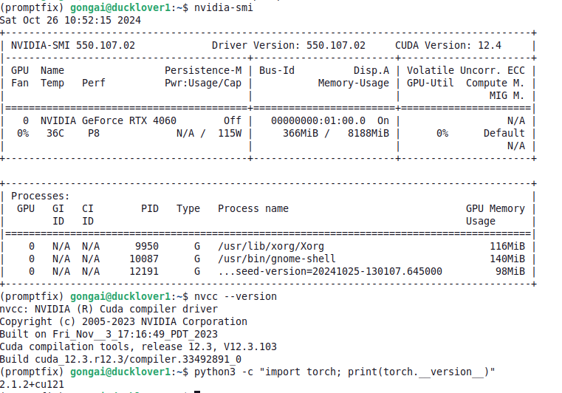
https://pytorch.org/

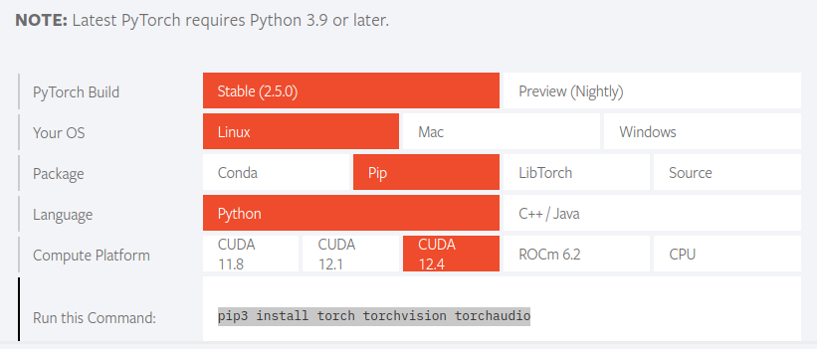

```
pip3 install torch torchvision torchaudio
```
Instead of installing the version (which is old) you suggested, I went to pytorch.org, and ran this command to install the latest pytorch 2.5: """pip3 install torch torchvision torchaudio """, then verify its version by """ python3 -c "import torch; print(torch.version); print(torch.cuda.is_available())" """, it throws the following error: """ Traceback (most recent call last): File "<string>", line 1, in <module> File "/home/gongai/anaconda3/envs/promptfix/lib/python3.10/site-packages/torch/init.py", line 235, in <module> from torch._C import * # noqa: F403 ImportError: libcudnn.so.8: cannot open shared object file: No such file or directory """, libcudnn.so.8 share lib is missing, how to install that?

Need to install cuDNN (CUDA Deep Neural Network library)
```
sudo apt update
sudo apt install nvidia-cuda-toolkit

# Add NVIDIA repository key
wget https://developer.download.nvidia.com/compute/cuda/repos/ubuntu2204/x86_64/cuda-ubuntu2204.pin
sudo mv cuda-ubuntu2204.pin /etc/apt/preferences.d/cuda-repository-pin-600
sudo apt-key adv --fetch-keys https://developer.download.nvidia.com/compute/cuda/repos/ubuntu2204/x86_64/3bf863cc.pub
sudo add-apt-repository "deb https://developer.download.nvidia.com/compute/cuda/repos/ubuntu2204/x86_64/ /"

# Install cuDNN
sudo apt update
sudo apt install libcudnn8

python3 -c "import torch; print(torch.__version__); print(torch.cuda.is_available())"
```

New error:
Traceback (most recent call last):
File "<string>", line 1, in <module>
File "/home/gongai/anaconda3/envs/promptfix/lib/python3.10/site-packages/torch/__init__.py", line 235, in <module>
from torch._C import * # noqa: F403
ImportError: libnccl.so.2: cannot open shared object file: No such file or directory

You need to install the NVIDIA Collective Communications Library (NCCL).

```
# Install NCCL library
sudo apt update
sudo apt install libnccl2 libnccl-dev

$ python3 -c "import torch; print(torch.__version__); print(torch.cuda.is_available())"
2.1.2+cu121
True
```

running `scripts/inference.py` throws this error:
