E2E Test Report — TesAxrail App
Device: Pixel 7 (Android 17, emulator-5554)
Date: 2026-05-22 00:13
Results: 5/5 passed, 0 failed

Test Results
# | Test Case | Expected | Actual | Status
1 | Greeting Flow | "Hello, Kiro!" appears | "Hello, Kiro!" appeared | ✅ PASS
2 | Counter Increment (x3) | Counter: 3 | Counter: 3 | ✅ PASS
3 | Counter Decrement | Counter: 2 | Counter: 2 | ✅ PASS
4 | Counter Reset | Counter: 0 | Counter: 0 | ✅ PASS
5 | Negative Counter | Counter: -1 | Counter: -1 | ✅ PASS

Screenshots
Initial State (fresh app launch):
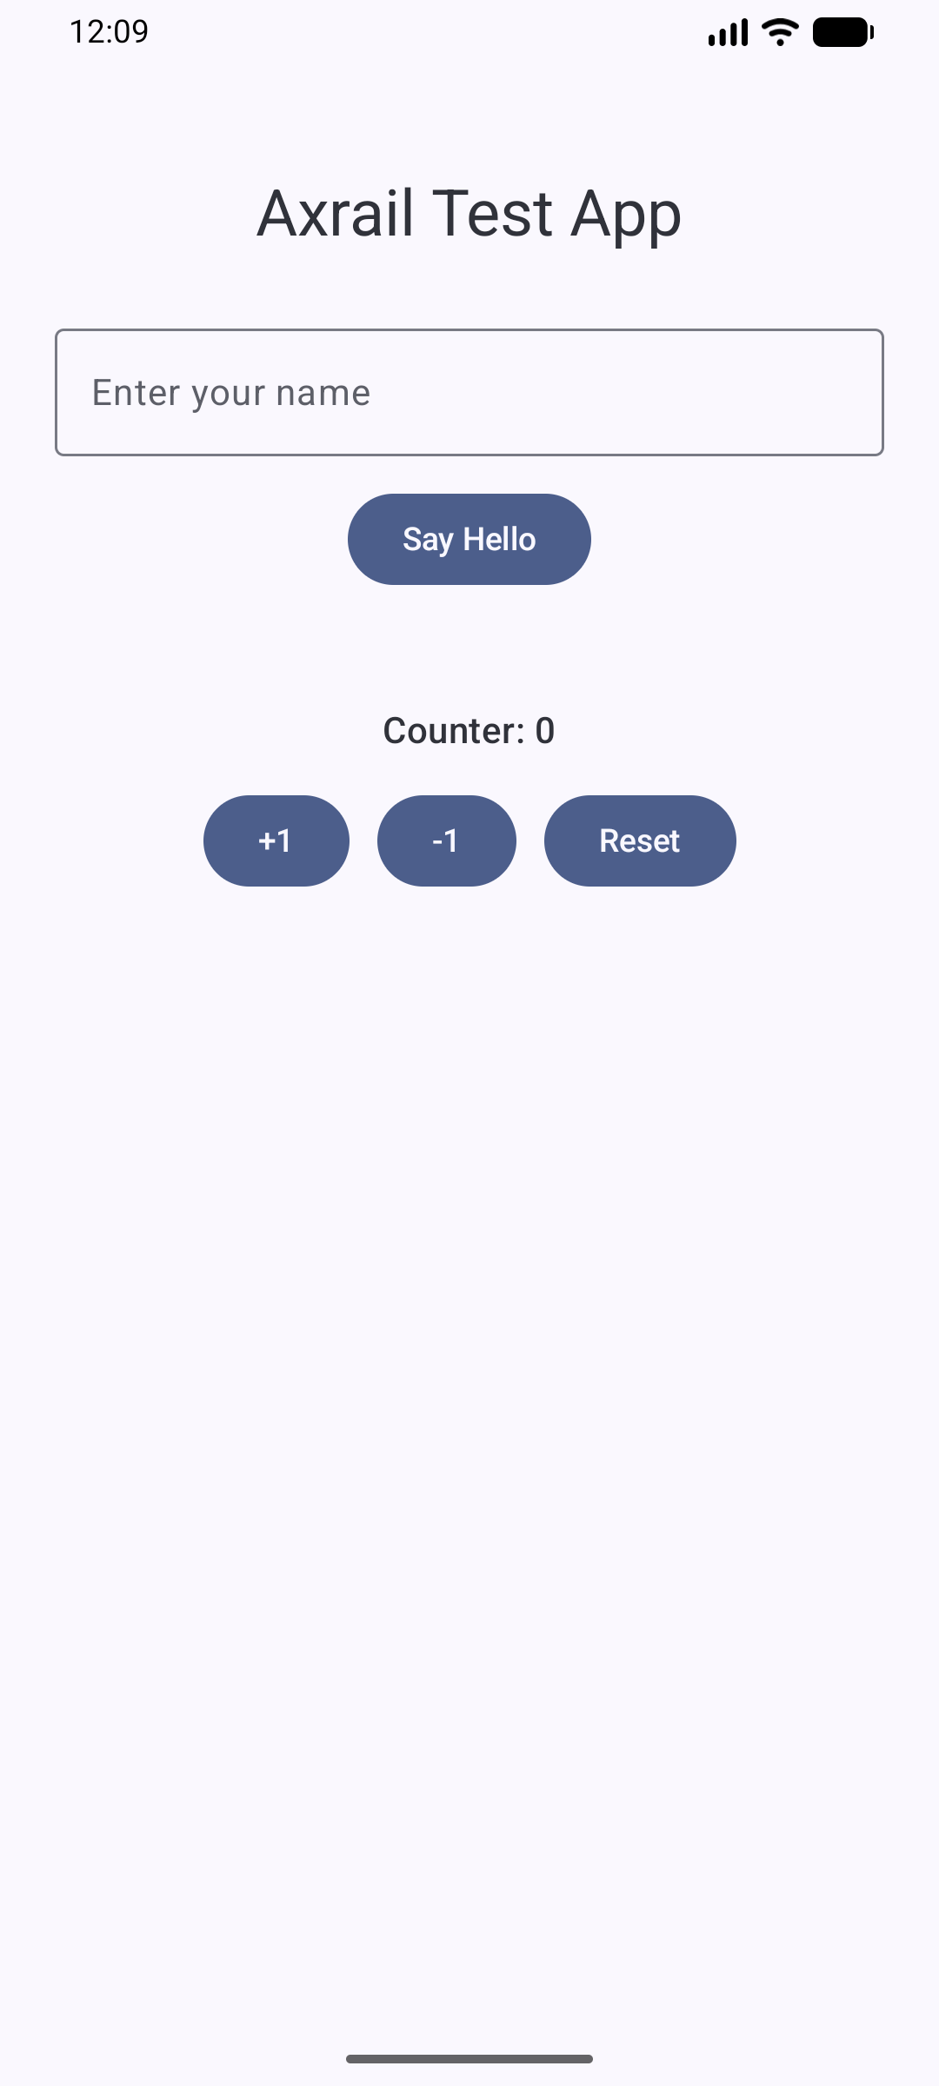

Test #1: Greeting Flow — ✅ PASS
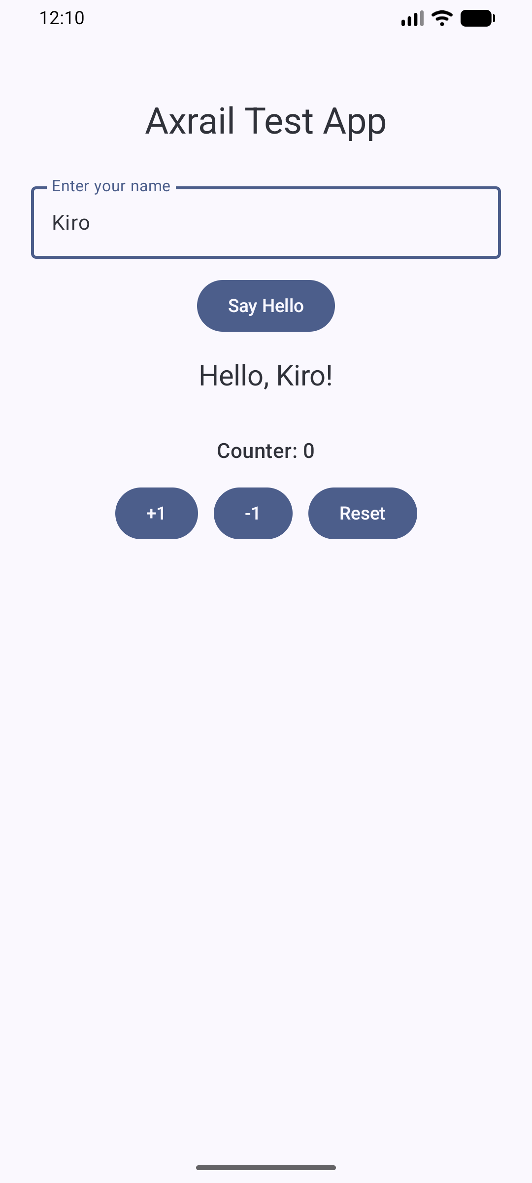

Test #2: Counter Increment (x3) — ✅ PASS
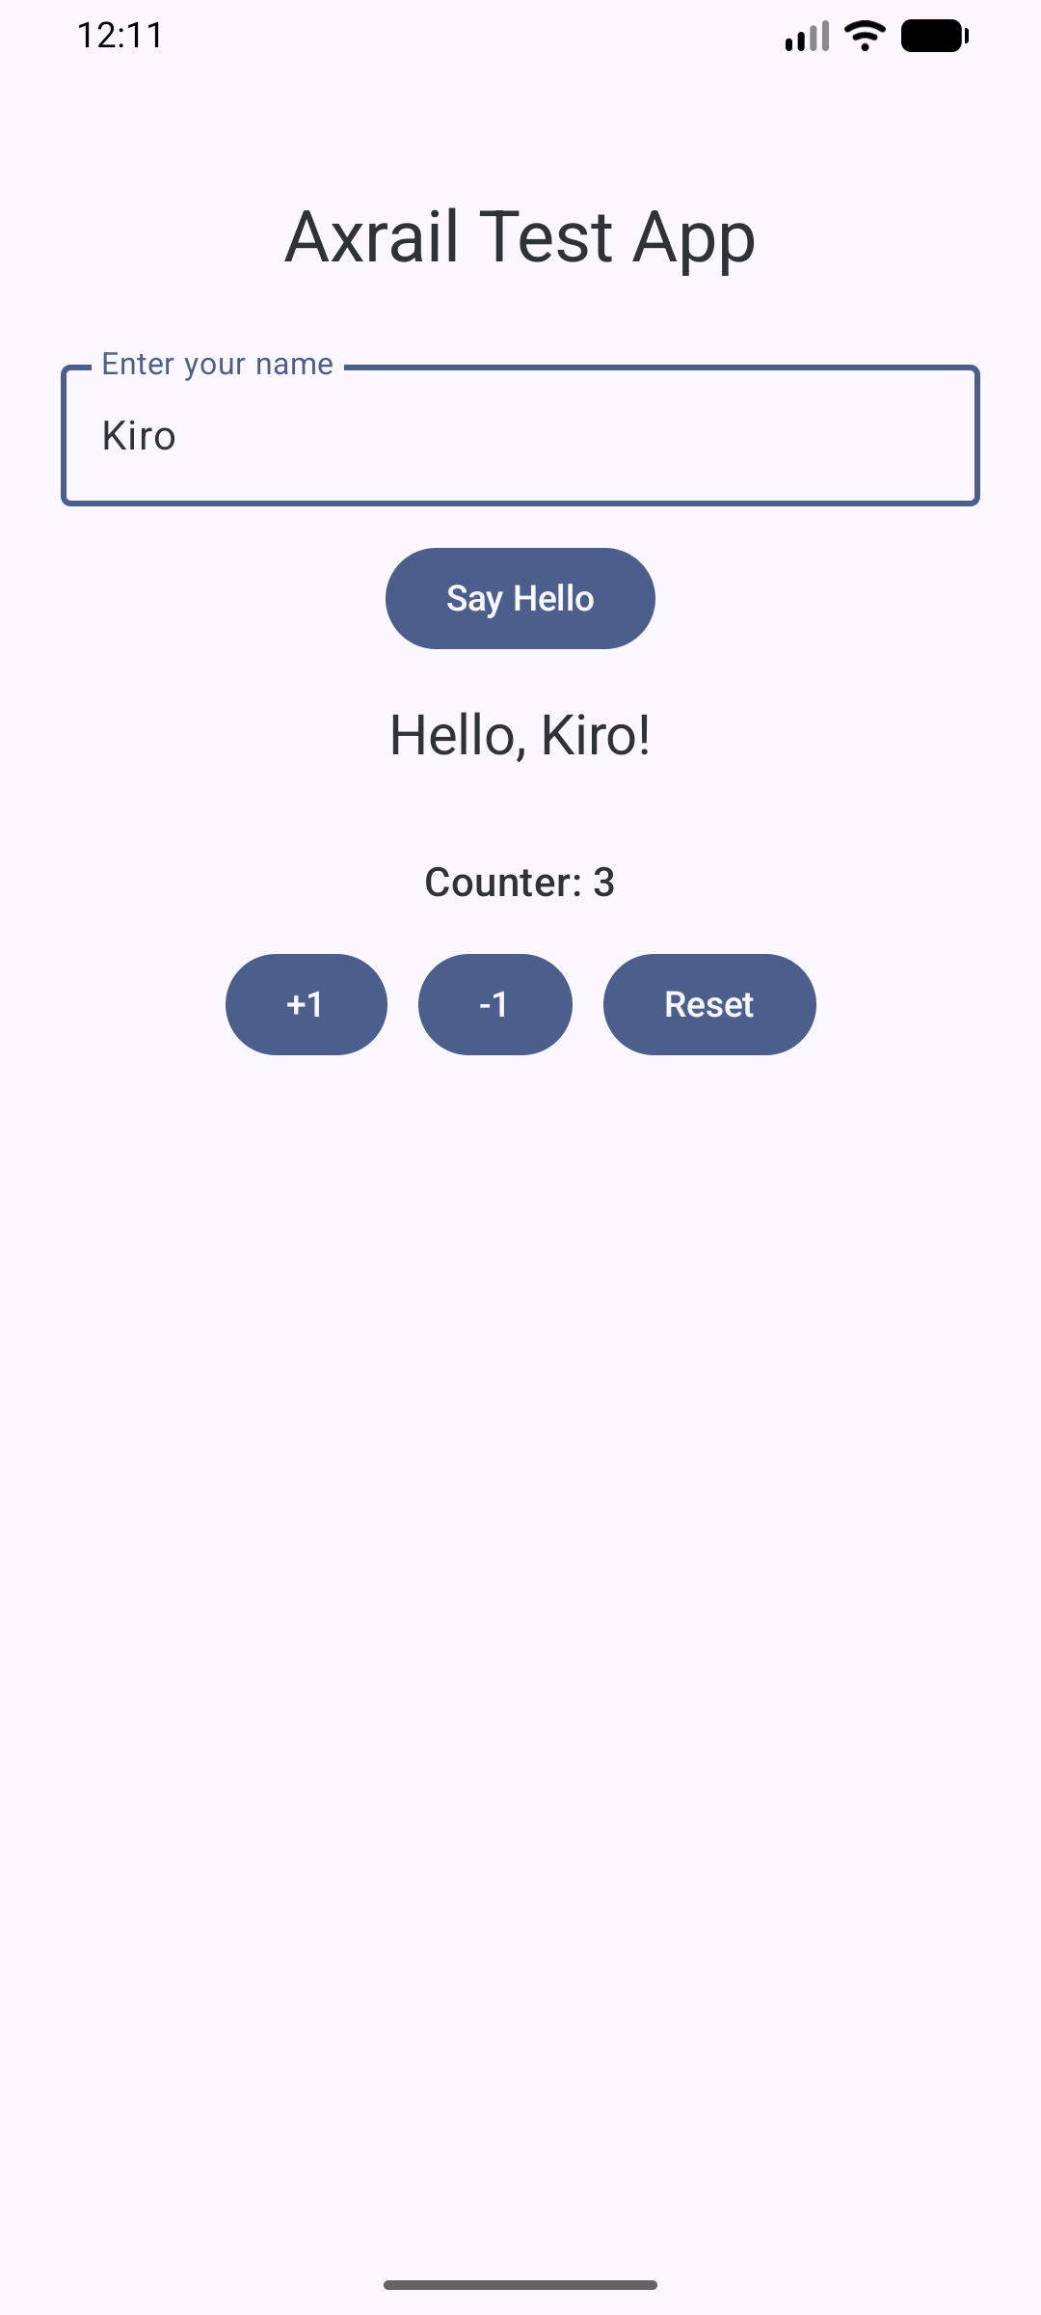

Test #3: Counter Decrement — ✅ PASS
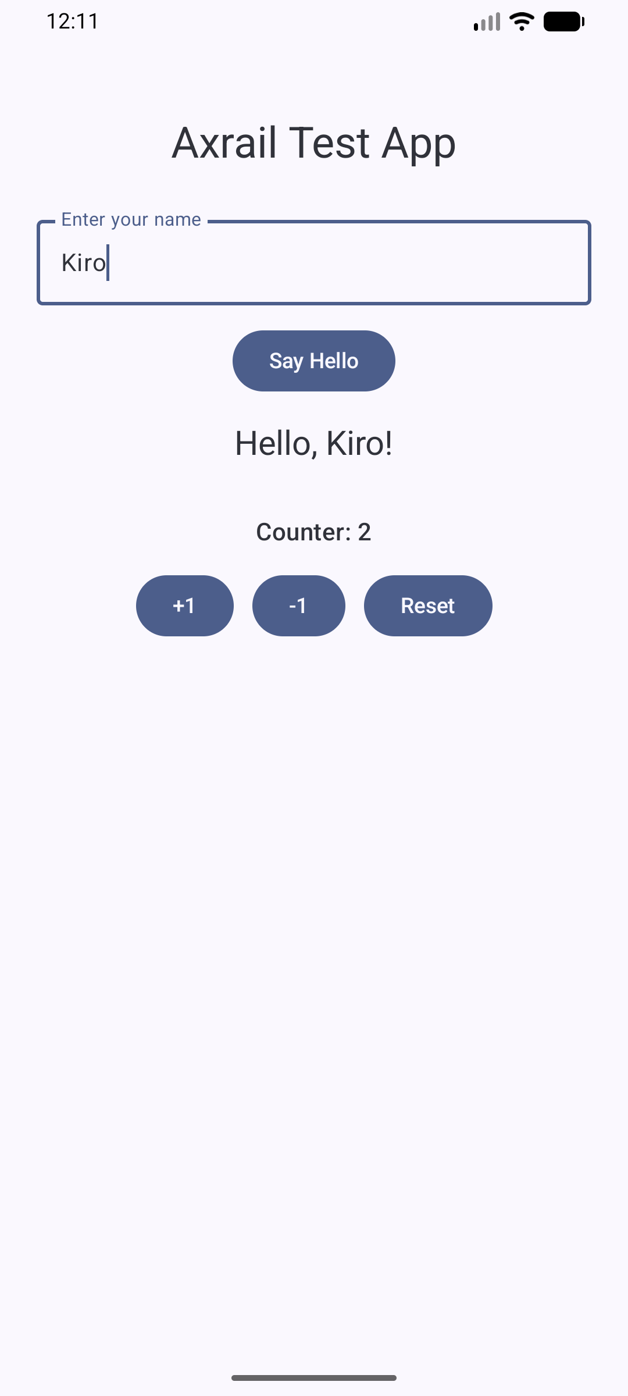

Test #4: Counter Reset — ✅ PASS
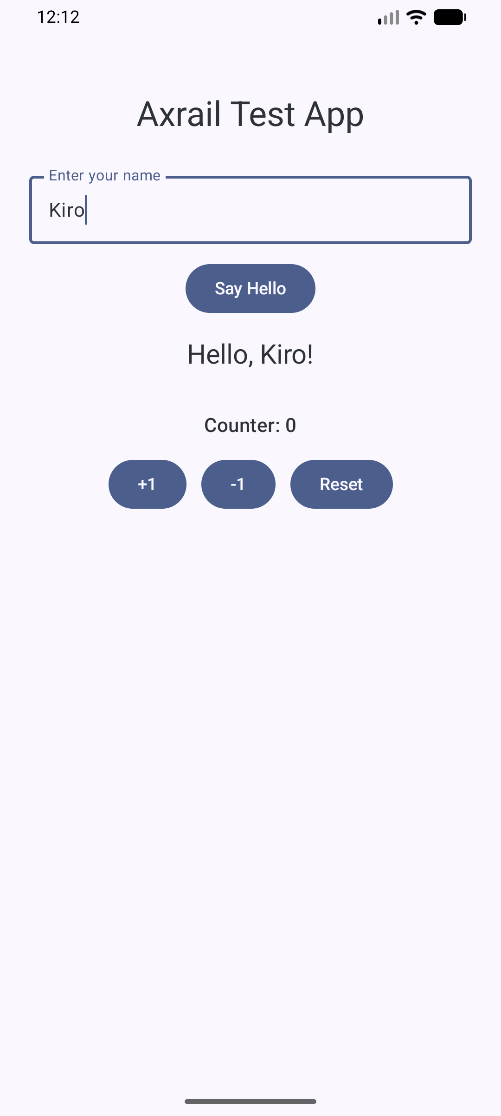

Test #5: Negative Counter — ✅ PASS
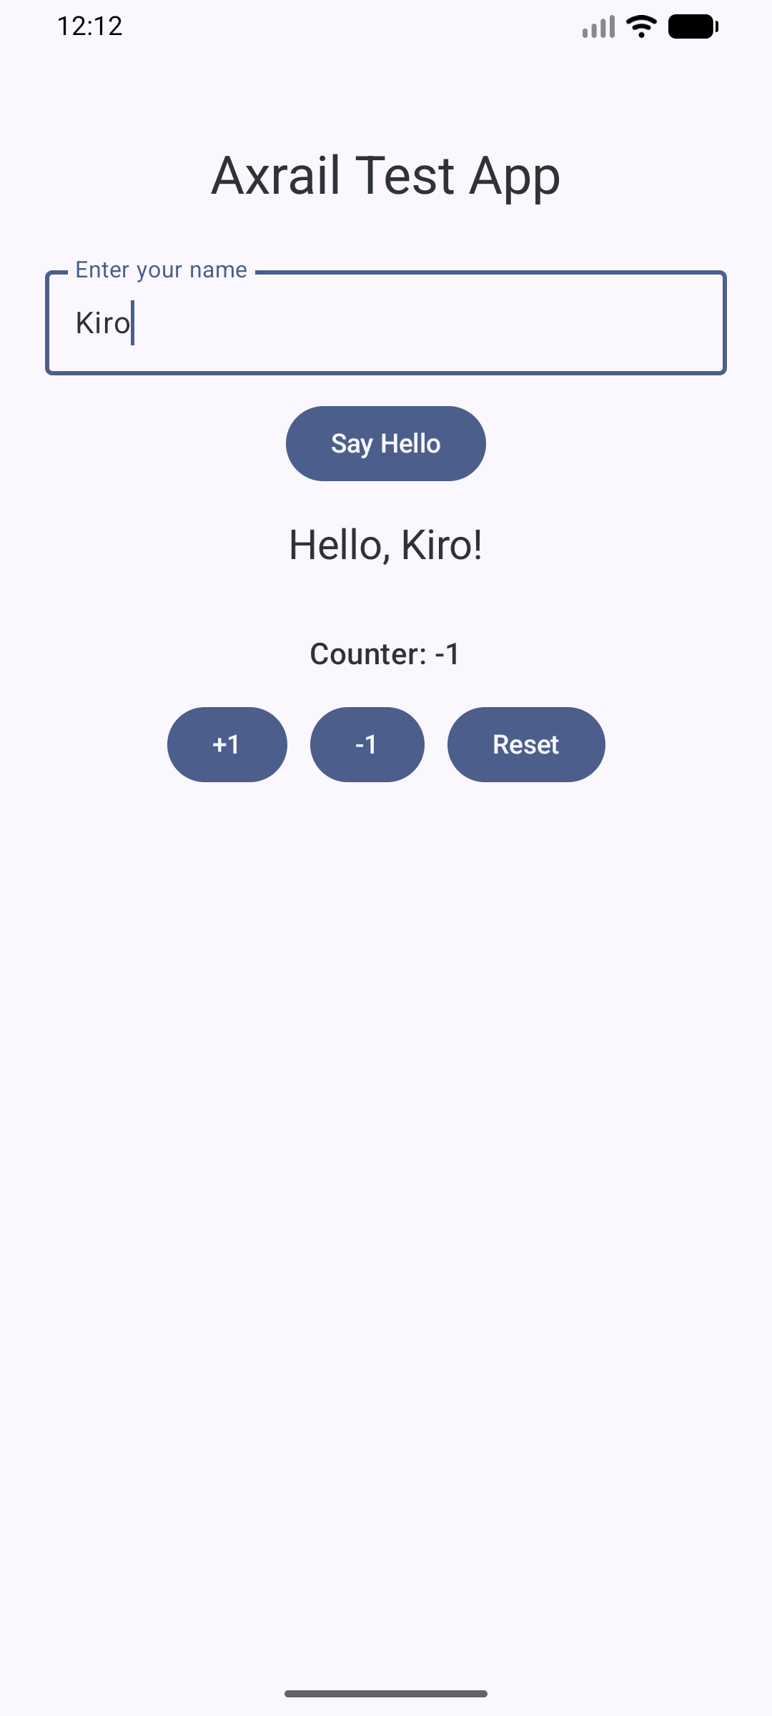

Findings & Observations
1. All core functionality works correctly — greeting and counter features behave as coded.
2. No input validation on empty name — tapping 'Say Hello' with empty field shows 'Hello, !' (UX issue).
3. Counter has no lower bound — can go negative. Worth noting if spec requires non-negative values.
4. All UI elements have proper accessibility labels (contentDescription) for testability.

