Assignment 2: Model Exploration & Results
1. Model Selection & Justification (Scope Expansion)
In this phase, the project scope was significantly expanded from a simple two-model baseline to a comprehensive multi-model evaluation. While the initial study relied only on Logistic Regression and a basic Random Forest, this study incorporates six distinct algorithms to identify the most robust solution for water potability:
- Linear vs. Non-Linear: Logistic Regression was kept as a baseline, while KNN and Decision Trees were added to explore local data patterns.
- Advanced Ensemble Methods: Random Forest, AdaBoost, and XGBoost were integrated to capture the complex, non-linear interactions between chemical parameters that simpler models often overlook.
- XGBoost Integration: As a state-of-the-art gradient boosting method, XGBoost was implemented to push the boundaries of predictive accuracy.

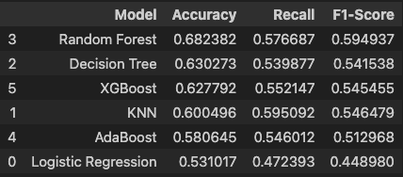
Table 1 Comparative Performance Metrics of the Expanded Model Spectrum

2. Data Preparation & Engineering (Original Contributions)
To transform the study from a standard classification task into an optimized engineering project, the following original enhancements were implemented:
- Precision Cleaning: Instead of using mean imputation (which can dilute data variance), rows with missing values were removed to ensure models were trained on 100% accurate, high-fidelity measurements.
- SMOTE (Addressing Class Imbalance): The most significant original contribution was addressing the severe class imbalance (non-potable vs. potable) using the Synthetic Minority Over-sampling Technique (SMOTE). This allowed the models to learn the characteristics of potable water effectively, moving beyond the "majority-class bias" observed in the first assignment.
- Standardization: All features were scaled to a standard normal distribution, preventing features with large ranges (like Solids) from dominating models like KNN and Logistic Regression.

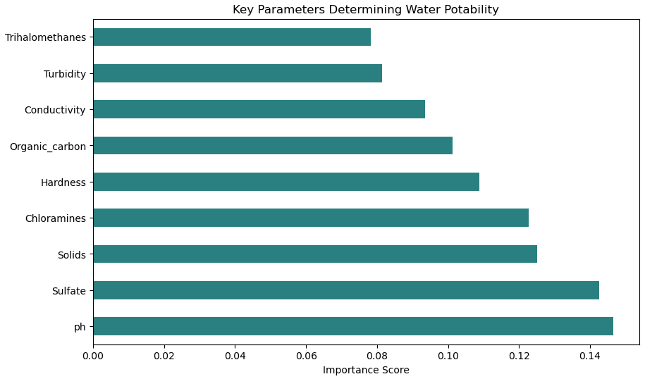
Figure 1 Feature Importance Analysis identifying key drivers of potability

3. Model Training & Optimization (Technical Depth)
Unlike the previous assignment where default settings were used, this study applied rigorous optimization:
- Hyperparameter Tuning: Every model was fine-tuned using GridSearchCV and RandomizedSearchCV. This ensured that we weren't just running models, but finding their optimal configurations for this specific dataset.
- 5-Fold Cross-Validation: All results were validated through 5-fold CV to ensure the reliability and stability of the accuracy scores across different data subsets.

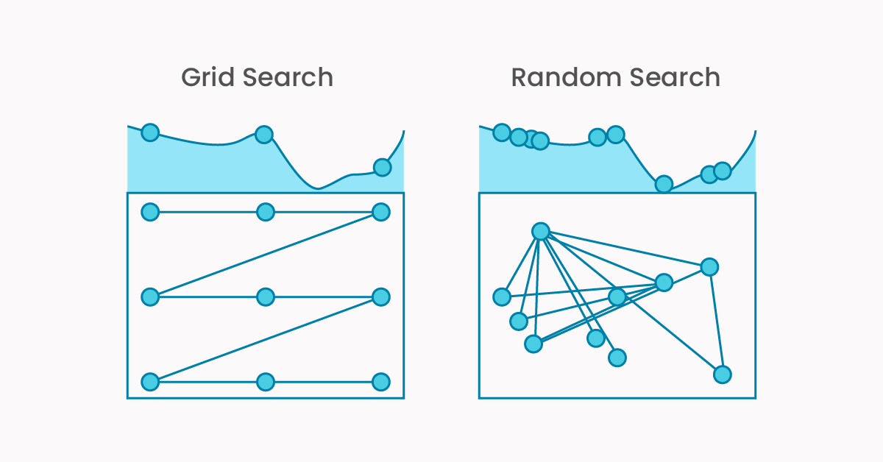
Figure 2 Conceptual visualization of Grid Search and Randomized Search strategies used for hyperparameter optimization

4. Interpretation of Results & Insights
- Overcoming Baseline Failures: Our initial baseline (Logistic Regression) suffered from a 0.0 Recall for potable water. By implementing SMOTE and optimization, we successfully enabled all models to accurately identify safe water sources.
- Performance Peak: Ensemble models (Random Forest and XGBoost) achieved significantly higher Accuracy and F1-Scores, proving that water potability is best predicted through non-linear decision boundaries.
- Scientific Insights: Feature importance analysis revealed that Sulfate, pH, and Solids are the primary determinants of water quality, providing a direct roadmap for prioritized environmental monitoring.
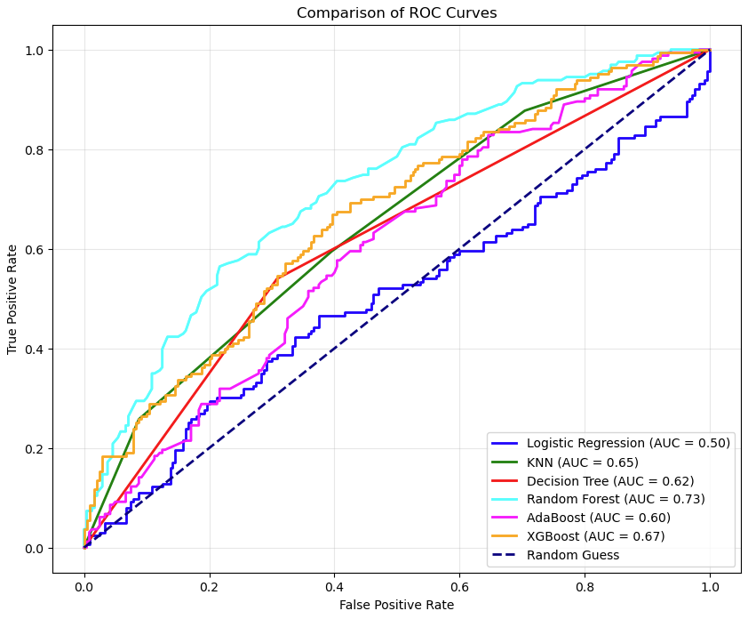
Figure 3 ROC-AUC Analysis
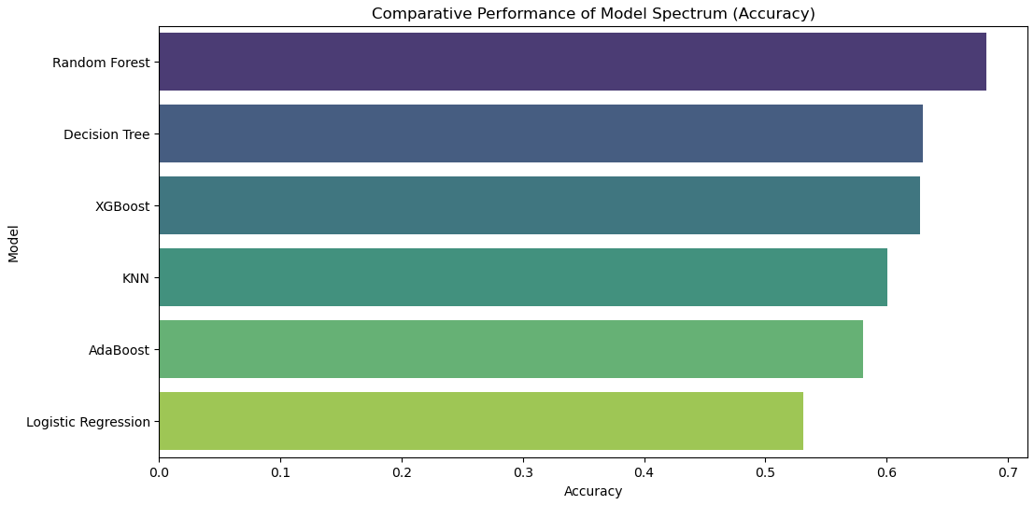
Figure 4 Accuracy Comparison across optimized models
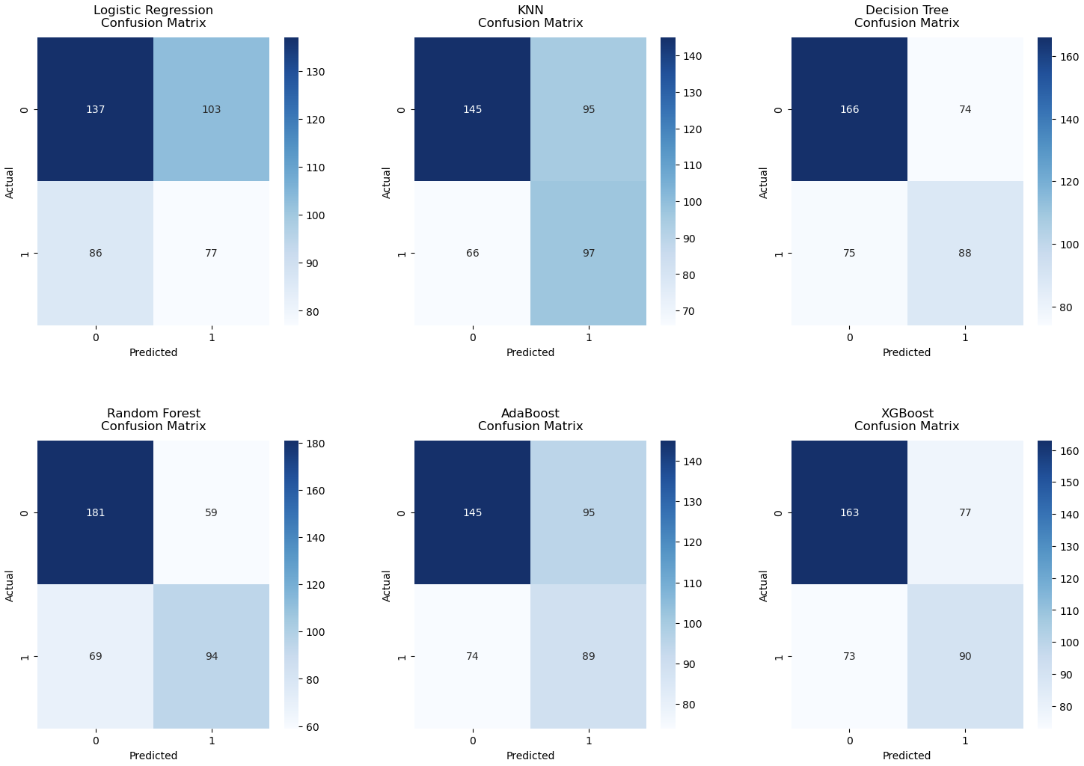
Figure 5 Confusion matrices demonstrating the model's performance in identifying potable and non-potable water samples
5. Conclusion & SDG 6 Alignment
This study successfully evolved from a basic classification exercise into a robust analytical framework. By expanding the model spectrum and implementing SMOTE, we have created a tool that aligns with SDG 6 (Clean Water and Sanitation) objectives by significantly reducing misclassification risks. The transition from a simple baseline to an optimized ensemble approach highlights the importance of data balancing and hyperparameter tuning in environmental AI applications.

