DSD created via backup received:

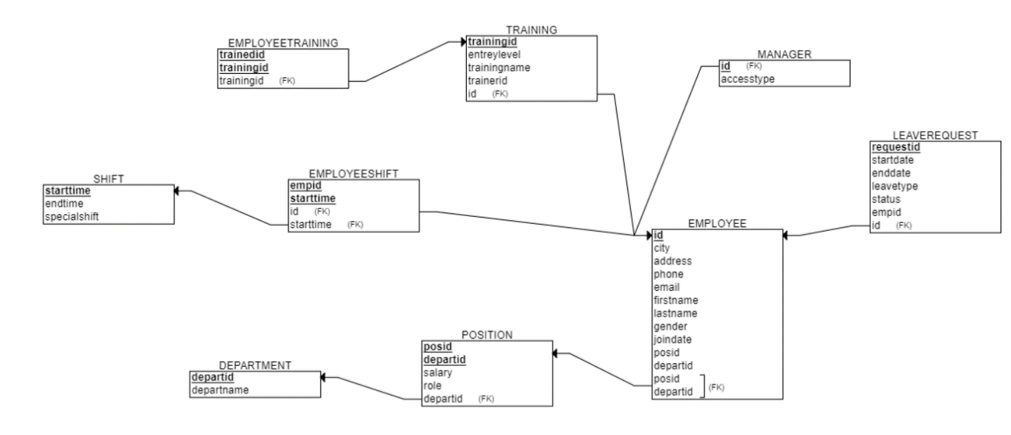

ERD created via reverse engineering

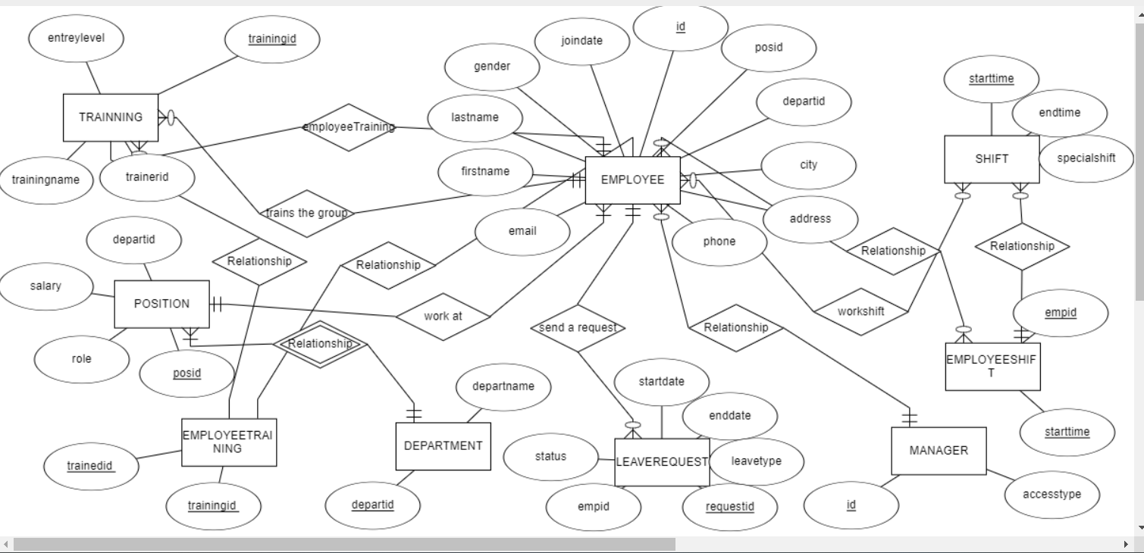

ERD Unify:

Dsd unify :

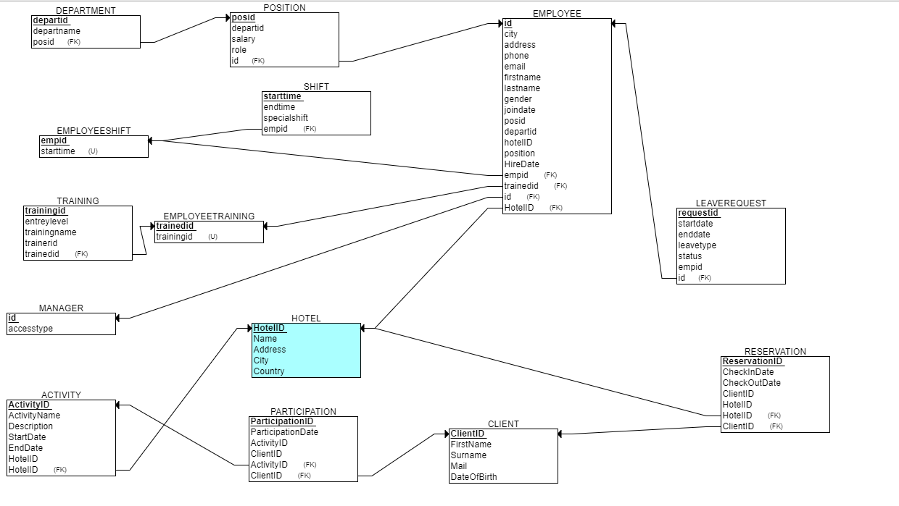

Integrate.sql:

Creating the department Table

Creating the position Table

Creating the leaverequest Table

Creating the training Table

Creating the shift Table

Creating the manager Table

Creating the employeetraining Table

Creating the employeeshift Table

updating the employee table

first view:

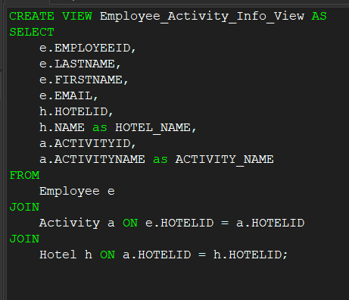

queries 1:

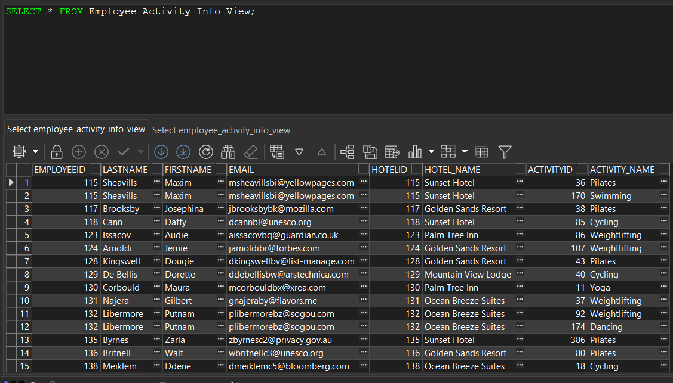

Queries 2:

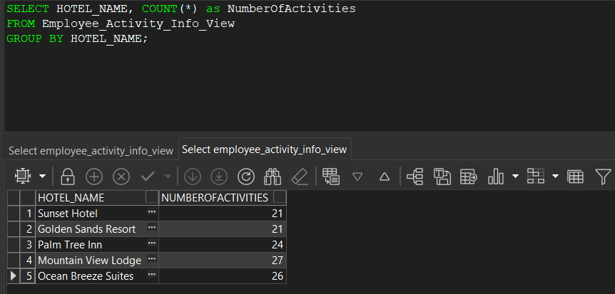

View 2:

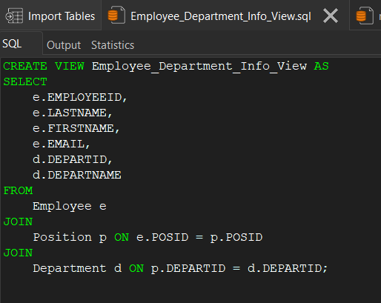

Queries 1:

Queries 2:

