web-application
Deploy a simple web application on AWS that demonstrates your understanding of cloud infrastructure, networking, and basic DevOps practices.

Architecture Overview
This project deploys a highly available web application using AWS services. Traffic is routed through an Application Load Balancer (ALB) to EC2 instances running in private subnets across multiple Availability Zones.

Key design highlights:
- Multi-AZ architecture
- Public and private subnet separation
- Secure access using security groups
- Outbound internet access via NAT Gateway
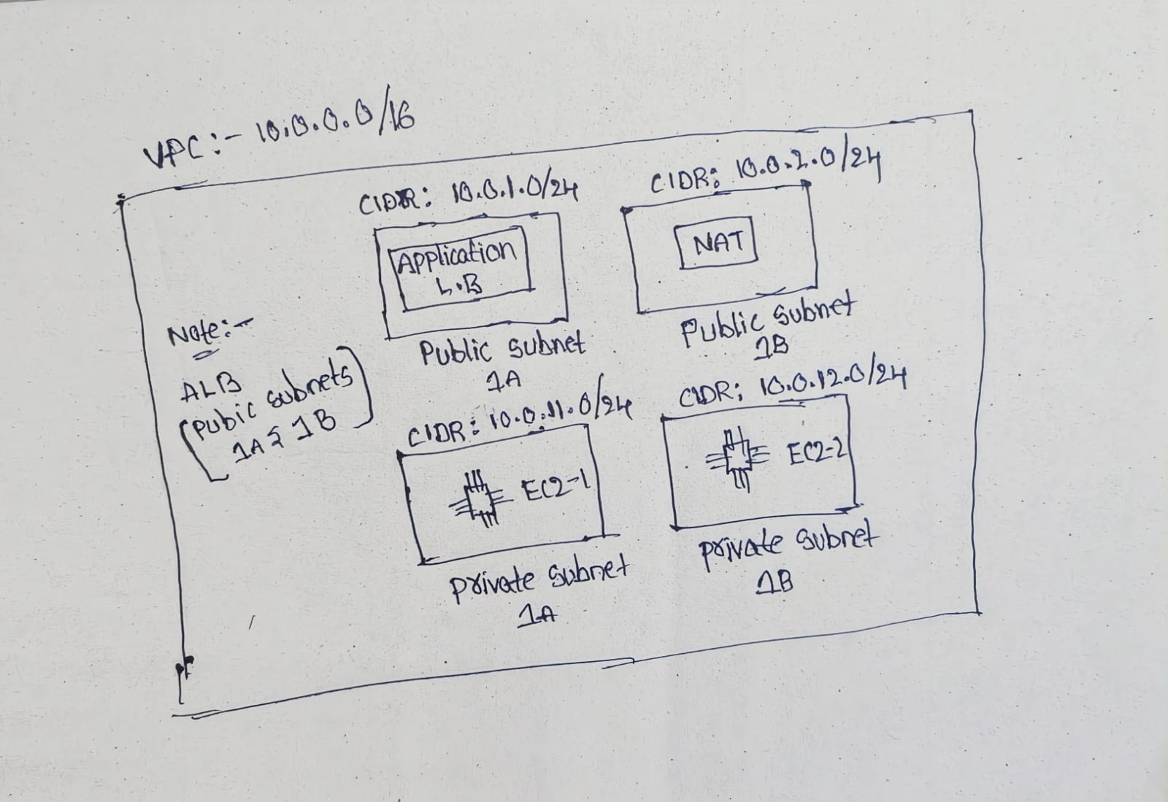
WhatsApp Image 2026-02-05 at 10 08 29 PM (1)

AWS Resources Used

Networking
- VPC (10.0.0.0/16)
- Public Subnets (AZ 1A, 1B)
- Private Subnets (AZ 1A, 1B)
- Internet Gateway
- NAT Gateway
- Public and Private Route Tables
- Elastic IP

Compute & Load Balancing
- Two EC2 Instances (Amazon Linux)
- Application Load Balancer
- Target Group

Security
- Security Group for ALB
- Security Group for EC2 instances

Step-by-Step Implementation

1. VPC and Subnets
- Created a VPC with CIDR 10.0.0.0/16
- Created public and private subnets across two Availability Zones

2. Internet & NAT Access
- Attached Internet Gateway to VPC
- Configured public route table for internet access
- Deployed NAT Gateway in a public subnet
- Associated private subnets with NAT Gateway for outbound access

3. EC2 Setup
- Launched EC2 instances in private subnets
- Installed and configured Nginx
- Deployed a sample webpage displaying: Instance ID Availability Zone Served by Nginx

4. Application Load Balancer
- Created ALB in public subnets
- Configured listener on port 80
- Registered EC2 instances in target group
- Enabled health checks
- Health checks configured on path / using HTTP

5. Validation
- Accessed application using ALB DNS name
- Confirmed successful response
- Verified load distribution between EC2 instances
Instance 1

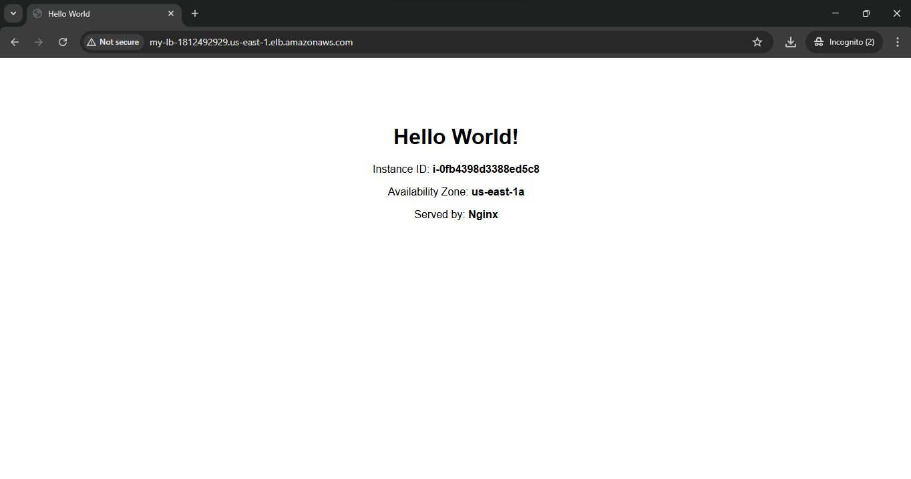

instance 2

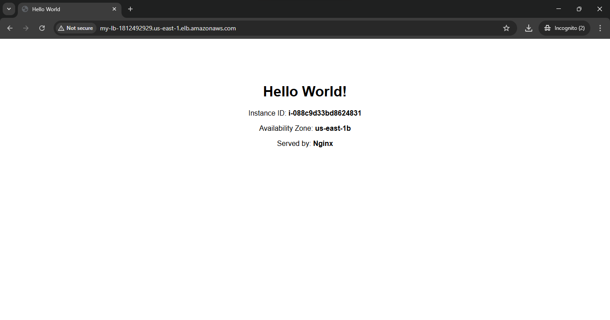

Security Group Configuration
- EC2 instances do not have public IPs
- EC2 instances are not directly accessible from the internet
- All inbound traffic to EC2 flows only through the Application Load Balancer
- NAT Gateway is used only for outbound internet access (package updates, installs)

ALB Security Group
- Inbound: HTTP (80) from 0.0.0.0/0
- Outbound: All traffic allowed

EC2 Security Group
- Inbound: HTTP (80) from ALB Security Group only
- Outbound: All traffic allowed via NAT Gateway

Configuration Files

EC2 User Data Script
The EC2 instances are configured using a user data script during launch.
This script installs and configures Nginx, retrieves instance metadata securely using IMDSv2, and dynamically generates a custom HTML page.

User Data Script
#!/bin/bash
dnf update -y
dnf install nginx -y
systemctl enable nginx
systemctl start nginx

TOKEN=$(curl -X PUT "http://169.254.169.254/latest/api/token" \
-H "X-aws-ec2-metadata-token-ttl-seconds: 21600")

INSTANCE_ID=$(curl -H "X-aws-ec2-metadata-token: $TOKEN" \
http://169.254.169.254/latest/meta-data/instance-id)

AZ=$(curl -H "X-aws-ec2-metadata-token: $TOKEN" \
http://169.254.169.254/latest/meta-data/placement/availability-zone)

cat <<EOF > /usr/share/nginx/html/index.html
<!DOCTYPE html>
<html>
<head>
<title>Hello World</title>
</head>
<body style="text-align: center; font-family: Arial; margin-top: 100px;">
<h1>Hello World!</h1>
<p>Instance ID: <strong>$INSTANCE_ID</strong></p>
<p>Availability Zone: <strong>$AZ</strong></p>
<p>Served by: <strong>Nginx</strong></p>
</body>
</html>
EOF

