Assignment2 BreakThrough

**7. Break-through**

Break-through is a two-player game, played on a board consists of *n* x *n* fields. Each player has *2n* dolls in two rows, placed on at the player’s side initially (similarly to the chess game, but now every dolls of a player look like the same). A player can move his doll one step forward or one step diagonally forward (can’t step backward). A player can beat a doll of his opponent by stepping diagonally forward onto it. A player wins when his doll reaches the opposite edge of the board.

Implement this game, and let the board size be selectable (6x6, 8x8, 10x10). The game should recognize if it is ended, and it has to show in a message box which player won. After this, a new game should be started automatically.

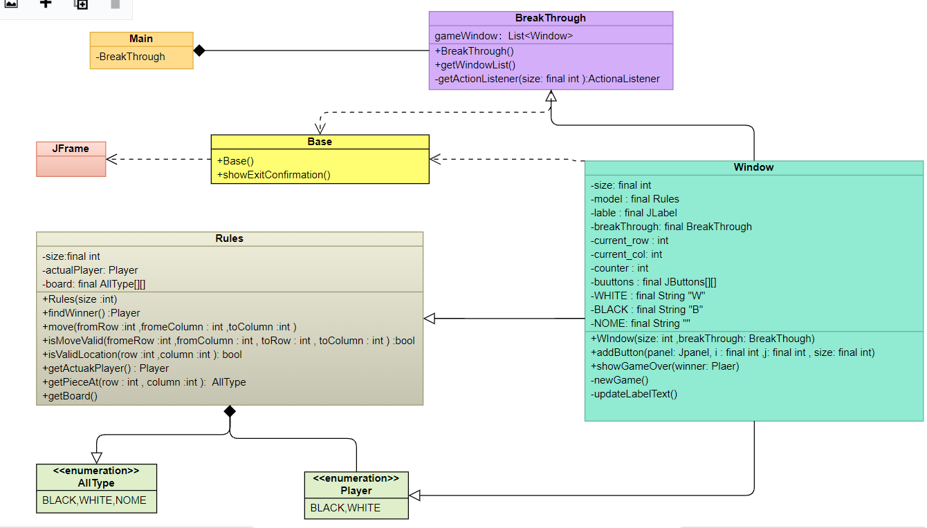

Two types of button clicks are needed in this game to implement what we want. The first button click should be a click on the button and the figure on it, which we want to move. This click should save the position of the button and its piece type (white, black, none) and then the position should be freed up. Then with the second click – we should transfer the piece type to the desired destination. – This is what the action listener in Window.java does.

• Rules.java shows how the game works – how it is played correctly. When the window is initialized, the figures of both players should be on the bottom 2 and top 2horisontal lines.The move method is valid if: figures only move up/up left/up right by only 1 unit; if they can “kill” the figure of another player only diagonally and not from the front; if in case there is a figure of the same pieceType in front/left/right, we cannot move it; if we cannot kill a figure from the same pieceType; if the pieces don’t go out of bound of the board and if the players each have a go at playing one by one. A white player cannot move its figures when it’s black player’s turn. – This is what move and isMoveValid methods implement. We also have some getters: getPieceAt, getBoard and getActualPlayer in Rules.java file.

TEST：

1. Any figure tries to go more than 1 unit up/left/right +

2. White tries to go up, when there’s another white figure in front +

3. White tries to kill by going up, where there’s a black figure +

4. White kills diagonally a black figure (success) +