1. Exercises 23 (한글 교재 25)
2. Exercises 26 ~ 31 (한글 교재 29 ~ 34)
3. Exercises 32 (한글 교재 35)
4. Exercises 35 (한글 교재 38)

(5,6판)

1. Exercises 21

2. Exercises 24 ~ 29

3. Exercises 30

4. Exercises 33

1.



2.

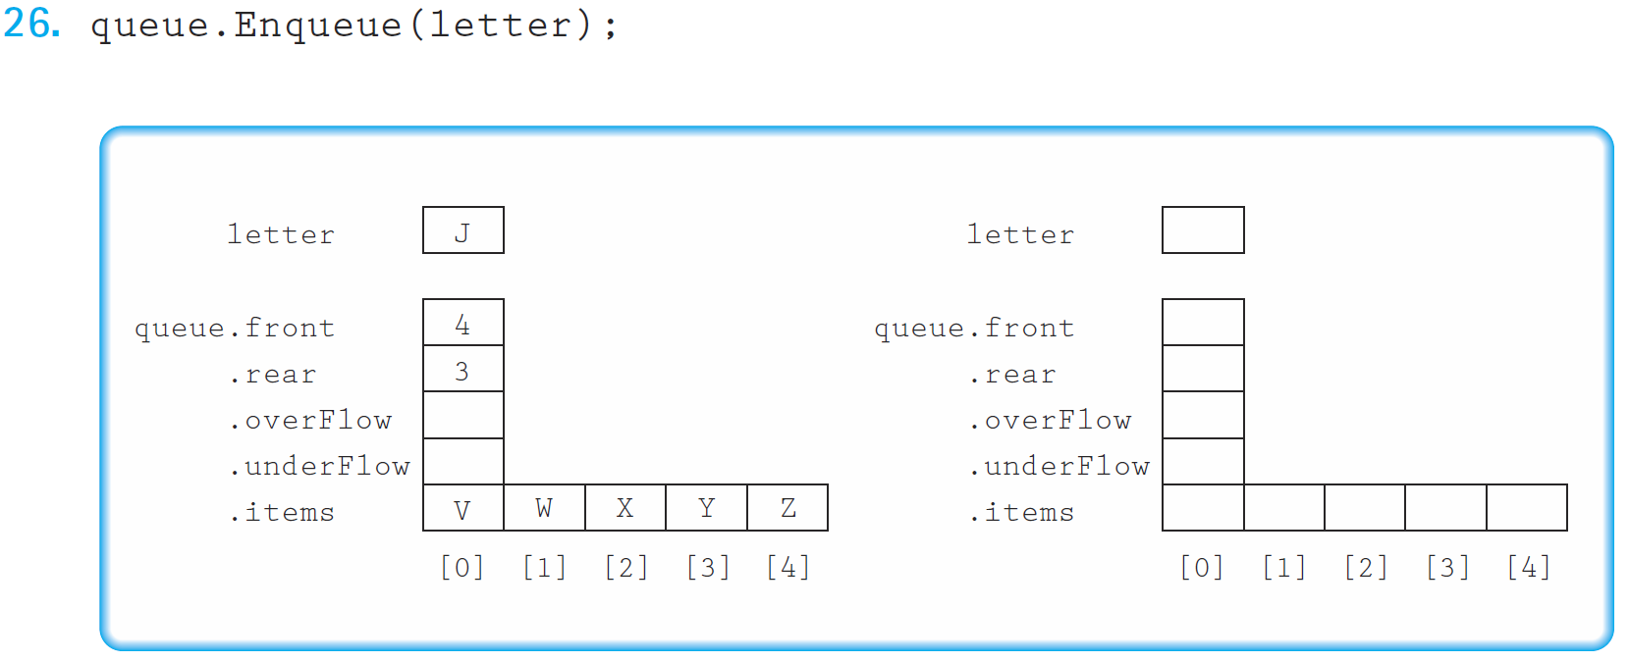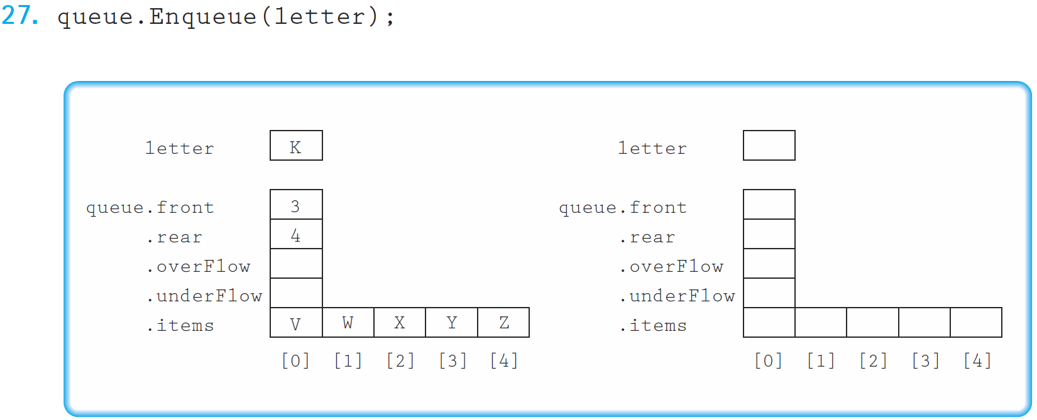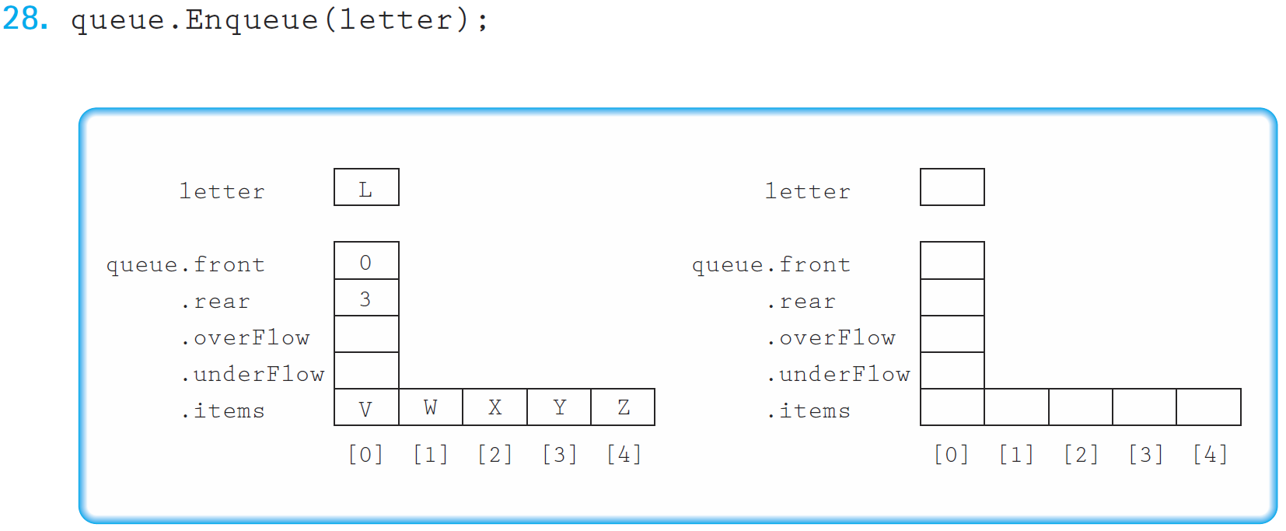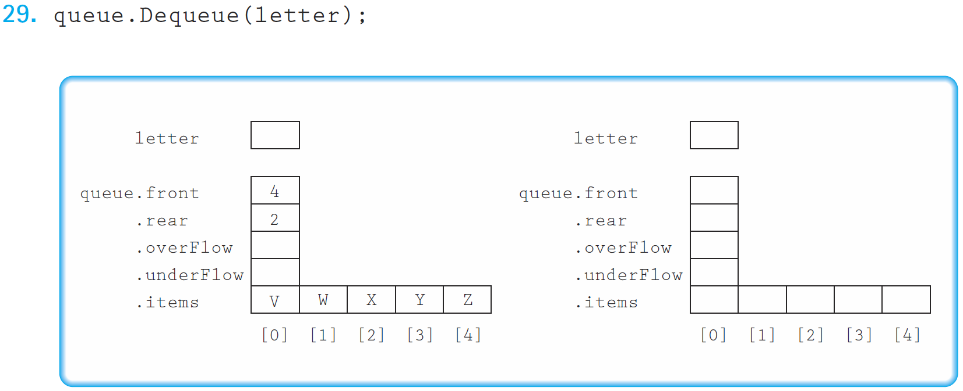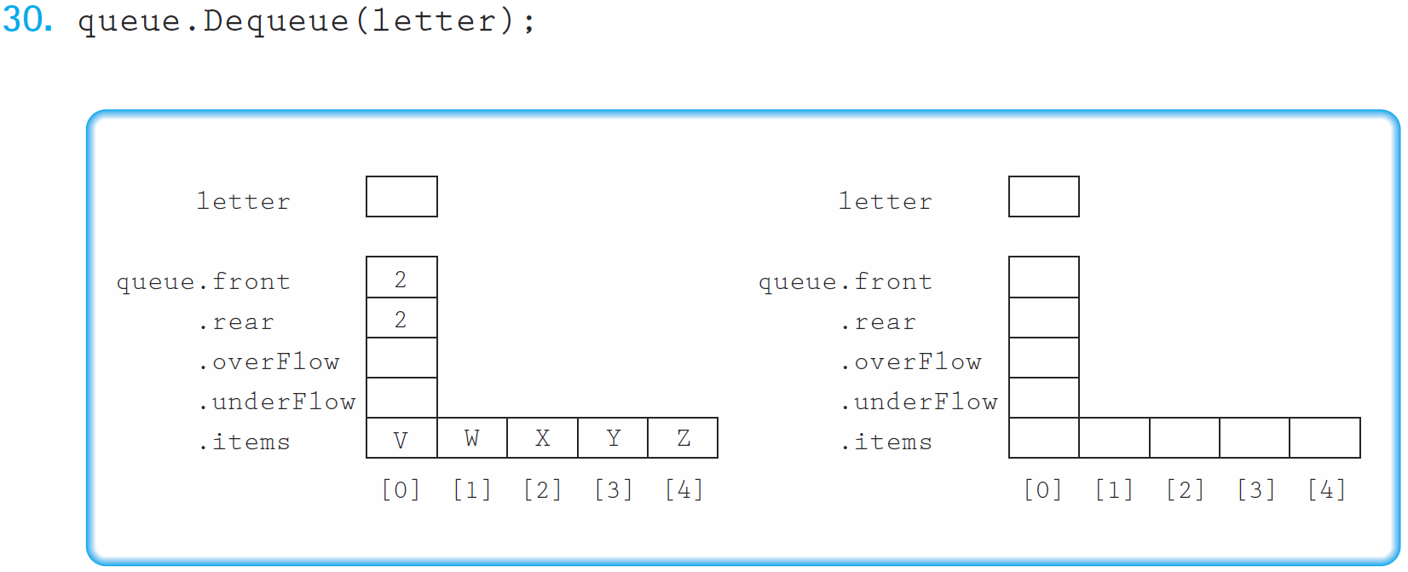

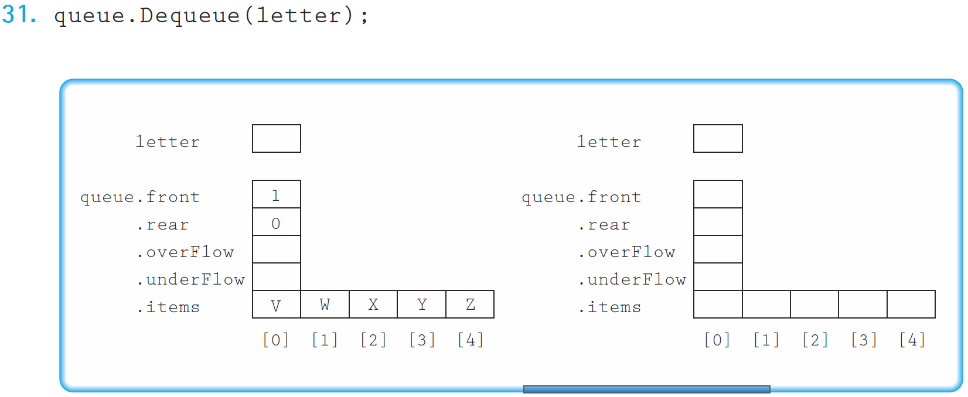

3.

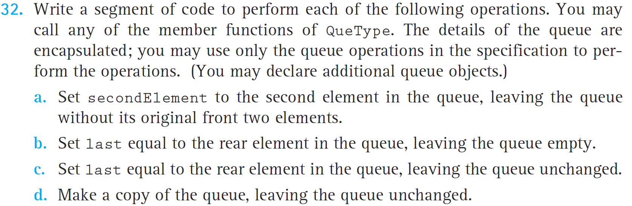

4.

