HW 10

1. Exercise 1

2. Exercise 2

3. Exercise 3

4. Exercise 4

5. Exercise 5

6. Exercise 8

7. Exercise 9

8. Exercise 12

9. Exercise 13

10. Exercise 33

(5,6판도 동일)

1.

D:\2014-자료구조 가을\말똥가리\81.PNG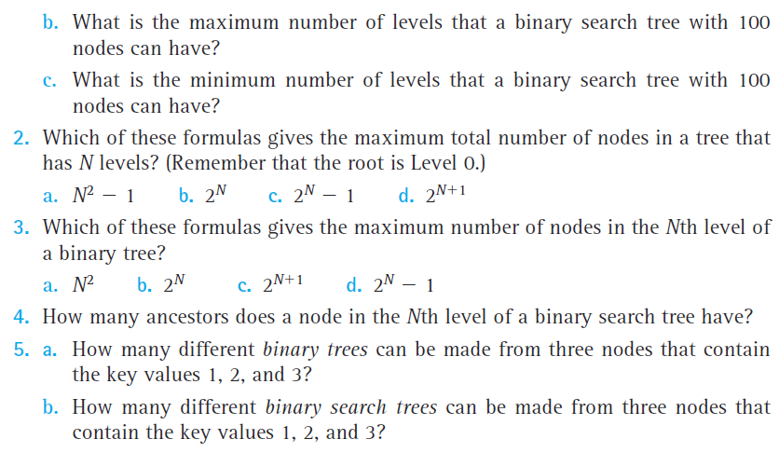

2. 

3.

4.



5.



6.

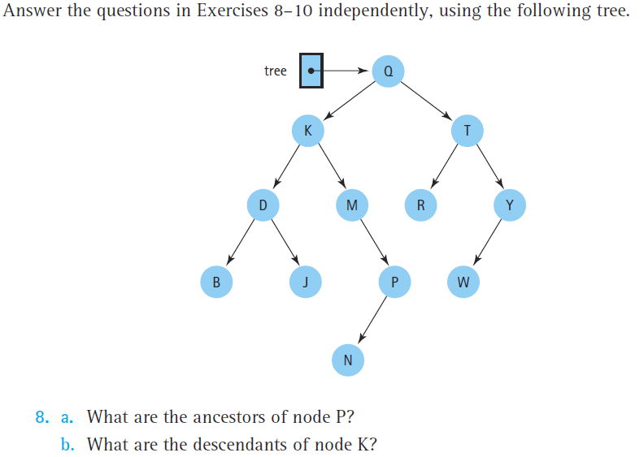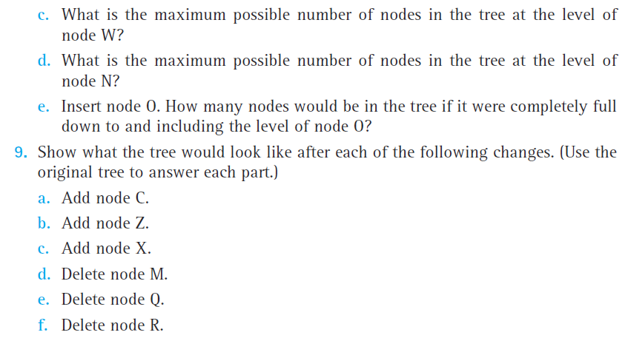

7.

Exercise 12,13번은 교재 3판(519page), 5판(558page) 6판(566page)그림 참조

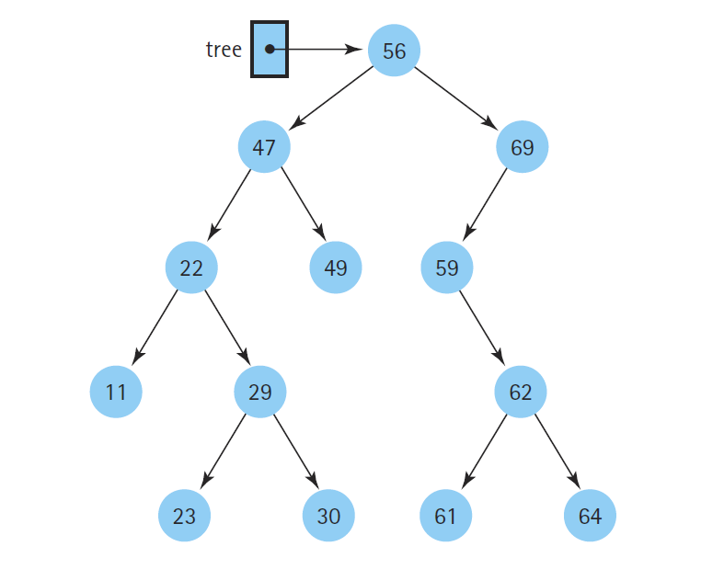

8.

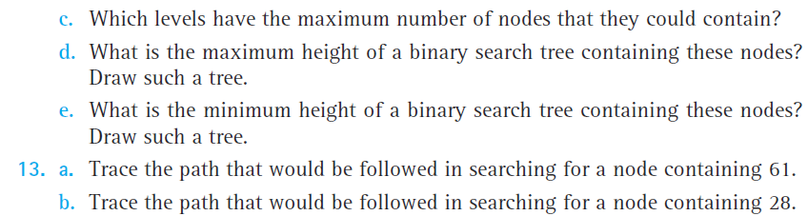

9.



10.

