HW 11

1.       Exercise 7

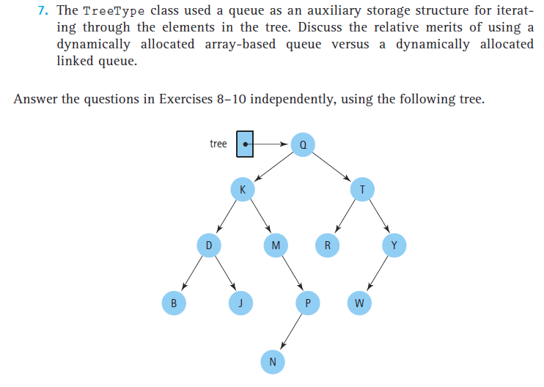

2.       Exercise 10

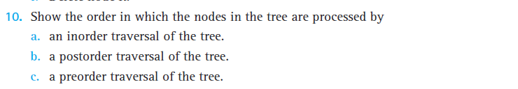

3.       국문/영문 Exercise 28



4.       국문/영문 Exercise 34

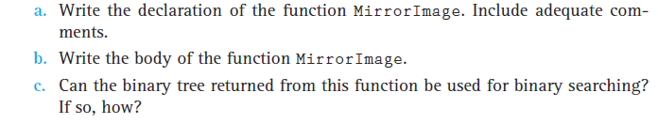

Exercise 37 ~ 41 Figure

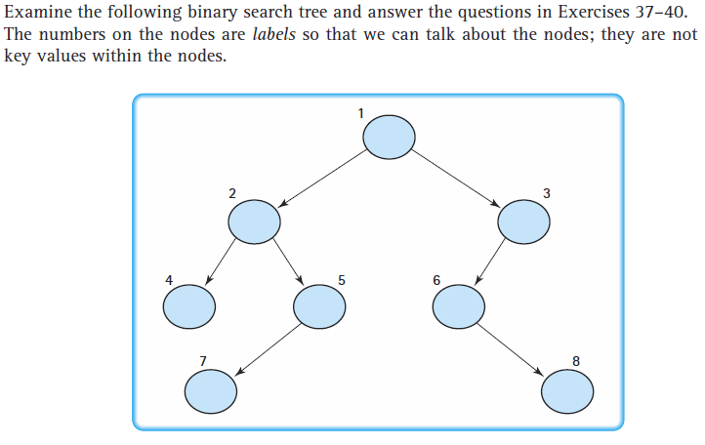

5.       Exercise 37



6.       Exercise 38



7.       Exercise 41

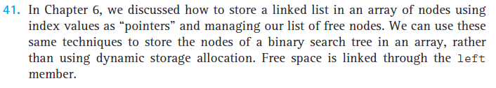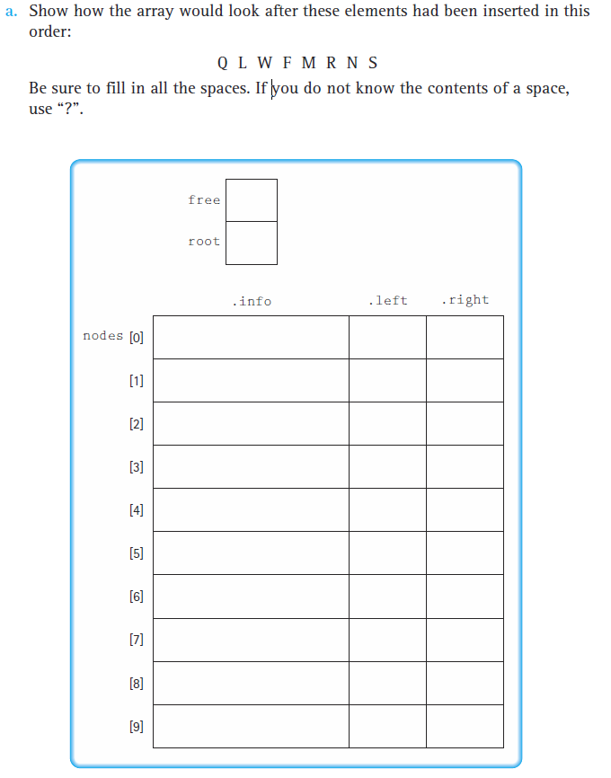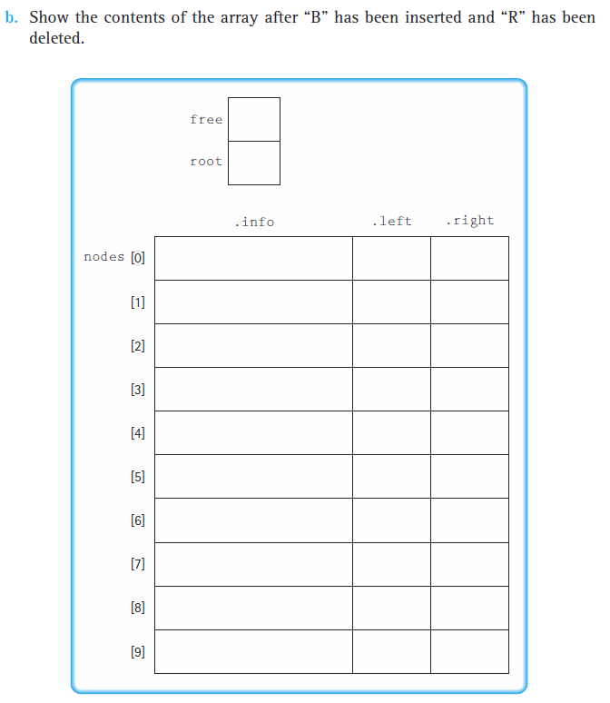

8.       Exercise 42

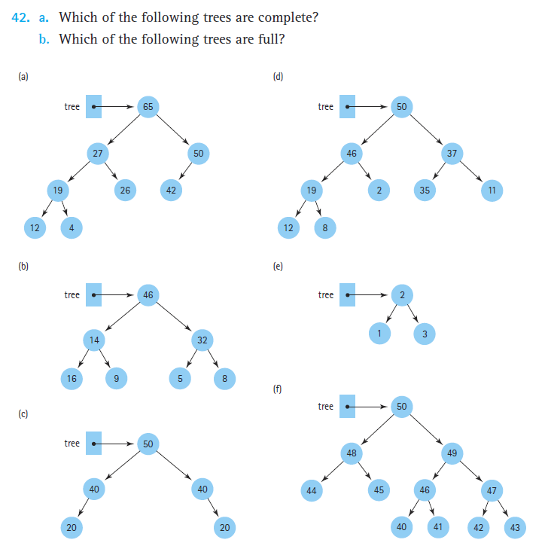

9.       Exercise 43

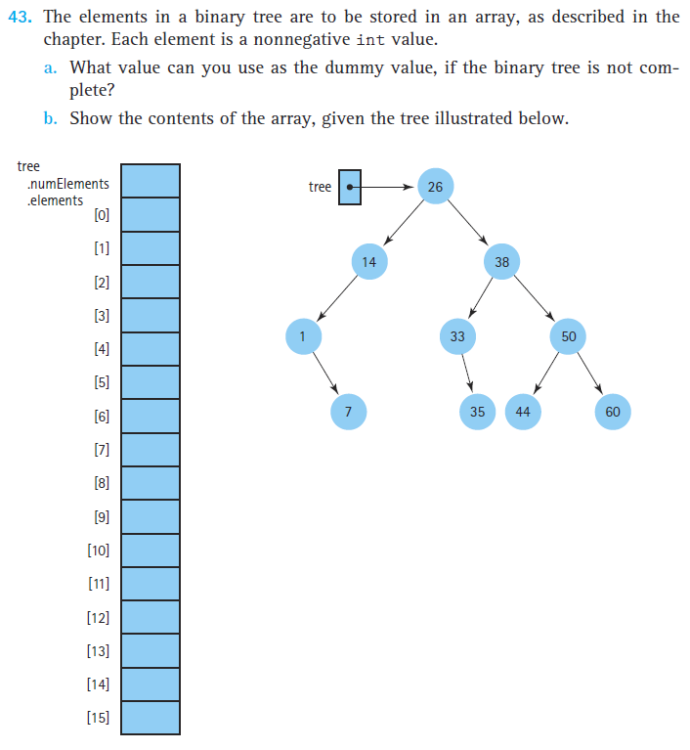

10.   Exercise 46

