HW 2

1. Exercises 4, 17, 21, 22, 23 (3판, 4판,5판,6판 동일함)
   * 4, 17, 21, 22번은 한글 교재도 동일함

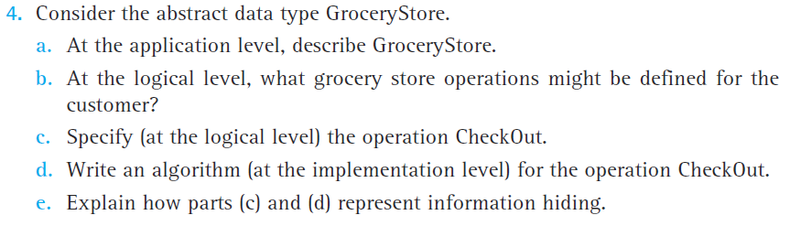

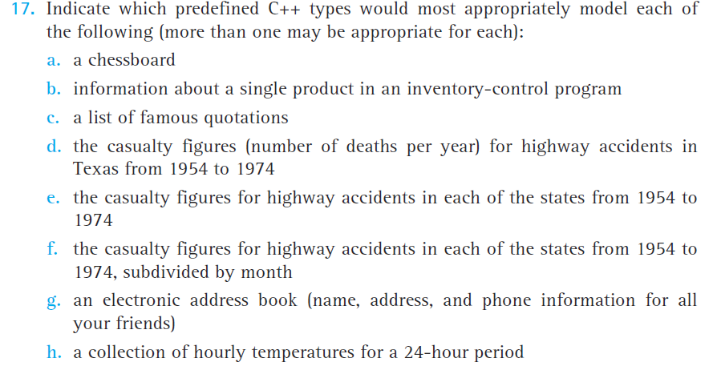

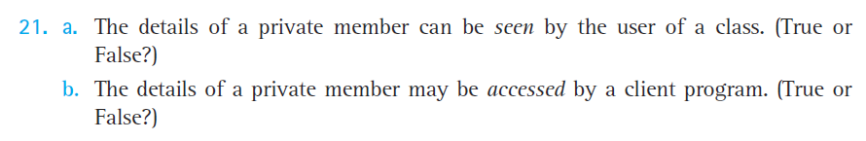



* + 23번 문제는 “Name three ways that classes can relate to each other”



1. Exercise 28 (한글교재 23)의 d번 문제에서 만든 test plan을 사용하여 test driver를 만드시오 (SquareMatrix 클래스도 포함하여 실행 파일 만듦).
2. 실습 시간에 다룬 SquareMatrix를 좀 더 확장한 MatrixType 클래스를 만들고 test driver를 작성하시오. 각 멤버 함수의 precondition과 postcondition은 프로그램 안에 코멘트로 삽입한다.

Many mathematical problems require the addition, subtraction, and multiplication of two matrices.

Write an ADT Matrix. You may use the following class definition.

const int MAX_ROWS = 10;

const int MAX_COLS = 10;

class MatrixType

{

public:

MatrixType();

void MakeEmpty();

void SetSize(int rowsSize, int colSize);

void StoreItem(int item, int row, int col);

void Add(MatrixType otherOperand, MatrixType& result);

void Sub(MatrixType otherOperand, MatrixType& result);

void Mult(MatrixType otherOperand, MatrixType& result);

void Print(ofstream& outfile);

bool AddSubCompatible(MatrixType otherOperand);

bool MultCompatible(MatrixType otherOperand);

private:

int values[MAX_ROWS][MAX_COLS];

int numRows;

int numCols;

};

Before you start looking at how to implement this class, you must determine the appropriate preconditions and postconditions for each operation. Note that the class provides the member functions to allow the client to determine if the binary matrix operations are possible. Before this class can become a permanent part of your program library, it must be thoroughly tested. Write a menu driven testing program to test your MatrixType.

#### Menu Driven Testing Interface:

The menu should contain the following options.

GetNewMatrix <matrix>

Number of rows and number of columns are on the next line.

Number of column values on the next number of rows lines

AddMatrices <matrix> <matrix> <matrix>

Add first and second, leaving the result in the third

SubMatrices <matrix> <matrix> <matrix>

Subtract second from first, leaving the result in the third

MultiplyMatrices <matrix> <matrix> <matrix>

Multiply first and second, leaving the result in the third

PrintMatrix <matrix>

Print the matrix one row per line on DataOut

Quit

#### Processing Notes

1. <matrix> is a number between 0 and 9. This value is used as an index into an array of MatrixType.
2. The main function must include a *Switch* statement where the case expression is a user-defined enumeration type. This means that the command is recognized and its enumeration equivalent is sent back to be used in the case statement.
3. The driver must ensure the preconditions of the member functions of MatrixType. Throw an exception if an error occurs and continue processing.