1.

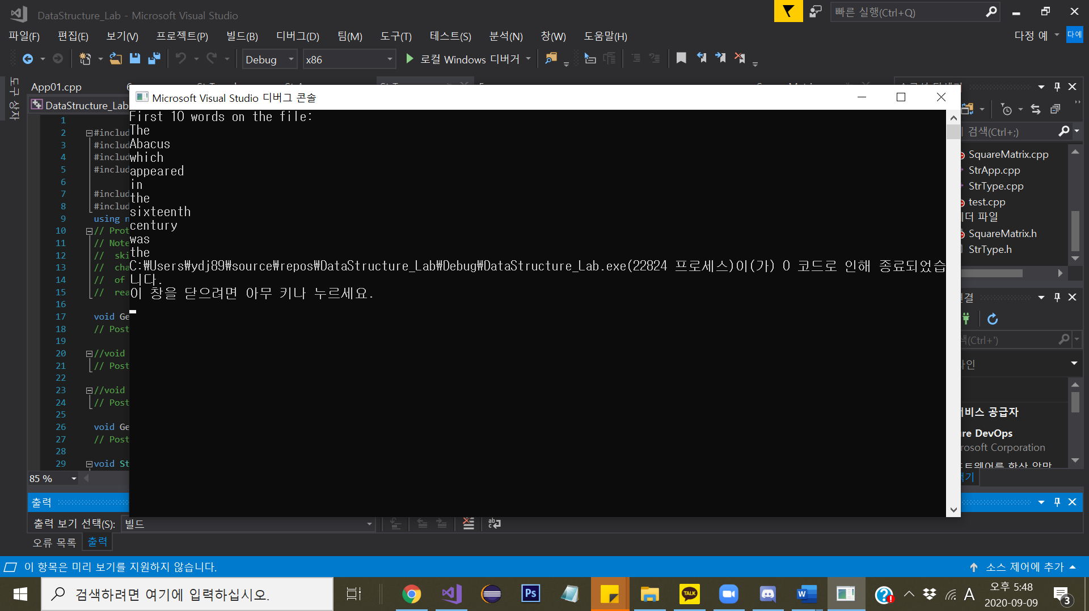

2.

|  |  |  |
| --- | --- | --- |
|  | Length | Offset |
| firstName | 9 | 0 |
| lastName | 9 | 9 |
| Id | 4 | 18 |
| Gpa | 4 | 22 |
| currentHours | 4 | 26 |
| totalHours | 4 | 30 |

3.

student.gpa address = 100 + 22 = 122

4.

students = StudentRecord형의 원소 100개를 가지는 배열

(9+9+4+4+4+4) * 100 = 3400(bytes) //sizeof(StudentRecord)==36 (students배열도 3600)🡪firstName, lastName뒤에 padding byte(2bytes)가 추가됨