1. AIM: Design TM using simulator to accept the input string wcw

INPUT:

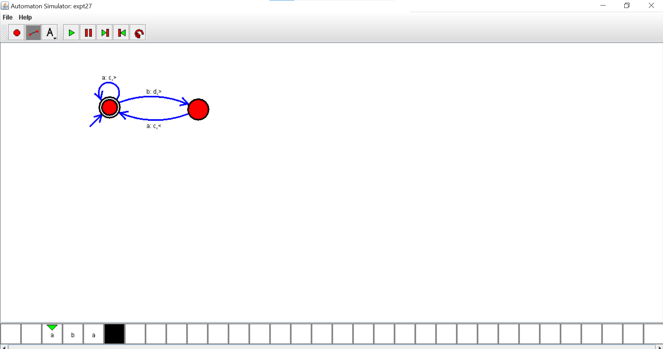

OUTPUT:

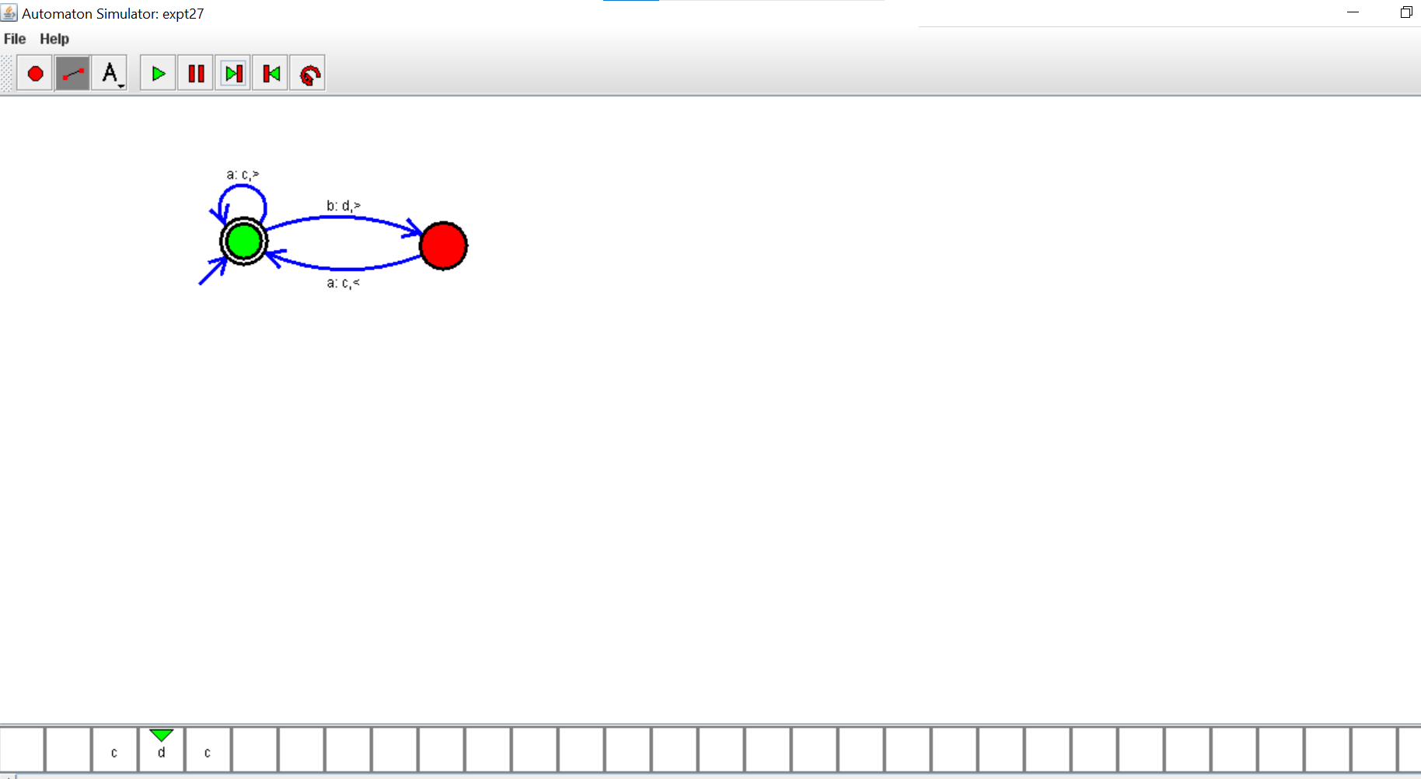

RESULTS: thus designed TM using simulator to accept the input string wcw