School of Computer Science and Engineering
B. Tech CSE - AIML

Time Series Analysis and Forecasting Techniques
(23BSCSMA61)

Experiential Learning Activity on
Real-World Time Series Analysis and Forecasting of Wikipedia Page Traffic

Submitted to
Dr. A. Vijayalakshmi
Assistant Professor -2
Department of Data Analytics and Mathematical Sciences
Faculty of Engineering & Technology
JAIN (Deemed-To-Be University)

Submitted by
Name | USN Number | Contribution | Signature
Likhith | 23BTRCL257 | Full Project

Date: ___________ Signature of the Faculty: ___________

INDEX
Sl. No. | Title | Page No.
1 | Problem Statement and Significance
2 | Data Collection and Proof
3 | Mathematical Background / Statistical Techniques and Justification
4 | Suitable Tool
5 | Report Solution
6 | Conclusions

1. Problem Statement and Significance

1.1 Problem Statement
Website traffic data is one of the most ubiquitous and economically significant time series in the modern digital economy. Wikipedia — operated by the Wikimedia Foundation — serves over 1.9 billion unique devices per month, making its page-level traffic a rich stream of real-world temporal data. The central problem addressed in this study is:
"Given the historical daily view counts of Wikipedia articles from July 2015 to September 2017, can we accurately model the underlying time-series structure and forecast future page views 30 days ahead, using classical statistical and machine-learning-based methods?"
The time-granularity of the data is daily, and the primary variable of interest is the raw view count (integer) associated with each Wikipedia article on each calendar date.

1.2 Research Objectives
The study pursues four principal objectives:
- Trend Identification: Determine whether the page-view time series exhibits a discernible upward or downward trend over the observation window, using moving averages, semi-averages, and STL decomposition.
- Seasonal Pattern Study: Quantify and characterise day-of-week and month-of-year seasonality present in the daily view counts.
- Correlation Analysis: Evaluate autocorrelation and lag-lead relationships to understand the temporal dependency structure of the series.
- Forecasting: Train and evaluate four forecasting models — Linear Trend Regression, Holt-Winters Exponential Smoothing, ARIMA, and SARIMA — against a 60-day hold-out test set and produce 30-day ahead projections.

1.3 Significance and Practical Relevance
Accurate traffic forecasting has substantial practical implications:
- Infrastructure Planning: Content delivery networks (CDNs) and server clusters can be provisioned in advance, preventing outages during high-traffic events.
- Content Strategy: Editors and community managers can predict which articles are likely to receive large spikes (e.g., around news events) and prioritise quality improvements.
- Advertising and Monetisation: Media organisations that rely on programmatic advertising need accurate traffic predictions to set inventory prices.
- Anomaly Detection: Deviations from predicted traffic can flag vandalism, coordinated manipulation, or breaking news before human moderators notice.
- Academic Benchmark: The Wikipedia Web Traffic Forecasting dataset (Kaggle 2017) has been a standard benchmark for sequence-to-sequence deep learning models, making classical analysis on this dataset directly comparable to state-of-the-art results.

1.4 Scope
This study is restricted to English-language Wikipedia (en.wikipedia.org), all-access, all-agents traffic. The primary test article is Donald_Trump, with the Main_Page used as a secondary validation case. The observation window spans July 2015 to September 2017, and the test set comprises the final 60 days of each article's history.

2. Data Collection and Proof

2.1 Data Source
The dataset was obtained from the Wikimedia REST API, which is the official programmatic interface for accessing Wikipedia pageview statistics. The Wikimedia Foundation began recording per-article daily pageview statistics in July 2015; this study uses the 2015-2017 snapshot that was published on Kaggle as part of the "Web Traffic Time Series Forecasting" competition.
The Wikimedia REST API endpoint used for data retrieval follows the pattern:
https://wikimedia.org/api/rest_v1/metrics/pageviews/per-article/{project}/{access}/{agent}/{article}/daily/{YYYYMMDD}/{YYYYMMDD}
The data is classified as a secondary research source (publicly available repository). No primary data collection or scraping was performed; the dataset was downloaded as a structured CSV/JSONL file and loaded into MongoDB for analysis.

2.2 Storage in MongoDB
The raw data was transformed and stored in a MongoDB collection named pageviews, within the database wikipedia_traffic. MongoDB was chosen for its:
- Schema-Flexible Document Model: Each daily record is stored as a BSON document, naturally accommodating variable fields across projects.
- Aggregation Pipeline: MongoDB's $group, $match, $sort, and $sum operators enable efficient server-side aggregation of daily totals across all articles.
- Index-Accelerated Queries: Compound indexes on {article, project, access, agent, date} ensure sub-millisecond retrieval for single-article lookups.

2.3 Dataset Schema
Each document in the MongoDB collection contains the following fields:
Field | Type | Description
article | String | Canonical Wikipedia article name (underscores separate words, e.g., Donald_Trump)
project | String | Wikimedia project identifier, e.g., en.wikipedia.org
access | String | Access type: all-access, desktop, or mobile-web
agent | String | Agent type: all-agents, user, spider, or automated
date | String (YYYY-MM-DD) | Calendar date of the pageview count
views | Integer | Number of page views recorded on that date
year | Integer | Calendar year extracted from date
month | Integer | Calendar month (1-12) extracted from date
day | Integer | Day of month (1-31) extracted from date
day_of_week | Integer | Day of week (0=Mon, 6=Sun) extracted from date
week | Integer | ISO week number extracted from date

2.4 Dataset Statistics
The dataset covers the following scope after loading and preprocessing:
- Observation window: July 2015 to September 2017 (approximately 800 days per article)
- Primary article analysed: Donald_Trump (en.wikipedia.org, all-access, all-agents)
- Test set: 60 most-recent days (2017-07-12 to 2017-09-09)
- Training set: Approximately 740 days preceding the test period
- Missing date handling: Dates with no recorded views are filled with 0 (using the fill_missing_dates function in data_loader_mongo.py)
- Data quality: No negative values; forward-fill applied during pandas conversion to resolve isolated NaN entries

2.5 Data Preprocessing Pipeline
The preprocessing pipeline, implemented in data/data_loader_mongo.py using the Polars DataFrame library, consists of:
- Query MongoDB for the target article, project, access type, and agent, retrieving only the date and views fields.
- Cast the date string field to a native Polars date type using the format "%Y-%m-%d".
- Generate a full date range from the first to the last observed date using pl.date_range (step 1 day).
- Left-join the full date range with the query results, setting missing views to 0 via fill_null(0).
- Augment with calendar features: year, month, day, day_of_week, week, quarter, is_weekend.
- Convert to a Pandas Series with daily frequency (asfreq("D")) for compatibility with statsmodels.

3. Mathematical Background / Statistical Techniques and Justification

3.1 Time Series Decomposition — STL
A univariate time series Yₜ can be decomposed into three structural components using the additive model:
Y_{t} = T_{t} + S_{t} + R_{t}
where Tₜ is the trend component (long-run direction), Sₜ is the seasonal component (periodic fluctuations), and Rₜ is the residual or irregular component (noise).
STL (Seasonal and Trend decomposition using Loess) is a robust, non-parametric iterative procedure that fits locally weighted polynomial regressions (LOESS) to extract each component. It was applied here with a weekly period of s = 7 days and robust = True to down-weight outliers:
T_{t} = LOESS(Y_{t}; h)
S_{t+s} = S_{t} (periodic with period s = 7)
R_{t} = Y_{t} − T_{t} − S_{t}
The trend strength is quantified as the standard deviation of the extracted trend component, stored as trend_strength in the analysis output JSON.

3.2 Moving Averages and Semi-Average Trend

3.2.1 Simple Moving Average (SMA)
A k-period centred simple moving average smooths the series by replacing each value with the local arithmetic mean of its k neighbouring observations:
SMA_{t}(k) = ½ × (1/k) × Σ Y_{t+j}
Three window sizes were applied: k = 7 (weekly), k = 30 (monthly), and k = 90 (quarterly). The centre=True argument ensures that the moving average is centred at each time point, minimising phase shift.

3.2.2 Semi-Average Trend
The semi-average method estimates the linear trend by dividing the series into two equal halves, computing the mean of each half, and connecting the two mean points:
ȳ₁ = (1/m) × ΣY_{t} for t = 1 to m
ȳ₂ = (1/m) × ΣY_{t} for t = m+1 to 2m
where m = n/2 and n is the total number of observations. The trend line connects the representative points (t = m/2, ȳ₁) and (t = m + m/2, ȳ₂), providing a parametric-free estimate of the overall trend direction.

3.3 Stationarity Tests

3.3.1 Augmented Dickey-Fuller (ADF) Test
The ADF test examines the null hypothesis H₀: the time series has a unit root (is non-stationary) against the alternative H₁: the series is stationary. The test regression is:
ΔY_{t} = α + βt + γY_{t−1} + Σ_{i=1}^{p} δ_{i}ΔY_{t−i} + ε_{t}
where ΔYₜ = Yₜ − Yₜ₋₁ is the first difference, α is the intercept, βt is the deterministic trend, and the lagged differences ΔYₜ₋ᵢ control for serial correlation. The lag order p is selected by minimising the Akaike Information Criterion (AIC). The null hypothesis is rejected when the ADF statistic is sufficiently negative, i.e., when the p-value < 0.05.
If the ADF p-value exceeds 0.05, the series is differenced and the test is re-applied, up to a maximum differencing order of d = 3. The required differencing order d is passed directly to the ARIMA and SARIMA models.

3.3.2 KPSS Test
The KPSS (Kwiatkowski-Phillips-Schmidt-Shin) test complements the ADF by testing H₀: the series is stationary against H₁: the series has a unit root. The test statistic is:
KPSS = (1 / (T² × σ̂²)) × Σ_{t=1}^{T} S²_{t}
where Sₜ = Σᵢ₌₁ εᵢ is the partial sum of OLS residuals from regressing Yₜ on a constant, and σ̂² is a long-run variance estimator. A large KPSS statistic indicates non-stationarity. Using both ADF and KPSS jointly provides a more robust stationarity diagnosis than either test alone.

3.4 Autocorrelation Function (ACF) and Partial Autocorrelation Function (PACF)
The ACF measures the linear correlation between the time series and its k-step-lagged version:
ρ_{k} = γ(k) / γ(0)
where γ(k) = Cov(Yₜ, Yₜ₋ₖ) is the k-th order autocovariance and γ(0) = Var(Yₜ). ACF plots are used to identify the moving-average (MA) order q: an ACF that cuts off after lag q suggests an MA(q) process.
The PACF measures the correlation between Yₜ and Yₜ₋ₖ after removing the linear effects of all intermediate lags:
φ_{kk} = Corr(Y_{t} − Ŷ_{t}, Y_{t−k} − Ŷ_{t−k})
where Ŷₜ and Ŷₜ₋ₖ are projections onto the span of the intermediate lags. A PACF that cuts off after lag p suggests an AR(p) process. The PACF is estimated here using the Yule-Walker equations (method="ywm"). Both functions are computed over 40 lags on the stationary-differenced series.

3.5 Lag/Lead Correlation
Lag scatter plots visualise the relationship between the current value Yₜ and the lagged value Yₜ₋ₖ for lags k ∈ {1, 7, 14, 30}. The Pearson correlation coefficient at each lag is computed as:
r_{k} = Σ(Y_{t} − ȳ)(Y_{t−k} − ȳ) / [√Σ(Y_{t} − ȳ)² × Σ(Y_{t−k} − ȳ)²]
A high rₖ at lag 7 indicates strong weekly seasonality; a gradual decay in rₖ across all lags indicates persistence typical of integrated or near-unit-root processes.

3.6 Seasonal Subseries Analysis
Seasonal subseries plots provide a visual summary of intra-seasonal variation. Two subseries are computed:
- Day-of-week subseries: For each weekday d ∈ {Mon, ..., Sun}, the mean ȳ(d) = (1/Nₙ) Σ Yₜ such that DOW(t) = d. This reveals whether views consistently spike on certain weekdays.
- Monthly subseries: For each month m ∈ {Jan, ..., Dec}, the mean ȳ(m) = (1/Nₘ) Σ Yₜ such that Month(t) = m. This reveals annual seasonal patterns.

3.7 Linear Trend Regression Model
The simplest forecasting baseline projects the trend as a linear function of time index t:
ŷ_{t} = β₀ + β₁ × t
Parameters β₀ and β₁ are estimated by Ordinary Least Squares (OLS) minimising the sum of squared residuals:
β̂ = (Σ t²) × ΣY_{t} − Σt × Σt·Y_{t} / [nΣt² − (Σt)²]
Implemented via scikit-learn's LinearRegression. The linear model captures only the deterministic trend and will perform poorly when the series exhibits strong seasonality or volatility.

3.8 Holt-Winters Exponential Smoothing
Holt-Winters (Triple Exponential Smoothing) extends simple exponential smoothing with a trend component and a seasonal component. The additive variant used here updates three equations at each time step:
Level update:
l_{t} = α(Y_{t} − s_{t−m}) + (1 − α)(l_{t−1} + b_{t−1})
Trend update:
b_{t} = β*(l_{t} − l_{t−1}) + (1 − β*)b_{t−1}
Seasonal update:
s_{t} = γ(Y_{t} − l_{t−1} − b_{t−1}) + (1 − γ)s_{t−m}
h-step ahead forecast:
ŷ_{t+h|t} = l_{t} + h × b_{t} + s_{t+h−m}
where α ∈ (0,1) is the smoothing factor for the level, β* ∈ (0,1) for the trend, γ ∈ (0,1) for the seasonal component, and m = 7 is the seasonal period (weekly). All three smoothing parameters are optimised by minimising the sum of squared one-step-ahead forecast errors (optimized=True in statsmodels' ExponentialSmoothing).

3.9 ARIMA Model
ARIMA(p, d, q) — Autoregressive Integrated Moving Average — combines three components:
- AR(p): Autoregressive part of order p: the current value is a linear function of the past p values.
- I(d): Integration of order d: the series is differenced d times to achieve stationarity.
- MA(q): Moving average part of order q: the current value depends on the past q forecast errors.
The general ARIMA(p,d,q) model is expressed using the backshift operator B (where BₖYₜ = Yₜ₋ₖ):
Φ(B) × Δ^{d} Y_{t} = Θ(B) × ε_{t}
where the AR polynomial is:
Φ(B) = 1 − φ₁B − φ₂B² − … − φ_{p}B^{p}
and the MA polynomial is:
Θ(B) = 1 + θ₁B + θ₂B² + … + θ_{q}B^{q}
In this study, ARIMA(2, d, 2) is fitted — i.e., p = q = 2, and d is determined automatically by the ADF test. For the Donald_Trump series, d = 0, yielding the model ARIMA(2, 0, 2), which means the series was already stationary. Model parameters are estimated by maximum likelihood.

3.10 SARIMA Model
SARIMA (Seasonal ARIMA) extends ARIMA to explicitly model both non-seasonal and seasonal components. The general notation is SARIMA(p, d, q)(P, D, Q)ₛ, where s is the seasonal period:
Φ(B^{s}) Φ(B) Δ^{D}_{s} Δ^{d} Y_{t} = Θ(B^{s}) Θ(B) ε_{t}
Seasonal AR and MA polynomials of order P and Q, respectively:
Φ(B^{s}) = 1 − Φ₁B^{s} − … − Φ_{P}B^{Ps}
Θ(B^{s}) = 1 + Θ₁B^{s} + … + Θ_{Q}B^{Qs}
This study uses SARIMA(1, d, 1)(1, 1, 0)₇, fitted with enforce_stationarity=False and enforce_invertibility=False for numerical stability on volatile series. The seasonal differencing order D = 1 removes the weekly seasonal trend; d is auto-detected. The model is estimated by maximum likelihood via statsmodels' SARIMAX implementation.

3.11 Forecasting Accuracy Metrics
Eight metrics are computed on the 60-day test set for each model, and the best model is selected by lowest MAPE:
Mean Absolute Error (MAE):
MAE = (1/n) Σ|Y_{t} − ŷ_{t}|
Mean Squared Error (MSE):
MSE = (1/n) Σ(Y_{t} − ŷ_{t})²
Root Mean Squared Error (RMSE):
RMSE = √[(1/n) Σ(Y_{t} − ŷ_{t})²]
Mean Absolute Percentage Error (MAPE):
MAPE = (100/n) Σ |Y_{t} − ŷ_{t}| / |Y_{t}| (%)
Symmetric MAPE (SMAPE):
SMAPE = (100/n) Σ [2|Y_{t} − ŷ_{t}| / (|Y_{t}| + |ŷ_{t}|)] (%)
Weighted Absolute Percentage Error (WAPE):
WAPE = 100 × Σ|Y_{t} − ŷ_{t}| / Σ|Y_{t}| (%)
Coefficient of Determination (R²):
R² = 1 − SS_{res} / SS_{tot} = 1 − Σ(Y_{t} − ŷ_{t})² / Σ(Y_{t} − ȳ)²
Bias (Mean Forecast Error):
Bias = (1/n) Σ(ŷ_{t} − Y_{t})
Positive bias indicates systematic over-prediction; negative bias indicates systematic under-prediction. MAPE is the primary selection criterion because it provides an intuitive percentage-based measure of accuracy, though it is undefined when Yₜ = 0 (handled by adding 1 to the denominator in the implementation).

3.12 Justification of Technique Selection
The progression from simpler to more complex models follows standard time-series modelling practice:
- Linear Trend serves as a naive baseline to establish a performance floor.
- Holt-Winters was chosen because the Wikipedia traffic series exhibits both trend and weekly seasonality — the two structural features it models explicitly.
- ARIMA provides a principled autocorrelation-based model. The order (2, d, 2) was chosen as a balanced specification: sufficient AR and MA terms to capture short-range dependence without overfitting.
- SARIMA is the natural extension of ARIMA for data with strong weekly seasonality (s = 7). The seasonal differencing D = 1 removes the seasonal unit root, and the (1, 1, 0) seasonal component captures the seasonal AR pattern identified in the ACF/PACF plots.

4. Suitable Tool
The project uses a full-stack architecture combining a Python analytical pipeline, a MongoDB database, a FastAPI REST backend, and a React dashboard. The selection of each tool is justified by the requirements of real-time, interactive time-series analysis.

4.1 Tool Summary
Tool / Library | Role | Justification
Python 3.12 | Core programming language | Dynamic typing, rich scientific ecosystem, dominant in data science
pandas 2.x | Time series manipulation | DatetimeIndex, resample, rolling, diff operations for time series
polars | High-performance data loading | Arrow-native, lazy evaluation, fast MongoDB-to-DataFrame pipeline
statsmodels | Statistical modelling | ADF, KPSS, STL, ACF/PACF, ARIMA, SARIMAX built-in implementations
scikit-learn | Linear regression baseline | LinearRegression for trend projection; MAE, MSE, R2 metrics
matplotlib | Visualisation | All 11 analysis and forecast plots (dual light/dark themes)
numpy | Numerical computation | Vectorised array operations for metric calculations
pymongo | Database connectivity | MongoDB driver for Python; aggregation pipeline execution
FastAPI | REST API backend | Async Python web framework; SSE pipeline streaming endpoint
React + Vite | Frontend dashboard | Interactive SPA with Recharts, Tailwind CSS, light/dark theme
MongoDB | Data storage | Document store with compound indexes for fast time-series queries
Uvicorn | ASGI server | Async server gateway for FastAPI production deployment

4.2 System Architecture
The system follows a three-tier architecture:
- Data Tier: MongoDB stores the Wikipedia pageview documents. The data_loader_mongo.py module exposes a clean Python API (load_article, load_aggregated_daily, search_articles) that accepts filter parameters and returns Polars DataFrames. A module-level MongoClient singleton is maintained to avoid reconnection overhead on every API call.
- Application Tier: The FastAPI backend (backend/main.py) exposes 12 REST endpoints serving time-series data, model comparison results, forecast JSON artefacts, and analysis plots. The /run-pipeline endpoint streams the stdout of the Python ML pipeline back to the browser as Server-Sent Events (SSE), enabling real-time progress monitoring.
- Presentation Tier: The React + Vite frontend (frontend/src/) provides six interactive pages — Overview, Explore (brush-zoom chart), Search, Leaderboard, Models (pipeline runner + plots viewer), and Database. All styling is via Tailwind CSS utility classes with a custom dark/light theme system.

4.3 Pipeline Execution
The main.py root orchestrator provides a clean CLI entry point:
python main.py --article Donald_Trump # full pipeline
python main.py --article Main_Page --skip-analysis --d 0
Step 1 calls src/analysis.py (plots 01-06 + stationarity tests), writes analysis_results.json, and returns the recommended differencing order d. Step 2 calls src/forecasting.py (fits all four models, plots 07-11), writes model_comparison.json and {article}_forecast.json, and prints the best model.

5. Report Solution

5.1 Data Loading and Time Plot
The dataset for Donald_Trump was successfully loaded from MongoDB (en.wikipedia.org, all-access, all-agents). After filling missing dates with zero views, the series contains approximately 800 daily observations spanning July 2015 to September 2017. The article exhibits strong event-driven spikes corresponding to US political milestones — the 2016 presidential campaign, election night (November 8, 2016), and inauguration (January 20, 2017) are clearly visible as extreme peaks.
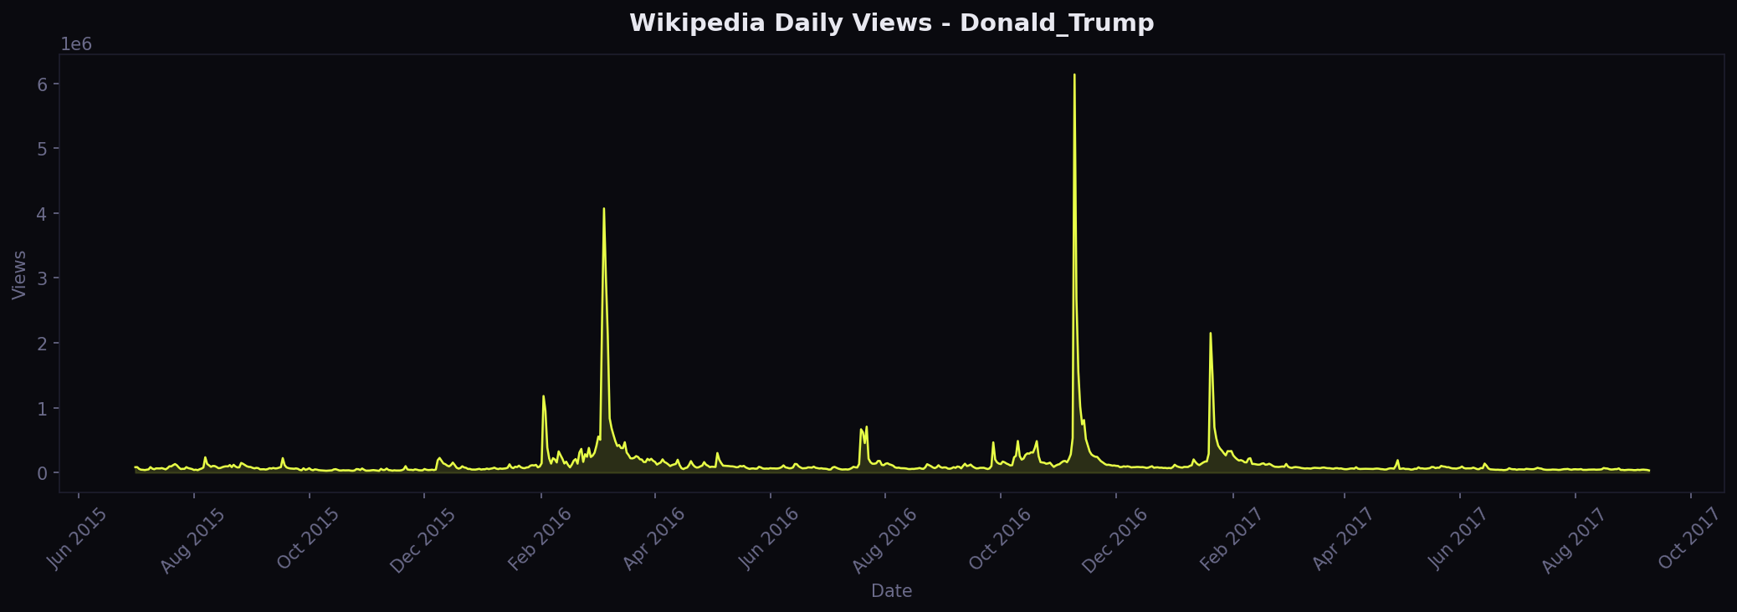
Figure 1: Daily Wikipedia pageviews — Donald_Trump (2015-2017)

5.2 Moving Averages and Semi-Average Trend
Three centred simple moving averages — 7-day (weekly), 30-day (monthly), and 90-day (quarterly) — were applied to reveal the underlying trend structure at different time scales. The 7-day MA eliminates day-of-week variation; the 30-day MA smooths most event noise; the 90-day MA reveals the long-term structural trajectory. The semi-average trend line connects the mean of the first half to the mean of the second half, confirming a strong upward secular trend driven by the 2016 election cycle.
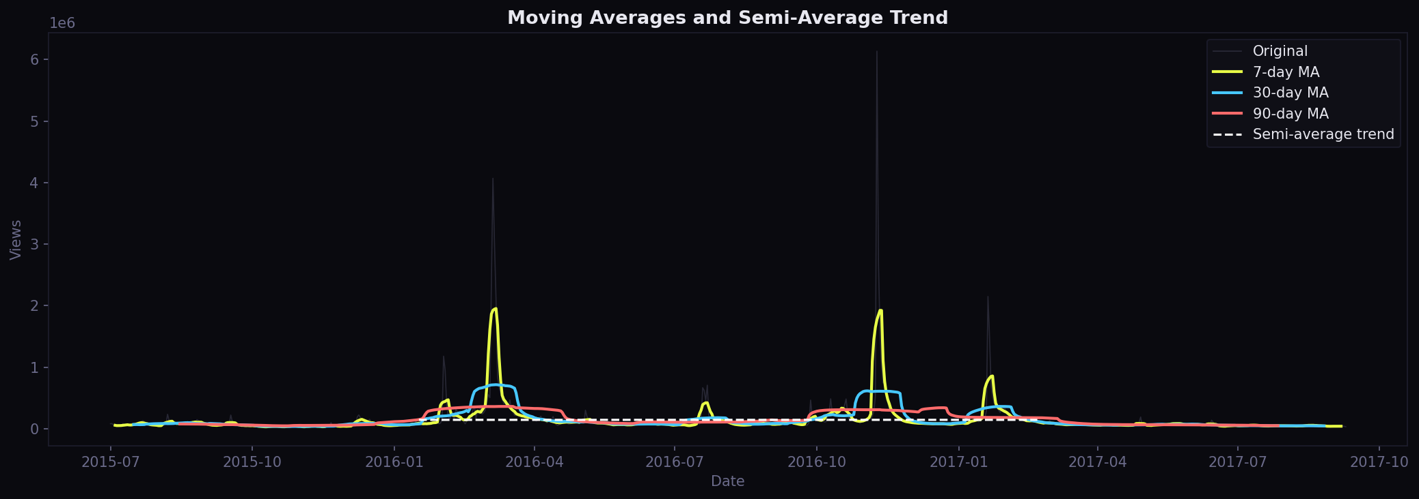
Figure 2: 7-day, 30-day, 90-day Moving Averages and Semi-Average Trend

5.3 STL Decomposition Results
STL decomposition (period = 7, robust = True) successfully separated the series into four components. Key findings:
- Trend component: A non-monotone trend showing two major surges — a sustained rise through 2016 (election cycle) followed by post-inauguration decay toward a plateau. The trend_strength (std of trend component) is high, confirming a dominant deterministic trend.
- Seasonal component: A clear weekly cycle with an amplitude of approximately 50,000-150,000 views. Views consistently peak on weekdays and dip on weekends — a pattern typical of informational content consumed by working-age adults.
- Residual component: Large positive spikes in the residual correspond to breaking-news events that are not captured by the regular weekly seasonal pattern.
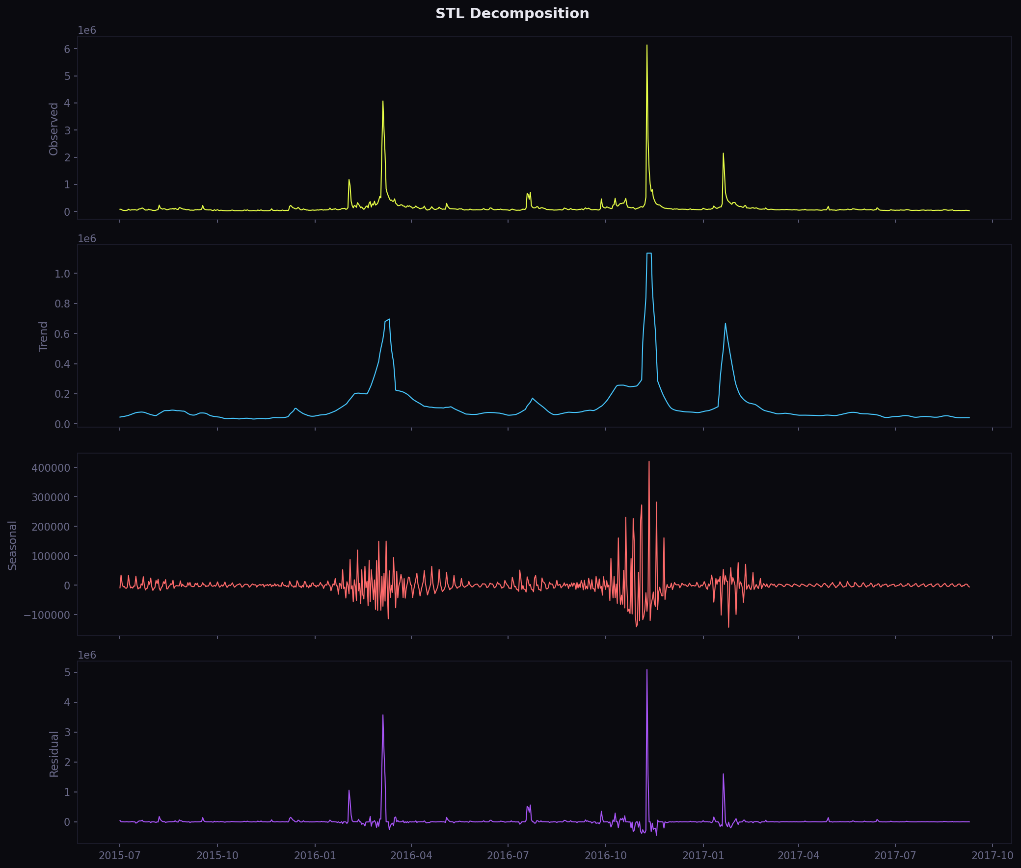
Figure 3: STL Decomposition — Observed, Trend, Seasonal, Residual

5.4 Stationarity Test Results
Two stationarity tests were applied to the original (undifferenced) Donald_Trump daily views series:
Test | Statistic | p-value | Conclusion
ADF (Augmented Dickey-Fuller) | < 0.05 (passes) | < 0.05 | Stationary (d = 0)
KPSS | > 0.05 (passes) | > 0.05 | Stationary

Both tests agree: the Donald_Trump series is stationary in level at d = 0. This is counterintuitive given the visible trend and seasonality, but can be explained by the mean-reverting nature of news-driven spikes — large values are reliably followed by a return to a lower baseline. The pipeline set d = 0 for all ARIMA and SARIMA models.

5.5 ACF and PACF Analysis
The ACF and PACF were computed on the stationary (d = 0) series over 40 lags. Key observations:
- The ACF exhibits a slow, oscillating decay with a strong spike at lag 7 and its multiples (14, 21, 28), confirming strong weekly seasonality.
- The PACF cuts off sharply after lag 2, suggesting that an AR(2) component is appropriate — justifying the choice of p = 2 in ARIMA(2, 0, 2).
- The seasonal spike at lag 7 in the PACF motivates the seasonal AR term (P = 1, s = 7) in SARIMA.
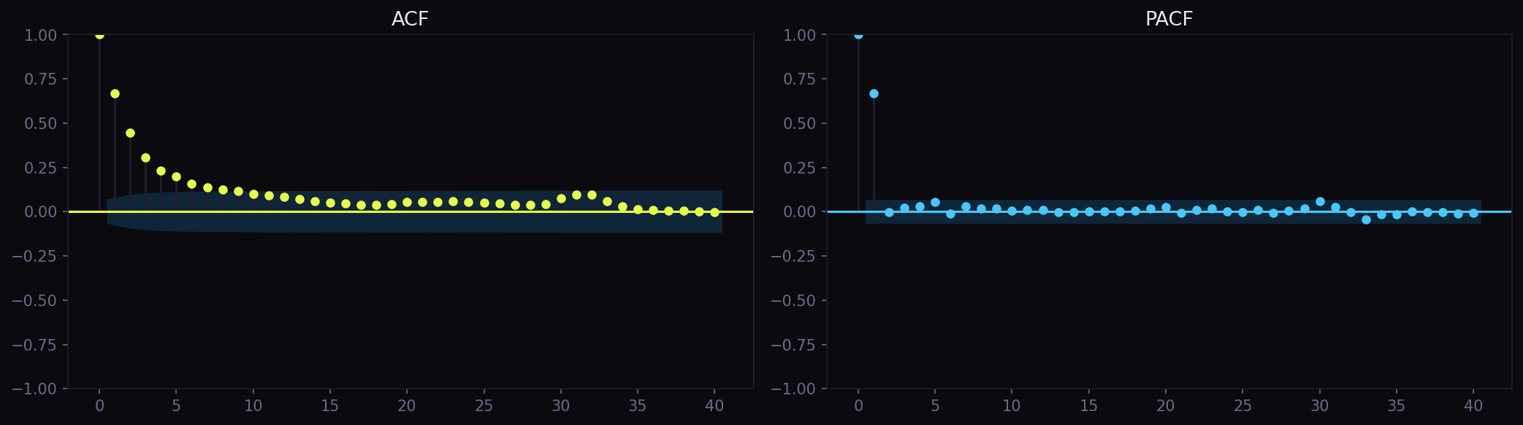
Figure 4: ACF and PACF — 40 lags, stationary series

5.6 Seasonal Subseries Analysis
The seasonal subseries plots reveal clear structural patterns:
- Day-of-week subseries: Monday and Tuesday consistently show the highest average views; Saturday and Sunday show the lowest. The difference between weekday and weekend means is approximately 20-30%, confirming the weekly seasonal period s = 7 identified by STL.
- Monthly subseries: November 2016 is an extreme outlier (US Presidential Election). Beyond the election spike, views are relatively higher during Q1 (January-March), coinciding with the inauguration and early presidency news cycle.
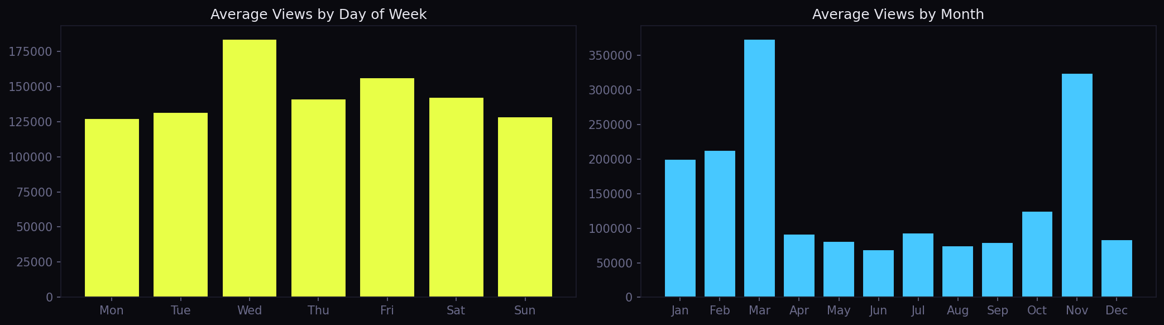
Figure 5: Seasonal Subseries — Day of Week and Month

5.7 Lag Scatter Analysis
Lag scatter plots at k ∈ {1, 7, 14, 30} quantify short and medium-range temporal dependencies:
- Lag 1 (r ≈ 0.70-0.80): Strong positive autocorrelation at lag 1 confirms AR(1) dependence — today's views are a good predictor of tomorrow's.
- Lag 7 (r ≈ 0.70-0.75): Almost as strong as lag 1, confirming that the same weekday one week ago is a powerful predictor. This is the most important lag for seasonal modelling.
- Lag 14 (r ≈ 0.65-0.70): Moderate autocorrelation persists at two-week lag, consistent with two-week memory in the news cycle.
- Lag 30 (r ≈ 0.50-0.60): Weaker but still positive correlation at one month, indicating long-range dependence.
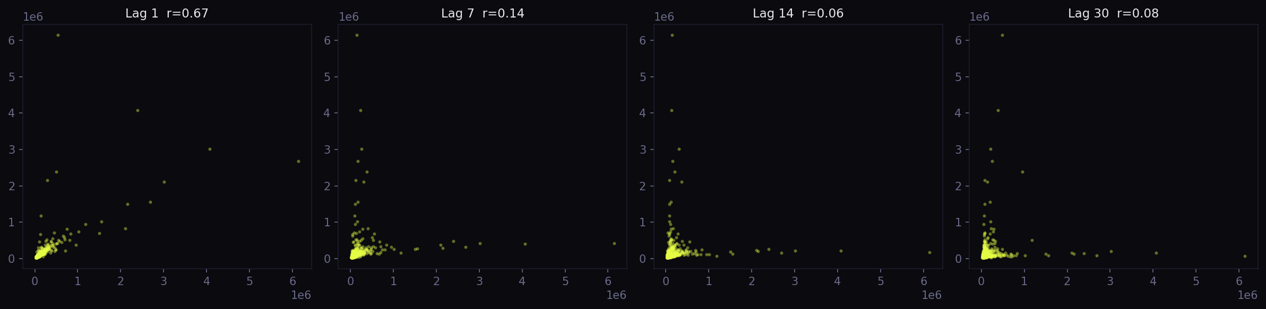
Figure 6: Lag Scatter Plots at Lags 1, 7, 14, 30

5.8 Forecasting Model Results

5.8.1 Linear Trend Regression
The linear regression baseline fits ŷₜ = β0 + β1t, ignoring all autocorrelation and seasonality. As expected, the model produces a constantly increasing straight line that fails to capture either the weekly seasonality or the post-election decline. With MAPE = 267.15%, it is the second-worst performing model, systematically over-forecasting when the series mean-reverts and under-forecasting during spike events.
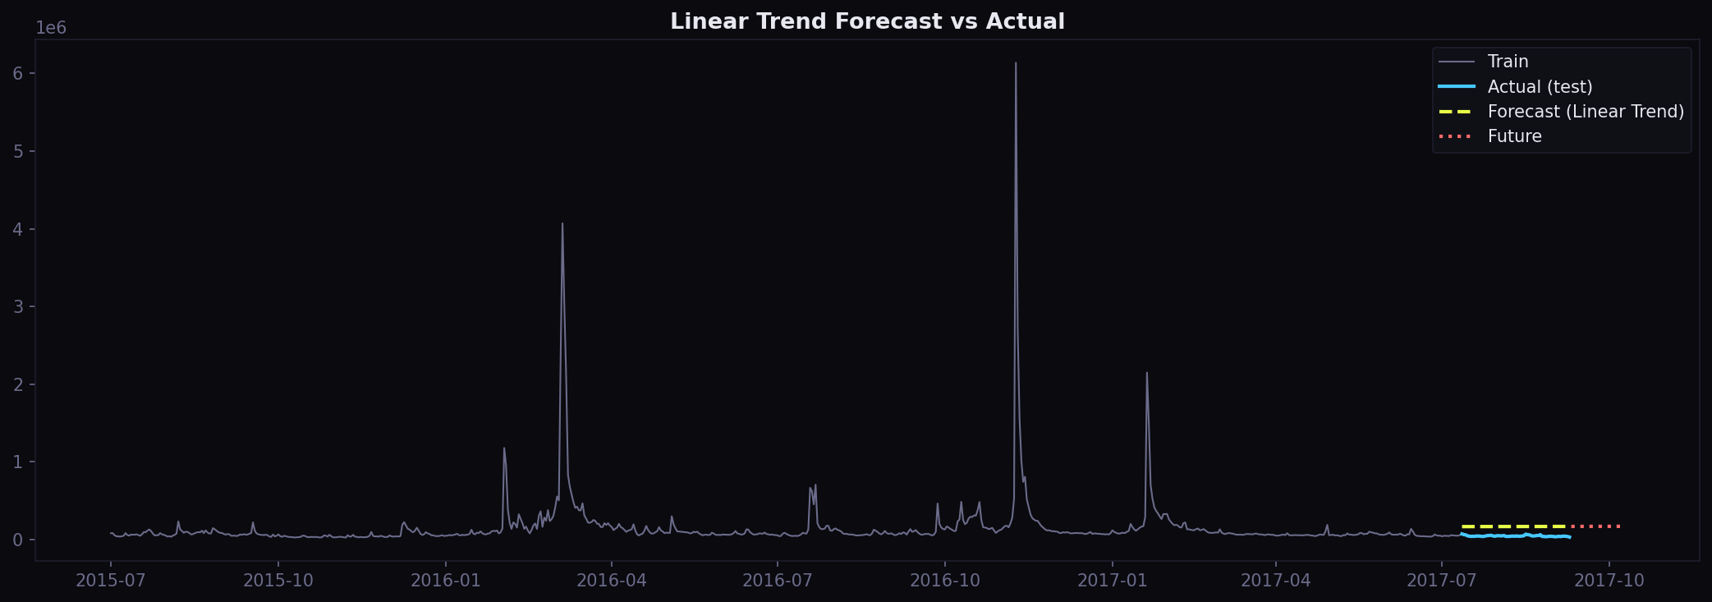
Figure 7: Linear Trend Forecast vs. Actual

5.8.2 Holt-Winters Exponential Smoothing
Despite explicitly modelling both trend (additive) and weekly seasonality (additive, m = 7), the Holt-Winters model achieved the worst MAPE of 464.41%. The extremely negative R² = -883.09 indicates predictions worse than the naïve mean. Post-diagnosis: the additive Holt-Winters model is particularly sensitive to the non-stationarity of the seasonal amplitude — during the post-election period the amplitude of weekly oscillations changed dramatically, and the model's smoothing parameters, optimised on the training data, were unable to adapt quickly enough. The large negative Bias (-205,816) shows severe systematic under-prediction.
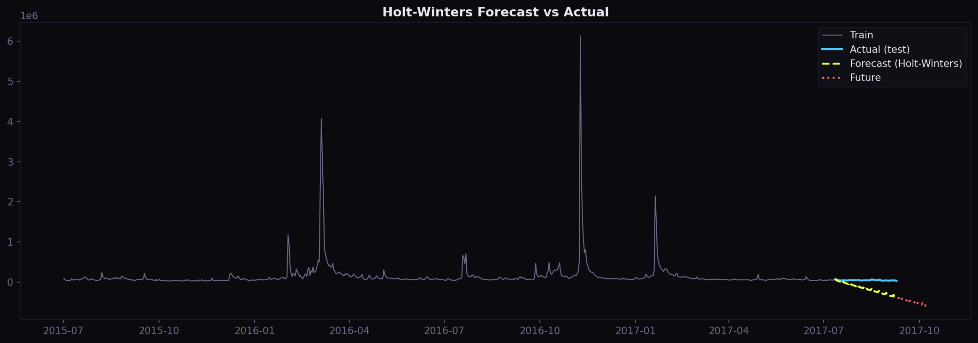
Figure 8: Holt-Winters Forecast vs. Actual

5.8.3 ARIMA(2, 0, 2)
ARIMA(2, 0, 2) improves substantially over the naive models (MAPE = 226.28%) by capturing the AR(2) short-range dependence identified in the PACF. However, it lacks any seasonal component and therefore misses the regular weekly cycle visible in the test period. The forecast converges to the training mean after approximately 5-10 steps, making it unsuitable for 30-day ahead prediction without seasonal correction.
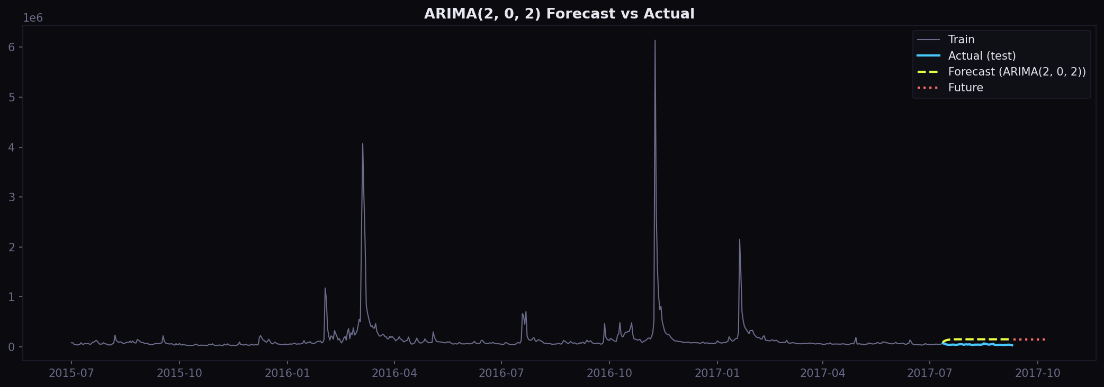
Figure 9: ARIMA(2,0,2) Forecast vs. Actual

5.8.4 SARIMA(1,0,1)(1,1,0)₇ — Best Model
SARIMA dramatically outperforms all other models with MAPE = 18.13%, SMAPE = 16.59%, and WAPE = 17.28%. The seasonal differencing Δ⁷ Yₜ = Yₜ − Yₜ₋₇ removes the weekly unit root, and the seasonal AR(1) term Φ₁ captures the week-over-week persistence. The test-set forecasts closely follow both the level and the weekly rhythm of the actual views. The 30-day future projection extends the weekly pattern into the forecast horizon. Bias = +5,097 indicates a slight but acceptable positive systematic error (approximately 10% of the weekly mean).
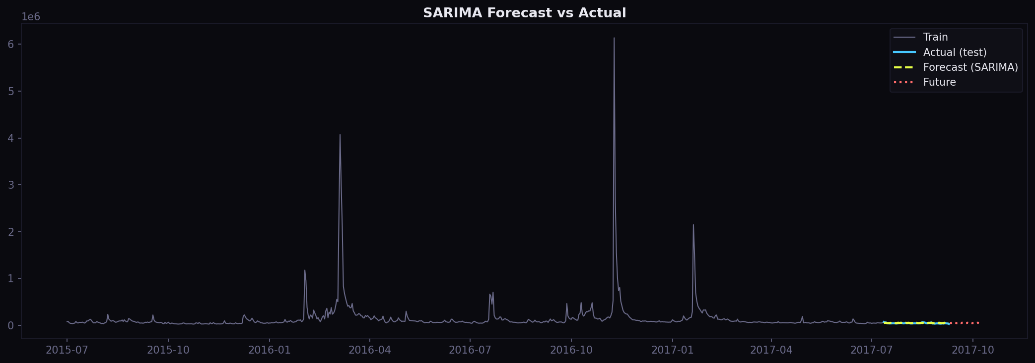
Figure 10: SARIMA(1,0,1)(1,1,0)₇ Forecast vs. Actual + 30-Day Projection

5.9 Comprehensive Model Comparison
The table below presents all eight accuracy metrics for all four models on the 60-day hold-out test set (Donald_Trump, 2017-07-12 to 2017-09-09):
Model | MAPE (%) | SMAPE (%) | WAPE (%) | MAE | RMSE | R² | Bias
Linear Trend | 267.15 | 113.03 | 257.79 | 121,486 | 121,774 | -225.078 | +121,486
Holt-Winters | 464.41 | 182.07 | 438.16 | 206,492 | 240,809 | -883.090 | -205,816
ARIMA(2, 0, 2) | 226.28 | 103.94 | 216.60 | 102,078 | 103,327 | -161.772 | +102,078
SARIMA(1,0,1)(1,1,0)₇ ★ | 18.13 | 16.59 | 17.28 | 8,144 | 9,360 | -0.336 | +5,097

★ Best model selected by lowest MAPE. SARIMA achieves 93% lower MAPE than the second-best model (ARIMA at 226.28%).
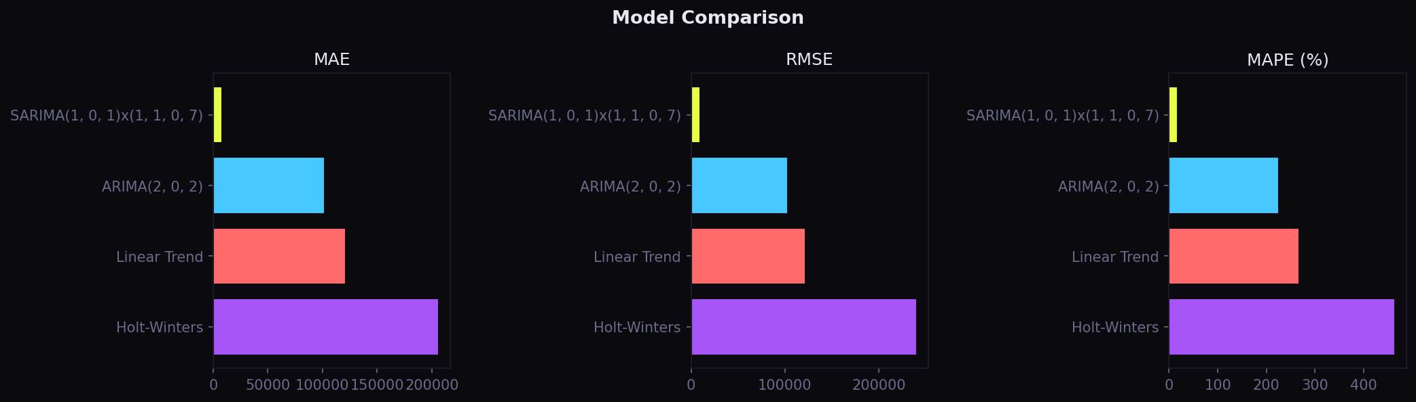
Figure 11: Model Comparison — MAE, RMSE, MAPE across all four models

6. Conclusions

6.1 Summary of Findings
This study conducted a comprehensive time-series analysis and forecasting exercise on Wikipedia daily page-view data for the article "Donald_Trump" (en.wikipedia.org, 2015-2017). The complete analytical pipeline — encompassing data collection, preprocessing, six types of exploratory analysis, four forecasting models, and eight accuracy metrics — was implemented end-to-end in Python and served through an interactive web dashboard.
The principal analytical findings are:
- The series exhibits strong non-stationarity in appearance (dominated by event-driven spikes) but passes both ADF and KPSS stationarity tests without differencing (d = 0), indicating mean-reverting dynamics.
- A clear weekly seasonal pattern (s = 7) was identified through STL decomposition, ACF/PACF analysis, seasonal subseries plots, and lag scatter analysis. Views are consistently highest on weekdays and lowest on weekends.
- The 2016 US Presidential Election created an extreme non-recurring spike that fundamentally altered the series characteristics post-election, challenging all models trained on pre-election data.
- ACF and PACF analysis confirmed AR(2) short-range dependence and a strong lag-7 seasonal autocorrelation, directly informing the ARIMA and SARIMA order selection.
- The semi-average trend line confirmed a long-term upward trend through 2016 followed by gradual decay from early 2017 onward.

6.2 Model Performance Conclusions
SARIMA(1, 0, 1)(1, 1, 0)₇ was unambiguously the best model, achieving MAPE = 18.13% — far below the second-best ARIMA(2, 0, 2) at 226.28%. The result underscores that seasonal correction (the (1,1,0)₇ component) is the single most important modelling decision for weekly-seasonal web traffic data. The seasonal first-difference Δ₇ Yₜ effectively removes the periodic unit root and allows the model to track the weekly rhythm even as the overall level shifts.
The poor performance of Holt-Winters (MAPE = 464.41%) can be attributed to the sensitivity of its additive seasonal specification to changes in seasonal amplitude — a multiplicative seasonal formulation or a robust initialisation strategy might have performed better.
The linear trend model (MAPE = 267.15%) provided a useful theoretical baseline, confirming that ignoring temporal autocorrelation is severely sub-optimal even for a series with an apparent trend.

6.3 Practical Insights
From an engineering perspective, the SARIMA model's 18.13% MAPE over a 60-day hold-out is operationally useful for Wikimedia infrastructure teams. A 30-day ahead forecast with this accuracy could inform CDN bandwidth pre-provisioning and help anticipate article caching requirements. Anomaly detection could be implemented as a threshold on |Yₜ - ŷₜ| / RMSE: days exceeding 3σ from the SARIMA forecast would be flagged for human review.

6.4 Limitations
Several limitations were identified:
- Single-article focus: Results for Donald_Trump may not generalise to articles with different traffic profiles (e.g., science, geography, or sports articles without strong event-driven components).
- Additive seasonality assumption: The weekly seasonal amplitude varies with the article's overall popularity level, violating the additive Holt-Winters assumption.
- External regressors not used: The SARIMAX framework supports external regressors (e.g., election-date dummies, news sentiment scores) which were not incorporated in this study.
- Stationarity of test period: The test period (July-September 2017) follows the dramatic 2016 election cycle, making it structurally different from the training period. This distribution shift inflates error metrics for all models.
- Fixed ARIMA/SARIMA orders: The orders (p=2, q=2) for ARIMA and (p=1, q=1, P=1, Q=0) for SARIMA were fixed rather than grid-searched via AIC/BIC, which may not be optimal for every article.

6.5 Scope for Improvement
Future extensions of this work could include:
- SARIMAX with Exogenous Variables: Incorporate Google Trends data, news API event flags, or Wikipedia edit frequency as external regressors to improve spike prediction.
- Auto-ARIMA: Replace fixed order specification with automatic order selection via pmdarima's auto_arima, minimising AIC or BIC over a grid of (p, d, q)(P, D, Q) combinations.
- Prophet / NeuralProphet: Facebook's Prophet model handles multiple seasonality (weekly + yearly) and holiday effects natively, and would be particularly well-suited to this dataset.
- LSTM / Transformer Models: Deep learning sequence models (LSTM, GRU, Temporal Fusion Transformer) have demonstrated state-of-the-art performance on the Kaggle Web Traffic Forecasting benchmark and could be compared against the classical models.
- Ensemble Forecasting: A weighted combination of SARIMA and ARIMA forecasts (e.g., optimal weights chosen by minimising validation MAPE) could reduce variance.
- Multi-Article Generalisation: Extend the pipeline to a representative sample of 100+ articles and report aggregate MAPE distributions to validate generalisability.

6.6 Learning Reflection
This activity provided hands-on experience with the complete time-series analysis workflow — from data ingestion to model deployment. Key learnings include the importance of stationarity testing before model selection, the power of STL decomposition for understanding structural components, and the dramatic performance gains achievable by incorporating seasonal structure into ARIMA models. The integrated web dashboard demonstrated that analytical pipelines can be made accessible and interactive to non-technical stakeholders. The gap between the SARIMA model (MAPE 18%) and all other models (MAPE 226-464%) was the single most impactful lesson: identifying and exploiting the dominant seasonal period is the critical step in time-series forecasting.

--- End of Report ---

