# MONGODB ASSIGNMENT

## 1.Retrieve all products in the "Electronics" category.

## Screenshot_20240702_112644

## Find all products with a price less than $500. Screenshot_20240702_113337

## 3.Retrieve all products with a rating greater than 4.

## Screenshot_20240702_113840

#### 4.Find all products with a specific color (e.g., Black).

#### Screenshot_20240702_114141

## Retrieve all products sorted by price in descending order.Screenshot_20240702_114411

## 6.Calculate the average rating of all products

## Screenshot_20240702_170919

## 7.Find all products where the stock quantity is less than 10.

## Screenshot_20240702_171951

## 8.Retrieve all products with a specific brand (e.g., BrandX).

## Screenshot_20240702_172037

## 9.Find all products where the storage is 128GB and RAM is 8GB.

## Screenshot_20240702_172558

## 10.Retrieve all products with a specific user's review (e.g., user\_id: ObjectId("987654321098765432109876")).

## Screenshot_20240702_172803

## 11.Calculate the total number of reviews for each product.

## Screenshot_20240702_230348

## Find all products with a price between $400 and $600.Screenshot_20240702_230450

## Find all products with a specific category (e.g., "Mobile") and a stock quantity greater than 50.

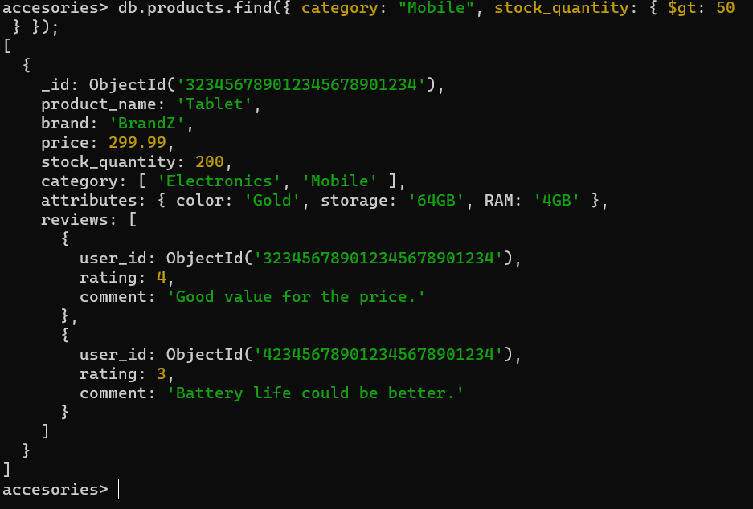

## Find the highest rated product.

## Screenshot_20240702_230621

## 15.Retrieve all products sorted by brand in ascending order and then by price in descending order.

## Screenshot_20240702_230715

## 16.Find all products with a specific comment in their reviews (e.g.,"Greatphone!").Screenshot_20240702_231756