CUDA C++ for AI/ML Interviews
Beginner to expert roadmap, architecture notes, runnable code, execution commands, and interview drills
Audience: a full-stack engineer moving into C++ CUDA, GPU computing, AI/ML systems, inference, training, and performance engineering.
How to use this PDF: Read it in passes: first understand the mental model, then compile every sample, then profile and explain each optimization aloud.

0. What CUDA C++ Is
CUDA C++ is C++ plus NVIDIA GPU extensions. You write normal host code that runs on the CPU and kernel code that runs on the GPU. The GPU is not a faster CPU; it is a throughput machine designed to run many lightweight threads and hide memory latency with massive concurrency.
- CPU code is called host code. GPU code is called device code.
- A kernel is a GPU function launched from the CPU with the <<<grid, block>>> syntax.
- A thread is the smallest CUDA execution unit you program directly.
- A warp is a hardware scheduling group, commonly 32 threads.
- A block is a group of threads that can synchronize and share fast shared memory.
- A grid is all blocks created by one kernel launch.
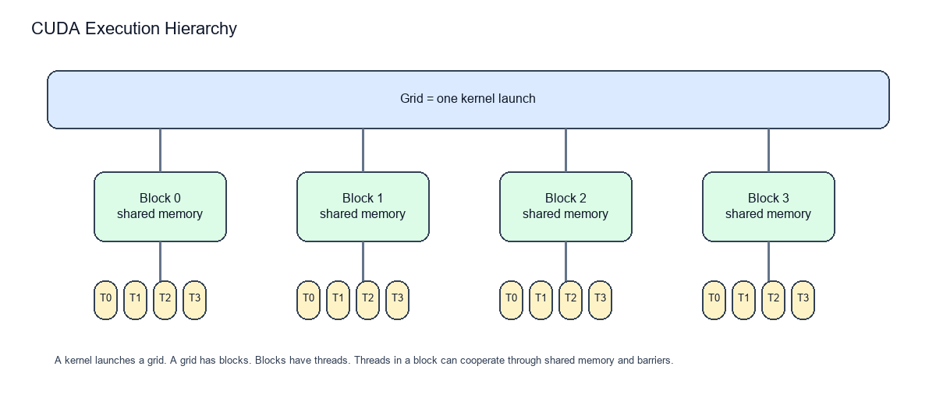

1. Setup And First Execution
- Install an NVIDIA driver that supports your GPU.
- Install the CUDA Toolkit. On Windows, install a compatible Visual Studio C++ toolchain first.
- Confirm the toolchain with: nvcc --version
- Confirm the GPU and driver with: nvidia-smi
- Compile a .cu file with: nvcc file.cu -o file.exe
- Run the executable from PowerShell: .\file.exe
cd C:\Users\ygirish\Documents\Codex\2026-05-28\hi\cuda_samples
nvcc 01_hello.cu -o 01_hello.exe
.\01_hello.exe

2. CUDA Language Keywords
Keyword | Meaning | Interview signal
__global__ | Function runs on GPU and is launched by CPU. | Used for kernels; returns void.
__device__ | Function or variable lives on GPU device. | Callable from device code.
__host__ | Function runs on CPU host. | Can combine with __device__ for dual-use helpers.
__shared__ | Per-block shared memory. | Fast cooperation inside one block.
__syncthreads() | Barrier for threads in a block. | Needed before reading shared data written by peers.
threadIdx/blockIdx | Built-in coordinates. | Used to map work to data.
blockDim/gridDim | Launch dimensions. | Used for bounds and grid-stride loops.

3. Memory Model
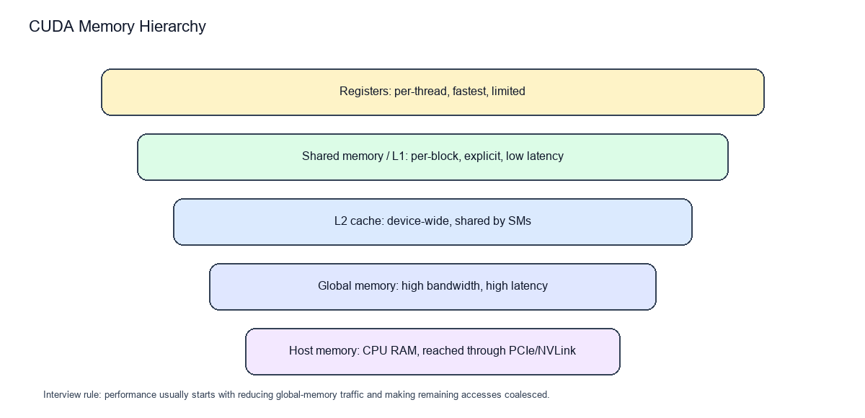
Memory | Lifetime / scope | Typical use | Pitfall
Registers | One thread | Local scalars | Too many registers can reduce occupancy.
Local memory | One thread, backed by global | Spilled arrays/variables | Slow if compiler spills registers.
Shared memory | One block | Tiling, reductions, stencil reuse | Bank conflicts and missing barriers.
Global memory | Whole device allocation | Large arrays and tensors | Latency, non-coalesced access.
Constant memory | Device-wide read-only | Small broadcast constants | Bad for random per-thread access.
Unified memory | Managed CPU/GPU address | Simplicity and prototyping | Page migration surprises.
Pinned host memory | CPU page-locked | Async copies and overlap | Overuse hurts system memory.

Interview answer: Coalescing means adjacent threads in a warp access adjacent memory addresses, allowing the hardware to combine requests efficiently.

4. Writing Correct Kernels
The most common CUDA beginner bug is forgetting that you usually launch more threads than data elements. Every kernel that maps one thread to one element needs a bounds check.
__global__ void saxpy(float a, const float* x, float* y, int n) {
int i = blockIdx.x * blockDim.x + threadIdx.x;
if (i < n) y[i] = a * x[i] + y[i];
}
- Always check cudaGetLastError after a kernel launch while learning.
- Use cudaDeviceSynchronize when you need to catch asynchronous kernel errors immediately.
- Test small sizes, odd sizes, and sizes smaller than one block.
- Compare GPU output against a simple CPU reference before optimizing.

5. Grid-Stride Loops
A grid-stride loop lets each thread process multiple elements. This makes kernels work for arbitrary N and lets you tune launch size independently from input size.
__global__ void add(float* x, int n) {
for (int i = blockIdx.x * blockDim.x + threadIdx.x;
i < n;
i += blockDim.x * gridDim.x) {
x[i] += 1.0f;
}
}

6. Shared Memory And Tiling
Shared memory is a programmer-managed cache scoped to a block. In matrix multiplication, tiling loads submatrices into shared memory so many threads reuse the same global-memory values.
- Each block cooperatively loads a tile from A and a tile from B.
- Threads synchronize after loading tiles.
- Each thread accumulates one output element using tile data.
- The pattern reduces global reads from repeated per-thread loads to reused block-level loads.
__shared__ float As[TILE][TILE];
__shared__ float Bs[TILE][TILE];
As[threadIdx.y][threadIdx.x] = A[row * N + tiled_col];
Bs[threadIdx.y][threadIdx.x] = B[tiled_row * N + col];
__syncthreads();

7. Synchronization
Tool | Scope | Use
__syncthreads() | One block | Barrier before consuming shared data.
Atomic operations | Address/global or shared | Correctness for concurrent updates; can serialize.
cudaDeviceSynchronize() | Whole device from host | Wait for queued work before CPU reads or exits.
Stream sync | One stream | Wait for ordered work in a stream.
Events | Device timestamp/order | Measure GPU time or create cross-stream dependencies.

Common trap: __syncthreads() only synchronizes threads in the same block. CUDA has no cheap global barrier inside a normal kernel.

8. Performance Model
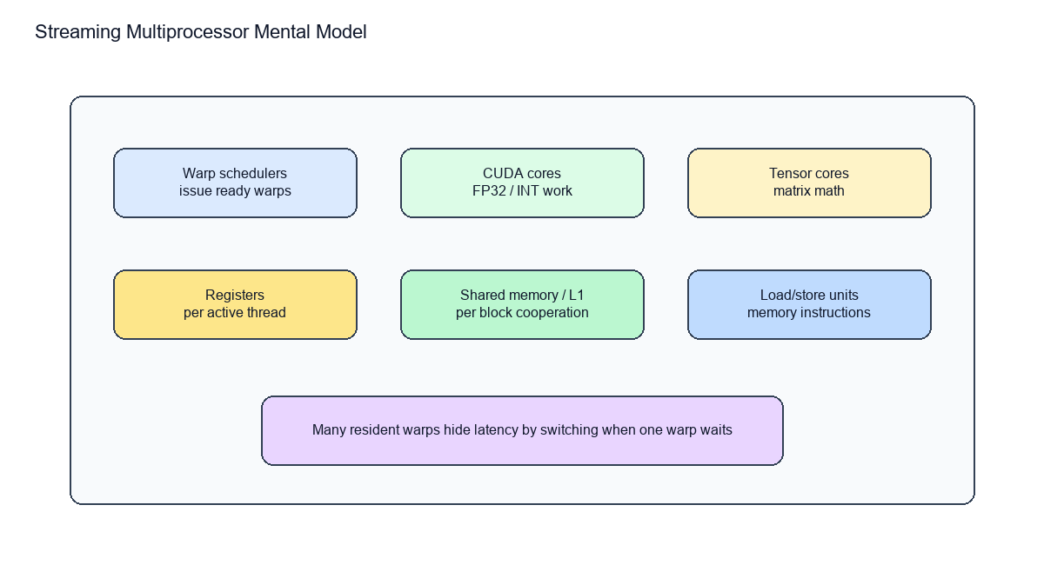
A CUDA performance explanation usually starts with three questions: Is the kernel memory-bound or compute-bound? Is memory access coalesced? Is there enough occupancy and instruction-level work to hide latency?
Concept | Plain-English meaning | How to improve
Occupancy | How many warps can reside on an SM. | Reduce excessive registers/shared memory; choose reasonable block sizes.
Latency hiding | Switch to another ready warp while one waits. | Expose enough parallelism and independent work.
Arithmetic intensity | Math per byte moved. | Reuse data through shared memory, caches, or better algorithms.
Divergence | Threads in a warp take different branches. | Group similar work; simplify branch-heavy kernels.
Coalescing | Warp memory addresses form efficient transactions. | Use structure-of-arrays and contiguous indexing.
Bank conflicts | Shared memory accesses collide by bank. | Pad or reorganize shared arrays.

9. Profiling Workflow
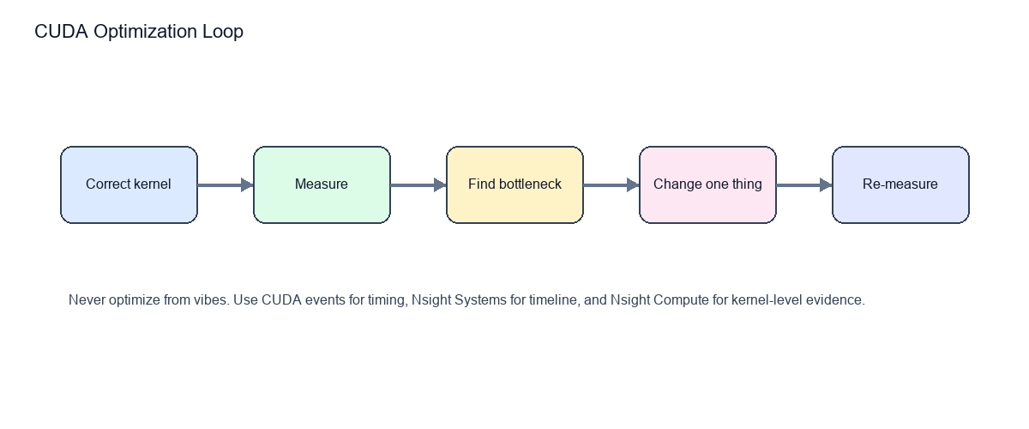
- Use CPU timers only for end-to-end user-visible latency.
- Use CUDA events for GPU elapsed time between operations.
- Use Nsight Systems to see CPU/GPU overlap, transfers, gaps, and stream timelines.
- Use Nsight Compute to inspect one kernel: occupancy, memory throughput, cache behavior, divergence, and instruction mix.
- Change one thing at a time; keep the CPU reference and correctness tests alive.
cudaEvent_t start, stop;
cudaEventCreate(&start);
cudaEventCreate(&stop);
cudaEventRecord(start);
kernel<<<blocks, threads>>>(...);
cudaEventRecord(stop);
cudaEventSynchronize(stop);
float ms = 0.0f;
cudaEventElapsedTime(&ms, start, stop);

10. Streams, Async Copies, And Overlap
A CUDA stream is an ordered queue of work. Operations in the same stream run in issue order. Independent streams may overlap if the hardware and dependencies allow it.
- Use cudaMemcpyAsync plus pinned host memory for asynchronous host-device transfers.
- Use multiple streams to pipeline copy, compute, and copy-back chunks.
- Avoid synchronizing the whole device unless necessary.
- Remember that default-stream behavior matters; know whether your code uses legacy or per-thread default stream semantics.

11. AI/ML CUDA Concepts
Topic | What to know for interviews
Tensor cores | Specialized matrix-multiply hardware used by deep learning kernels.
Mixed precision | FP16/BF16/TF32/FP8 trade precision for throughput and memory savings.
cuBLAS/cuDNN | Use vendor libraries for GEMM, convolutions, reductions, and neural-network primitives.
Custom ops | Write CUDA extensions when framework primitives do not express your operation efficiently.
Memory bandwidth | Large models are often limited by data movement, not raw FLOPs.
Batching | Improves throughput by increasing parallel work and matrix sizes.
Kernel fusion | Combines operations to reduce intermediate memory traffic and launch overhead.

Domain-change advice: For CUDA AI/ML roles, become fluent in C++, linear algebra, GPU memory behavior, profiling, and at least one ML runtime such as PyTorch extensions, TensorRT, or Triton.

12. Debugging And Correctness
- Compile debug builds with -G while debugging, then remove -G for performance measurements.
- Use compute-sanitizer to catch illegal memory access, race conditions, and uninitialized values.
- Keep CPU reference implementations for kernels with tricky indexing.
- Check every CUDA API call with a macro during development.
- Treat printf inside kernels as a debugging tool only; it changes timing and can be buffered.
nvcc -G 02_vector_add.cu -o debug_vector_add.exe
compute-sanitizer .\debug_vector_add.exe

13. Runnable Sample Programs
File | Concept | Compile command
01_hello.cu | Kernel launch and thread coordinates | nvcc 01_hello.cu -o 01_hello.exe
02_vector_add.cu | Memory allocation, copies, error checking | nvcc 02_vector_add.cu -o 02_vector_add.exe
03_matrix_mul_tiled.cu | Shared-memory tiling | nvcc 03_matrix_mul_tiled.cu -o 03_matrix_mul_tiled.exe
04_reduction.cu | Parallel reduction | nvcc 04_reduction.cu -o 04_reduction.exe
05_streams_async.cu | Pinned memory and async stream work | nvcc 05_streams_async.cu -o 05_streams_async.exe
06_unified_memory.cu | Managed memory | nvcc 06_unified_memory.cu -o 06_unified_memory.exe

Vector Add Example
#include <cuda_runtime.h>
#include <iostream>
#include <vector>
#define CUDA_CHECK(call) do { \
cudaError_t err = call; \
if (err != cudaSuccess) { \
std::cerr << "CUDA error: " << cudaGetErrorString(err) \
<< " at " << __FILE__ << ":" << __LINE__ << "\n"; \
std::exit(1); \
} \
} while (0)
__global__ void vector_add(const float* a, const float* b, float* c, int n) {
int i = blockIdx.x * blockDim.x + threadIdx.x;
if (i < n) c[i] = a[i] + b[i];
}
int main() {
int n = 1 << 20;
size_t bytes = n * sizeof(float);
std::vector<float> h_a(n, 1.0f), h_b(n, 2.0f), h_c(n);
float *d_a = nullptr, *d_b = nullptr, *d_c = nullptr;
CUDA_CHECK(cudaMalloc(&d_a, bytes));
CUDA_CHECK(cudaMalloc(&d_b, bytes));
CUDA_CHECK(cudaMalloc(&d_c, bytes));
CUDA_CHECK(cudaMemcpy(d_a, h_a.data(), bytes, cudaMemcpyHostToDevice));
CUDA_CHECK(cudaMemcpy(d_b, h_b.data(), bytes, cudaMemcpyHostToDevice));
int threads = 256;
int blocks = (n + threads - 1) / threads;
vector_add<<<blocks, threads>>>(d_a, d_b, d_c, n);
CUDA_CHECK(cudaGetLastError());
CUDA_CHECK(cudaMemcpy(h_c.data(), d_c, bytes, cudaMemcpyDeviceToHost));
std::cout << "c[123] = " << h_c[123] << "\n";
cudaFree(d_a); cudaFree(d_b); cudaFree(d_c);
return 0;
}

Tiled Matrix Multiplication Example
#include <cuda_runtime.h>
#include <iostream>
#include <vector>
constexpr int TILE = 16;
__global__ void matmul_tiled(const float* A, const float* B, float* C, int N) {
__shared__ float As[TILE][TILE];
__shared__ float Bs[TILE][TILE];
int row = blockIdx.y * TILE + threadIdx.y;
int col = blockIdx.x * TILE + threadIdx.x;
float sum = 0.0f;
for (int t = 0; t < (N + TILE - 1) / TILE; ++t) {
int a_col = t * TILE + threadIdx.x;
int b_row = t * TILE + threadIdx.y;
As[threadIdx.y][threadIdx.x] = (row < N && a_col < N) ? A[row * N + a_col] : 0.0f;
Bs[threadIdx.y][threadIdx.x] = (b_row < N && col < N) ? B[b_row * N + col] : 0.0f;
__syncthreads();
for (int k = 0; k < TILE; ++k) {
sum += As[threadIdx.y][k] * Bs[k][threadIdx.x];
}
__syncthreads();
}
if (row < N && col < N) C[row * N + col] = sum;
}
int main() {
int N = 512;
size_t bytes = N * N * sizeof(float);
std::vector<float> A(N * N, 1.0f), B(N * N, 2.0f), C(N * N);
float *d_A, *d_B, *d_C;
cudaMalloc(&d_A, bytes); cudaMalloc(&d_B, bytes); cudaMalloc(&d_C, bytes);
cudaMemcpy(d_A, A.data(), bytes, cudaMemcpyHostToDevice);
cudaMemcpy(d_B, B.data(), bytes, cudaMemcpyHostToDevice);
dim3 threads(TILE, TILE);
dim3 blocks((N + TILE - 1) / TILE, (N + TILE - 1) / TILE);
matmul_tiled<<<blocks, threads>>>(d_A, d_B, d_C, N);
cudaMemcpy(C.data(), d_C, bytes, cudaMemcpyDeviceToHost);
std::cout << "C[0] = " << C[0] << "\n";
cudaFree(d_A); cudaFree(d_B); cudaFree(d_C);
return 0;
}

Reduction Example
#include <cuda_runtime.h>
#include <iostream>
#include <numeric>
#include <vector>
__global__ void reduce_sum(const float* in, float* block_sums, int n) {
extern __shared__ float s[];
unsigned int tid = threadIdx.x;
unsigned int i = blockIdx.x * blockDim.x * 2 + threadIdx.x;
float x = 0.0f;
if (i < n) x += in[i];
if (i + blockDim.x < n) x += in[i + blockDim.x];
s[tid] = x;
__syncthreads();
for (unsigned int stride = blockDim.x / 2; stride > 0; stride >>= 1) {
if (tid < stride) s[tid] += s[tid + stride];
__syncthreads();
}
if (tid == 0) block_sums[blockIdx.x] = s[0];
}
int main() {
int n = 1 << 20;
std::vector<float> h(n, 1.0f);
int threads = 256;
int blocks = (n + threads * 2 - 1) / (threads * 2);
float *d_in, *d_sums;
cudaMalloc(&d_in, n * sizeof(float));
cudaMalloc(&d_sums, blocks * sizeof(float));
cudaMemcpy(d_in, h.data(), n * sizeof(float), cudaMemcpyHostToDevice);
reduce_sum<<<blocks, threads, threads * sizeof(float)>>>(d_in, d_sums, n);
std::vector<float> partial(blocks);
cudaMemcpy(partial.data(), d_sums, blocks * sizeof(float), cudaMemcpyDeviceToHost);
float total = std::accumulate(partial.begin(), partial.end(), 0.0f);
std::cout << "sum = " << total << "\n";
cudaFree(d_in); cudaFree(d_sums);
return 0;
}

14. Interview Questions And Model Answers
Q: What happens when you launch kernel<<<blocks, threads>>>?
A: The host queues work for the GPU. The launch creates a grid of blocks; each block contains threads. The launch is usually asynchronous with respect to the CPU.
Q: Why do we need an if (i < n) guard?
A: Grid sizes are commonly rounded up. Extra threads would otherwise access memory past the valid range.
Q: What is a warp?
A: A hardware scheduling group of threads, commonly 32. Threads in a warp execute together, so divergent branches serialize paths.
Q: Shared memory vs global memory?
A: Global memory is large and high latency. Shared memory is per-block, much lower latency, and used for cooperation and data reuse.
Q: What is occupancy?
A: The ratio of active warps on an SM to the hardware maximum. It matters because more resident warps can hide latency, but maximum occupancy is not always maximum performance.
Q: How do you optimize a memory-bound kernel?
A: Reduce bytes moved, coalesce accesses, reuse data through shared memory/cache, avoid unnecessary transfers, and consider fusion.
Q: When are atomics appropriate?
A: When multiple threads update the same location and exact correctness matters. Use them carefully because contention can serialize execution.
Q: How do streams improve performance?
A: They let independent copies and kernels be queued separately so the GPU can overlap transfers and compute when dependencies and hardware permit.
Q: How do you profile CUDA?
A: Start with end-to-end timing, use CUDA events for GPU work, Nsight Systems for timeline gaps/overlap, and Nsight Compute for kernel metrics.
Q: Why use cuBLAS instead of writing GEMM?
A: Vendor libraries are heavily optimized for architecture-specific tiling, tensor cores, memory layouts, and edge cases.

15. 0-to-10 Roadmap
Level | Focus | You can prove it by
0 | C++ refresh and toolchain | Compile C++ and CUDA hello-world programs.
1 | Kernel launches and indexing | Write vector add and SAXPY from memory.
2 | CUDA memory APIs | Explain malloc/copy/free and error checking.
3 | Thread/block/grid mapping | Handle 1D and 2D data correctly.
4 | Shared memory | Implement tiled matrix multiplication.
5 | Reductions and atomics | Implement sum reduction and explain contention.
6 | Streams and events | Overlap copy/compute and time kernels correctly.
7 | Profiling | Use Nsight to justify a bottleneck.
8 | Advanced memory/performance | Discuss coalescing, bank conflicts, occupancy, divergence.
9 | AI/ML systems | Use cuBLAS/cuDNN or write a PyTorch CUDA extension.
10 | Expert interview readiness | Whiteboard kernels, debug failures, and defend optimization choices.

16. Sources And Further Reading
- NVIDIA CUDA C++ Programming Guide: https://docs.nvidia.com/cuda/cuda-c-programming-guide/
- NVIDIA CUDA C++ Best Practices Guide: https://docs.nvidia.com/cuda/cuda-c-best-practices-guide/
- NVIDIA CUDA Runtime API: https://docs.nvidia.com/cuda/cuda-runtime-api/
- NVIDIA CUDA Installation Guide for Microsoft Windows: https://docs.nvidia.com/cuda/cuda-installation-guide-microsoft-windows/
- NVIDIA Nsight Compute User Guide: https://docs.nvidia.com/nsight-compute/
- NVIDIA Deep Learning Performance Documentation: https://docs.nvidia.com/deeplearning/performance/

