**Name:YedhuKrishnan KJ**

**Roll No: 57**

**Batch: MCA B**

**Date:**

**NETWORKING & SYSTEM ADMINISTRATION LAB**

**Experiment No.: 24**

**Aim**

To familiarize with the installation of Docker in Linux using terminal and to run an Apache server on the created container

**Procedure**

**Installing Docker**

1. Open the terminal on Ubuntu

2.Remove any [Docker files](https://www.simplilearn.com/tutorials/docker-tutorial/what-is-dockerfile) that are running in the system, using the following command:

**$ sudo apt-get remove docker docker-engine docker.io**

After entering the above command, you will need to enter the password of the root and press enter.

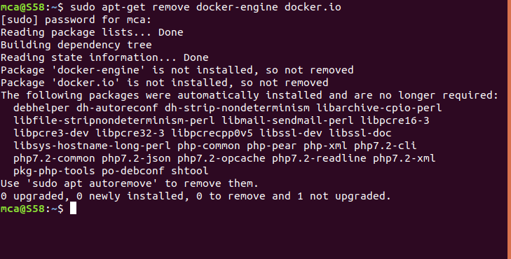

3. Check if the system is up-to-date using the following command:

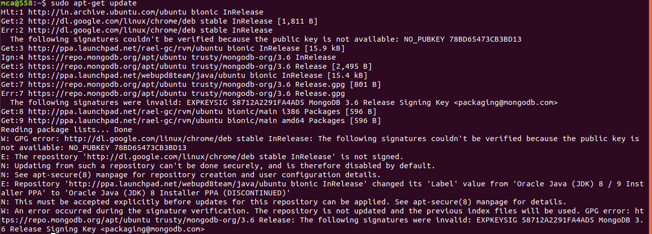**$ sudo apt-get update**

4. Install Docker using the following command:

**$ sudo apt install docker.io**

You’ll then get a prompt asking you to choose between y/n - choose*y*

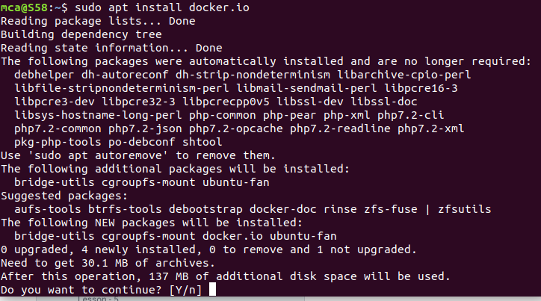

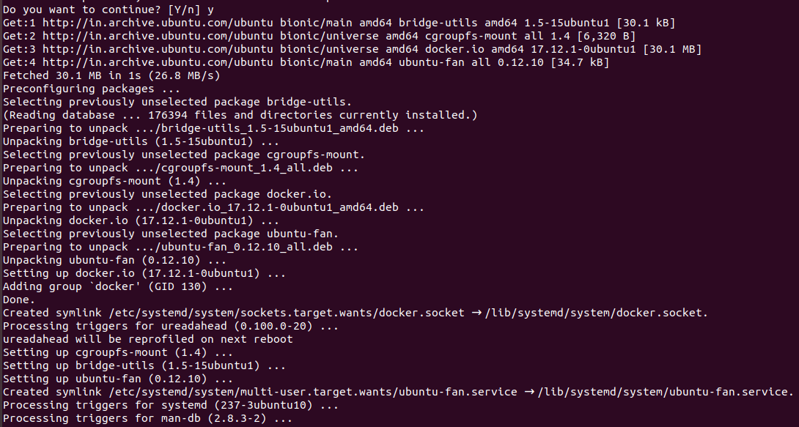

5.Install all the dependency packages using the following command:

**$ sudo snap install docker**



6. Before testing Docker, check the version installed using the following command:

**$ docker –version**



7. Pull an image from the Docker hub using the following command:

**$ sudo docker run hello-world**

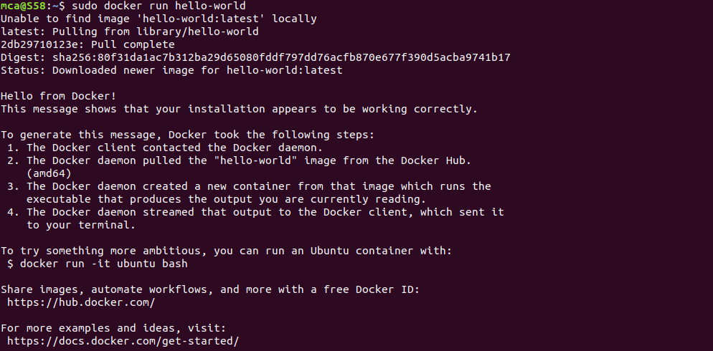Here,*hello-world*is the docker image present on the Docker hub.

8. Check if the docker image has been pulled and is present in your system using the following command:

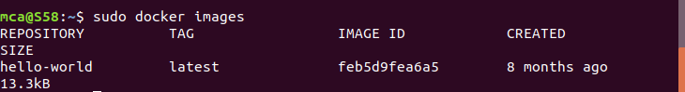  **$ sudo docker images**

9. To display all the containers pulled, use the following command:

**$ sudo docker ps -a**

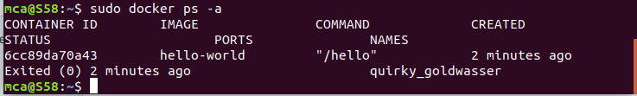

10. To check for containers in a running state, use the following command:

**$ sudo docker ps**

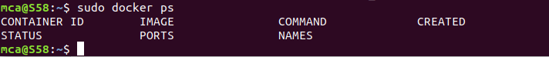

**You’ve just successfully installed Docker on Ubuntu!**

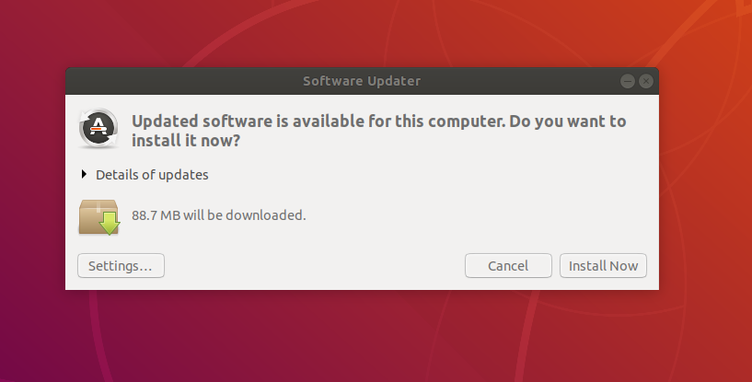

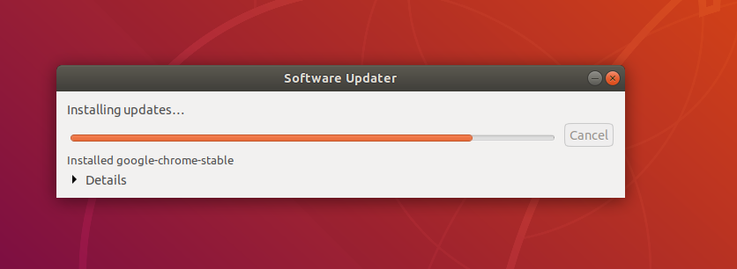

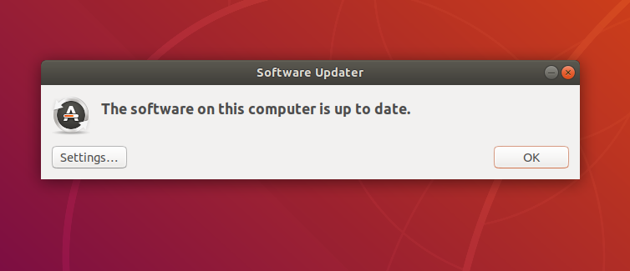

**Running Apache Web server and executing an HTML file**

1. The public IP address on port number 8080 be directed to port 80 on the container.Also instead of serving content from the container itself, We will serve a simple web page from /home/user/website

We do this by mapping /home/user/website on the /usr/local/apache2/htdocs/ on the container. Note that you will need to use sudo or login as root to proceed, and do not omit the forward slashes at the end of each directory.

**$ sudo docker run -dit --name tecmint-web -p 8080:80 -v /home/user/website/:/usr/local/apache2/htdocs/ httpd:2.4**

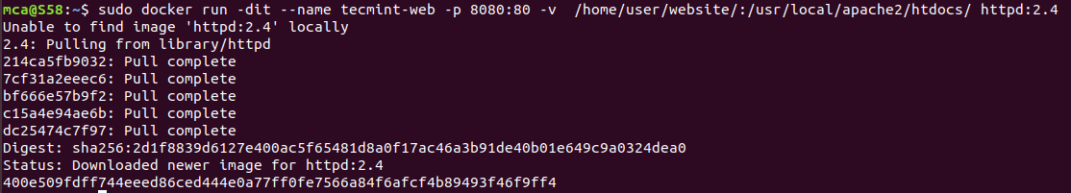

1. At this point, our Apache container should be up and running.

**$ sudo docker ps**



1. Now let’s create a simple web page named docker.html inside the /home/user/website directory.

**$ sudo gedit /home/user/website/docker.html**

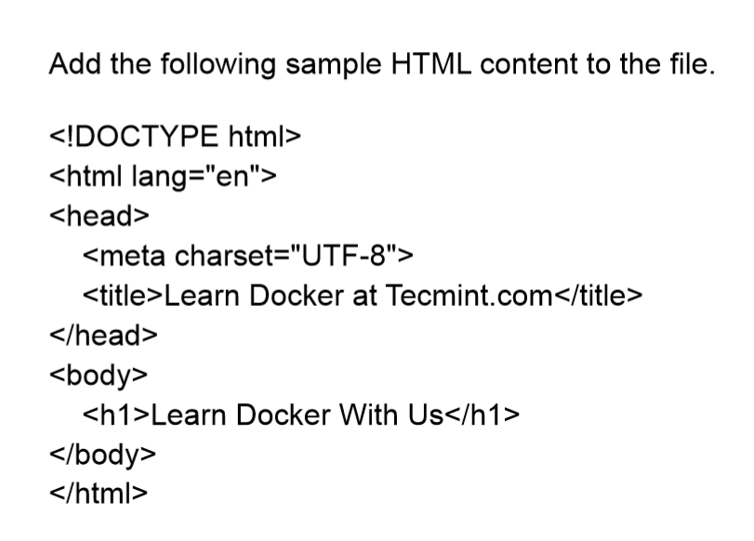



1. Next, point your browser to Server-IP:8080/docker.html (where Server-IP is your host’s public IP address). You should be presented with the page we created previously.

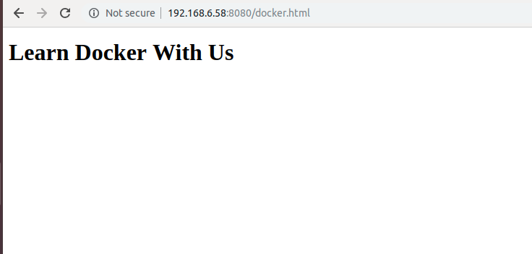

1. If you wish , you can now stop the container

**$ sudo docker stop tecmint-web**



1. To remove the container, use the below command

**$ sudo docker rm tecmint-web**



1. To finish cleaning up, you may want to delete the image that was used in the container (omit this step if you’re planning on creating other Apache 2.4 containers soon).

**$ sudo docker image remove httpd:2.4**

