Visdemo Fusion MCP Server
Implementation, Connection & Deployment Guide
Server-side build & publish • Client-side connect & reuse
Prepared for: yedla26 / Prabhanand Yedla
Repository target: github.com/yedla26/visdemo-fusion-mcp (public)
Note on screenshots: This guide uses illustrative mockups of the GitHub, terminal, and Claude Desktop screens to show exactly what to expect at each step. Your actual screens may look slightly different depending on OS and app version, but the fields, buttons, and file locations are accurate.

Table of Contents

1. Overview & Architecture
This guide walks through implementing, connecting, reusing, and deploying the visdemo-fusion-mcp server — an MCP (Model Context Protocol) server that lets Claude query the Visdemo Oracle Fusion Cloud instance (suppliers, purchase orders, invoices, and project costs) through natural-language requests.
The setup has two sides:
- Server side — the Python MCP server that authenticates to Oracle Fusion and exposes tools. Built once, published to a public GitHub repo.
- Client side — Claude Desktop, configured to launch that server and call its tools during a conversation.
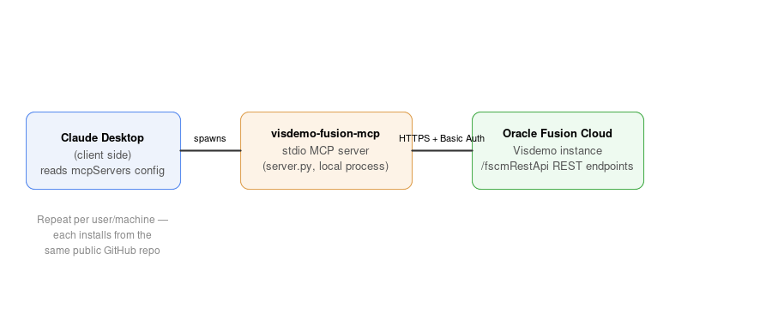
Figure 1 — Server and client relationship. Claude Desktop spawns the local MCP process, which calls Oracle Fusion over HTTPS with Basic Auth.
Security first: Real credentials (the FUSION_PASSWORD value) are never written into any file that gets committed to the public repo. They live only in your local .env file or directly inside your local Claude Desktop config, both of which stay on your machine.

2. Part 1 — Server Side
This part covers building the server, testing it against Oracle Fusion, and publishing (“deploying”) it as a public GitHub repository so it can be installed anywhere.

2.1 Prerequisites
- Python 3.10+ and pip
- uv / uvx installed (https://docs.astral.sh/uv/)
- Git, and optionally the GitHub CLI (gh), authenticated to your yedla26 account
- Oracle Fusion connection details: host, username, password (already provided for Visdemo)

2.2 Clone the project and install dependencies
Navigate to a working folder and pull down the project files (or use the files already prepared in your VisionFusion folder).
git clone https://github.com/yedla26/visdemo-fusion-mcp.git
cd visdemo-fusion-mcp
python3 -m venv .venv && source .venv/bin/activate
pip install -r requirements.txt
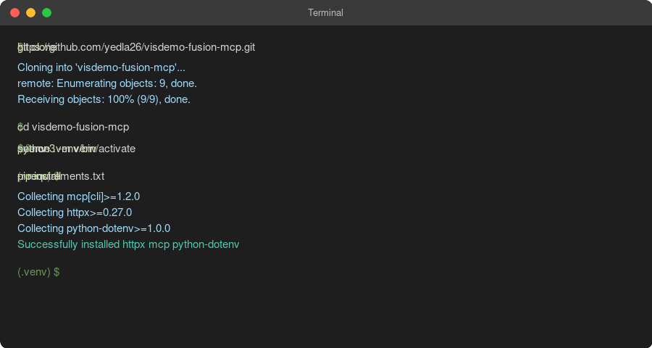
Figure 2 — Cloning the repo and installing dependencies in a virtual environment.

2.3 Configure credentials
Copy the example environment file and fill in the real password. This file is listed in .gitignore, so it will never be pushed to GitHub.
cp .env.example .env
nano .env # or open in any editor
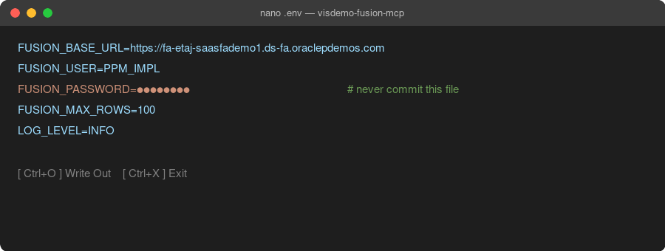
Figure 3 — .env populated with connection details. The password is masked here for the guide; type the real value in your own file.
Connection details used: Connection name: Visdemo · Host: fa-etaj-saasfademo1.ds-fa.oraclepdemos.com · Username: PPM_IMPL · Password: set locally in .env, never in this document.

2.4 Test the connection
Before wiring anything into Claude Desktop, confirm the credentials actually work:
python test_connection.py
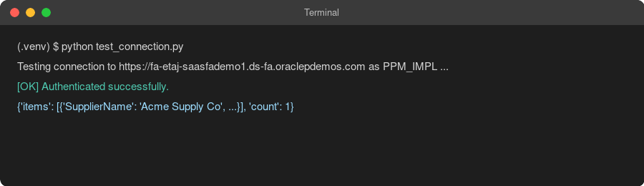
Figure 4 — Expected output on a successful connection test.
Result | Meaning
401 Unauthorized | Wrong password, or MFA is enabled on PPM_IMPL (Basic Auth requires MFA off)
403 Forbidden | The user lacks the data role needed for that resource
Connection/DNS error | VPN required, or the demo instance is temporarily down

2.5 Publish (deploy) the server
“Deployment” for this server means publishing the code as a public GitHub repository — the server itself runs locally on each user's machine via Claude Desktop (stdio transport), not as a hosted cloud service.

Create the repository
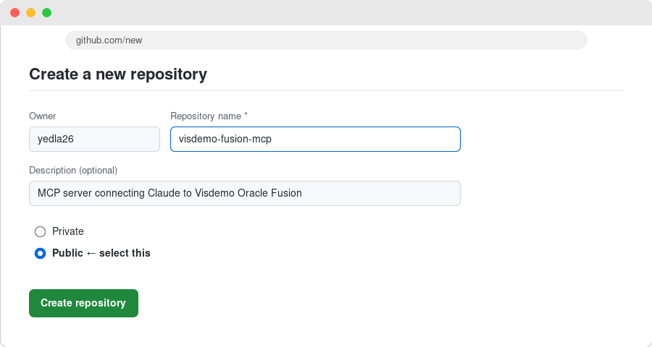
Figure 5 — github.com/new: owner yedla26, repository name visdemo-fusion-mcp, visibility set to Public.

Push the code
git init
git add .
git status # confirm .env is NOT listed, only .env.example
git commit -m "Initial commit: Visdemo Fusion MCP server"
git branch -M main
git remote add origin https://github.com/yedla26/visdemo-fusion-mcp.git
git push -u origin main
Or, in one step with the GitHub CLI:
gh repo create yedla26/visdemo-fusion-mcp --public --source=. --remote=origin --push
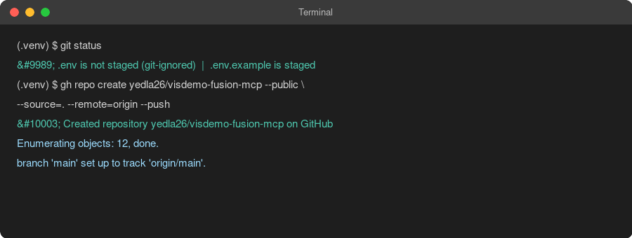
Figure 6 — Verifying .env is excluded, then creating and pushing via gh.
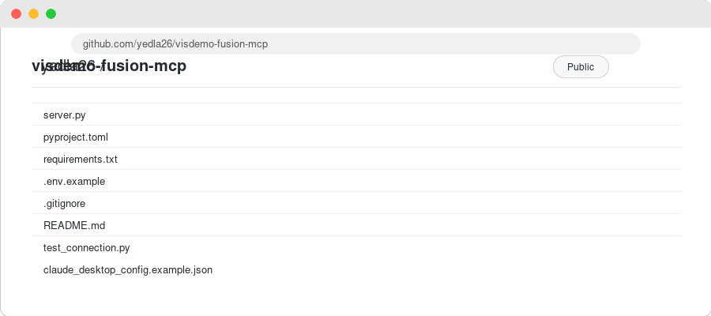
Figure 7 — The published public repository on GitHub, containing all project files except .env.

3. Part 2 — Client Side (Claude Desktop)
This part covers connecting Claude Desktop to the published server, verifying the connection, and reusing it going forward.

3.1 Locate the Claude Desktop config file
OS | Path
macOS | ~/Library/Application Support/Claude/claude_desktop_config.json
Windows | %APPDATA%\Claude\claude_desktop_config.json
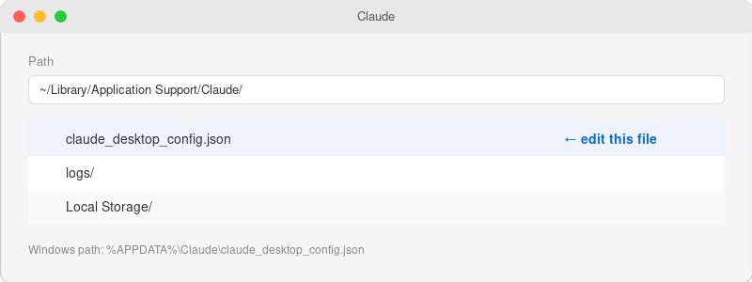
Figure 8 — Locating claude_desktop_config.json.

3.2 Add the MCP server entry
Open the file in any text editor and add a visdemo-fusion-mcp entry under mcpServers. Two supported ways to run it:

Option A — from a local clone
"visdemo-fusion-mcp": {
"command": "uv",
"args": ["--directory", "/absolute/path/to/visdemo-fusion-mcp", "run", "python", "server.py"],
"env": { "FUSION_BASE_URL": "...", "FUSION_USER": "PPM_IMPL", "FUSION_PASSWORD": "..." }
}

Option B — directly from the public GitHub repo (uvx)
Since the repo is public, no access token is required in the install URL at all:
"visdemo-fusion-mcp": {
"command": "uvx",
"args": ["--from", "git+https://github.com/yedla26/visdemo-fusion-mcp", "visdemo-fusion-mcp"],
"env": { "FUSION_BASE_URL": "...", "FUSION_USER": "PPM_IMPL", "FUSION_PASSWORD": "..." }
}
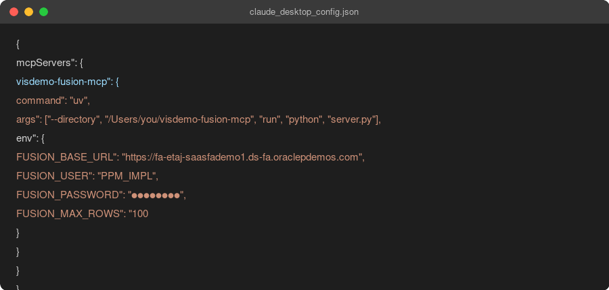
Figure 9 — Completed config entry (password masked).
Reminder: Paste the real FUSION_PASSWORD only into this local config file on your machine. Never paste it into the GitHub repo, an issue, or a chat message.

3.3 Restart and verify
- Save the config file.
- Fully quit and reopen Claude Desktop.
- Look for “visdemo-fusion-mcp” listed as a connected tool/server.
- Ask Claude: “Run test_connection on the Visdemo Fusion server.”
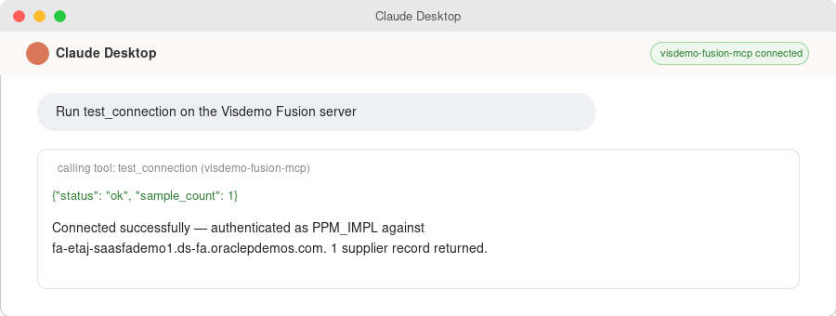
Figure 10 — Claude Desktop showing the server connected and a successful test_connection call.

4. Reusing the Server
Because the repo is public and self-contained (no secrets inside it), the same install command works for any machine or teammate who has their own Oracle Fusion credentials — they just add the same config block with their own env values.
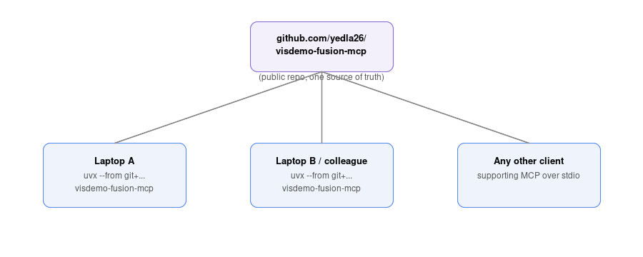
Figure 11 — Multiple clients installing and running the same published server independently.
- To update the server: edit the code, commit, and push to the same repo — every uvx-based client picks up the latest version on next launch.
- To reuse on a new machine: install uv, add the same mcpServers block with that machine's own .env values, restart Claude Desktop.
- To share with a teammate: send them the repo URL and the Option B config block; they supply their own Oracle credentials.

5. Tools Reference
Tool | Purpose
test_connection | Verifies auth/connectivity against Visdemo
get_suppliers | Search suppliers by name
get_purchase_orders | Look up purchase orders by PO number
get_invoices | Look up payables invoices by supplier name
get_project_costs | Look up PPM project costs by project number

6. Troubleshooting
Symptom | Fix
401 + MFA error | Use a dedicated implementation user with MFA disabled, or add OAuth 2.0
429 Too Many Requests | Oracle rate limit (~5000/hr); add retry/backoff
Server not listed in Claude Desktop | Check JSON syntax with a validator, restart the app, check app logs
uvx can't find the entry point | Confirm pyproject.toml [project.scripts] matches the args in your config

7. Security Checklist
- Real password only in local .env or local Claude Desktop config — never committed
- .env is listed in .gitignore and confirmed absent from `git status` before every push
- Repo is Public but contains zero live secrets
- Do not reuse GitHub tokens found in other examples/snippets — a public repo needs none
- Rotate FUSION_PASSWORD immediately if it is ever pasted into a commit, issue, or shared doc

