COLLEGE MANAGEMENT SYSTEM USING MONGODB
YEDLA UDAY KUMAR
22BIT0245

Title
College Management System using MongoDB (Backend Application)

Tools Used (with Versions)
Node.js – v18.x
Express.js – v4.18.x
MongoDB – v6.x
Mongoose – v7.x
Postman – v10.x
Visual Studio Code – Latest Version

Outcome of the Project
Successfully developed a backend-based College Management System.
Implemented CRUD operations.
Established relationships between collections.
Learned MongoDB integration with Node.js.
Tested APIs using Postman.

Output Screenshots with Explanation

MongoDB Connecion
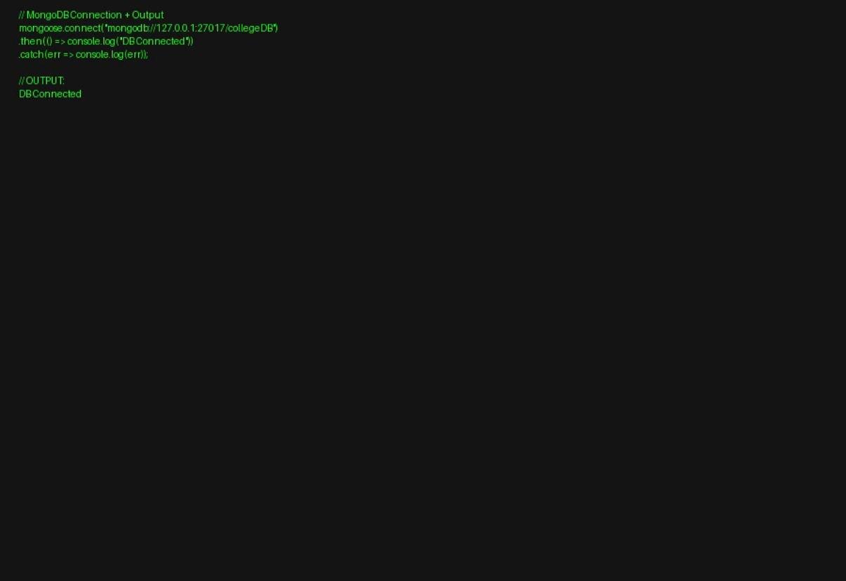

Ensures backend is connected to database.

Insert Operation

Stores new student data using POST API.

Read Operation


Fetches all student records using GET API.

Update Operation

Modifies existing records using PUT API.

Delete Operation

Removes records using DELETE API.

Summary
This project demonstrates backend development using MongoDB and Node.js with CRUD operations and API handling.

Conclusion
The system successfully manages college data and provides a strong base for full-stack development. Future work can include frontend and deployment.

