METHODOLOGY
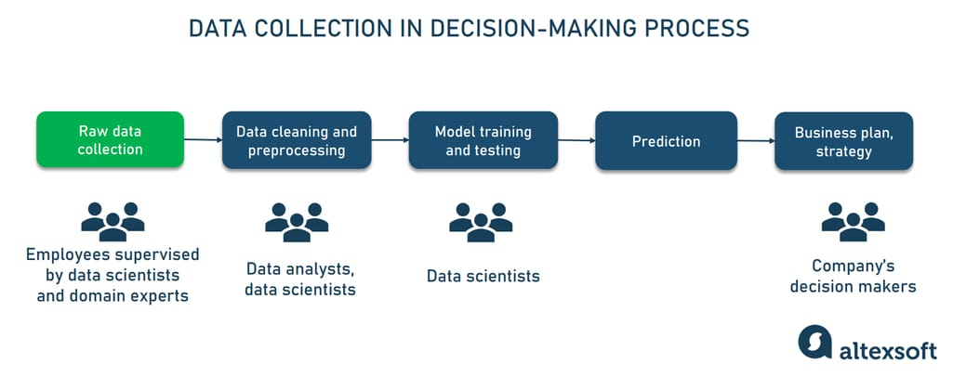

Step 1: Data Collection
Text data is collected from datasets such as reviews, comments, or feedback.
Step 2: Data Preprocessing
- Tokenization
- Removing stop words
- Lowercasing
- Stemming / Lemmatization
Step 3: Feature Extraction
Text is converted into numerical form using techniques like:
- Bag of Words
- TF-IDF

Step 4: Model Training
Machine learning models are trained using labeled sentiment data.
Step 5: Chatbot Integration
The trained model is integrated with the chatbot interface.
Step 6: Testing and Evaluation
The system is tested using sample inputs to verify accuracy.

