The decision tree model developed to predict whether income exceeds $50K/year based on census data shows a strong performance, as reflected in its metrics. The model achieved an accuracy of 83.9%, indicating that a significant proportion of the predictions were correct. The 95% confidence interval for accuracy is between 83.3% and 84.48%, underscoring the model's reliability.

The confusion matrix reveals that the model has a sensitivity (true positive rate) of 94.82%, meaning it correctly identified 94.82% of the individuals with income below $50K/year. However, the specificity (true negative rate) is 50.35%, showing that the model struggles to accurately identify individuals with income above $50K/year, as evidenced by the relatively lower specificity score.

The positive predictive value (PPV) is 85.43%, indicating that when the model predicts an income below $50K/year, it is correct 85.43% of the time. Conversely, the negative predictive value (NPV) is 76.01%, reflecting the proportion of individuals correctly identified as having income above $50K/year.

Additionally, the area under the ROC curve (AUC) is 0.8431, which illustrates a good level of discrimination by the model. This AUC score indicates that the model is effective in distinguishing between individuals who earn more than $50K/year and those who earn less.

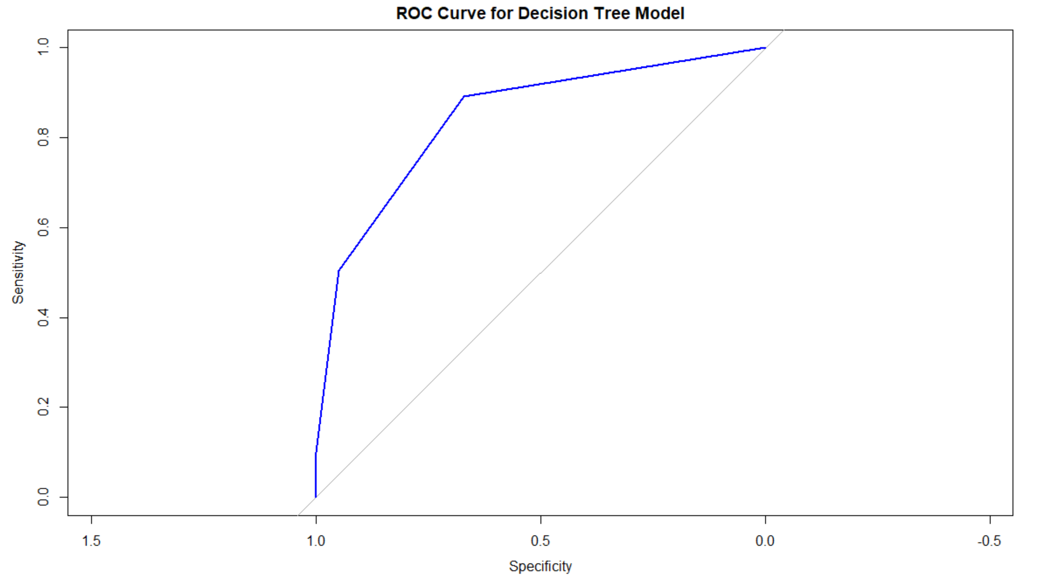

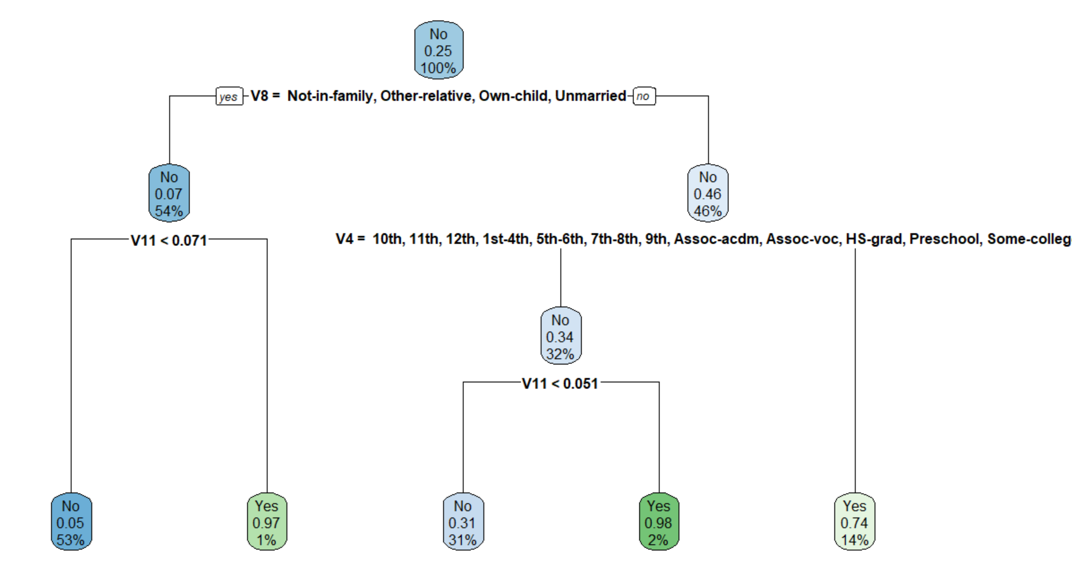

The ROC curve, presented in the first graph, provides a visual representation of the trade-off between sensitivity and specificity. The second graph displays the decision tree itself, showcasing how different variables and their values contribute to the final classification.

These findings collectively highlight that while the model is generally effective, there is room for improvement in predicting higher incomes, which is crucial for refining the model’s overall accuracy and utility.