The k-Nearest Neighbors (k-NN) classification model was applied to predict whether an individual's income exceeds $50K/year based on the dataset provided. The model's performance was assessed using several key metrics, including accuracy, sensitivity, specificity, and the area under the ROC curve (AUC). The confusion matrix revealed that the model correctly classified 3,277 true positives (income ≤ $50K) and 11,051 true negatives (income > $50K), while it misclassified 309 false positives and 423 false negatives.

Overall, the model achieved an accuracy of 95.14%, indicating that it correctly identified 95.14% of the cases in the test set. The sensitivity of the model was 88.57%, reflecting its ability to accurately detect positive instances, while the specificity was 97.28%, showing its effectiveness in identifying negative instances. The Kappa statistic of 0.8675 suggests a strong agreement between the predicted and actual classifications, even after adjusting for chance.

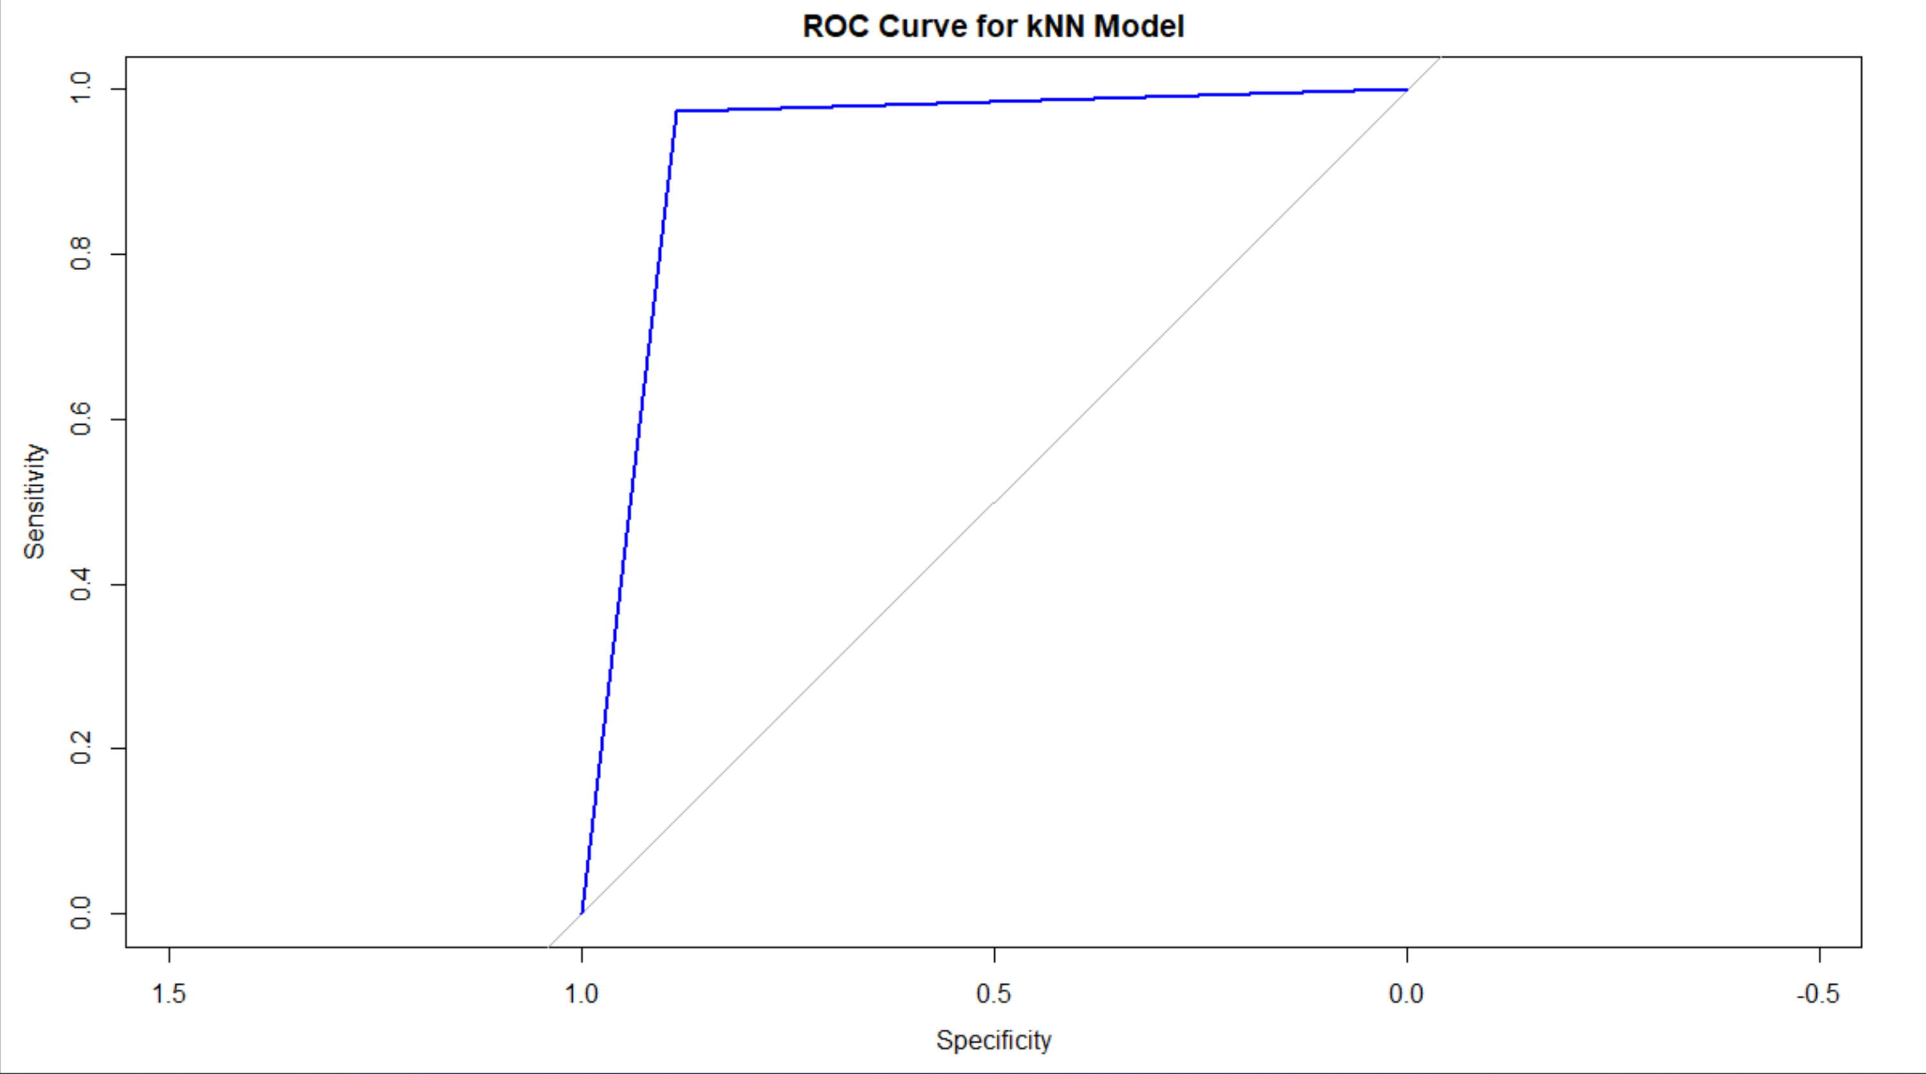

Additionally, the Area Under the ROC Curve (AUC) was calculated to be 0.9292, underscoring the model's strong discriminatory power. The ROC curve, which illustrates the trade-off between sensitivity and specificity, shows that the k-NN model maintains a high true positive rate while keeping the false positive rate low. The curve's proximity to the top left corner of the graph further confirms the model's robust performance.

In summary, the k-NN model demonstrated a high level of accuracy and effectiveness in predicting income levels, with strong metrics across all performance indicators and a well-supported ROC curve, confirming its reliability.