  - 
Master of Applied Computing
PRJ70404 Capstone Project I

  - Predictive Standby Dispatch: Machine Learning-based Smart Elevator Idle Positioning

Student Name | : | TEN YEE CHERN
Student ID | : | 0381084
Supervisor | : | Prof. Afizan Azman

Predictive Standby Dispatch: Machine Learning-based Smart Elevator Idle Positioning

Abstract
Elevator waiting times in multi-storey buildings remain a significant challenge in modern building operations. This project proposes a predictive multi-label classification Machine Learning (ML) model to forecast elevator call events, to guide the control system in repositioning the idle elevators. The model will learn from historical elevator call records and identify possible future call floors and their directions (up/down) within a defined time window. These predictions enable the control system to proactively reposition the idle elevators, therefore reducing the passenger waiting time. A simulated dataset is used as a training dataset, and a sliding window is used to extract input features, and the model outputs a multi-dimensional vector corresponding to each floor-direction label. This work serves as a foundation for implementing ML-enhanced dispatch strategy into the elevator group control system (EGCS), contributing to a more efficient and responsive building mobility.

Table of Contents
Abstract I
Table of Contents II
List of Figures III
List of Tables III
List of Abbreviations III
1 Introduction 1
1.1 Background 1
1.2 Problem Statement 1
1.3 Research Question 2
1.4 Research Objective 2
2 LITERATURE REVIEW 3
2.1 Elevator dispatch optimisation 3
2.1.1 Reactive Strategies 3
2.1.2 Proactive strategies 4
2.1.3 Summary 5
2.2 Dataset 5
2.3 Predictor / Classifier 7
2.3.1 Statistical Models 7
2.3.2 Shallow Machine Learning 7
2.3.3 Deep Learning 7
3 METHODOLOGY 11
3.1 Research Design 11
3.2 Data and Environment Simulations 11
3.2.1 Arrival Simulation 11
3.2.2 Elevator calls record 11
3.2.3 Building Simulation 12
3.2.4 Elevator Simulation 12
3.3 Machine Learning 12
3.3.1 Predictor 12
3.3.2 Prediction Evaluation 13
3.4 Standby Dispatch Strategy 13
3.5 Improvement Evaluation 14
3.6 Cost Optimisation 14
CHALLENGES & LIMITATIONS V
EXPECTED RESULT V
REFERENCE VI
APPENDICES A
Appendix 1: Arrival Simulator and Elevator Simulator A
Appendix 2: Presentation Slides B
Appendix 3: Student Proposal Form and Supervisor Meeting Record E
Gantt Chart I

List of Figures
Figure 1 Input of Machine Learning 13
Figure 2 Output of Machine learning 13

List of Tables
Table 1 Decay function of Score_wait in the standby floors scoring system 4
Table 2 Summary of previous studies and their optimisation strategy 5

List of Abbreviations
ARIMA | Autoregressive Integrated Moving Average
AWT | Average Waiting Time
BPTT | Backpropagation through time
CV | Computer vision
DL | Deep Learning
DQL | Deep Q-Learning
EGCS | Elevator Group Control System
GA | Genetic Algorithm
GRU | Gated Recurrent Unit
LSTM | Long Short-Term Memory
ML | Machine Learning
RL | Reinforcement Learning
RNN | Recurrent Neural Network
SARIMA | Seasonal Autoregressive Integrated Moving Average
TCN | Temporal Convolution Network

- Introduction
  - Background
The number of high-rise and multi-storey buildings grows rapidly with the progress of urbanisation. These buildings rely heavily on elevators to transport people between floors. The size of the elevator and escalator market in 2024 Malaysia is estimated at 2,691 units and projected to reach 3,549 units by 2030. (Laura Wood, 2025) As urban density increases, the movement of people vertically with elevators is becoming more frequent, and the time spent while travelling in elevators and waiting for elevators also increases. A study shows that office workers waste 15minutes a day in waiting for lifts. (Tennent, 2016) To improve users' experience, send users to their destination floor faster, different strategies are developed.
Traditional elevator dispatch systems are reactive: wait and only respond when the user presses a call button. Some advanced systems implement rule-based strategies or ML techniques to optimise strategies in destination control or dispatch assignments to reduce waiting and travel time. However, many do not proactively reposition idle elevators, it often stays where it last dropped off, which might be rare to make a call, and foolishly waits for the next call. The idea of standby / idle repositioning has been discussed in a recent study, which introduces a module to reposition idle elevators to likely demand hotspots using recent traffic history. (Tsai et al., 2025)

  - Problem Statement
While reactive dispatch strategies are well-established, the waiting time gap is insurmountable:
- Waiting Time Gap: Reactive systems only send the elevator once a call is made, even though different optimisation strategies have been established to reduce waiting time, but elevators need time to reach the calling floor. In a high-rise building, this waiting time can be considerable.
Thus, the implementation of idle repositioning can effectively leverage the idle period of elevators and reduce waiting time. Compared to the module established by Tsai et al. (2025), which uses a simple formula to calculate a demand score with historic data, ML can learn more complex patterns from data and can be customised for different buildings.

The purpose of this research is to develop an ML-based model that predicts and guides elevators in idle repositioning, and therefore reduces waiting time. However, several concerns should be taken into consideration:
- System’s Effectiveness in different scenarios: The developed predictive system might not improve much in demand-saturated scenarios compared to low-demand scenarios, as it only repositions the elevator when it is idle.
- Cost-Benefit balance: Even if repositioning idle elevators proactively can reduce waiting time, excessive or poorly chosen movements could incur high energy, operational, and maintenance costs. The balance between waiting reduction and extra movement cost needs careful design.

  - Research Question
- Can machine learning algorithms reliably predict future hall calls (floor and direction) before they occur?
- Does using prediction to reposition idle elevators (standby dispatch) reduce waiting time compared to baseline in different scenarios (high and low demand)?
- How should the system trade off between decreasing waiting time and minimising repositioning movement/energy cost?

  - Research Objective
- How should the system trade off between decreasing waiting time and minimising repositioning movement/energy cost?
- Implement and simulate the predictive standby dispatching strategy, and compare its average waiting time (AWT) versus a baseline reactive dispatch strategy in different scenarios (high and low demand).
- Design a framework or strategy to balance between AWT reduction and movement cost.
- LITERATURE REVIEW
  - Elevator dispatch optimisation
Elevator dispatch systems optimisation in previous research can be broadly grouped into two categories:
- Reactive Strategies: respond to the elevator calls when they are made, make dispatch decisions in reaction to demand.
- Proactive Strategies: send or reposition idle elevators (standby) to match predicted future demand even though no calls are made.

    - Reactive Strategies
These methods focus on improving dispatching after calls are received, minimising waiting/travelling time and avoiding unnecessary moves/stops through optimising dispatching decisions under a multi-elevator group system.

      - Deep learning (DL) real-time occupancy-aware
Computer vision (CV) and a Mask R-CNN model is implemented to detect real-time occupancy information, how full the elevator cab is, to avoid pickup failures and unnecessary stops, thereby improving dispatch decisions. Compared to the traditional method, which only used weight to assess the capability of an elevator cab to pick up new passengers, this system is able to detect a low-weight full occupancy situation (eg, a large cardboard box ). In moderate to heavy traffic intensity situations, this system is able to reduce 4-7% of waiting & travelling time. However, in low traffic intensity and saturated situations, improvement is limited or even draws back.(Wang et al., 2021)

      - Optimising elevator dispatch with Discrete-event Q-learning
Discrete-event Q-learning, a reinforcement learning (RL) algorithm, have been implemented to optimise the EGCS. In this study, the RL optimised controller is compared with heuristic controllers, like FIM and ESA, across multiple traffic profiles. The results show that RL achieved the lowest Average Wait Time (AWT) and, most notably, the lowest System Time (wait + travel time), even though this was not the direct objective. The controller is trained only on “down-peak” traffic, however, it generalised effectively when tested with mixed (up and down) traffic patterns. (Crites & Barto, 1995)

      - Optimising elevator dispatch with Deep Q-Learning (DQL)
Cao et al. (2024) also tried to leverage an RL algorithm, DQL, in optimising elevator dispatch. However, the DQN model did not improve over the naïve model (a rule-based algorithm that moves to the closest floor and in one direction, picking up/dropping off passengers until empty). Cao explained that it’s due to the environment of the EGCS is non-Markovian.
Cao also suggests adding a module to predict future elevator calls, and giving the model knowledge of future calls may help improve model performance.

    - Proactive strategies
These are methods that include prediction / idle elevator repositioning/standby behaviour to anticipate demand.

      - A scoring system for strategic standby floors
A scoring system is developed to decide where to reposition idle elevators. The standby floors are decided by a combined score of two scores:
- Demand-Based Score (Score_{wait}(f)): Calculate the decayed frequency of recent calls, which means a high frequency of recent calls on a floor indicates a high possibility of making calls again, and those calls far from the current timestamp have a lower impact on the score.
$${Score}_{wait}​(f) = \sum_{t∈H\left(f\right)}{ϕ\left(t\right)}​$$
H(f): the set of recent elevator call timestamps at floor f
φ(t): a decay function to reduce the effect of older requests. Three functions are used:
Table 1 Decay function of Score_wait in the standby floors scoring system
Mode | Formula | Characteristics
Linear | φ(t) = max(0, 1 - t/(λW)) | The weight decreases linearly over time, dropping to zero after the threshold λW. It is simple but has a hard cut-off.
Exponential | φ(t) = e^(-t/(λW)) | The weight decays smoothly following an exponential curve, approaching zero but never truly reaching it. This mode retains a longer "memory" of past activity, making it suitable for stable traffic patterns.
Quadratic | φ(t) = max(0, 1 - (t/(λW))^2) | The weight decays rapidly in the beginning. This mode is highly sensitive to very recent calls and is well-suited for fast-changing demand scenarios.
W: time window size; λ: factor to control decay speed;
- Energy-Based Score (Score_{energy}(f)): Penalises floors that are far away to save energy.
$${Score}_{energy}(f) = exp⁡(-\frac{{\left(f-f_{0}\right)}^{2}}{{2σ}^{2}})$$
f : candidate floor
f₀: the current floor of the idle elevator
σ: the standard deviation controlling the sensitivity to distance
- Combined Score (Score_{combined} ( f )): The combined of Score_{wait}(f) and Score_{energy}(f)
$${Score}_{combined}\left(f\right)= w ·{Score}_{wait}​(f) + (1 - w) · {Score}_{energy}(f)$$
The floor with the highest Combined Score will be selected as the standby floor.
This strategy was tested in simulations of mid-rise (10 floors) and high-rise (20 floors) office buildings, which significantly reduced AWT by over 24% compared to common baseline algorithms (like the Closest Car Algorithm). (Tsai et al., 2025)

      - Transformer neural network and linear regression model to predict passengers’ arrival time at the elevator
Instead of predicting future elevator calls with pass calls, Zhang et al. (2022) combined a transformer neural network and a linear regression model to predict a passenger’s arrival time at the elevator, so the system can proactively dispatch a cab before the call is made. First, the transformer neural network will predict the final destination of a moving person based on their partial trajectory, to find out the person with high probability becomes a passenger. Then, a linear regression model is used to predict the arrival time at the elevator, and the system will dispatch the elevator according to the predicted arrival time. This system achieves up to 80% true predictions, reduces AWT above 50% in light traffic and around 15% in medium traffic.

    - Summary
Overall, while reactive strategies improve real-time dispatching efficiency, proactive strategies show greater potential in anticipating passenger demand and significantly reducing waiting times through predictive modelling and intelligent standby management.
Table 2 Summary of previous studies and their optimisation strategy
Study | Strategy | ML Algorithm
Wang et al. (2021) | CV techniques to detect occupancy | Mask R-CNN
Crites & Barto (1995) | RL in EGCS dispatch optimisation | Discrete-event Q-learning
Tsai et al. (2025) | A custom scoring system to determine the standby floor | Custom scoring system
Zhang et al. (2022) | A transformer network and regression model to predict passengers' arrival time and send the elevator before they call | Seq2seq Transformer + linear regression

  - Dataset
To train a ML model to predict the future elevator calls, a dataset with historical calls is needed. Unfortunately, there is a lack of an open-sourced high-quality dataset. In several recent works related to elevator dispatch strategy optimisation, which require call records, simulated elevator behaviours are used as their dataset. The following are the studies and their simulator strategy:
- Crites and Barto (1995) Simulate a 10-floor building with 4 elevators, and 1st is the lobby. Operated as a discrete-event system, key events include: passenger arrivals, car arrivals at floors, loading/unloading completions, and decision points, and the time between events is variable and real-valued.
Arrival Process:
  - Poisson process for passenger arrivals at each floor
  - Time-varying rates based on a detailed "down-peak" traffic profile (rates change every 5 minutes)
  - Two traffic types:
    - Down traffic: Passengers from floors 2-10 going to lobby (primary traffic)
    - Inter-floor traffic: 0-10% of down traffic volume, representing traffic between other floors
Destination Modelling:
- For down-peak: Most passengers have destination = lobby (floor 1)
- Inter-floor traffic has random destinations following some distribution (not fully specified)
Fixed Timing Parameters: Moving speed 1.45s/floor; Stop time 7.19s; Turn time 1s (change direction); Load time: random variable with Erlang distribution (range: 0.6-6.0s, mean: 1s)
- Cao et al. (2024) Simulate an 8-floor building with one elevator and around 200 workers. Arrival times are generated based on the canonical three-peak model of elevator traffic (morning up-peak, lunch peak, evening down-peak) and follow truncated Poisson distributions around each peak.
Key parameters:
- Work schedule: 9 a.m. to 5 p.m. with a 30-minute lunch break.
- Arrival time: (mean) 9:00 a.m. and 5:00 p.m.; (std) 30 minutes
- Elevator moving speed: 5s/floor
- Load time: 15s
Arrival and destination process: Randomly assigned based on three-peak patterns.
Recorded table columns: time (seconds), start floor, destination floor, weight

- Tsai et al. (2025) Simulate two scenarios: mid-rise (10 floors, 2 elevators) and high-rise (20floors, 4 elevators). They define a formula to decide a global arrival rate c in time, and determine where passengers arrive and are heading according to time.
Global arrival rate formula λ(t):
$$λ(t)=A_{1}​⋅exp(-\frac{{(t-μ_{1}​)}^{2}}{2σ_{1}^{2}})+A_{2}​⋅exp(-\frac{{(t-μ_{2})}^{2}}{2σ_{2}^{2}}​)+A_{3}​⋅exp(-\frac{{(t-μ_{3})}^{2}}{{2σ}_{3}^{2}}​)+ε$$
t: Time of day (in minutes).
μ_{i} and σ_{i}: The mean and standard deviation for each of the three canonical traffic peaks, eg, μ₁ = 480 for 08:00.
A_{i}: The amplitude (intensity) of each peak.
ε: A small baseline rate to ensure minimal off-peak activity.
Traffic Peaks Modelled:
- Morning Up-Peak (7:00–10:00): Predominantly incoming traffic (from ground floor to upper floors).
- Lunchtime Peak (11:00–14:30): Mainly inter-floor traffic.
- Evening Down-Peak (16:00–21:00): Predominantly outgoing traffic (from upper floors to the ground floor).
Passenger generation: Generate passengers according to the arrival rate in time, and the actual time between passenger arrivals is determined stochastically based on this rate (using a Poisson process)
Arrival and destination process: Once a passenger's arrival is triggered, the simulator assigns an origin and destination floor based on the time of day and the corresponding peak pattern (morning up-peak/ lunchtime peak/ evening down-peak).

  - Predictor / Classifier
In order to deal with time series tasks, various algorithms have been developed. From classical statistical models to advanced ML models, each algorithm has its own advantages and disadvantages, and application scenarios.

    - Statistical Models
Time series statistical models like Autoregressive Integrated Moving Average (ARIMA) and Seasonal Autoregressive Integrated Moving Average (SARIMA) are excellent in interpretability and computational efficiency. SARIMA is less accurate, but it offers advantages in simplicity, faster computation, and reasonably good performance even with smaller datasets.
However, they struggle in capturing complex patterns and non-linear relationships, which are commonly found in real-world data. They are also limited in flexibility, not well-adapted to handling high-dimensional data or learning interactions between multiple variables. (Fatima & Rahimi, 2024)
Moreover, time series statistical models are commonly used in regression tasks, but not in classification tasks, as classification tasks require models to process non-linearity, multiple variables, high dimensionality and label sparsity.

    - Shallow Machine Learning
Shallow ML algorithms can fit complex, non-linear patterns and are more computationally efficient compared with DL algorithms. However, most shallow ML, like SVM, Random Forest and XGBoost, are not designed for sequential data; implementing these algorithms in time series tasks requires feature engineering to ensure performance, which can be time-consuming and require domain expertise. Shallow ML algorithms also struggle with temporal dependencies, they cannot capture long-range dependencies as effectively as specialised DL models. (Fatima & Rahimi, 2024)
Moreover, classic shallow ML classification algorithms are designed for single-label classification, binary or multi-class classification. They need to process problem transformation (eg, binary relevance, classifier chains) to work with a multi-class classification task or just using a multi-label adapted algorithm (eg, Multi-label SVM, ML-kNN, etc.) (Endut et al., 2022)

    - Deep Learning
DL algorithms are widely used and have demonstrated superior performance in various industrial forecasting tasks. Compared with statistical models and shallow ML models, DL can automatically learn relevant features and hierarchies directly from raw, sequential data. DL have higher performance in complex data and can handle high-dimensionality. Often used time-series DL algorithms include Recurrent Neural Network (RNN), Temporal Convolution Network (TCN), Long Short-Term Memory (LSTM), Gated Recurrent Unit (GRU), and Transformers.

      - RNNs
        - Vanilla RNN
RNN is a DL architecture that is designed to train and predict sequential or time series data, which maintains a hidden state (acts as the memory) that is updated at each step. The usual backpropagation in traditional neural networks is replaced with backpropagation through time (BPTT) algorithms to determine the gradients (Stryker, 2025). The simplest form of RNN is known as Vanilla RNN, which uses the same weight matrices across time steps. Though Vanilla RNN are able to process sequential tasks and look easy to apply as their architecture is simple and has fewer parameters, the performance is limited in larger capacity and longer time dependencies tasks, which makes the training process far more difficult. (Collins et al., 2017) When working on long-range dependencies, Vanilla RNN always struggles with the gradient vanishing and exploding problem, which is why mutation of RNN (eg, LSTM, GRU) or Transformers is preferred in sequential tasks. (Sherstinsky, 2020)

        - LSTM
LSTM is a mutation of RNN, it introduces the cell state, which can add or remove information through structures called gates (Forget Gate, Input Gate and Output Gate). By using these gates, LSTM provides a continuous, regulated path for gradient flow during training (BPTT), preventing gradients from vanishing quickly, and is able to process the long-term dependency problem. (Ghojogh & Ghodsi, 2023)
LSTM have been widely used in various sequential tasks. Kim (2020) and Diarra et al. (2023) used LSTM in predicting the occupancy of rooms. Kim’s system reduced around 50% of energy usage, and Diarra achieved the highest F1-score of 91.9%. Both of them found that the accuracy reduced when the output time window increased from 30 minutes to 1hour.
W. Zhang et al. (2019) propose an encoder-decoder structure in multi-label classification tasks, which uses two separate LSTM as encoder and decoder. With this structure, only the decoder needs to be trained when fitting the model to different lengths of output time window. They also suggest that this structure will help in training the model, stabilise the training process and accelerate convergence. Weighted loss functions are also implemented to conquer sparsity.

        - GRU
Compared with the three-gate structure with a separate memory cell, GRU only have two gates, the Update Gate and Reset Gate, and does not have a separate memory cell. GRU’s structure is simpler, which makes it more computationally efficient and tends to converge faster than LSTM. GRU often performs close to LSTM, and sometimes even better. However, there is no clear winner, the best choice depends on the specific dataset and task. (Chung et al., 2014)
Many applications show GRU performs well in time series forecasting, especially where sequences include long-time dependencies or nonlinear dynamics. For example, N. Li et al. (2021) developed a satellite network traffic prediction system based on GRU, which can pre-train on offline historical data and transfer the learned model to online satellite data to address the scarcity of real-time data. This system achieves higher prediction accuracy (compared with FARIMA and SVM) while maintaining adorable computational complexity and training time, making it suitable for resource-limited satellite environments.
There are several advanced models based on GRU. For example, GA-GRU, implementing the Genetic Algorithm (GA) to optimise critical GRU hyperparameters, specifically the training-testing window size and the number of hidden neural network units. The GA evolves a population of chromosomes (representing window size and NN units) to find the configuration that maximises classification accuracy. (S et al., 2022)
Although GRU is able to process multi-label classification tasks, GRU exhibited challenges in handling multi-label dependencies. (Findawati et al., 2025) Nanni et al. (2021) propose a GRU-TCN architecture to process a multi-label classification task, and this architecture has been validated on multiple datasets. This work suggests GRU is a potential predictor in our task.

      - TCN
TCN is a specialised CNN designed specifically for sequential data processing. TCN use 1D convolutions and dilated convolutions to efficiently model long-range dependencies. Compared with RNNs, TCN is more efficient and effective in capturing long-term patterns. (D. Kim, 2023) Several research studies show that TCN outperform RNNs, for example, a heart rate and blood pressure prediction research shows TCN outperforms GRU and LSTM, and this is put down to its dilated convolutions, residual connections and parallel computation capabilities. (Saleh et al., 2025) However, RNNs still excel in certain scenarios. (Bednarski et al., 2022) Yunita et al. (2025) state that there is no “absolute” best architecture among RNN, LSTM, GRU and hybrid models.
It is believed that TCN is often a strong candidate in tasks that involve long-range dependencies, multi-channel/multi-variable input or require high-parallel training. (Bai et al., 2018)

    - Transformers
Transformers are a type of neural network architecture that involves the self-attention mechanism, allowing the model to capture long-range dependencies and relationships between variables. Transformers are more parallelizable and can handle longer-range dependencies than RNNs. (Hall & Rasheed, 2025) However, Transformers also have higher computational and memory costs, especially for very long sequences, compared to RNNs or TCNs. (Kong et al., 2025)

    - Summary
Statistical models like ARIMA, SARIMA are computationally efficient and low-cost, offering acceptable performance given their minimal resource requirements. However, they are designed for regression and are unsuitable for classification tasks. RNNs are adept at capturing long-term dependencies, but struggle with the gradient explosion/vanishing problem, which limits them in processing longer-range dependencies. TCN’s dilated convolution allows it to capture longer-range dependencies and avoid the gradient explosion/vanishing problem when collaborating with TCN’s residual connection. TCN is also able to compute in parallel, bringing high training efficiency. Transformers’ self-attention mechanism allows models to capture global temporal dependencies, which makes it suitable for long-sequance time series forecasting. However, transformers require higher computation and memory, and are sensitive to data periodicity and stationarity.

Considering the type of task and deployment difficulty, TCN is the primary option in my work. GRU also show potential in my work, especially its hybrid, GRU-TCN. Although Transformer-based models achieve notable performance, their substantial computational cost and training difficulty are not warranted for our project, which utilises a dataset of moderate size.

- METHODOLOGY
  - Research Design
This project aims to develop and evaluate an intelligent elevator dispatch optimisation model that integrates predictive idle elevator reposition strategies to minimise passenger waiting and travelling time. The methodology consists of five main stages: data preparation, environment design, model development, simulation and evaluation, and performance analysis.

  - Data and Environment Simulations
The system will rely on a simulated elevator call dataset that contains information such as floor numbers, timestamps of elevator calls, elevator positions, and directions.

    - Arrival Simulation
The arrival simulation design draws on the design by Tsai et al. (2025)’s research, which simulated the arrival rate based on Gaussian distributions. A Gaussian-based formula will be used to decide the global arrival rate in time, then decide which floors passengers arrive on and where their destination is, according to the period of time.
Global arrival rate formula λ(t):
$$λ(t)=A_{1}​⋅exp(-\frac{{(t-μ_{1}​)}^{2}}{2σ_{1}^{2}})+A_{2}​⋅exp(-\frac{{(t-μ_{2})}^{2}}{2σ_{2}^{2}}​)+A_{3}​⋅exp(-\frac{{(t-μ_{3})}^{2}}{{2σ}_{3}^{2}}​)+ε$$
t: Time of day (in minutes).
μ_{i} and σ_{i}: The mean and standard deviation for each of the three canonical traffic peaks.For example, μ₁ = 480 for 08:00.
A_{i}: The amplitude (intensity) of each peak.
ε: A small baseline rate to ensure minimal off-peak activity.
Determine the traffic pattern according to the period of time:
  - Morning up-peak (7:00-10:00): predominantly upward movement, from lobby or carpark to upper floors
  - Lunchtime peak (11:00-14:30): mainly inter-floor trips
  - Evening down-peak (16:00-21:00): predominantly downward movement, from upper to lobby or carpark
To differentiate weekdays, weekends and holidays, a different group of A_{i} will be used according to the data to control the number of arrivals, larger A_{i} in weekdays, lower A_{i} in weekends and holidays.
To enhance and test system robustness, two sets of data with different dense levels will be generated (low dense level with lower A_{i}, high dense level with higher A_{i}).

    - Elevator calls record
First, the passengers' arrival at the whole building in a day will be generated according to the residents’ behaviour mode. Then, the simulator will decide whether to trigger a call. For example, repeating demands before a car arrives will be ignored, and if the car is full, it will call for a new car. The simulator will run for 4 months and generate a 4-month record, 3 months for training and 1 month for testing.

    - Building Simulation
To test and enhance system robustness, the model will be trained and tested in the simulator with two different building profiles:
- Low-rise: 10-floor, 1 elevator, no carpark
- High-rise: 40-floor, 4 elevators, 2-5 floors are the carparks

    - Elevator Simulation
The elevator will run with the following parameters:
- Capacity: 15 units
- Moving speed: 3s/floor
- Load/Unload time: The total load/unload time is estimated as the sum of a fixed overhead C (door opening/closing, acceleration delay, etc.) and two geometric sums representing the time to load and unload passengers. Each subsequent passenger requires half the time of the previous one due to partial overlap in movement or simultaneous boarding/unloading actions.
$$T\left(n_{load},n_{unload}\right)=C+ \sum_{k=0}^{n_{load}-1}{3 × {0.5}^{k}}+ \sum_{k=0}^{n_{unload}-1}{3 × {0.5}^{k}}$$
C: a constant that represents time taken by door opening/closing, acceleration delay, etc.
n_{load}: number of passengers to load on the floor
nun_{load}: number of passengers to unload on the floor
- Dispatch rule: Closet Car Algorithms (CCA), selects the elevator that is closest to the calling floor, giving priority to cars already moving in the same direction as the call. If no car is moving in that direction, an idle or least-cost car is assigned based on distance and direction penalties.

  - Machine Learning
    - Predictor
Algorithms: TCN & GRU-TCN
Features: A matrix of features within a time window that consists of
- Timestamp
- One-hot encode call and direction record of floors (0/1)
Output: One-hot encode call and direction record of floors (0/1) in the future time window.
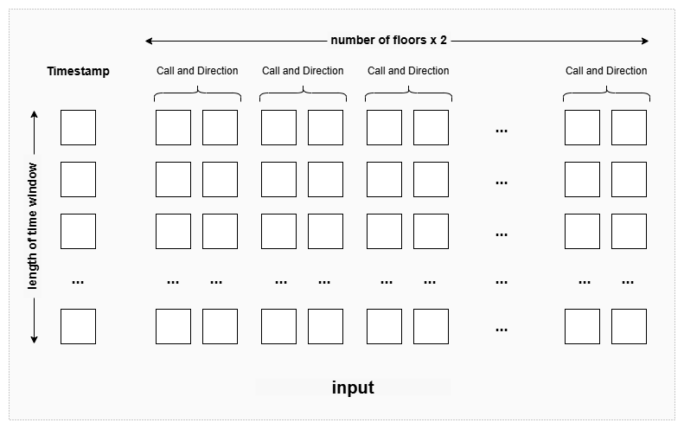
Figure 1 Input of Machine Learning
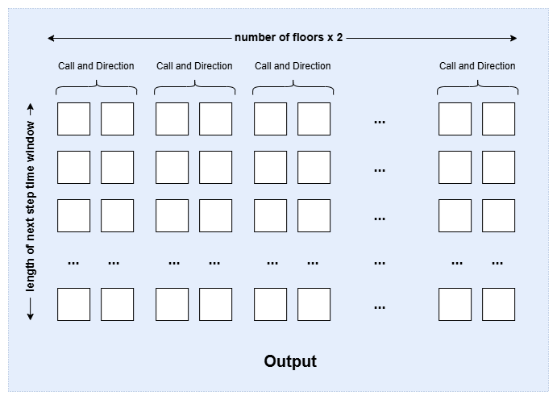
Figure 2 Output of Machine learning

    - Prediction Evaluation
To ensure the predictor is able to predict the future elevator calls accurately, the predictor will be evaluated on the test set with the accuracy, precision, and recall scores.

  - Standby Dispatch Strategy
Add a standby module to the EGCS, sending the idle elevator to the standby floor according to the prediction.
Standby strategy:
- Standby threshold: A threshold probability to trigger standby dispatch, for example, only floors with a probability > 0.8 will be sent a standby elevator.
- Grouped floors’ average probability: If there are idle elevators left (number of floors with probability beyond standby threshold < number of elevators), then select the highest probability floors from the rest floors as the group centre, calculate the average probability together with up and down n floors. Send a standby elevator if the average is greater than a threshold value (eg, 0.5, which should be lower than the standby threshold).
The standby threshold is used to find out the high probability floors, while the grouped floors' average probability aims to let the idle elevator stand by at the floors with relatively high probability neighbours when there are non-dispatched elevators left.

  - Improvement Evaluation
Run the standby module enhanced control system in the simulator, evaluate its performance in AWT and total move. This system will also be compared with baseline strategies, the traditional dispatching strategy, CCA and Tsai’s standby scoring system to compare the improvement.

  - Cost Optimisation
To balance the AWT reduction and movement cost, a decay function will be implemented to penalty the floors’ probability which are far from the elevator. Therefore, reduce the tendency of the elevator moving to far and medium-level probability floors.
In this work, the exponential decay will be used as the probability decay function. Probability decay function:
$$P^{'}\left(d\right)=P×λ^{d}$$
P: the original probability
d: the distance between the floor and the target idle elevator
λ: the decay value

CHALLENGES & LIMITATIONS
Real-Synthetic Gap: A synthetic dataset might be highly different from the real world. Though the designed simulator is trying to simulate a real-world environment, the gap still exists. To ensure the system can perform well in a real-world environment, it’s suggested that testing with real EGCS be conducted in the future.

Cross-scenario Performance: The elevator call pattern varies between different scenarios, different buildings and different time ranges; the performance of the system might change in different scenarios. It is suggested that training and testing the system in different scenarios.

EXPECTED RESULT
The predictor is expected to be able to predict future elevator calls accurately and significantly help in reducing AWT in the low-density level environment. However, in a high-density level environment, improvement might be minimal as the elevators' workload is saturated, which means fewer idle elevators are available for repositioning.

REFERENCE
Bai, S., Kolter, J. Z., & Koltun, V. (2018). An empirical evaluation of generic convolutional and recurrent networks for sequence modeling. arXiv (Cornell University). https://doi.org/10.48550/arxiv.1803.01271
Bednarski, B. P., Singh, A. D., Zhang, W., Jones, W. M., Naeim, A., & Ramezani, R. (2022). Temporal convolutional networks and data rebalancing for clinical length of stay and mortality prediction. Scientific Reports, 12(1). https://doi.org/10.1038/s41598-022-25472-z
Cao, Z., Guo, R., Tuguinay, C. M., Pock, M., Gao, J., & Wang, Z. (2023, September). Application of Deep Q Learning with Simulation Results for Elevator Optimization. In Proceedings of SAI Intelligent Systems Conference (pp. 849-861). Cham: Springer Nature Switzerland. https://doi.org/10.1007/978-3-031-47721-8_56
Chung, J., Gülçehre, Ç., Cho, K., & Bengio, Y. (2014). Empirical evaluation of gated recurrent neural networks on sequence modeling. arXiv (Cornell University). https://doi.org/10.48550/arxiv.1412.3555
Collins, J., Sohl-Dickstein, J., & Sussillo, D. (2017). Capacity and trainability in recurrent neural networks. International Conference on Learning Representations. https://openreview.net/pdf?id=BydARw9ex
Crites, R., & Barto, A. (1995). Improving elevator performance using reinforcement learning. Advances in neural information processing systems, 8. http://papers.nips.cc/paper/1073-improving-elevator-performance-using-reinforcement-learning.pdf
Diarra, M. K., Maniar, A., Masson, J., Marhic, B., & Delahoche, L. (2023). Occupancy State Prediction by Recurrent Neural Network (LSTM): Multi-Room context. Sensors, 23(23), 9603. https://doi.org/10.3390/s23239603
Endut, N., Hamzah, W. M. a. F. W., Ismail, I., Yusof, M. K., Baker, Y. A., & Yusoff, H. (2022). A Systematic Literature Review on Multi-Label Classification based on Machine Learning Algorithms. TEM Journal, 658–666. https://doi.org/10.18421/tem112-20
Fatima, S. S. W., & Rahimi, A. (2024). A review of Time-Series Forecasting Algorithms for Industrial Manufacturing Systems. Machines, 12(6), 380. https://doi.org/10.3390/machines12060380
Findawati, Y., Raharjo, A. B., Navastara, D. A., Yonathan, V., Yatestha, A. A., & Purwitasari, D. (2025). Multi-label aspect dangerous speech classification using Keyword-Driven Ensemble Classifier on imbalanced data. JOIV International Journal on Informatics Visualization, 9(4), 1592. https://doi.org/10.62527/joiv.9.4.3129
Ghojogh, B., & Ghodsi, A. (2023). Recurrent Neural Networks and Long Short-Term Memory Networks: Tutorial and survey. arXiv (Cornell University). https://doi.org/10.48550/arxiv.2304.11461
Hall, T., & Rasheed, K. (2025). A survey of Machine learning methods for time series prediction. Applied Sciences, 15(11), 5957. https://doi.org/10.3390/app15115957
Kim, D. (2023, July 23). Temporal Convolutional Networks - Architectures and Applications: Investigating temporal convolutional networks (TCNs) and their applications in modeling sequential data with long-range dependencies. https://aimlstudies.co.uk/index.php/jaira/article/view/70/
Kim, J. (2020). LSTM-based Space Occupancy Prediction towards Efficient Building Energy Management. arXiv (Cornell University). https://doi.org/10.48550/arxiv.2012.08114
Kong, X., Chen, Z., Liu, W., Ning, K., Zhang, L., Marier, S. M., Liu, Y., Chen, Y., & Xia, F. (2025). Deep learning for time series forecasting: a survey. International Journal of Machine Learning and Cybernetics. https://doi.org/10.1007/s13042-025-02560-w
Laura Wood. (2025, February 13). Malaysia Elevators and Escalators Market Size & Growth Forecast 2025-2030. Research and Markets. https://www.researchandmarkets.com/reports/5945972/malaysia-elevators-escalators-market-size-and?utm_source=CI&utm_medium=PressRelease&utm_code=lcnt6r&utm_campaign=1786141+-+Malaysia+Elevator+and+Escalator+Market+Analysis+Report+2022-2028+Featuring+Mitsubishi+Electric%2c+Schindler%2c+TK+Elevator%2c+KONE%2c+Hitachi%2c+Otis%2c+Hyundai+Elevator%2c+%26+Fujitec&utm_exec=chdo54prd
Li, N., Hu, L., Deng, ZL. et al. Research on GRU Neural Network Satellite Traffic Prediction Based on Transfer Learning. Wireless Pers Commun 118, 815–827 (2021). https://doi.org/10.1007/s11277-020-08045-z
Nanni, L., Lumini, A., Manfe, A., Rampon, R., Brahnam, S., & Venturin, G. (2021). Gated recurrent units and temporal convolutional network for multilabel classification. arXiv (Cornell University). https://doi.org/10.48550/arxiv.2110.04414
S, S., R, K. G., & B, V. K. (2022). GENETIC ALGORITHM - OPTIMIZED GATED RECURRENT UNIT (GRU) NETWORK FOR SEMANTIC WEB SERVICES CLASSIFICATION. Malaysian Journal of Computer Science, 35(1), 70–88. https://doi.org/10.22452/mjcs.vol35no1.5
Saleh, H., El-Rashidy, N., Mostafa, S., AlMohimeed, A., El-Sappagh, S., & Ali, Z. H. (2025). Cloud based real-time multivariate multi-step prediction of systolic blood pressure and heart rate using temporal convolutional network and Apache Spark. Journal of Big Data, 12(1). https://doi.org/10.1186/s40537-025-01207-5
Sherstinsky, A. (2020). Fundamentals of Recurrent Neural Network (RNN) and Long Short-Term Memory (LSTM) network. Physica D Nonlinear Phenomena, 404, 132306. https://doi.org/10.1016/j.physd.2019.132306
Stryker, C. (2025, October 21). Recurrent Neural Network (RNN). IBM think. Retrieved October 25, 2025, from https://www.ibm.com/think/topics/recurrent-neural-networks
Tennent, J. (2016, May 29). Office workers waste 15 minutes a day waiting for lifts, claims app developer. International Business Times UK. https://www.ibtimes.co.uk/office-workers-waste-15-minutes-day-waiting-lifts-1562621?utm_source=chatgpt.com
Tsai, I. N., Wu, Y. X., Huang, Y. H., Chen, Y. C., & Ding, J. J. (2025). Optimization of Elevator Standby Scheduling Strategy in Smart Buildings. Applied System Innovation, 8(5), 132. https://doi.org/10.3390/asi8050132
Wang, S., Gong, X., Song, M., Fei, C. Y., Quaadgras, S., Peng, J., ... & Jiao, R. J. (2021). Smart dispatching and optimal elevator group control through real-time occupancy-aware deep learning of usage patterns. Advanced Engineering Informatics, 48, 101286. https://doi.org/10.1016/j.aei.2021.101286
Zhang, J., Tsiligkaridis, A., Taguchi, H., Raghunathan, A., & Nikovski, D. (2022). Transformer networks for predictive group elevator control. 2022 European Control Conference (ECC), 1429–1435. https://doi.org/10.23919/ecc55457.2022.9838059
Zhang, W., Jha, D. K., Laftchiev, E., & Nikovski, D. (2019). Multi-label Prediction in Time Series Data using Deep Neural Networks. International Journal of Prognostics and Health Management, 10(4). https://doi.org/10.36001/ijphm.2019.v10i4.2611

APPENDICES

Appendix 1: Arrival Simulator and Elevator Simulator
Figure 3 Sample of Simulated Passenger Arrival
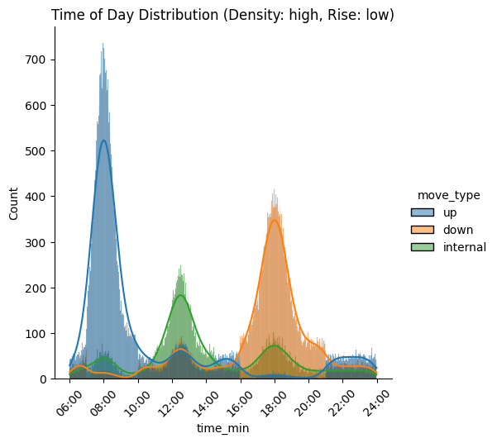
Figure 4 Distribution of Passenger Arrival in Passenger Arrival Sample
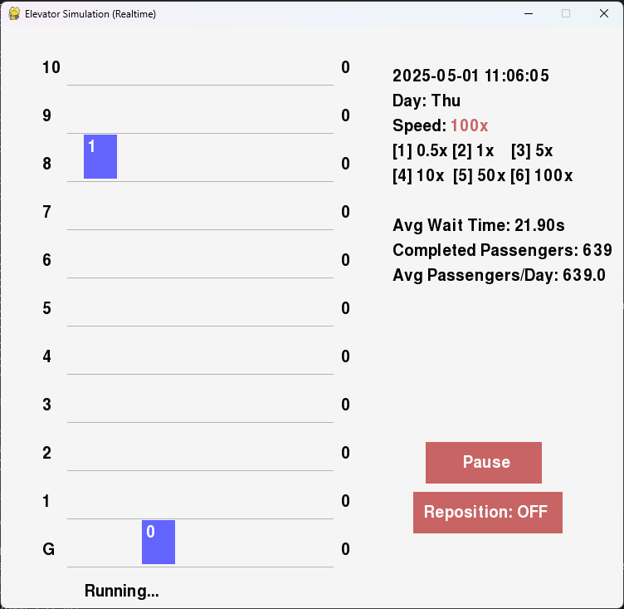
Figure 5 Prototype of Elevator Simulator

Appendix 2: Presentation Slides
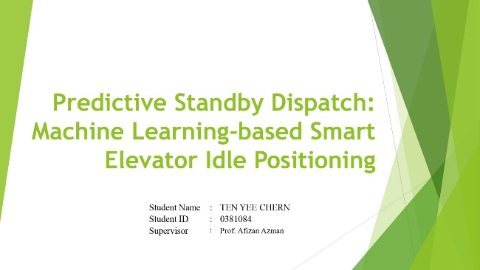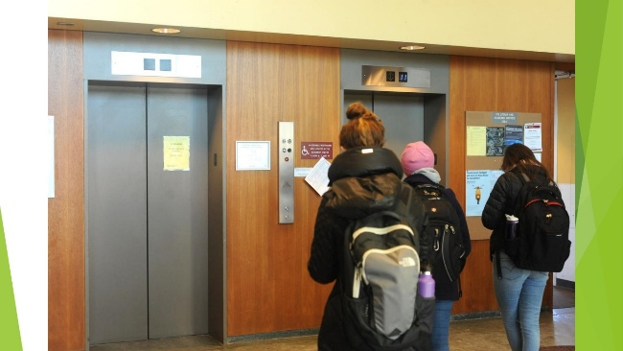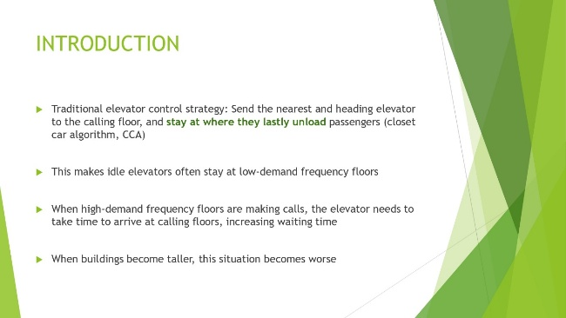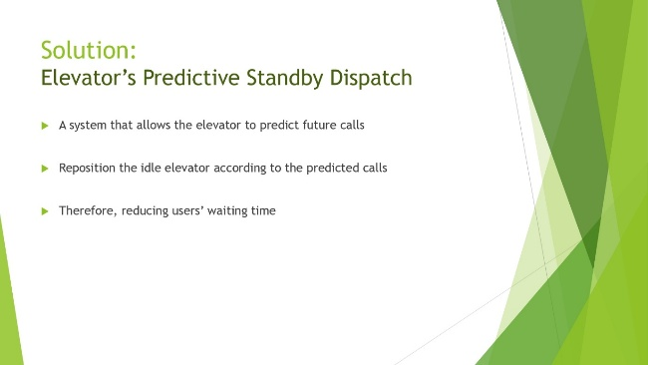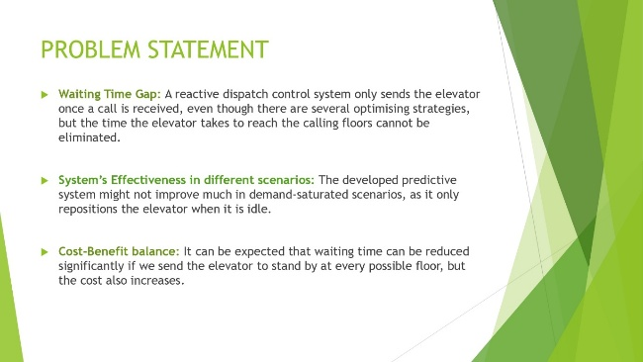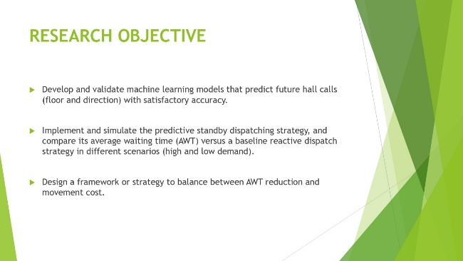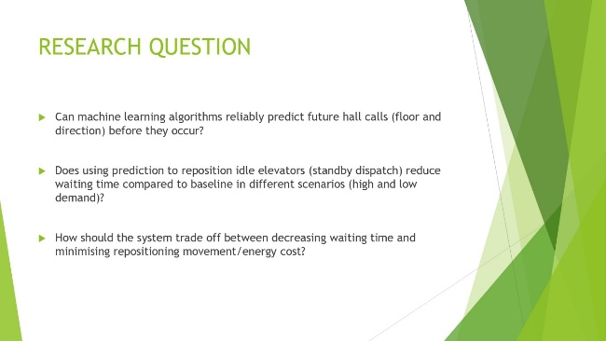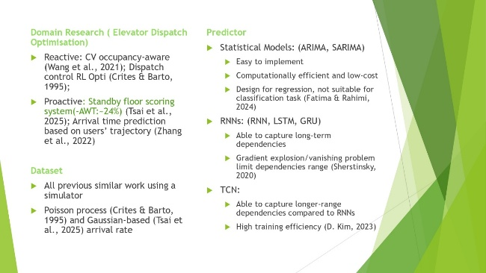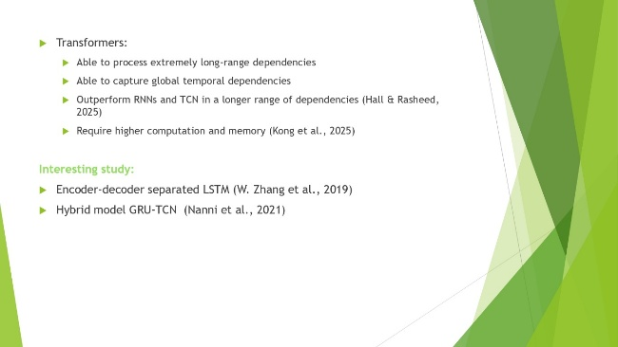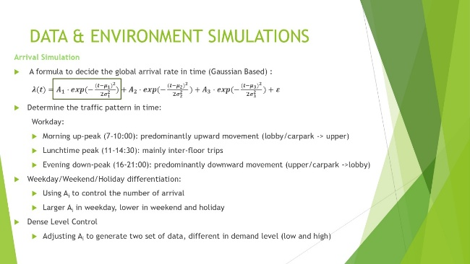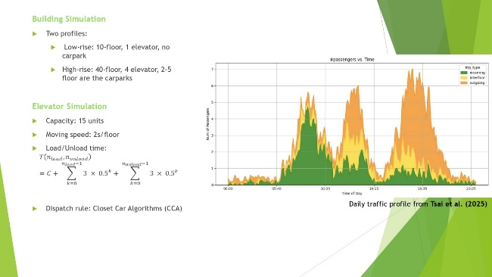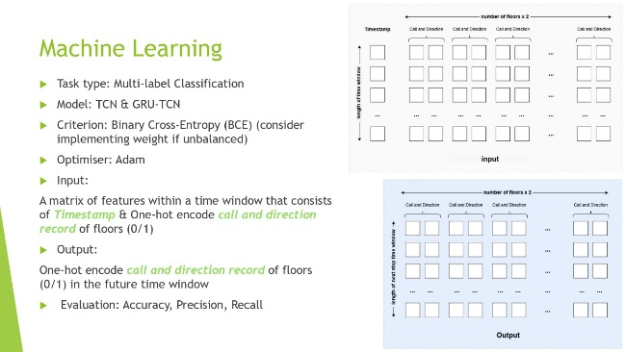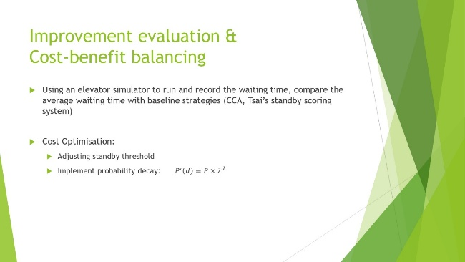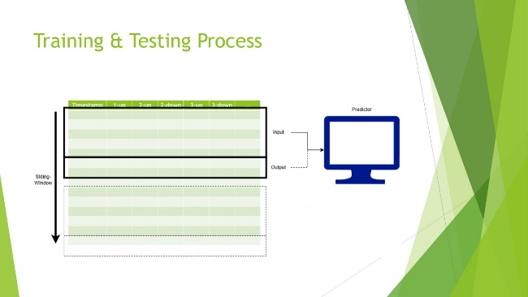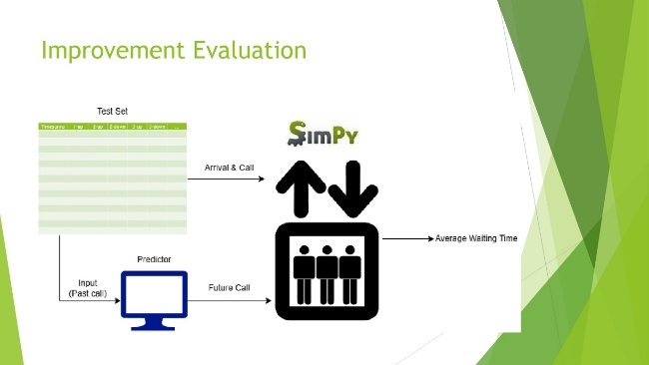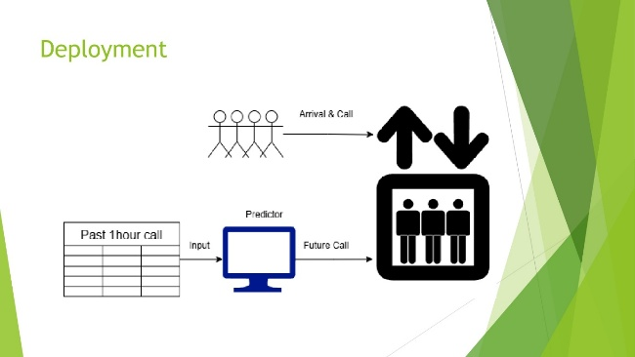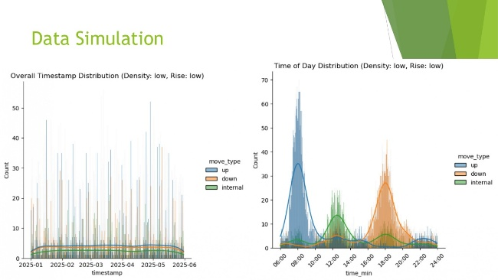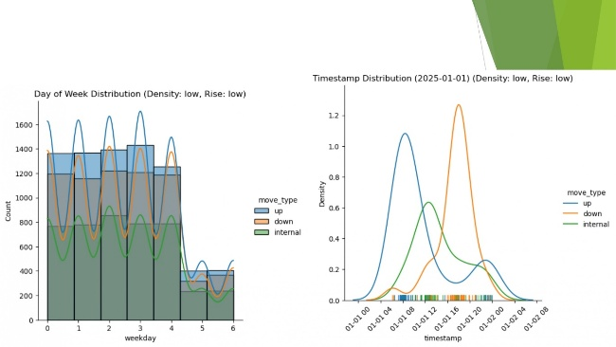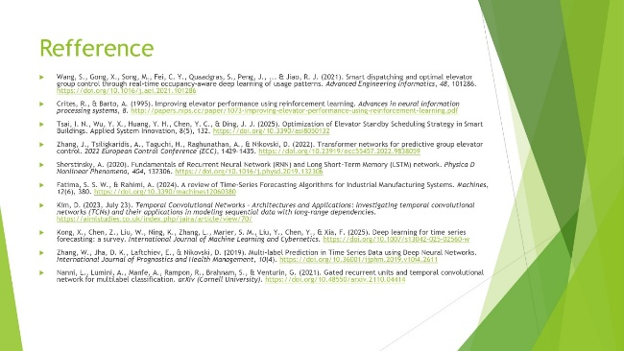

Appendix 3: Student Proposal Form and Supervisor Meeting Record

PROPOSAL BY STUDENT

Instructions:

There are THREE (3) sections to this form.

SECTION A : | Student Profile (To Be Completed by The Student)
SECTION B : | Research Proposal (To Be Completed by The Student)
SECTION C : | Reviewer Profile (To Be Completed by The Reviewer)

- To the student: Please complete Section A & B and pass this form to your Module Leader.
- To the reviewer: Please complete Section C after reviewing details in the previous sections filled by student.

SECTION A:
STUDENT PROFILE (TO BE COMPLETED BY THE STUDENT)

Programme Name  & Course Code: | Master of Applied Computing | 12703 | Programme Type:  (Please select box  to tick ( ) ): | ☐ Part Time  Full Time
 | Programme Name | Course Code

Semester:  (Please select box  to tick ( ) ): | ☐ 1  2 | Session: | 2025

Full Name: | TEN YEE CHERN | IC / Passport No.: | 980601016101

Email: | 0381084@sd.taylors.edu.my | Contact No.: | 018-6661061
Signature: |  | Date: | 13/10/2025
SECTION B:
RESEARCH PROPOSAL (TO BE COMPLETED BY THE STUDENT)

Project Title:
Predictive Standby Dispatch: Machine Learning-based Smart Elevator Idle Positioning
Project Summary (Problems and Scope):
Implementing machine learning algorithms to predict future elevator calls and reposition idle elevators to stand by at predicted floors to reduce passenger waiting time.
Objectives of Study:
Develop a predictive standby elevator dispatch control system and explore the potential of predictive machine learning algorithms in reducing elevator passenger waiting time.
Proposed Supervisor (If Any):
Prof. Afizan Azman
SECTION C:
REVIEWER PROFILE (TO BE COMPLETED BY THE REVIEWER)

Proposal reviewed by: Click or tap here to enter text.
Signature: |  | Date: | Click or tap to enter a date.

Reviewer’s Comment:

Approval By Module Leader:
Full Name: | Click or tap here to enter text.

Signature: |  | Date: | Click or tap to enter a date.



Gantt Chart

