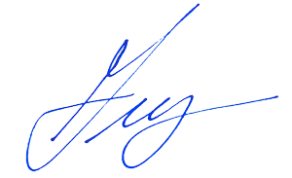

**Date:** _____________________

**Issued At:** _________________________________________ **on:** ____________________________________

**Happy 1st birthday to my brother's precious princess, filling our lives with love and laughter since day one.**

**Signature of Doctor:** _____________________________________

**Stamp of Doctor’s Clinic:** _____________________________________

**Medical Certificate**