CPE301 – SPRING 2019

Design Assignment 1B

Student Name: yeeunLee

Student #:2001614222

Student Email: leey81@unlv.nevada.edu

Primary Github address: https://github.com/yeeun219/submission_da.git

Directory: cpe301\DesignAssignments\DA1B

1. **COMPONENTS LIST AND CONNECTION BLOCK DIAGRAM w/ PINS**

FILL_UP ;store at STARTDDS using poiter

SEPERATE_DIVISION: ;separate data by divisibe 3

ADD_X: ;sum of the data divisibe 3

ADD_Y: ;sum of the data not divisibe 3

1. **DEVELOPED CODE OF TASK 1**

;

; AssemblerApplication9.asm

;

; Created: 2019-02-23 오전 8:17:45

; Author : llje2

;

.ORG 0

LDI ZL, LOW($200) ;pointer of STARTDDS

LDI ZH, HIGH($200)

LDI XL, LOW($400) ; x pointer that point value storing divisible by 3

LDI XH, HIGH($400)

LDI YL, LOW($600) ; y pointer that point value storing not divisible by 3

LDI YH, HIGH($600)

LDI R20, 12 ; initial value of STARTDDS, increasing by 1

LDI R24, 99 ; counter of fill_up loop

FILL_UP: INC R20

ST Z+,R20 ;store at STARTDDS using poiter

DEC R24

BREQ SEPERATE_DIVISION ;go SEPERATE_DIVISION to do seperate

RJMP FILL_UP ; fill up of 99times

1. **DEVELOPED CODE OF TASK 2 from TASK 1**

SEPERATE_DIVISION: DEC ZL ;decreasing z pointer

LDI R24, 99 ; counter of seperate

SEPERATE: LD R20, Z;load from RAM, r20 store of the rest

MOV R25, R20 ;r25 is the temporary value of loaded value that are used to store in RAM of x pointer

DEC ZL ;decreasing z pointer and load 1 data from ram

.DEF NUM = R23

MOV NUM, R20;the value of dividend

.DEF DENOMINATOR =R21

.DEF QUOTIENT = R22

LDI QUOTIENT,0

LDI DENOMINATOR, 3

L1: INC QUOTIENT ;Subtract until zero or negative, Increasing by one QUOTIENT for each subtraction

SUB NUM, DENOMINATOR

BRCC L1

DEC QUOTIENT ;because of one more time adding

MUL QUOTIENT,DENOMINATOR ; the rest is the value of dividend - QUOTIENT*DENOMINATOR(r0)

SUB R20, R0 ;store the rest in r20

BRNE Y_STORE ;if the value of r20 is not 0(not divisible by 3), then go Y_STORE

X_STORE: ST X+, R25 ; else go X_STORE

JMP NEXT

Y_STORE: ST Y+, R25

NEXT: DEC R24

BREQ ADD_X

RJMP SEPERATE

1. **DEVELOPED CODE OF TASK 3 from TASK 2**

ADD_X: LDI R24, 40;counter of add_x_loop

LDI R21,0 ; initialize the upper value of r 20

ADD_X_LOOP: DEC XL

LD R20, X ;load the data of pointer x

ADD R16, R20 ;add considering carry overflow

ADC R17,R21

DEC R24

BREQ ADD_Y

RJMP ADD_X_LOOP

ADD_Y: LDI R24, 90;counter of add_y_loop

LDI R21,0 ; initialize the upper value of r 20

ADD_Y_LOOP: DEC YL

LD R20, Y ;load the data of pointer y

ADD R18, R20; add considering carry overflow

ADC R19,R21

DEC R24

BREQ END

RJMP ADD_Y_LOOP

END: RJMP END

1. **The code of verifying my algorithm using c program TASK4**

#include <iostream>

#include <stdio.h>

int main() {

int total_sum = 0;

int temp = 13;

for (int i = 1; i <= 99; i++) {

total_sum = total_sum + temp; //sum of the 13~111

temp++;

}

int temp_2 = 15; //sum of the value pointing pointer x

int total_div = 0;

for (int j = 0; j < 33; j++) {

total_div += temp_2;

temp_2 = temp_2 + 3;

}

printf("total sum(hex value) of divisible 3 (x pointer) :0x%X \n", total_div);

printf("total sum(hex value) of not divisible 3 (y pointer) :0x%X", total_sum-total_div);

// sum of the value pointing pointer y = sum of the 13~111 - sum of the value pointing pointer x

}

**Result**



**The same value 0x081F(R17:R16), 0x0FDB(R19:R18) with assembly code**

1. **THE EXECUTION TIME TASK5**

Initialize: 9cycle

FILL_UP : 5*99cycle

SEPERATE_DIVISION: 2+99*(9+3*15(average value +8) cycle

ADD_X: ; 2+7*40cycle

ADD_Y: 2+7*90cycle

**Total 75580 cycle**

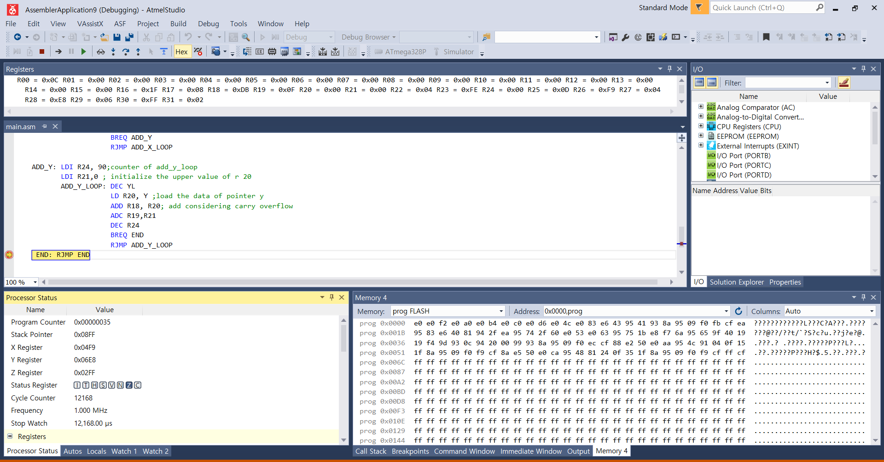

1. **SCREENSHOTS OF EACH TASK OUTPUT (ATMEL STUDIO OUTPUT)**

## The beginning of Task 1 snapshot

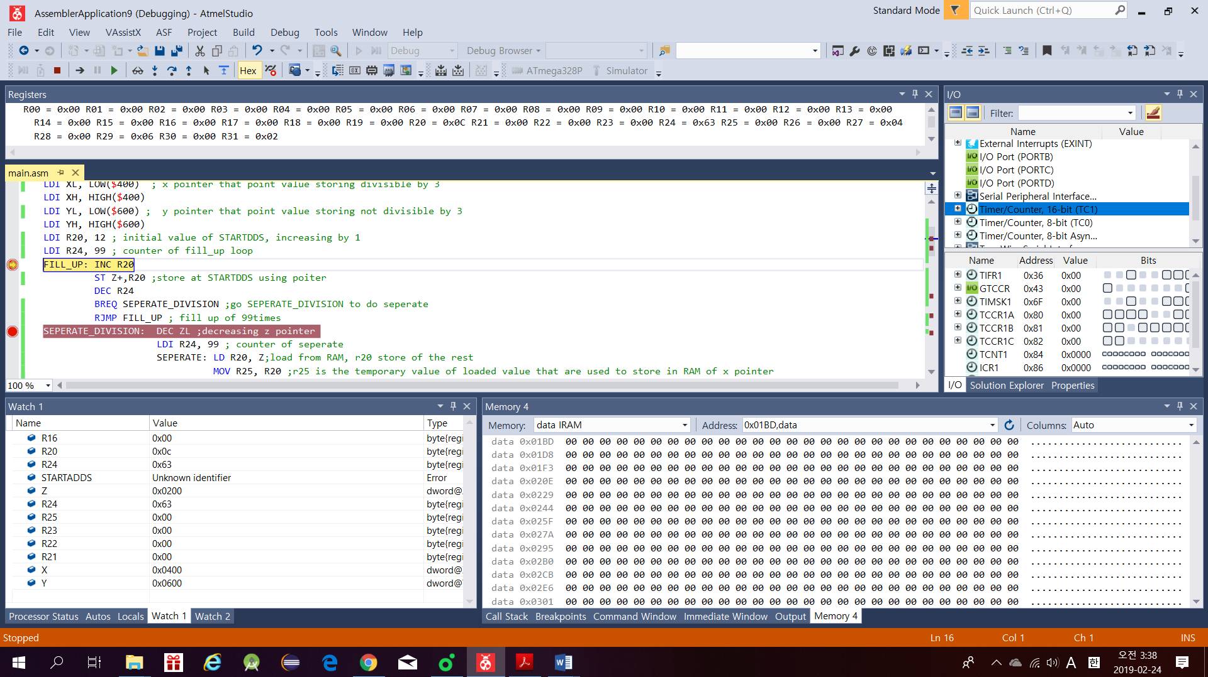

## The end of Task 1 snapshot

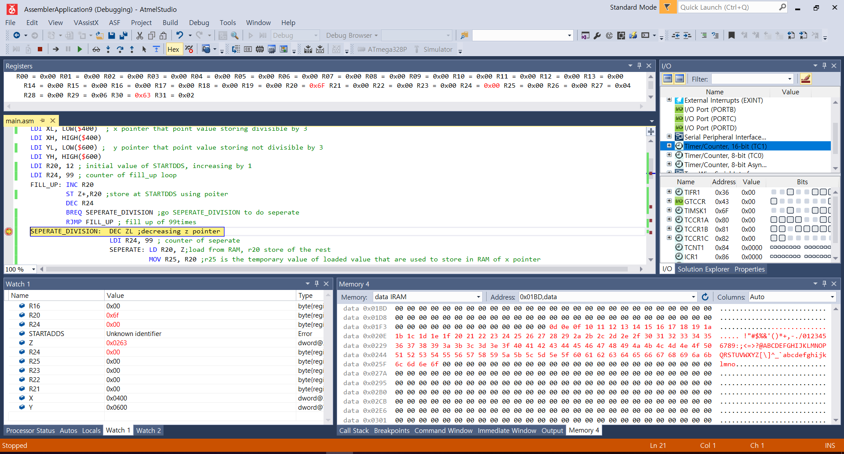

## The end of Task 2 snapshot_1

## The end of Task 2 snapshot_2

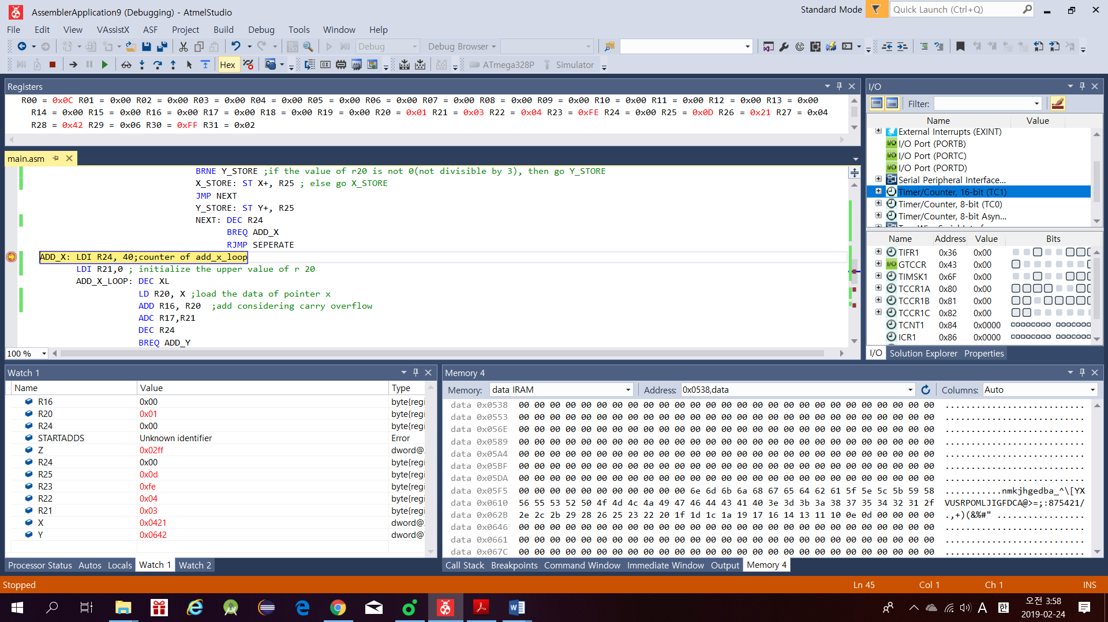

## The END of Task 3 snapshot_1

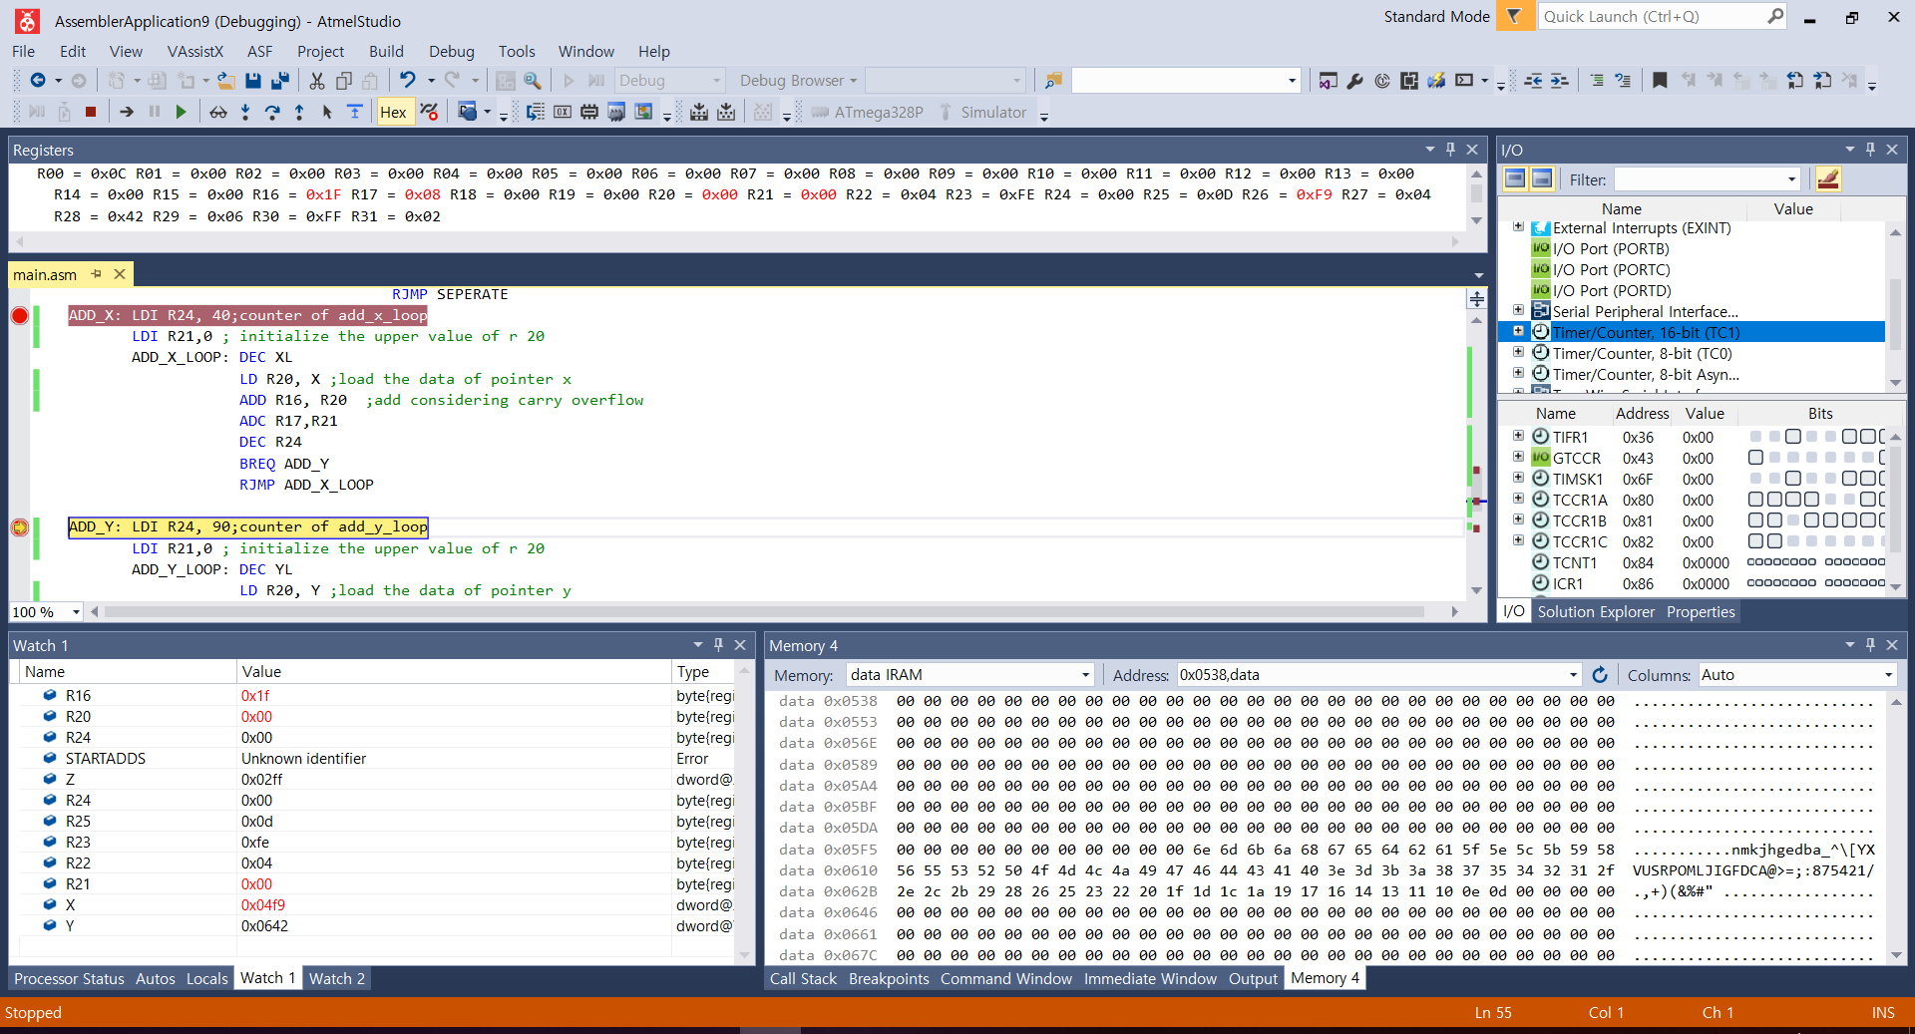

## The end of Task 3 snapshot _2

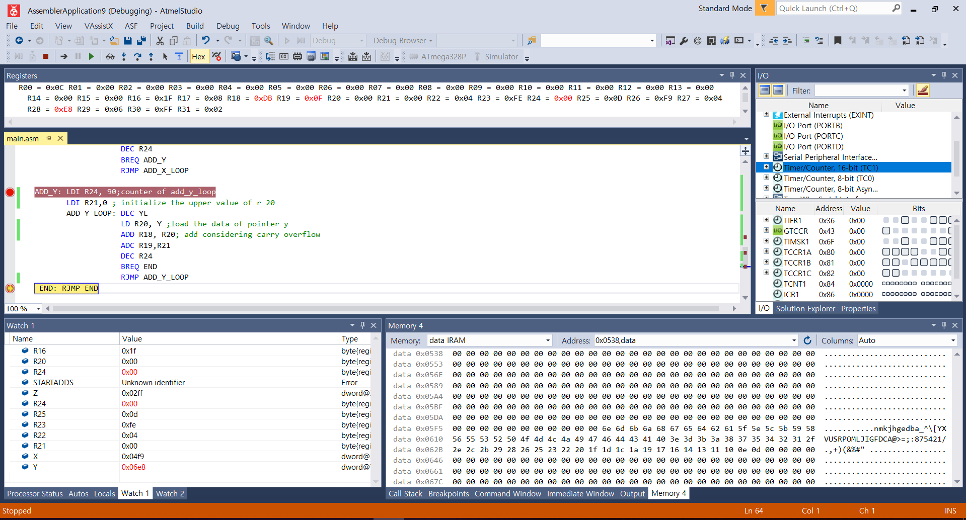

1. **VIDEO LINKS OF EACH DEMO**

<https://youtu.be/nIRHM2ILrIs>

1. **GITHUB LINK OF THIS DA**

Primary Github address: https://github.com/yeeun219/submission_da.git

Directory: cpe301\DesignAssignments\DA1B

**Student Academic Misconduct Policy**

<http://studentconduct.unlv.edu/misconduct/policy.html>

“This assignment submission is my own, original work”.

Yeeunlee