CPE301 – SPRING 2019

Design Assignment 2A TASK1

Student Name: yeeunLee

Student #:2001614222

Student Email: leey81@nevada.unlv.com

Primary Github address: https://github.com/yeeun219/submission_da.git

Directory: cpe301\DesignAssignments\DA2A\T1. cpe301\DesignAssignments\DA2A\T1

1. **COMPONENTS LIST AND CONNECTION BLOCK DIAGRAM w/ PINS**

REPEAT ; //blinking LED

DELAY_1: //Create a Delay of 60%DC

DELAY_2: //Create a Delay of 40%DC

DELAY_3: //Create a Delay of 1s

1. **DEVELOPED CODE OF TASK 1**

;

; AssemblerApplication15.asm

;

; Created: 2019-03-09 오후 5:22:36

; Author : llje2

;

; Replace with your application code

.INCLUDE "M328PDEF.INC" //Include device file

.CSEG

.ORG 0x0000 //Beginning of Program Memory

SBI DDRB,5 //TURN OFF THE D1LED

SBI PORTB,5

CBI DDRC,2 //make portc.2 input

SBI DDRB, 2

REPEAT: SBI PORTB, 2 //Sets pin (PB2) high

RCALL DELAY_1 //0.435SEC DELAY (60%DC)

CBI PORTB, 2 //Sets pin (PB2) low

RCALL DELAY_2 //0.29SEC DELAY (40%DC)

SBIC PINC,2 //IF BUTTON IS PRESSED,THEN NEXT INSTRU(INTERUPTION)

RJMP REPEAT //Repeat continuously

CBI PORTB,2

RCALL DELAY_3 //1.25SEC delay

RCALL DELAY_2

RJMP REPEAT

//-------------------------------------------------------------------------------------

DELAY_1: LDI R16, 40 //Create a Delay of 60%DC

LOOP1_1: LDI R17, 87

LOOP2_1: LDI R18, 109

LOOP3_1: NOP

DEC R18

BRNE LOOP3_1

DEC R17

BRNE LOOP2_1

DEC R16

BRNE LOOP1_1

RET

DELAY_2: LDI R16, 23 //Create a Delay of 40%DC

LOOP1_2: LDI R17, 58

LOOP2_2: LDI R18, 72

LOOP3_2: NOP

DEC R18

BRNE LOOP3_2

DEC R17

BRNE LOOP2_2

DEC R16

BRNE LOOP1_2

RET

DELAY_3: LDI R16, 80 //Create a Delay of 1s

LOOP1_3: LDI R17, 200

LOOP2_3: LDI R18, 250

LOOP3_3: NOP

DEC R18

BRNE LOOP3_3

DEC R17

BRNE LOOP2_3

DEC R16

BRNE LOOP1_3

RET

1. **SCHEMATICS**

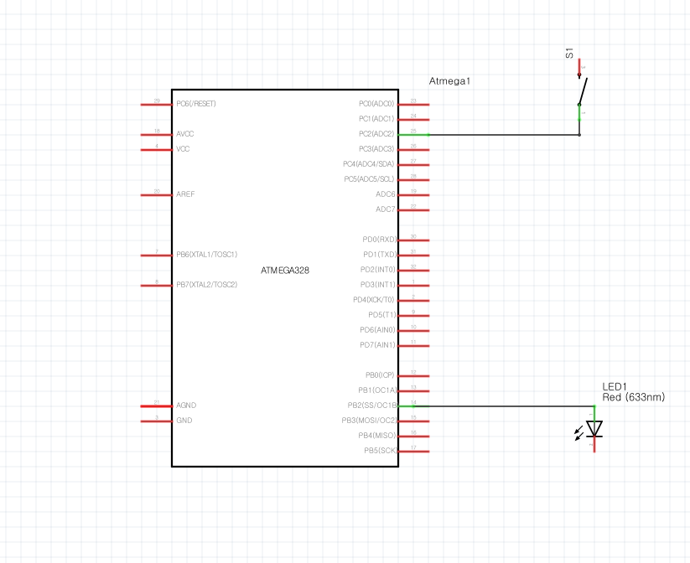

1. **SCREENSHOTS OF EACH TASK OUTPUT (ATMEL STUDIO OUTPUT)**

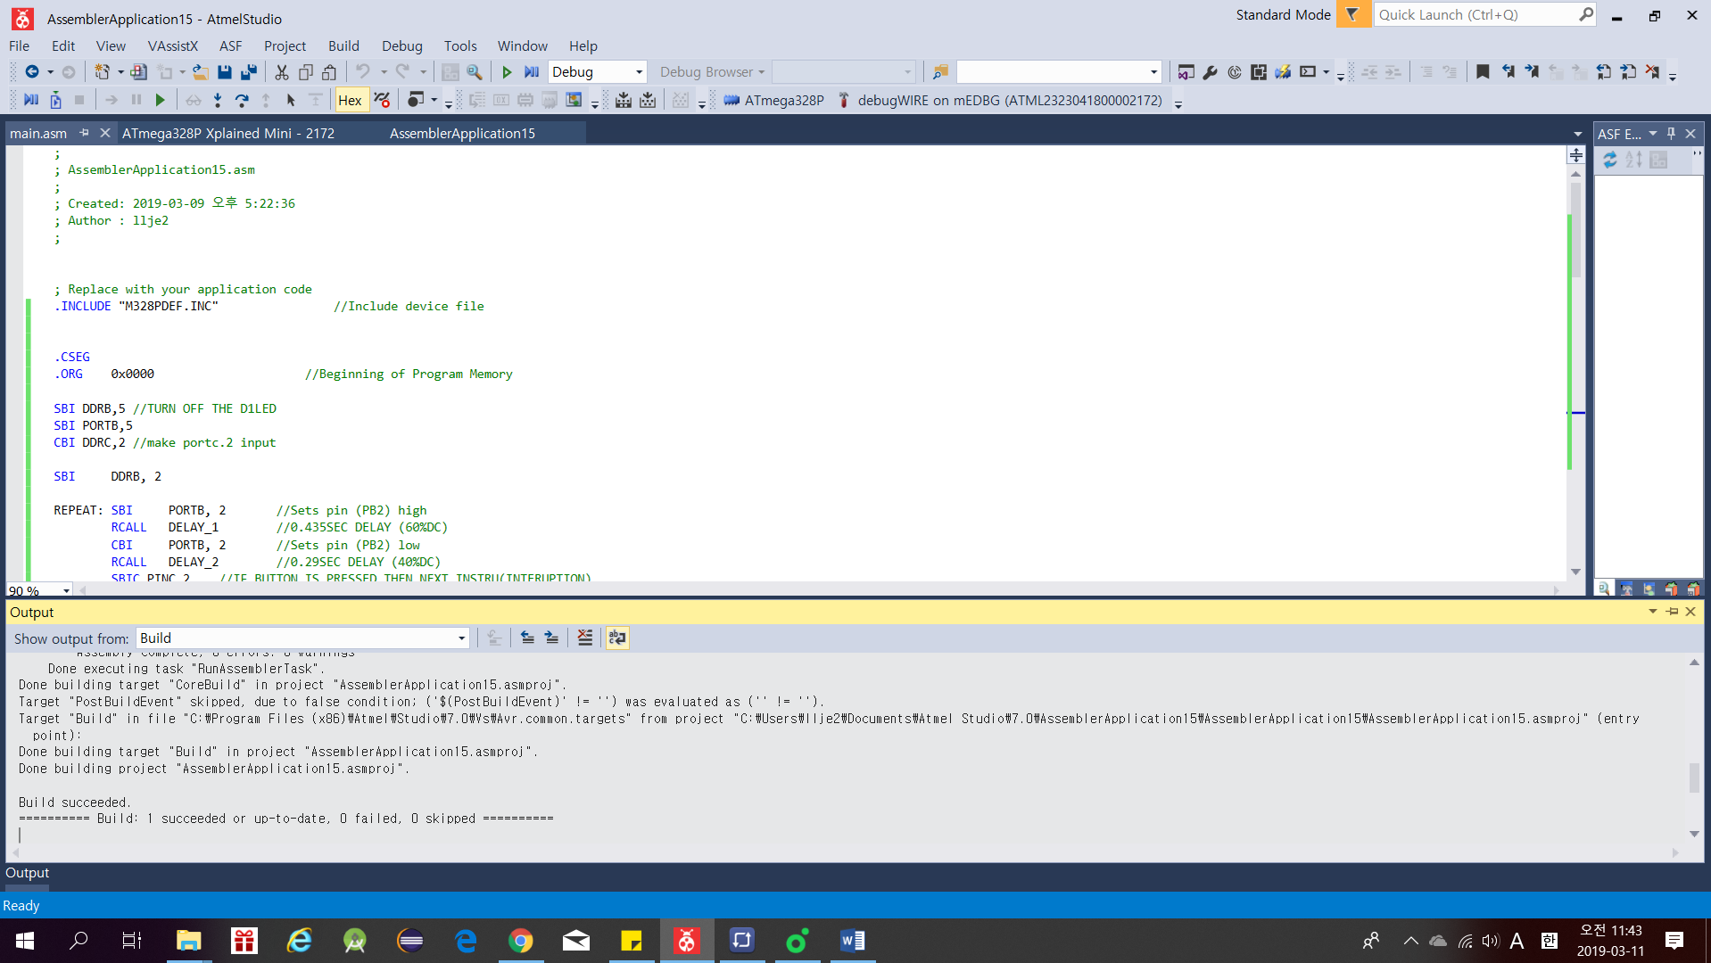

1. **SCREENSHOT OF EACH DEMO (BOARD SETUP)**

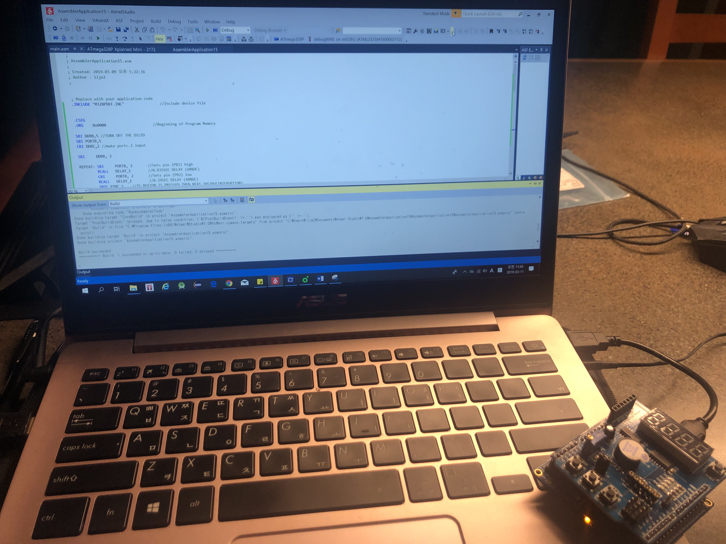

1. **VIDEO LINKS OF EACH DEMO**

https://youtu.be/fEA5JhAXYyA

1. **GITHUB LINK OF THIS DA**

Primary Github address: https://github.com/yeeun219/submission_da.git

Directory: cpe301\DesignAssignments\DA2A\T1. cpe301\DesignAssignments\DA2A\T2

**Student Academic Misconduct Policy**

<http://studentconduct.unlv.edu/misconduct/policy.html>

“This assignment submission is my own, original work”.

YEEUNLEE