CPE301 – SPRING 2019

Design Assignment 3A

Student Name: yeeunLee

Student #:2001614222

Student Email: leey81@nevada.unlv.com

Primary Github address: https://github.com/yeeun219/submission_da.git

Directory: cpe301\DesignAssignments\DA3A

1. **COMPONENTS LIST AND CONNECTION BLOCK DIAGRAM w/ PINS**

while (1) //Repeat continuously, Display a string, random integer and floating point void USART_init(void); //the USART initialization code

unsigned char USART_receive(void);

void USART_send( unsigned int data); //the USART receive int data code

void USART_putstring(char* StringPtr); //the USART receive string data code

void USART_putint(int rand_integer); //the USART receive random int data code

void USART_putfloat(char* FloatPtr); //the USART receive floating value data code

void InitializeRandomSeed() //set random initialize

char GetRandomCharacter() //get random character

int GetRandomInt()/get random int

ISR(TIMER0_COMPA_vect) // the interrupt service routine

1. **DEVELOPED CODE OF**

/*

* GccApplication6.c

*

* Created: 2019-03-26 am6:51:27

* Author : llje2

*/

#define *F_CPU* 16000000UL

#include <avr/io.h>

#include <util/delay.h>

#include <stdio.h>

#include <stdlib.h>

#include <time.h>

#include <avr/interrupt.h>

#define BAUDRATE 9600

#define BAUD_PRESCALLER (((*F_CPU* / (BAUDRATE * 16UL))) - 1)

//Declaration of our functions

void USART_init(void);

unsigned char USART_receive(void);

void USART_send( unsigned int data);

void USART_putstring(char* StringPtr);

void USART_putint(int rand_integer);

void USART_putfloat(char* FloatPtr);

void InitializeRandomSeed()

{

*srand*((unsigned int)*time*(0));

}

char GetRandomCharacter()

{

return *rand*() % 26 + 65 ;

}

int GetRandomInt(){

return *rand*() % 9+48;

}

int extraTime=0;

int main(void) {

USART_init(); //Call the USART initialization code

InitializeRandomSeed();

char String[5];//String[] is in fact an array but when we put the text between the " " symbols the compiler threats it as a String and automatically puts the null termination character in the end of the text

char f_number[3];

DDRB = 0x01; // setting the LED as an output

TCCR0A = (1 << WGM01); // Set CTC Bit

OCR0A = 195; // number of ticks we need for our specific time

TIMSK0 = (1 << OCIE0A);

TCCR0B = (1 << CS02) | (1 << CS00); // use 1024 prescaler

sei(); // setting the interrupt

while (1) { //Infinite loop

for(int i=0;i<5;i++){

String[i] = GetRandomCharacter();

}

USART_putstring(String);//Pass the string to the USART_putstring function and sends it over the serial

USART_putint(32); //tell from string and random integer

int rand_integer = GetRandomInt();

USART_putint(rand_integer);//Pass the random_int to the USART_putstring function and sends it over the serial

USART_putint(32); //tell from random integer and float

f_number[0]=GetRandomInt(); //make floating point value

f_number[1]='.';

f_number[2]=GetRandomInt();

USART_putfloat(f_number);//Pass the random_floating point value to the USART_putstring function and sends it over the serial

USART_putint(32); // display SPACE ascii '32' is space, tell from former and now

USART_putint(32);

*_delay_ms*(1000);

}

return 0;

}

ISR(TIMER0_COMPA_vect) // the interrupt service routine

{

extraTime++;

if(extraTime > 100)

{

PORTB ^= (1<<PORTB0); // toggle LED

extraTime = 0;

}

}

void USART_init(void) { //the USART initialization code

UBRR0H = (*uint8_t*)(BAUD_PRESCALLER >> 8);

UBRR0L = (*uint8_t*)(BAUD_PRESCALLER);

UCSR0B = (1 << RXEN0) | (1 << TXEN0);

UCSR0C = (3 << UCSZ00);

}

unsigned char USART_receive(void) {

while (!(UCSR0A & (1 << RXC0)));

return UDR0;

}

void USART_send( unsigned int data) { //the USART receive int data code

while (!(UCSR0A & (1 << UDRE0)));

UDR0 = data;

}

void USART_putstring(char* StringPtr) { //the USART receive string data code

int i;

for(i=0;i<5;i++){ // string length is 5

USART_send(*StringPtr);

StringPtr++;

}

}

void USART_putfloat(char* FloatPtr) { //the USART receive floating value data code

int i;

for(i=0;i<3;i++){ //random_floating point value length is 3

USART_send(*FloatPtr);

FloatPtr++;

}

}

void USART_putint(int rand_integer){ //the USART receive int value

USART_send(rand_integer);

1. **SCHEMATICS**

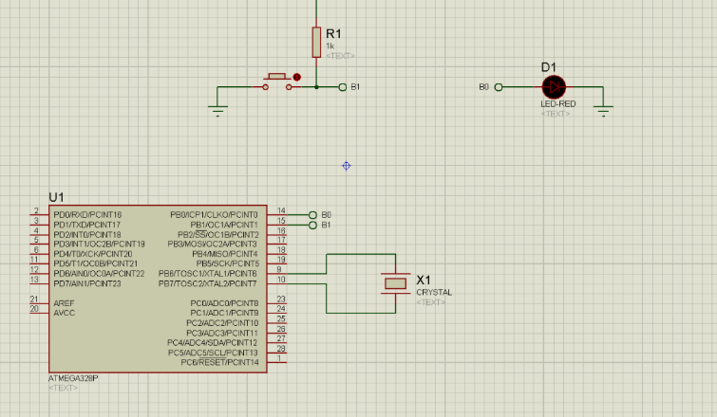

1. **SCREENSHOTS OF EACH TASK OUTPUT (ATMEL STUDIO OUTPUT)**

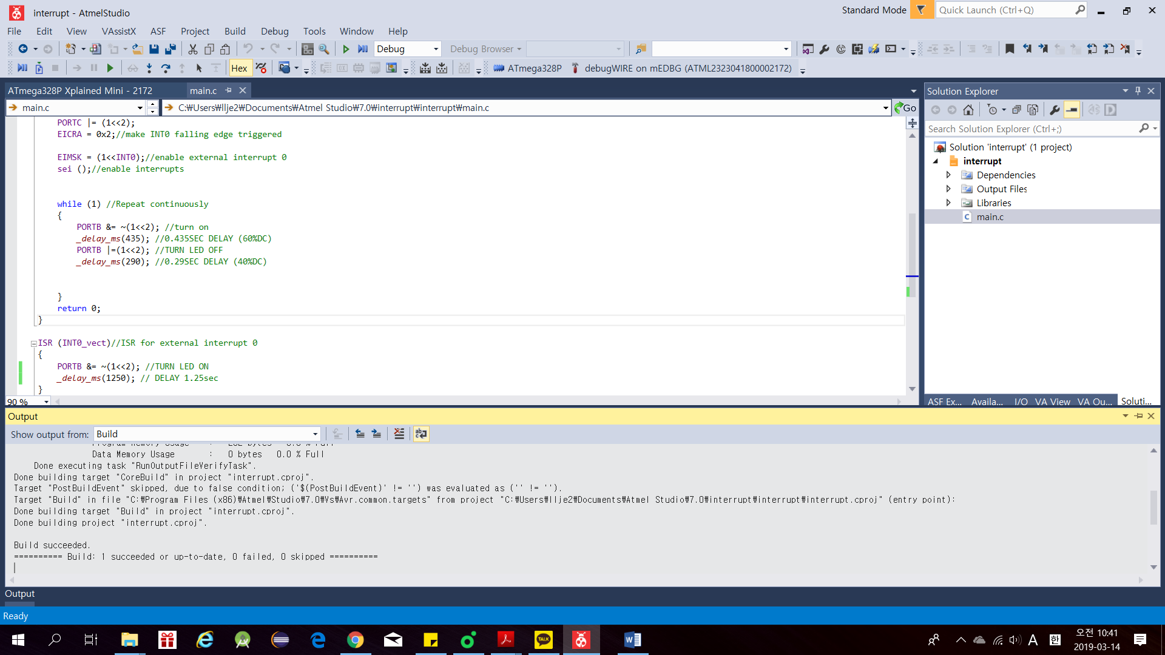

1. **SCREENSHOT OF EACH DEMO (BOARD SETUP)**

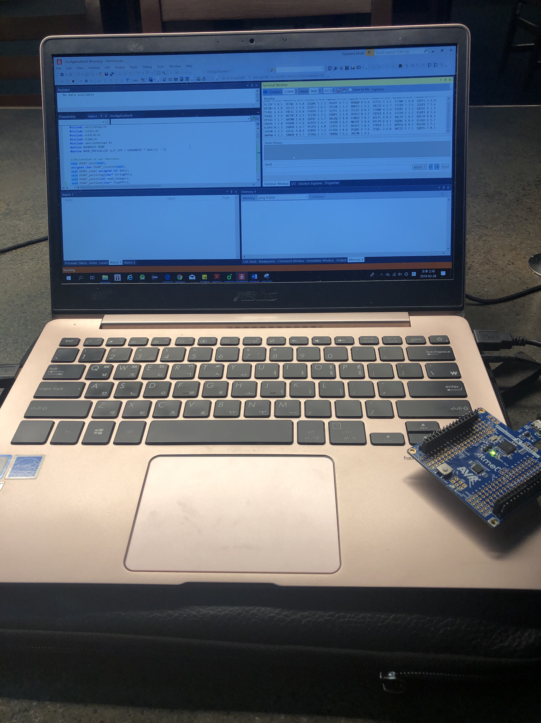

1. **VIDEO LINKS OF EACH DEMO**

https://youtu.be/R-6G9flUVQU

1. **GITHUB LINK OF THIS DA**

Primary Github address: https://github.com/yeeun219/submission_da.git

Directory: cpe301\DesignAssignments\DA3A

**Student Academic Misconduct Policy**

<http://studentconduct.unlv.edu/misconduct/policy.html>

“This assignment submission is my own, original work”.

YEEUNLEE