CPE301 – SPRING 2019

Design Assignment 4A

Student Name: yeeunLee

Student #:2001614222

Student Email: leey81@nevada.unlv.com

Primary Github address: https://github.com/yeeun219/submission_da.git

Directory: cpe301\DesignAssignments\DA4A

1. **COMPONENTS LIST AND CONNECTION BLOCK DIAGRAM w/ PINS**

while (1) //Repeat continuously,adjust the speed,interrupt using pc1/2/3

1. **DEVELOPED CODE OF**

/*

* motor_execution.c

*

* Created: 4/16/2019 9:35:09 AM

* Author : llje2

*/

#define *F_CPU* 16000000UL

#include <avr/io.h>

#include <util/delay.h>

#define ENABLE 1

#define MTR_1 2

#define MTR_2 3

#define SW (PINC&(1<<0))

int main ( )

{

PORTC |= (1<<0); //enable pull-up

DDRC |= 0b00001110; //PC1, PC2, and PC3 as outputs

PORTC &= ~(1<<ENABLE); //Enable = 0

PORTC &= ~(1<<MTR_1); //MTR_1 = 0

PORTC &= ~(1<<MTR_2); //MTR_2 = 0

DDRC |=(1<<0); //PC0 as output

OCR0A=50;//set the duty cycle of PWM

//FAST PWM, NON INVERTED

TCCR0A =(1<<COM0A1)|(1<<WGM01)|(1<<WGM00);

TCCR0B=0X02;//N=8

while (1)

{

PORTC |= (1<<ENABLE); //Enable = 1

if(SW != 0) //if PC0 is high

{

// Clockwise Rotation

*_delay_ms*(1000);

PORTC |= (1<<MTR_1); //MTR_1 = 1

PORTC &= (~(1<<MTR_2)); //MTR_2 = 0

}

else{

// Anti-Clockwise Rotation

*_delay_ms*(1000);

PORTC &= (~(1<<MTR_1)); //MTR_1 = 0

PORTC |= (1<<MTR_2); //MTR_2 = 1

}

*_delay_ms*(5000);

if(OCR0A>250){

OCR0A=50;

*_delay_ms*(1000);}

else

OCR0A=OCR0A+25;

}

}

1. **SCHEMATICS**

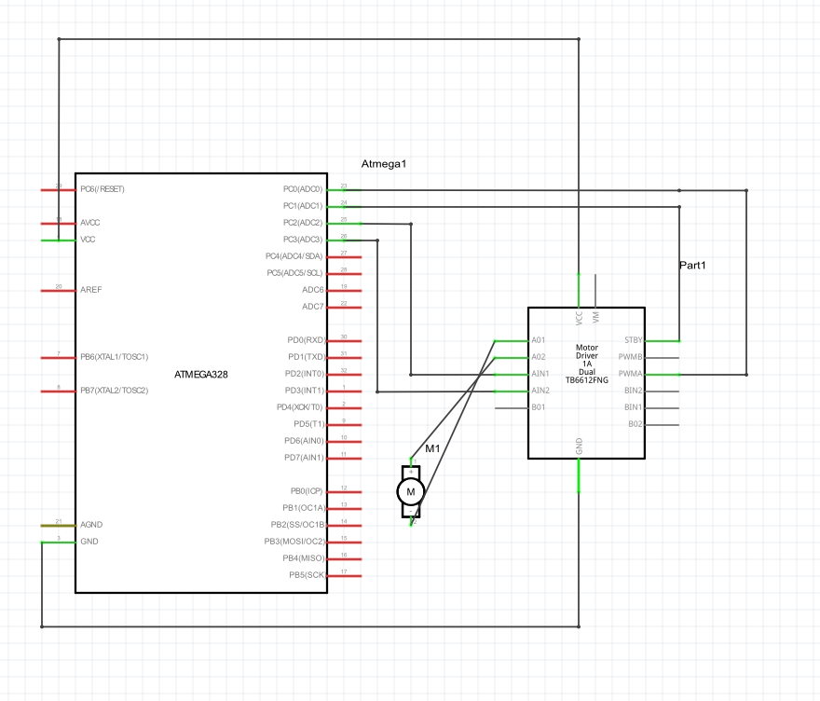

1. **SCREENSHOTS OF EACH TASK OUTPUT (ATMEL STUDIO OUTPUT)**

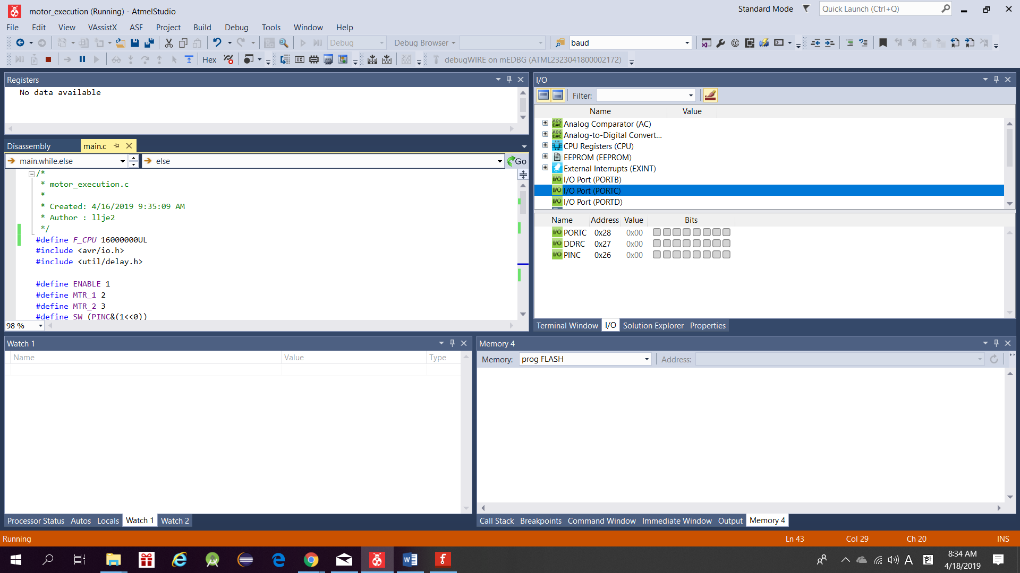

1. **SCREENSHOT OF EACH DEMO (BOARD SETUP)**

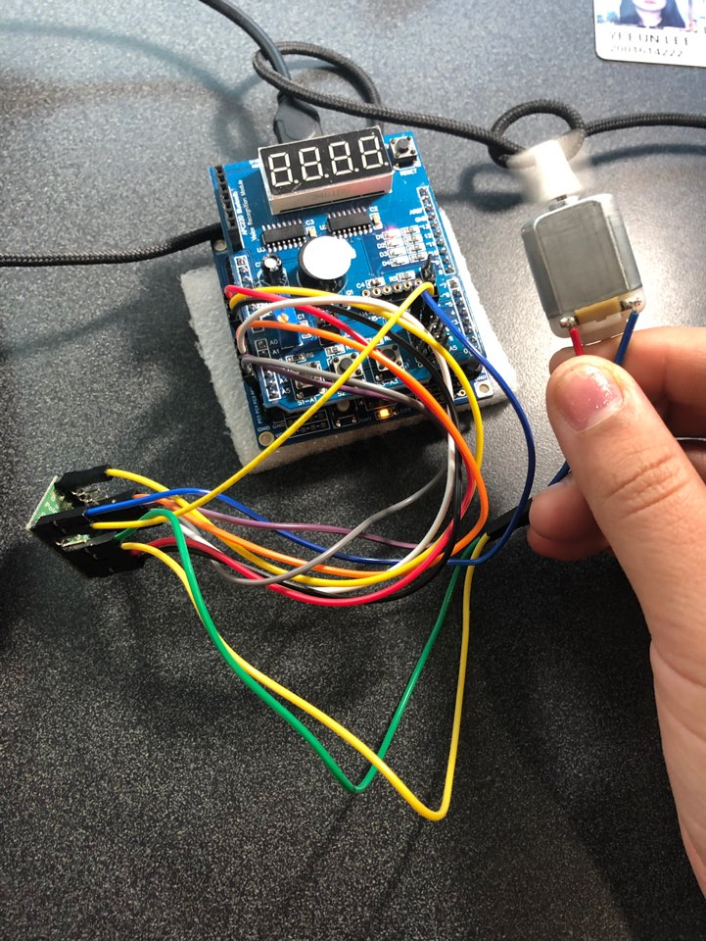

1. **VIDEO LINKS OF EACH DEMO**

https://youtu.be/hPQoyESOdHc

1. **GITHUB LINK OF THIS DA**

Primary Github address: https://github.com/yeeun219/submission_da.git

Directory: cpe301\DesignAssignments\DA4A

**Student Academic Misconduct Policy**

<http://studentconduct.unlv.edu/misconduct/policy.html>

“This assignment submission is my own, original work”.

YEEUNLEE