CPE301 – SPRING 2019

Design Assignment 4B_TASK1

Student Name: yeeunLee

Student #:2001614222

Student Email: leey81@nevada.unlv.com

Primary Github address: https://github.com/yeeun219/submission_da.git

Directory: cpe301\DesignAssignments\DA4B\T1

1. **COMPONENTS LIST AND CONNECTION BLOCK DIAGRAM w/ PINS**

while (1) //Repeat continuously,adjust the speed,interrupt using pc1/2/3

1. **DEVELOPED CODE OF**

/*

* step_motor.c

*

* Created: 4/26/2019 7:17:10 AM

* Author : llje2

*/

#include <avr/io.h>

#define *F_CPU* 16000000UL

#include <util/delay.h>

int main(void)

{

int period;

DDRC = 0x1F; //make PORTC lower pin as output

period=10; //set period in between two steps

/* Replace with your application code */

while (1)

{

//rotate stepper motor anticlockwise with full step sequence

PORTC=0X09;

*_delay_ms*(period);

PORTC=0X03;

*_delay_ms*(period);

PORTC=0X06;

*_delay_ms*(period);

PORTC=0X0C;

*_delay_ms*(period);

}

}

1. **SCHEMATICS**

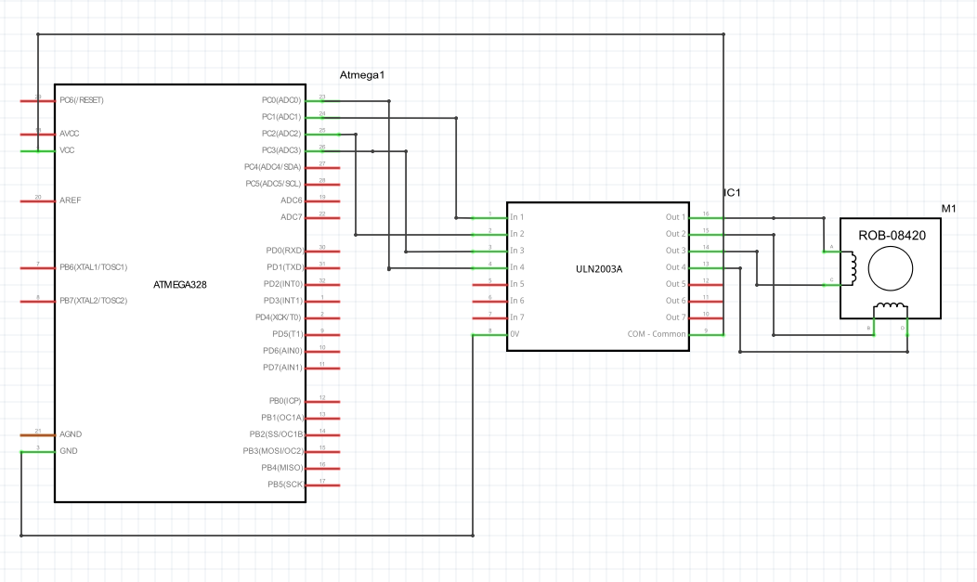

1. **SCREENSHOTS OF EACH TASK OUTPUT (ATMEL STUDIO OUTPUT)**

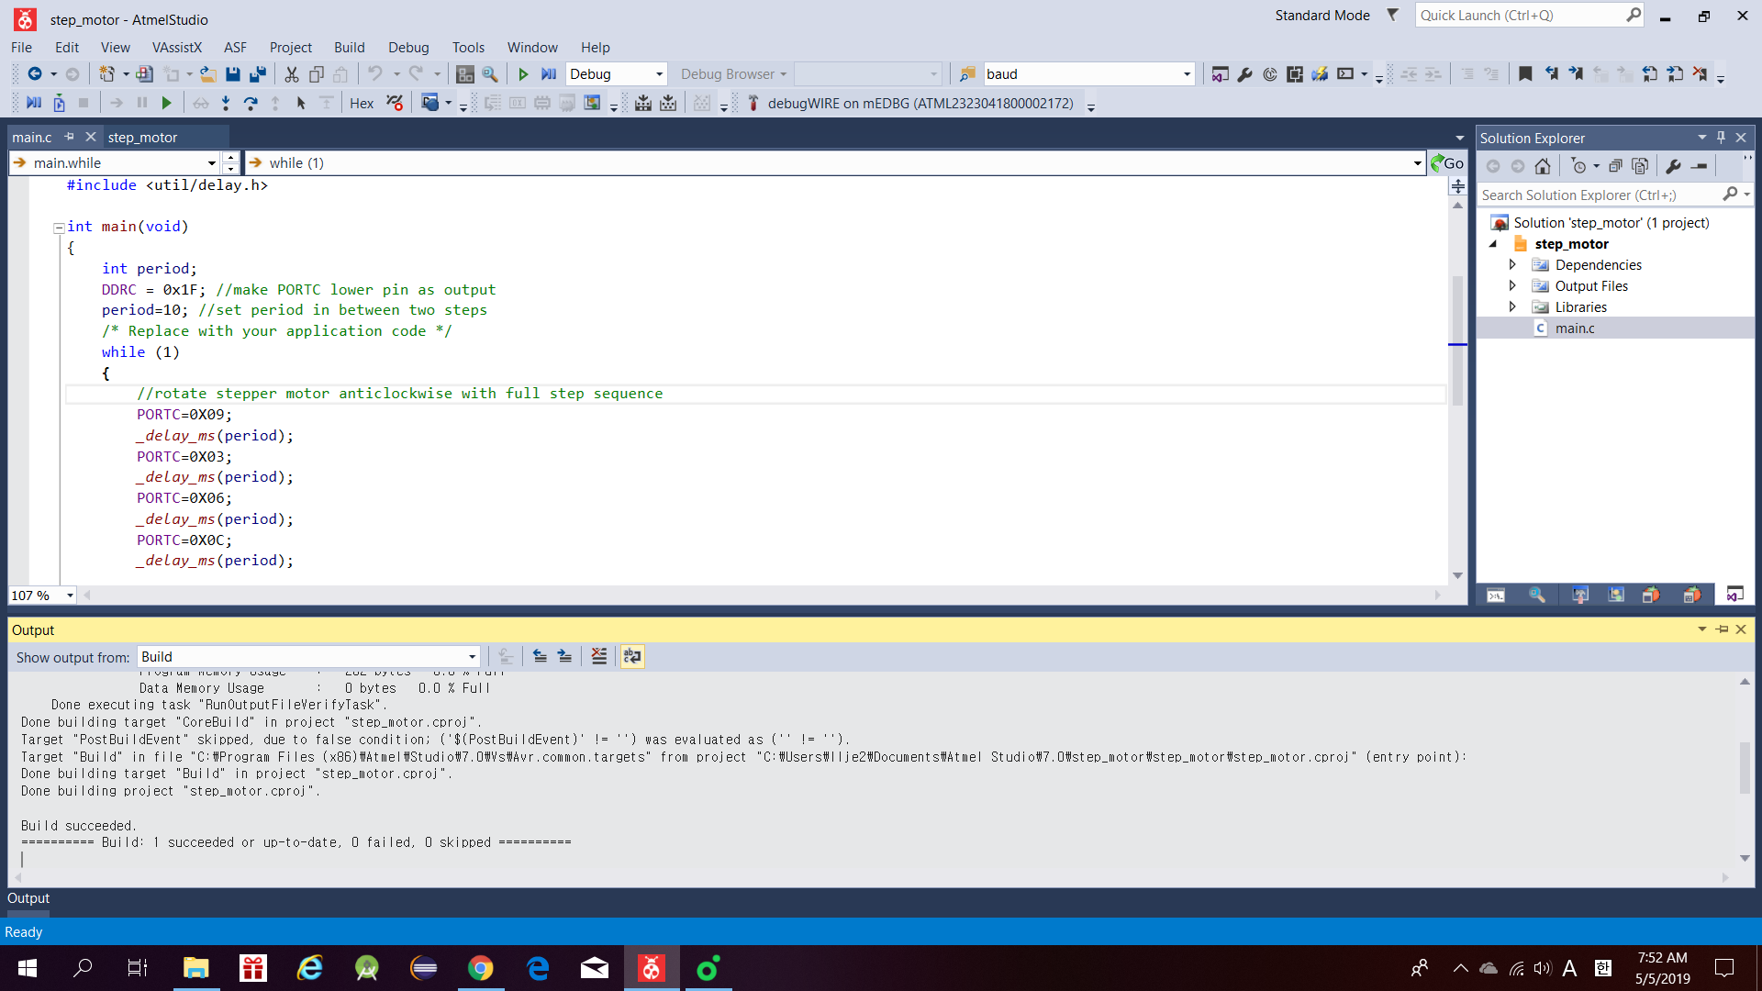

1. **SCREENSHOT OF EACH DEMO (BOARD SETUP)**

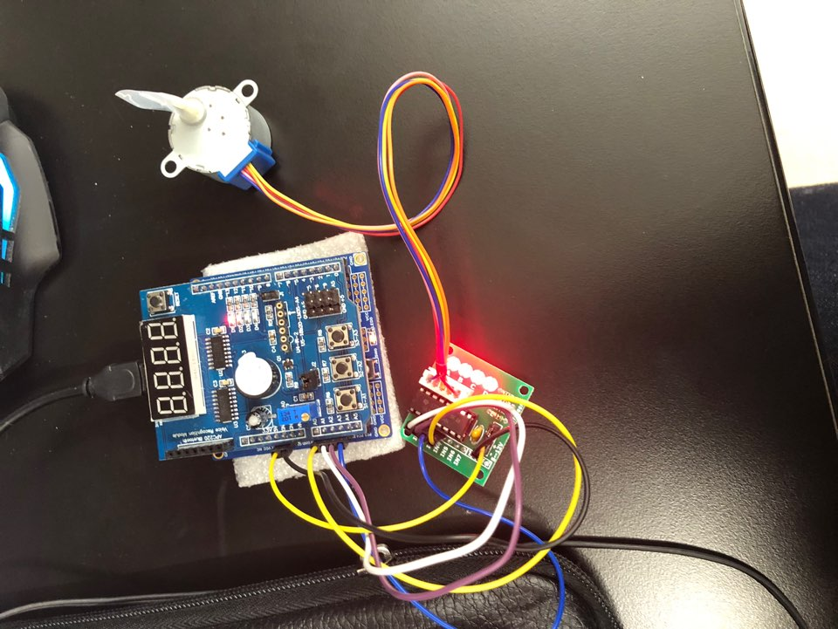

1. **VIDEO LINKS OF EACH DEMO**

<https://youtu.be/hw5OD2Lw-1g>

1. **GITHUB LINK OF THIS DA**

Primary Github address: https://github.com/yeeun219/submission_da.git

Directory: cpe301\DesignAssignments\ DA4B\T1

**Student Academic Misconduct Policy**

<http://studentconduct.unlv.edu/misconduct/policy.html>

“This assignment submission is my own, original work”.

YEEUNLEE