CPE301 – SPRING 2019

Design Assignment 4B_TASK2

Student Name: yeeunLee

Student #:2001614222

Student Email: leey81@nevada.unlv.com

Primary Github address: https://github.com/yeeun219/submission_da.git

Directory: cpe301\DesignAssignments\DA4B\T2

1. **COMPONENTS LIST AND CONNECTION BLOCK DIAGRAM w/ PINS**

while (1) //Repeat continuously,adjust the speed,interrupt using pc1/2/3

1. **DEVELOPED CODE OF**

/*

* servo_motor.c

*

* Created: 4/30/2019 10:59:07 AM

* Author : llje2

*/

#define *F_CPU* 16000000UL

#include <avr/io.h>

#include <util/delay.h>

int main(void)

{

//configure Timer1

TCCR1A |=(1<<COM1A1)|(1<<COM1B1)|(1<<WGM11); //NON inverted PWM

//PRESCALER=64MODE 14(FAST PWM)

TCCR1B |=(1<<WGM13)|(1<<WGM12)|(1<<CS11)|(1<<CS10);

ICR1=4999; //fPWM=50HZ(PERIOD =20MS STANDARD)

DDRB|=(1<<PB1);

/* Replace with your application code */

while (1)

{

OCR1A=70; //0 degree

*_delay_ms*(1000); //wait for 1sec

OCR1A=375; //90 degree

*_delay_ms*(1000);

OCR1A=600; //180degree

*_delay_ms*(1000);

}

}

1. **SCHEMATICS**

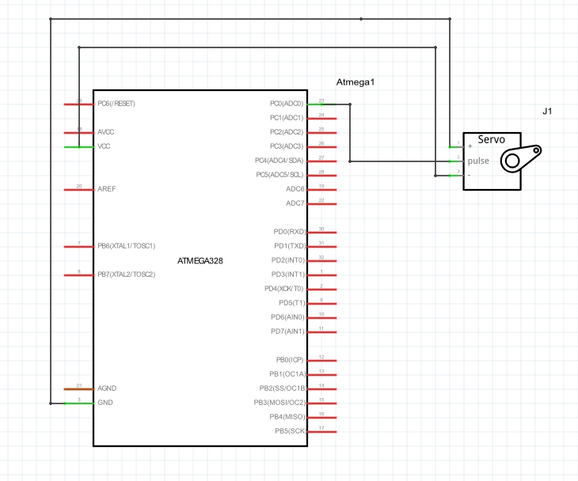

1. **SCREENSHOTS OF EACH TASK OUTPUT (ATMEL STUDIO OUTPUT)**

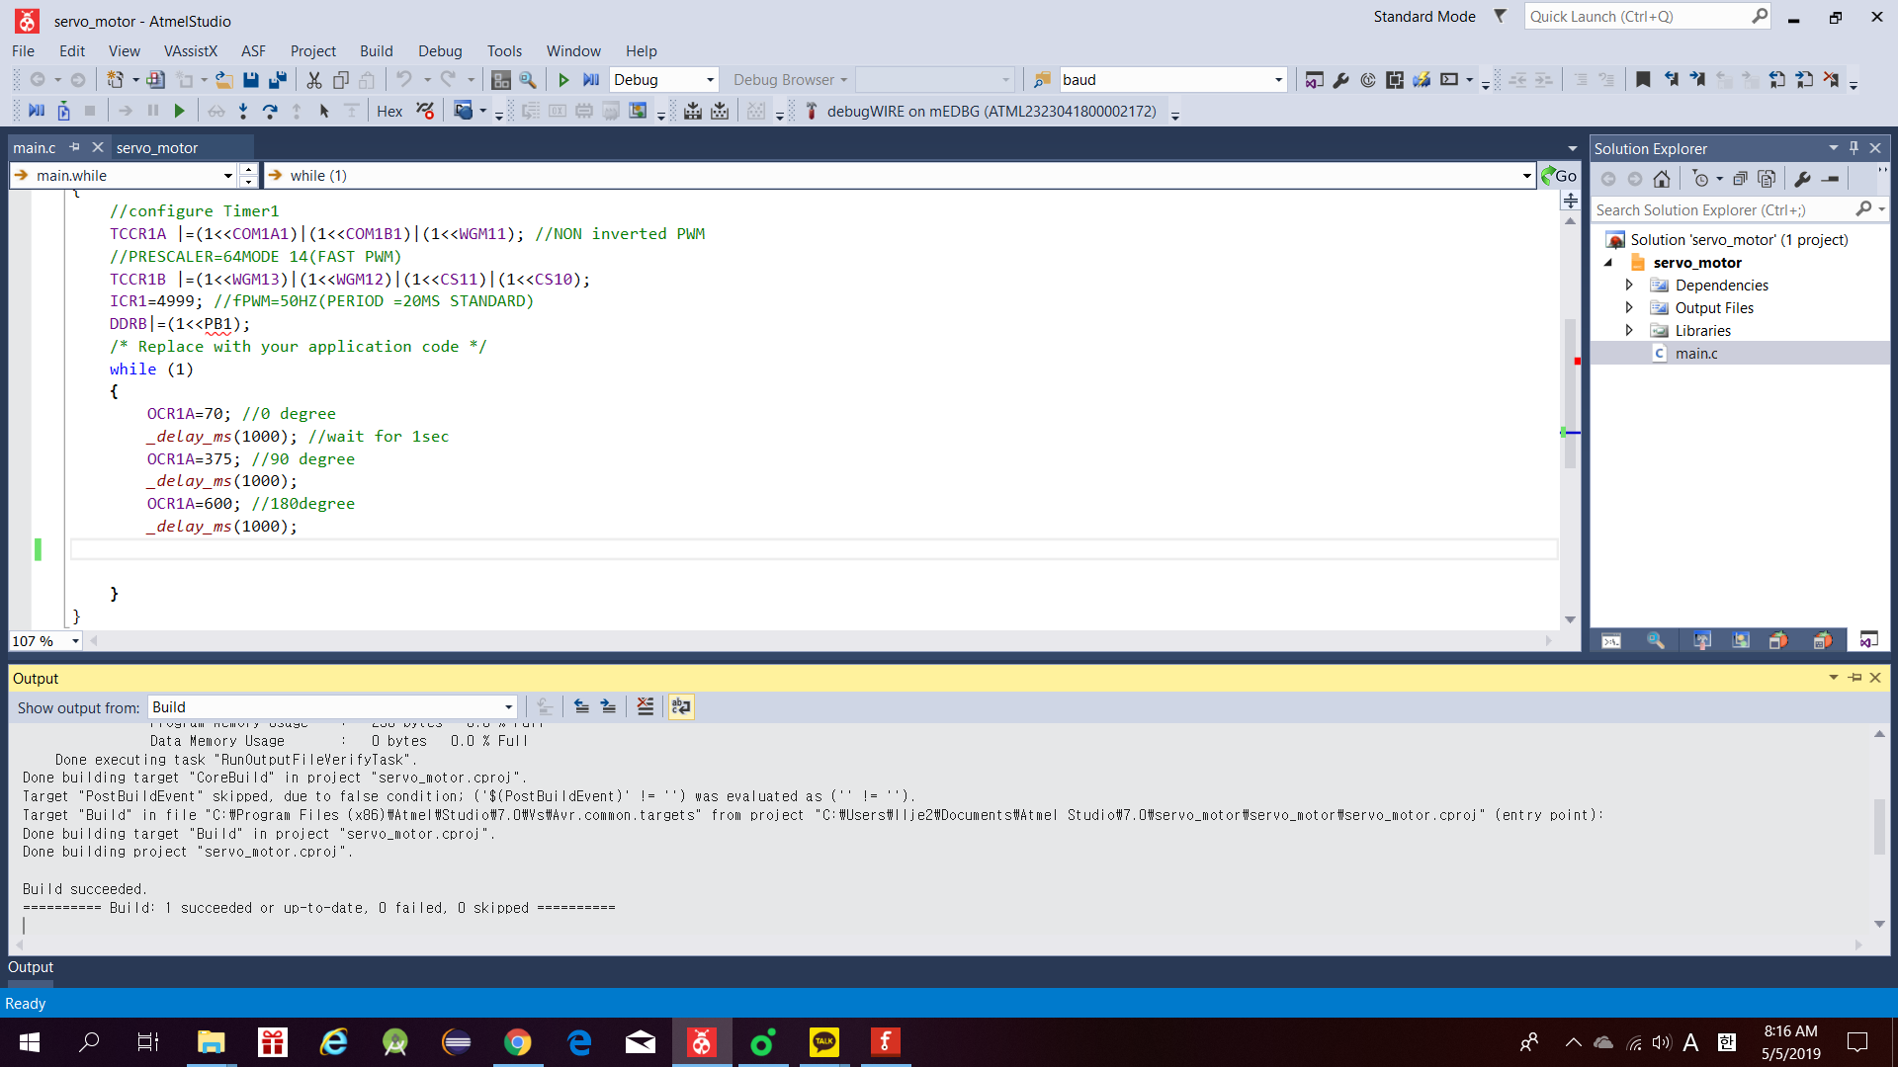

1. **SCREENSHOT OF EACH DEMO (BOARD SETUP)**

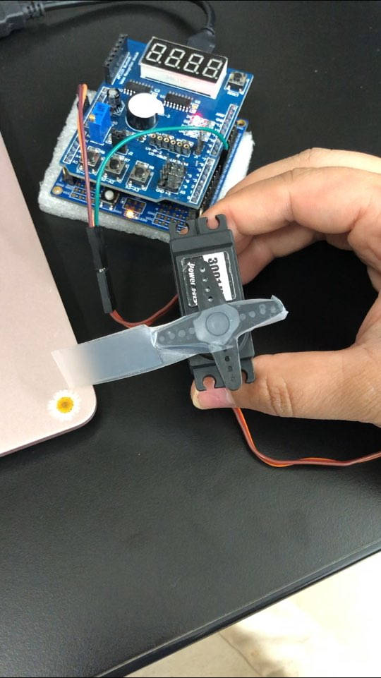

1. **VIDEO LINKS OF EACH DEMO**

<https://youtu.be/mS3pcnQ4YfU>

1. **GITHUB LINK OF THIS DA**

Primary Github address: https://github.com/yeeun219/submission_da.git

Directory: cpe301\DesignAssignments\ DA4B\T2

**Student Academic Misconduct Policy**

<http://studentconduct.unlv.edu/misconduct/policy.html>

“This assignment submission is my own, original work”.

YEEUNLEE