CPE301 – SPRING 2019

Design Assignment 6

Student Name: yeeunLee

Student #:2001614222

Student Email: leey81@nevada.unlv.com

Primary Github address: https://github.com/yeeun219/submission_da.git

Directory: cpe301\DesignAssignments\DA6

1. **COMPONENTS LIST AND CONNECTION BLOCK DIAGRAM w/ PINS**

void Gyro_Init() /* Gyro initialization function */

void MPU_Start_Loc()

void Read_RawValue()

void USART_tx_string( char *data ) /* SEND A STRING TO THE RS-232 */

void USART_init( unsigned int ubrr ) /* INIT USART (RS-232) */

while(1) read accelerometer and gyro value, then display on uart repeatly.

1. **DEVELOPED CODE OF**

/*

* DA6.c

*

* Created: 5/10/2019 11:15:17 AM

* Author : llje2

*/

/*

* ATmega16 Interface with MPU6050

* http://www.electronicwings.com

*

*/

#define F_CPU 16000000UL

#include <avr/io.h> /* Include AVR std. library file */

#include <util/delay.h> /* Include delay header file */

#include <inttypes.h> /* Include integer type header file */

#include <stdlib.h> /* Include standard library file */

#include <stdio.h> /* Include standard I/O library file */

#include "MPU6050_res_define.h" /* Include MPU6050 register define file */

#include "I2C_Master_H_file.h" /* Include I2C Master header file */

#include "uart.h" /* Include USART header file */

#define BAUDRATE 9600

#define BAUD_PRESCALLER (((F_CPU / (BAUDRATE * 16UL))) - 1)

float Acc_x,Acc_y,Acc_z,Temperature,Gyro_x,Gyro_y,Gyro_z;

void Gyro_Init() /* Gyro initialization function */

{

//_delay_ms(150); /* Power up time >100ms */

I2C_Start_Wait(0xD0); /* Start with device write address */

I2C_Write(SMPLRT_DIV); /* Write to sample rate register */

I2C_Write(0x07); /* 1KHz sample rate */

I2C_Stop();

I2C_Start_Wait(0xD0);

I2C_Write(PWR_MGMT_1); /* Write to power management register */

I2C_Write(0x01); /* X axis gyroscope reference frequency */

I2C_Stop();

I2C_Start_Wait(0xD0);

I2C_Write(CONFIG); /* Write to Configuration register */

I2C_Write(0x00); /* Fs = 8KHz */

I2C_Stop();

I2C_Start_Wait(0xD0);

I2C_Write(GYRO_CONFIG); /* Write to Gyro configuration register */

I2C_Write(0x18); /* Full scale range +/- 2000 degree/C */

I2C_Stop();

I2C_Start_Wait(0xD0);

I2C_Write(INT_ENABLE); /* Write to interrupt enable register */

I2C_Write(0x01);

I2C_Stop();

}

void MPU_Start_Loc()

{

I2C_Start_Wait(0xD0); /* I2C start with device write address */

I2C_Write(ACCEL_XOUT_H);/* Write start location address from where to read */

I2C_Repeated_Start(0xD1);/* I2C start with device read address */

}

void Read_RawValue()

{

MPU_Start_Loc(); /* Read Gyro values */

Acc_x = (((int)I2C_Read_Ack()<<8) | (int)I2C_Read_Ack());

Acc_y = (((int)I2C_Read_Ack()<<8) | (int)I2C_Read_Ack());

Acc_z = (((int)I2C_Read_Ack()<<8) | (int)I2C_Read_Ack());

Temperature = (((int)I2C_Read_Ack()<<8) | (int)I2C_Read_Ack());

Gyro_x = (((int)I2C_Read_Ack()<<8) | (int)I2C_Read_Ack());

Gyro_y = (((int)I2C_Read_Ack()<<8) | (int)I2C_Read_Ack());

Gyro_z = (((int)I2C_Read_Ack()<<8) | (int)I2C_Read_Nack());

I2C_Stop();

}

/* SEND A STRING TO THE RS-232 */

void USART_tx_string( char *data )

{

while ((*data != '\0'))

{

while (!(UCSR0A & (1 <<UDRE0)));

UDR0 = *data;

data++;

}

}

/* INIT USART (RS-232) */

void USART_init( unsigned int ubrr )

{

UBRR0H = (unsigned char)(ubrr>>8);

UBRR0L = (unsigned char)ubrr;

UCSR0B = (1 << TXEN0); // Enable RX, TX & RX interrupt

UCSR0C = (3 << UCSZ00); //asynchronous 8 N 1

}

int main()

{

char buffer[20], float_[10];

float Xa,Ya,Za,t;

float Xg=0,Yg=0,Zg=0;

I2C_Init(); /* Initialize I2C */

Gyro_Init(); /* Initialize Gyro */

USART_init(BAUD_PRESCALLER); // Initialize the USART

USART_tx_string("Connected!\r\n"); // we're alive!

while(1)

{

Read_RawValue();

/* Divide raw value by sensitivity scale factor */

Xa = Acc_x/16384.0;

Ya = Acc_y/16384.0;

Za = Acc_z/16384.0;

Xg = Gyro_x/16.4;

Yg = Gyro_y/16.4;

Zg = Gyro_z/16.4;

/* Convert temperature in /c using formula */

t = (Temperature/340.00)+36.53;

/* Take values in buffer to send all parameters over USART */

*dtostrf*( Xa, 3, 2, float_ );

*sprintf*(buffer," Ax = %s g\t",float_);

USART_tx_string(buffer);

*dtostrf*( Ya, 3, 2, float_ );

*sprintf*(buffer, " Ay = %s g\t",float_);

USART_tx_string(buffer);

*dtostrf*( Za, 3, 2, float_ );

*sprintf*(buffer," Az = %s g\t",float_);

USART_tx_string(buffer);

*dtostrf*( t, 3, 2, float_ );

/* 0xF8 Ascii value of degree on serial */

*sprintf*(buffer," T = %s%cC\t",float_,0xF8);

USART_tx_string(buffer);

*dtostrf*( Xg, 3, 2, float_ );

*sprintf*(buffer," Gx = %s%c/s\t",float_,0xF8);

USART_tx_string(buffer);

*dtostrf*( Yg, 3, 2, float_ );

*sprintf*(buffer," Gy = %s%c/s\t",float_,0xF8);

USART_tx_string(buffer);

*dtostrf*( Zg, 3, 2, float_ );

*sprintf*(buffer," Gz = %s%c/s\r\n",float_,0xF8);

USART_tx_string(buffer);

}

}

1. **SCHEMATICS**

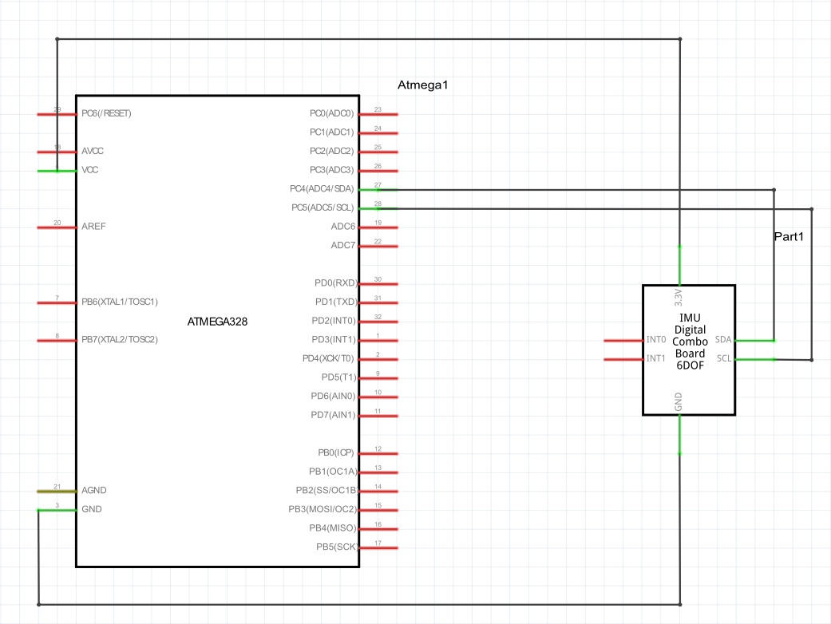

1. **SCREENSHOTS OF EACH TASK OUTPUT (ATMEL STUDIO OUTPUT)**

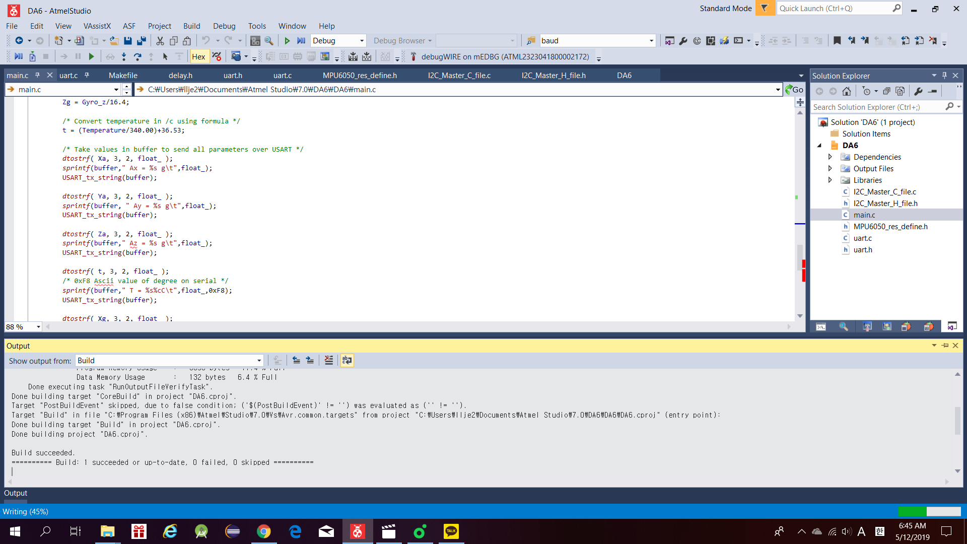

1. **SCREENSHOT OF EACH DEMO (BOARD SETUP)**

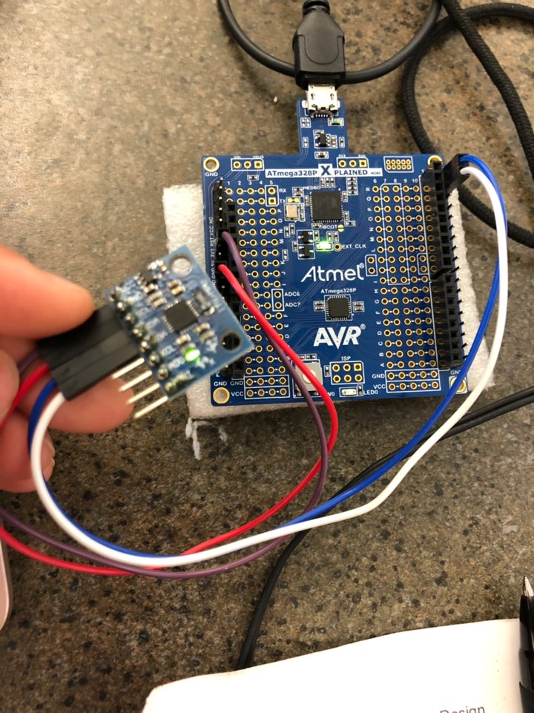

1. **VIDEO LINKS OF EACH DEMO**

<https://youtu.be/Puc4eGRTJQI>

1. **GITHUB LINK OF THIS DA**

Primary Github address: https://github.com/yeeun219/submission_da.git

Directory: cpe301\DesignAssignments\ DA6

**Student Academic Misconduct Policy**

<http://studentconduct.unlv.edu/misconduct/policy.html>

“This assignment submission is my own, original work”.

YEEUNLEE