CPE301 – SPRING 2019

MIDTERM 2

Student Name: yeeunLee

Student #:2001614222

Student Email: leey81@nevada.unlv.com

Primary Github address: https://github.com/yeeun219/submission_da.git

Directory: cpe301\DesignAssignments\MIDTEM2

1. **COMPONENTS LIST OF CODE TASK1/A – DISPLAY COLOR SENSOR**

List of Components used

Block diagram with pins used in the Atmega328P

void ADPS_Start_Loc() // Initialize the ADPS

void Read_RawValue() //READ VALUE OF the ADPS

USART_init(BAUD_PRESCALLER); // Initialize the USART and initialize the pin number0

USART_tx_string("Connected!\r\n");/* SEND A STRING TO THE RS-232 */

while(1) IN MAIN()//Repeat continuously, current COLOR DATA.

1. **CODE OF TASK 1/A**

/*

* color_sensor.c

*

* Created: 5/15/2019 3:36:25 AM

* Author : llje2

*/

#define F_CPU 16000000UL

#include <avr/io.h> /* Include AVR std. library file */

#include <util/delay.h> /* Include delay header file */

#include <inttypes.h> /* Include integer type header file */

#include <stdlib.h> /* Include standard library file */

#include <stdio.h> /* Include standard I/O library file */

#include <stdbool.h> /* Include standard boolean library */

#include "i2c_master.h"

#include "uart.h" /* Include USART header file */

#include "APDS9960_def.h"

#define BAUDRATE 9600

#define BAUD_PRESCALLER (((F_CPU / (BAUDRATE * 16UL))) - 1)

#include <util/delay.h>

int r,g,b,c, tmp = -11;

void USART_tx_string( char *data )

{

while ((*data != '\0'))

{

while (!(UCSR0A & (1 <<UDRE0)));

UDR0 = *data;

data++;

}

}

/* INIT USART (RS-232) */

void USART_init( unsigned int ubrr )

{

UBRR0H = (unsigned char)(ubrr>>8);

UBRR0L = (unsigned char)ubrr;

UCSR0B = (1 << TXEN0); // Enable RX, TX & RX interrupt

UCSR0C = (3 << UCSZ00); //asynchronous 8 N 1

}

void ADPS_Start_Loc()

{

i2c_start(0x72); /* I2C start with device write address */

i2c_write(APDS9960_CDATAL);/* Write start location address from where to read */

i2c_start(0x73);/* I2C start with device read address */

}

void Read_RawValue()

{

ADPS_Start_Loc(); /* Read Gyro values */

c = (((int)i2c_read_ack()<<8) | (int)i2c_read_ack());

r = (((int)i2c_read_ack()<<8) | (int)i2c_read_ack());

g= (((int)i2c_read_ack()<<8) | (int)i2c_read_ack());

b= (((int)i2c_read_ack()<<8) | (int)i2c_read_ack());

i2c_stop();

}

int main(void)

{

char buffer[20];

*uint8_t* Connect_Status;

i2c_init(); /* Initialize I2C */

ADPS_Init(); /* Initialize Gyro */

USART_init(BAUD_PRESCALLER); // Initialize the USART

USART_tx_string("Connected!\r\n"); // we're alive!

/* Replace with your application code */

while (1)

{

char _buffer[150];

Read_RawValue();

*sprintf*(buffer," clear: %d \t",c);

USART_tx_string(buffer);

*sprintf*(buffer, " Red: %d \t",r);

USART_tx_string(buffer);

*sprintf*(buffer," Green = %d \t",g);

USART_tx_string(buffer);

*sprintf*(buffer," Blue = %d \t",b);

USART_tx_string(buffer);

USART_tx_string("\n");

*_delay_ms*(5000);

}

}

1. **SCREENSHOTS OF EACH TASK OUTPUT (ATMEL STUDIO OUTPUT)**

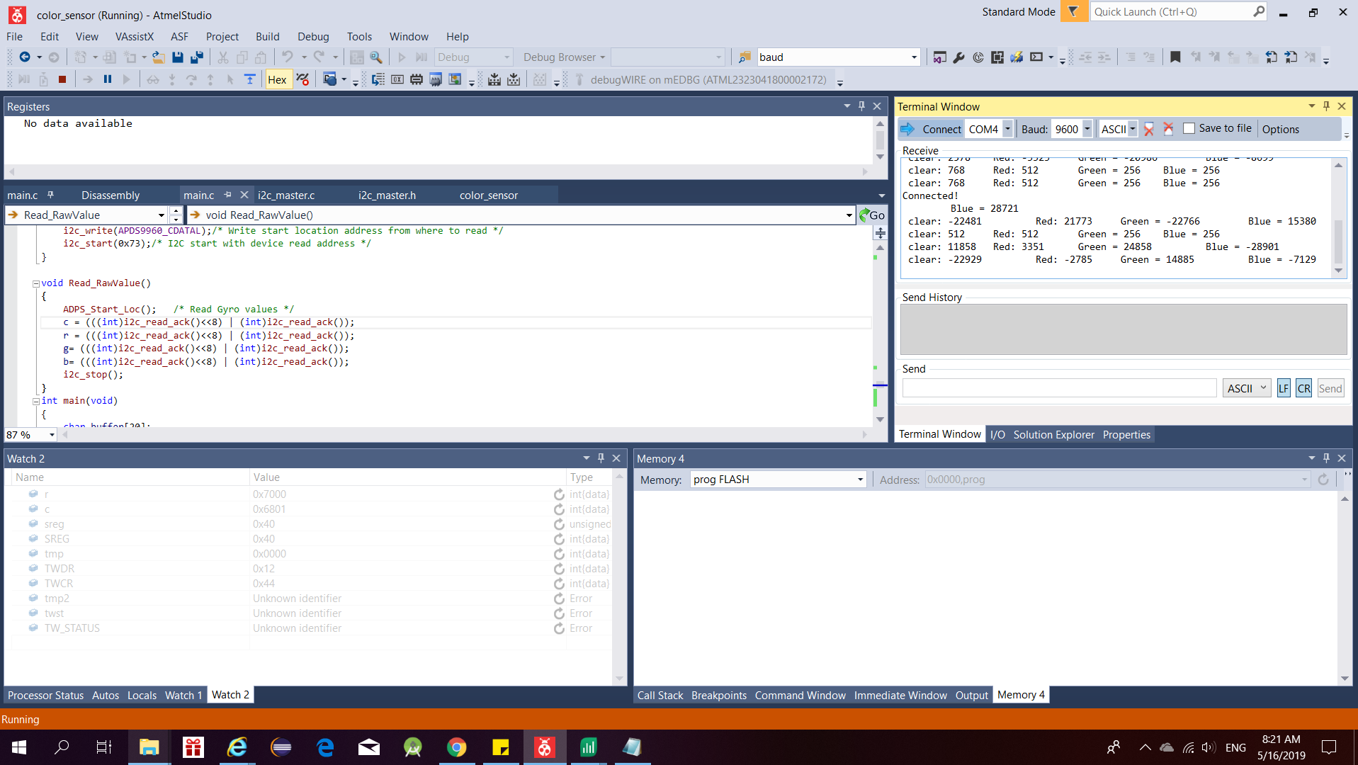

1. **DEVELOPED MODIFIED CODE OF TASK 2/A from TASK 1/A) – UPLOAD THE VALUE ON THE THHINGSPEAK**

List of Components used

Block diagram with pins used in the Atmega328P

void ADPS_Start_Loc() // Initialize the ADPS

void Read_RawValue() //READ VALUE OF the ADPS

USART_init(BAUD_PRESCALLER); // Initialize the USART and initialize the pin number0

USART_tx_string("Connected!\r\n");/* SEND A STRING TO THE RS-232 */

while(1) IN MAIN()//Repeat continuously, current COLOR DATA.

` // about the esp8266

ESP8266_WIFIMode(BOTH_STATION_AND_ACCESPOINT);/* 3 = Both (AP and STA) */

ESP8266_ConnectionMode(SINGLE); /* 0 = Single; 1 = Multi */

ESP8266_ApplicationMode(NORMAL);

ESP8266_connected()

ESP8266_JoinAccessPoint(SSID, PASSWORD);

ESP8266_Start(0, DOMAIN, PORT);

ESP8266_Send(_buffer);

Read_Data(_buffer);

*memset*(_buffer, 0, 150);

1. **DEVELOPED MODIFIED CODE OF TASK 2/A from TASK 1/A**

/*

* color_sensor.c

*

* Created: 5/15/2019 3:36:25 AM

* Author : llje2

*/

#define F_CPU 16000000UL

#include <avr/io.h> /* Include AVR std. library file */

#include <util/delay.h> /* Include delay header file */

#include <inttypes.h> /* Include integer type header file */

#include <stdlib.h> /* Include standard library file */

#include <stdio.h> /* Include standard I/O library file */

#include <stdbool.h> /* Include standard boolean library */

#include "i2c_master.h"

#include "uart.h" /* Include USART header file */

#include "APDS9960_def.h"

#define BAUDRATE 9600

#define BAUD_PRESCALLER (((F_CPU / (BAUDRATE * 16UL))) - 1)

#include <util/delay.h>

int r,g,b,c, tmp = -11;

#define SREG _SFR_IO8(0x3F)

#define DEFAULT_BUFFER_SIZE 160

#define DEFAULT_TIMEOUT 10000

/* Connection Mode */

#define SINGLE 0

#define MULTIPLE 1

/* Application Mode */

#define NORMAL 0

#define TRANSPERANT 1

/* Application Mode */

#define STATION 1

#define ACCESSPOINT 2

#define BOTH_STATION_AND_ACCESPOINT 3

/* Select Demo */

#define RECEIVE_DEMO /* Define RECEIVE demo */

//#define SEND_DEMO /* Define SEND demo */

/* Define Required fields shown below */

#define DOMAIN "api.thingspeak.com"

#define PORT "80"

#define API_WRITE_KEY "PWJ8GZ3QXFQ0MXUM"

#define CHANNEL_ID "751037"

#define SSID "Leeyeeun"

#define PASSWORD "02191919"

enum ESP8266_RESPONSE_STATUS{

ESP8266_RESPONSE_WAITING,

ESP8266_RESPONSE_FINISHED,

ESP8266_RESPONSE_TIMEOUT,

ESP8266_RESPONSE_BUFFER_FULL,

ESP8266_RESPONSE_STARTING,

ESP8266_RESPONSE_ERROR

};

enum ESP8266_CONNECT_STATUS {

ESP8266_CONNECTED_TO_AP,

ESP8266_CREATED_TRANSMISSION,

ESP8266_TRANSMISSION_DISCONNECTED,

ESP8266_NOT_CONNECTED_TO_AP,

ESP8266_CONNECT_UNKNOWN_ERROR

};

enum ESP8266_JOINAP_STATUS {

ESP8266_WIFI_CONNECTED,

ESP8266_CONNECTION_TIMEOUT,

ESP8266_WRONG_PASSWORD,

ESP8266_NOT_FOUND_TARGET_AP,

ESP8266_CONNECTION_FAILED,

ESP8266_JOIN_UNKNOWN_ERROR

};

*int8_t* Response_Status;

volatile *int16_t* Counter = 0, pointer = 0;

*uint32_t* TimeOut = 0;

char RESPONSE_BUFFER[DEFAULT_BUFFER_SIZE];

void Read_Response(char* _Expected_Response)

{

*uint8_t* EXPECTED_RESPONSE_LENGTH = *strlen*(_Expected_Response);

*uint32_t* TimeCount = 0, ResponseBufferLength;

char RECEIVED_CRLF_BUF[EXPECTED_RESPONSE_LENGTH];

while(1)

{

if(TimeCount >= (DEFAULT_TIMEOUT+TimeOut))

{

TimeOut = 0;

Response_Status = ESP8266_RESPONSE_TIMEOUT;

return;

}

if(Response_Status == ESP8266_RESPONSE_STARTING)

{

Response_Status = ESP8266_RESPONSE_WAITING;

}

ResponseBufferLength = *strlen*(RESPONSE_BUFFER);

if (ResponseBufferLength)

{

*_delay_ms*(1);

TimeCount++;

if (ResponseBufferLength==*strlen*(RESPONSE_BUFFER))

{

for (*uint16_t* i=0;i<ResponseBufferLength;i++)

{

*memmove*(RECEIVED_CRLF_BUF, RECEIVED_CRLF_BUF + 1, EXPECTED_RESPONSE_LENGTH-1);

RECEIVED_CRLF_BUF[EXPECTED_RESPONSE_LENGTH-1] = RESPONSE_BUFFER[i];

if(!*strncmp*(RECEIVED_CRLF_BUF, _Expected_Response, EXPECTED_RESPONSE_LENGTH))

{

TimeOut = 0;

Response_Status = ESP8266_RESPONSE_FINISHED;

return;

}

}

}

}

*_delay_ms*(1);

TimeCount++;

}

}

void ESP8266_Clear()

{

*memset*(RESPONSE_BUFFER,0,DEFAULT_BUFFER_SIZE);

Counter = 0; pointer = 0;

}

void Start_Read_Response(char* _ExpectedResponse)

{

Response_Status = ESP8266_RESPONSE_STARTING;

do {

Read_Response(_ExpectedResponse);

} while(Response_Status == ESP8266_RESPONSE_WAITING);

}

void GetResponseBody(char* Response, *uint16_t* ResponseLength)

{

*uint16_t* i = 12;

char buffer[5];

while(Response[i] != '\r')

++i;

*strncpy*(buffer, Response + 12, (i - 12));

ResponseLength = *atoi*(buffer);

i += 2;

*uint16_t* tmp = *strlen*(Response) - i;

*memcpy*(Response, Response + i, tmp);

if(!*strncmp*(Response + tmp - 6, "\r\nOK\r\n", 6))

*memset*(Response + tmp - 6, 0, i + 6);

}

bool WaitForExpectedResponse(char* ExpectedResponse)

{

Start_Read_Response(ExpectedResponse); /* First read response */

if((Response_Status != ESP8266_RESPONSE_TIMEOUT))

return true; /* Return true for success */

return false; /* Else return false */

}

bool SendATandExpectResponse(char* ATCommand, char* ExpectedResponse)

{

ESP8266_Clear();

USART_SendString(ATCommand); /* Send AT command to ESP8266 */

USART_SendString("\r\n");

return WaitForExpectedResponse(ExpectedResponse);

}

bool ESP8266_ApplicationMode(*uint8_t* Mode)

{

char _atCommand[20];

*memset*(_atCommand, 0, 20);

*sprintf*(_atCommand, "AT+CIPMODE=%d", Mode);

_atCommand[19] = 0;

return SendATandExpectResponse(_atCommand, "\r\nOK\r\n");

}

bool ESP8266_ConnectionMode(*uint8_t* Mode)

{

char _atCommand[20];

*memset*(_atCommand, 0, 20);

*sprintf*(_atCommand, "AT+CIPMUX=%d", Mode);

_atCommand[19] = 0;

return SendATandExpectResponse(_atCommand, "\r\nOK\r\n");

}

bool ESP8266_Begin()

{

for (*uint8_t* i=0;i<5;i++)

{

if(SendATandExpectResponse("ATE0","\r\nOK\r\n")||SendATandExpectResponse("AT","\r\nOK\r\n"))

return true;

}

return false;

}

bool ESP8266_Close()

{

return SendATandExpectResponse("AT+CIPCLOSE=1", "\r\nOK\r\n");

}

bool ESP8266_WIFIMode(*uint8_t* _mode)

{

char _atCommand[20];

*memset*(_atCommand, 0, 20);

*sprintf*(_atCommand, "AT+CWMODE=%d", _mode);

_atCommand[19] = 0;

return SendATandExpectResponse(_atCommand, "\r\nOK\r\n");

}

*uint8_t* ESP8266_JoinAccessPoint(char* _SSID, char* _PASSWORD)

{

char _atCommand[60];

*memset*(_atCommand, 0, 60);

*sprintf*(_atCommand, "AT+CWJAP=\"%s\",\"%s\"", _SSID, _PASSWORD);

_atCommand[59] = 0;

if(SendATandExpectResponse(_atCommand, "\r\nWIFI CONNECTED\r\n"))

return ESP8266_WIFI_CONNECTED;

else{

if(*strstr*(RESPONSE_BUFFER, "+CWJAP:1"))

return ESP8266_CONNECTION_TIMEOUT;

else if(*strstr*(RESPONSE_BUFFER, "+CWJAP:2"))

return ESP8266_WRONG_PASSWORD;

else if(*strstr*(RESPONSE_BUFFER, "+CWJAP:3"))

return ESP8266_NOT_FOUND_TARGET_AP;

else if(*strstr*(RESPONSE_BUFFER, "+CWJAP:4"))

return ESP8266_CONNECTION_FAILED;

else

return ESP8266_JOIN_UNKNOWN_ERROR;

}

}

*uint8_t* ESP8266_connected()

{

SendATandExpectResponse("AT+CIPSTATUS", "\r\nOK\r\n");

if(*strstr*(RESPONSE_BUFFER, "STATUS:2"))

return ESP8266_CONNECTED_TO_AP;

else if(*strstr*(RESPONSE_BUFFER, "STATUS:3"))

return ESP8266_CREATED_TRANSMISSION;

else if(*strstr*(RESPONSE_BUFFER, "STATUS:4"))

return ESP8266_TRANSMISSION_DISCONNECTED;

else if(*strstr*(RESPONSE_BUFFER, "STATUS:5"))

return ESP8266_NOT_CONNECTED_TO_AP;

else

return ESP8266_CONNECT_UNKNOWN_ERROR;

}

*uint8_t* ESP8266_Start(*uint8_t* _ConnectionNumber, char* Domain, char* Port)

{

bool _startResponse;

char _atCommand[60];

*memset*(_atCommand, 0, 60);

_atCommand[59] = 0;

if(SendATandExpectResponse("AT+CIPMUX?", "CIPMUX:0"))

*sprintf*(_atCommand, "AT+CIPSTART=\"TCP\",\"%s\",%s", Domain, Port);

else

*sprintf*(_atCommand, "AT+CIPSTART=\"%d\",\"TCP\",\"%s\",%s", _ConnectionNumber, Domain, Port);

_startResponse = SendATandExpectResponse(_atCommand, "CONNECT\r\n");

if(!_startResponse)

{

if(Response_Status == ESP8266_RESPONSE_TIMEOUT)

return ESP8266_RESPONSE_TIMEOUT;

return ESP8266_RESPONSE_ERROR;

}

return ESP8266_RESPONSE_FINISHED;

}

*uint8_t* ESP8266_Send(char* Data)

{

char _atCommand[20];

*memset*(_atCommand, 0, 20);

*sprintf*(_atCommand, "AT+CIPSEND=%d", (*strlen*(Data)+2));

_atCommand[19] = 0;

SendATandExpectResponse(_atCommand, "\r\nOK\r\n>");

if(!SendATandExpectResponse(Data, "\r\nSEND OK\r\n"))

{

if(Response_Status == ESP8266_RESPONSE_TIMEOUT)

return ESP8266_RESPONSE_TIMEOUT;

return ESP8266_RESPONSE_ERROR;

}

return ESP8266_RESPONSE_FINISHED;

}

*int16_t* ESP8266_DataAvailable()

{

return (Counter - pointer);

}

*uint8_t* ESP8266_DataRead()

{

if(pointer < Counter)

return RESPONSE_BUFFER[pointer++];

else{

ESP8266_Clear();

return 0;

}

}

*uint16_t* Read_Data(char* _buffer)

{

*uint16_t* len = 0;

*_delay_ms*(100);

while(ESP8266_DataAvailable() > 0)

_buffer[len++] = ESP8266_DataRead();

return len;

}

void USART_tx_string( char *data )

{

while ((*data != '\0'))

{

while (!(UCSR0A & (1 <<UDRE0)));

UDR0 = *data;

data++;

}

}

/* INIT USART (RS-232) */

void USART_init( unsigned int ubrr )

{

UBRR0H = (unsigned char)(ubrr>>8);

UBRR0L = (unsigned char)ubrr;

UCSR0B = (1 << TXEN0); // Enable RX, TX & RX interrupt

UCSR0C = (3 << UCSZ00); //asynchronous 8 N 1

}

void ADPS_Init() /* Gyro initialization function */

{

//_delay_ms(150); /* Power up time >100ms */

tmp = i2c_start(0x72); /* Start with device write address */

tmp = i2c_write(APDS9960_ENABLE); /* Write to sample rate register */

tmp = i2c_write(0x03); /* 1KHz sample rate */

i2c_stop();

tmp = i2c_start(0x72);

tmp = i2c_write(APDS9960_ATIME); /* Write to power management register */

i2c_write(0xdb);

i2c_stop();

tmp = i2c_start(0x72);

tmp = i2c_write(APDS9960_CONTROL); /* Write to Configuration register */

i2c_write (0x01);

i2c_stop();

}

void ADPS_Start_Loc()

{

i2c_start(0x72); /* I2C start with device write address */

i2c_write(APDS9960_CDATAL);/* Write start location address from where to read */

i2c_start(0x73);/* I2C start with device read address */

}

void Read_RawValue()

{

ADPS_Start_Loc(); /* Read Gyro values */

c = (((int)i2c_read_ack()<<8) | (int)i2c_read_ack());

r = (((int)i2c_read_ack()<<8) | (int)i2c_read_ack());

g= (((int)i2c_read_ack()<<8) | (int)i2c_read_ack());

b= (((int)i2c_read_ack()<<8) | (int)i2c_read_ack());

i2c_stop();

}

int main(void)

{

char buffer[20];

*uint8_t* Connect_Status;

i2c_init(); /* Initialize I2C */

ADPS_Init(); /* Initialize Gyro */

USART_init(BAUD_PRESCALLER); // Initialize the USART

USART_tx_string("Connected!\r\n"); // we're alive!

/* Replace with your application code */

ESP8266_WIFIMode(STATION); //3 = Both (AP and STA) */

ESP8266_ConnectionMode(SINGLE); /* 0 = Single; 1 = Multi */

ESP8266_ApplicationMode(NORMAL); /* 0 = Normal Mode; 1 = Transperant Mode */

if(ESP8266_connected() == ESP8266_NOT_CONNECTED_TO_AP)

ESP8266_JoinAccessPoint(SSID, PASSWORD);

ESP8266_Start(0, DOMAIN, PORT);

while (1)

{

char _buffer[150];

Read_RawValue();

Connect_Status = ESP8266_connected();

if(Connect_Status == ESP8266_NOT_CONNECTED_TO_AP)

ESP8266_JoinAccessPoint(SSID, PASSWORD);

if(Connect_Status == ESP8266_TRANSMISSION_DISCONNECTED)

ESP8266_Start(0, DOMAIN, PORT);

*sprintf*(buffer," clear: %d \t",c);

USART_tx_string(buffer);

*sprintf*(_buffer, "GET /update?api_key=%s&field1=%3d", API_WRITE_KEY, c);

ESP8266_Send(_buffer);

*sprintf*(buffer, " Red: %d \t",r);

USART_tx_string(buffer);

*sprintf*(_buffer, "GET /update?api_key=%s&field2=%3d", API_WRITE_KEY, r);

ESP8266_Send(_buffer);

*sprintf*(buffer," Green = %d \t",g);

USART_tx_string(buffer);

*sprintf*(_buffer, "GET /update?api_key=%s&field3=%3d", API_WRITE_KEY, g);

ESP8266_Send(_buffer);

*sprintf*(buffer," Blue = %d \t",b);

USART_tx_string(buffer);

*sprintf*(_buffer, "GET /update?api_key=%s&field4=%3d", API_WRITE_KEY, b);

ESP8266_Send(_buffer);

USART_tx_string("\n");

*_delay_ms*(5000);

}

}

1. **SCREENSHOTS OF EACH TASK OUTPUT (ATMEL STUDIO OUTPUT)**

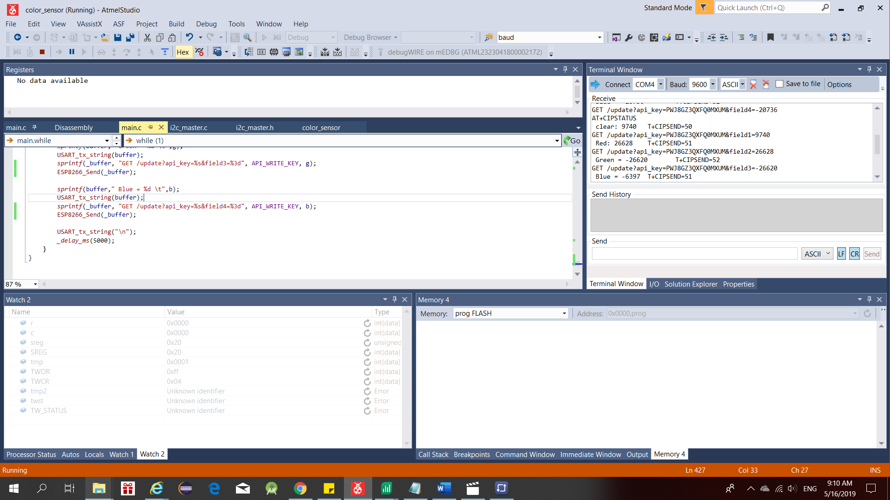

1. **SCHEMATICS**

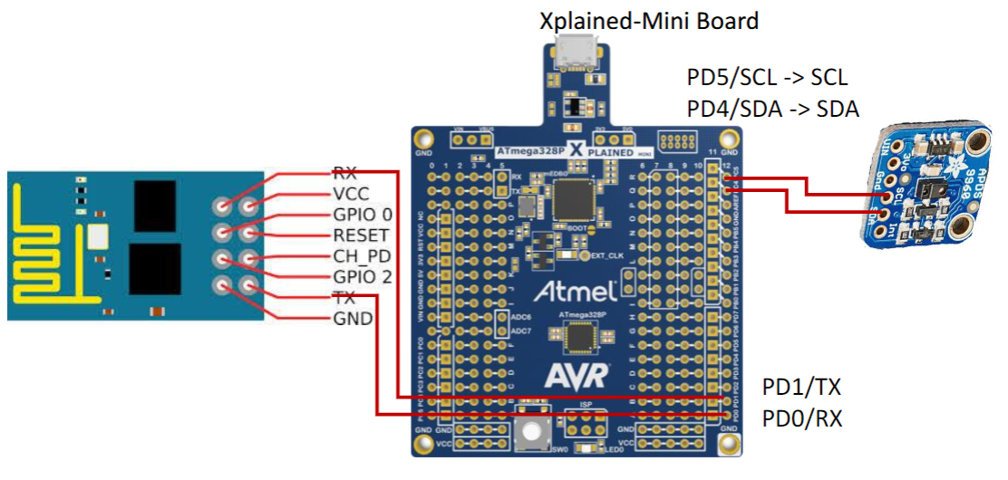

1. **SCREENSHOTS OF EACH TASK OUTPUT (THINGSPEAK)**

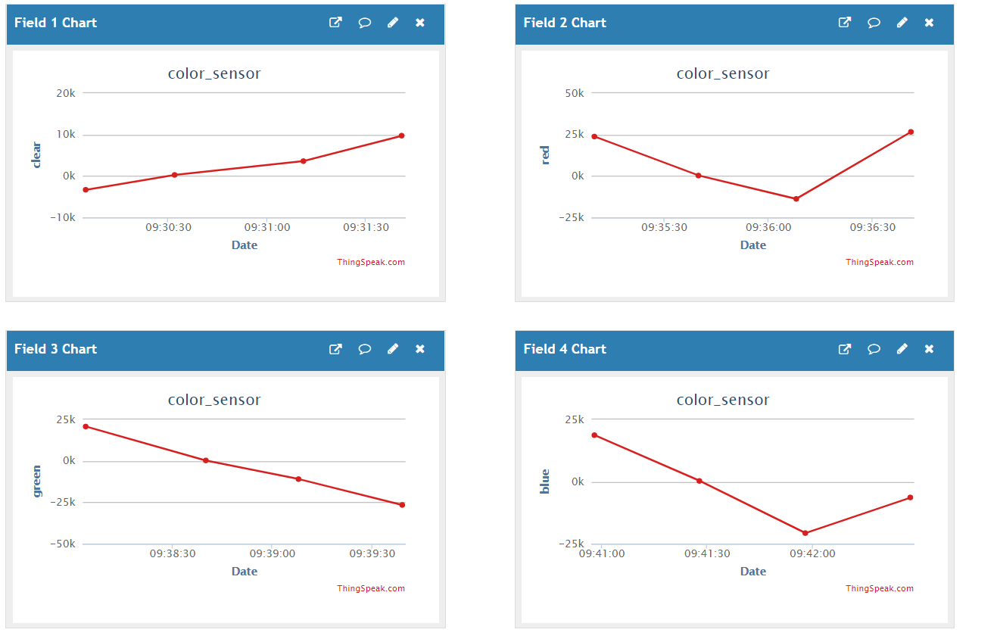

1. **SCREENSHOT OF EACH DEMO (BOARD SETUP)** 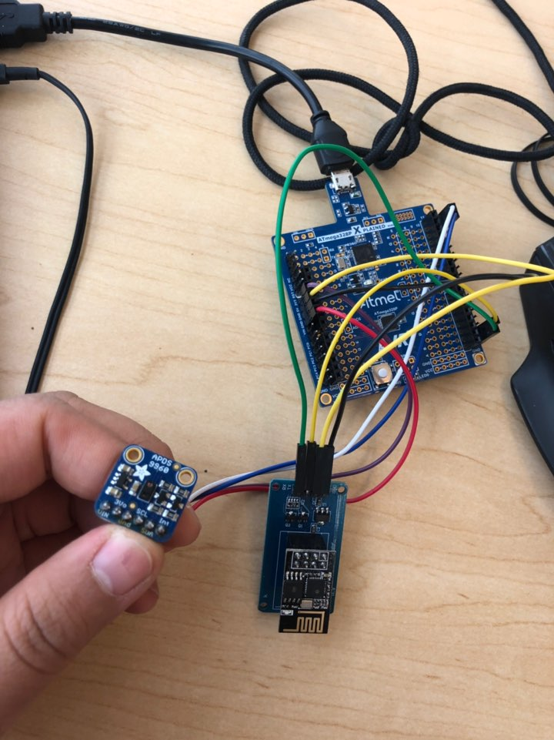
2. **VIDEO LINKS OF EACH DEMO**

<https://youtu.be/BhCjwT7UXCk>

1. **GITHUB LINK OF THIS DA**

Primary Github address: https://github.com/yeeun219/submission_da.git

Directory: cpe301\DesignAssignments\MIDTERM2

**Student Academic Misconduct Policy**

<http://studentconduct.unlv.edu/misconduct/policy.html>

“This assignment submission is my own, original work”.

NAME OF THE STUDENT