Measurement Library
For
Mirage

Author | Kapil Chaturvedi
Contributors | Gowie, Mike O, Rakesh
PGU | SPD
Revision | 1.0.0.0 – First draft of design document | 9th Oct, 07
 | - – Simplification, Pins removed as per suggestion from Rakesh | 25th Oct 07
 | - – Changed the terminology as per current Mirage architecture blocks (FP -> AML) | 18th Dec 07

1. Introduction 2
2. Requirements: 2
3. Design: 3
4. Implementation: 7
5. Unit Test Plan: 7
6. Performance Test Plan 7
7. Verification Plan 7
8. Release Matrix 7

Introduction

Agilent’s Measurement Library (ML) is a DSP library used to perform all the signal processing and generation in Mirage. This library provides common and easy to use .Net wrapper functions to interact and use building blocks from Backus, Bebop, 35670 code to develop the business logic or measurement flow for different personalities of Mirage (Low frequency dynamic signal analyzer).
The Bebop demodulation library is used by several projects within the Agilent Signal Analysis Division. This is an object oriented C++ library for various kinds of digital demodulation, and provides entire measurements rather than isolated DSP functions. It can't be directly compared with the Backus DSP library, as it is at a much higher level. Internal to Bebop, the vector library used is the Spokane vector library, which has few significant bugs as per Eric Backus’s observations. ML will use the measurement blocks from Bebop and will provide consistent interfaces to these measurement blocks.
The Backus DSP library is a library of C functions for digital signal processing. The library currently deals only with one-dimensional arrays, and is focused on the operations that are useful for mechanical and audio signal processing applications. Nearly all of the functions operate on either real or complex data. Commonly used functions, like the Fast Fourier Transform, have been extensively optimized. The DSP library is written entirely in ANSI C, and is designed to be portable to a variety of hardware platforms. Some of the algorithms implemented in this library may be considered proprietary to Agilent Technologies, so the source code to this library should not be distributed outside of Agilent. In particular, the coefficients for some of the data windows, and the methods used for re-sampling data, may be proprietary.
Small parts of 35670 source code is borrowed from Salsa project. The code for salsa is targeted for different OS and is not build able.
We will be investigating the CSpring’s libraries for time domain measurements in coming few weeks (TBD). We may have to change the design to accommodate this library.

Requirements:
The ML library should be able to provide following processing blocks to build the measurements in AML layer of Mirage. AML team will make the measurement flow in the front panel with the help of these building blocks. ML team will provide following building blocks for Mirage –

- Signal Generation blocks: Signal Generation from given specifications.
- Signal Analysis blocks: This contains -
  - Transforms
  - Filtering
  - Windowing
  - Math
  - Statistical
  - Correlation
  - More blocks to be added here
- Error Handling: The ML function will return well defined error codes in case an error occurs within the limits of ML. FP will translate these error codes into exception handling and update the user via UI and SCPI status systems.
- SCPI Status System: ML will not in any way interact with SCPI system including the SCPI status system. This responsibility now belongs to FP/AI.
- Licensing/Security: There is no requirement from ML for licensing or security. ML needs not to provide any support for this.
- Multi threading: Multithreading support not required from ML for Mirage. Threading issues will be handled at the client level of the ML (AI/AML).
- Documentation: ML will try to use standard tools to generate documentation about the library so that it can be easily used by other product development teams within SPD.

Design:
We have been discussing a about how best we can design the measurement library that is efficient yet easy to use and fits in AML’s signal flow framework. Following decisions were made on ML during past discussions –

- Users of the measurement library will provide all memory required for the calls into the measurement library (i.e. the measurement library should not allocate memory and give it back to the user).
- The one and only client for ML is AML. In no way ML is involved in communicating with AI or IE and thus will not handle complexities in design due to multiple threads accessing ML blocks. Whenever it is required to do so it will be done via AML.
- ML will help in implementing business logic; it will not implement any business logic.
- ML will not create any flow or larger building block using the basic building block to create a measurement as this will restrict saving intermediate result.
- All the clients who wish to use ML have to create their own measurement flow; verification of those flows is responsibility of clients.
- Data classes should not be tied to the measurement library.
- Data Types:
  - Support single dimension vectors.
  - Support for both complex and real data types.
  - Precision: float, and double.
  - Should be able to handle and interpret AML data model definitions.
  - Try to minimize local copy of data within ML.
- Calls to the library should be intuitive to the developer (i.e. intelli-sense should show the needed parameters for the function)
- Provide algorithms to transform input data into desired results.
- ML will provide a C# layer that will -
  - Map C# data to library specific data
  - Transform the data
  - Return the result and map it to C# data
  - Library function will return error code (if any)
- In order to interact with native data types ML will only use basic data types. This restricts use of structures, class or dictionary to pass any parameters from managed to native world.
- ML will not handle any intermediate results. This is to improve the pInvoke performance.
- Figure shows the current thinking of using ML. All the green blocks will be provided by the ML to the FP. Some of the concerns with this approach are-
  - Performance penalty due to too many pInvoke calls (ignore)
  - Implementation responsibility of measurement flow? (Owner?) - AML
  - Testing, Verification responsibilities of measurement flow (Owner?) - AML
  - Performance test of flow (Owner?) - AML
  - Validation of measurement flow (Owner?) - AML
  - Non-real time/Non-deterministic nature of managed code in creating measurement flow (ignore)
- ML needs not to provide mechanism for connecting meas blocks. This facility is already implemented in SFF and AML will use the SFF implementation to connect these blocks.

Managed

Managed

Managed
Window
FFT
Logarithm
IFFT
AML

Based on above discussions and decisions on responsibilities from ML, following is proposed simplified design of ML. MeasLib is an object oriented library of DSP functions providing wrapper around Backus and Bebop DSP libraries. The various interfaces exposed by this library, categorized based on functionality are shown below. Alternatively there may be separate interfaces to support managed and native development enviournment.

MeasBlock: Figure below shows definition of measurement block. Each measurement block will take input data pointers from client and on receiving the trigger signal, process the input data and result will be outputted on output buffer which is again provided by the client. The client can change the properties of a block as per requirement of measurement flow.

Properties
Trigger

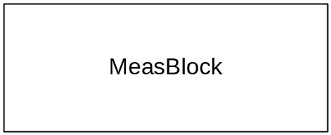
Input Buffer
Output Buffer

Meas Library: ML is collection of meas blocks.

MeasLib
ISigGen
IMath
IMarkerMeass
IWindow
ITransform
IMeasBlock
ITimeMeas
IFilter
IDistortionMeas
IAveraging

IResponse
Backus Library
Bebop
Library

Salsa
Code
Custom Code
C’Spring library

- IMeasLib: The main interface of library. Following is the definition for this interface. This is the root interface from which all other interfaces are derived.
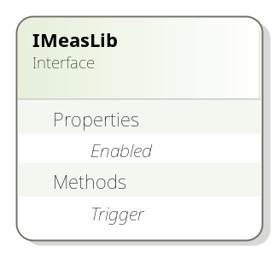
- ITransform: This interface, derived from IMeasLib, is root interface for different kind of transforms like fft, dft, ifft etc. Following is the definition of root Transforms interface and typical implementation of that interface for Fourier Transforms.
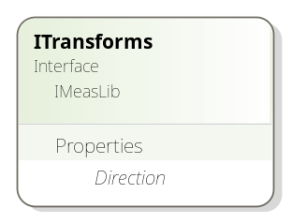
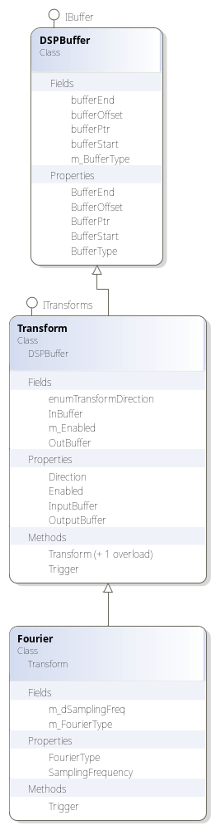
- ISigGen: This interface will provide following signal generation functions. Sine, Cosine, Square, Triangular, Sawtooth and Noise. All of these functions will take signal specification (frequency, level, phase etc) as input and will output the signal.
- IMath: This interface will provide all the math functions e.g. add, subtract, multiply, divide Integration, differentiation Inverse, Square, Square root, Absolute etc. Some of these functions will take two input parameters and some will take only single input parameter, in both cases result of math operation will be stores in a third parameter and will be returned to user.
- IStatistics: This interface will provide all the statistical functions e.g. mean mode, median, average. These functions normally return a single result value instead of data array.
- IFilter: This interface will provide functions to apply filters on signal. The filter to be used will be selectable from pre-define enum values.
- IDistortionMeas: This interface will provide various distortion measurement blocks (e.g. THD, SINAD)

Implementation:
To do.

Sr | Release version | Date | Includes
1. | 1.0.0.0 | xx-xx-xxxx | Time domain analysis and math functions
2. | To do | To do | To do

To do.

Unit Test Plan:
Being just a wrapper for Backus, Bebop, 35670 libraries, the unit test will concentrate more on the correctness of wrapper functions and thus will not cover testing of algorithms. It is assumed that the Backus and Bebop library are bug-free. For the measurement block not provided by any of the Agilent library, ML team will develop code to implement the blocks necessary for Mirage. The Backus library source provides some good unit test coverage with the source code and that will be used as starting point to write unit test and verify results. Again, we will use VS.Net 2005 team edition’s unit test project to develop unit tests for this library. It is also assumed that SPD will have the latest source code for Backus, Bebop libraries at the time of development phase.

Performance Test Plan
TBD

Verification Plan
TBD

Release Matrix
TBD

