Homework 7 (50 pts) Due 12/5/2018

1. (10) A soft drink manufacturer uses five agents to handle premium distributions for its various products. The marketing director desired to study the timeliness with which the premiums are distributed. Twenty transactions for each agent were selected at random, and the time lapse (in days) for handling each transaction was determined. The results are in premium.txt.

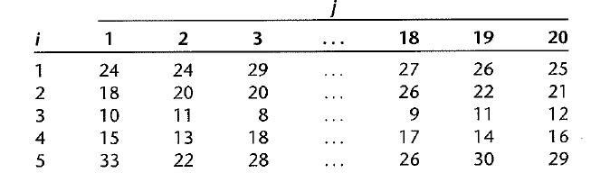

a) Use aligned box plots to compare the factor level means. Do they appear to be different? Does the variability of the observations within each factor level appear to be approximately the same for all factor levels?

b) Obtain the fitted values.

c) Obtain the residues. Do they sum to zero as in the regression model?

d) Obtain the analysis of variance table.

e) Test whether or not the mean time lapse differs for the five agents; use $α=0.1.$ State the alternatives, decision rule, and conclusion.

f) Test assumption for the test.

2. (6) Refer toproblem 1, suppose that 25 percent of all premium distribution are handled by agent1, 20 percent by agent 2, 20 percent by agent 3, 20 percent by agent 4, and 15 percent by agent 5.

a) Obtain a point estimate of the grand mean $μ$. when the ANOVA model is expressed in the factor effects with the weighs being the proportions of premium distribution handled by each agent.

$$μ.=Σw_{i}μ_{i}$$

b) Test whether or not the mean lapse differs for the five agents; use $=0.1.$ State the alternatives, decision rule, and conclusion.

3. (8) Refer to problem 1,

a) Construct a 90% confidence interval for the mean time lapse for agent 1.

b) Obtain a 90% confidence interval for $μ_{2}-μ_{1}$. Interpret your interval estimate.

c) The marketing director wishes to compare the mean time lapses for agents 1, 3, and 5. Obtain confidence interval for all pairwise comparisons among these three treatment means; use the Bonferroni procedure with a 90% family level.

4. (6) Refer to problem 1, suppose primary interest is in estimating the following comparisons:

$$L1=\frac{μ_{1}+μ_{2}}{2}-μ_{5}$$

$$L2=\frac{μ_{1}+μ_{2}}{2}-\frac{\left(μ_{3}+μ_{4}\right)}{2}$$

a) Obtain a 90% confidence interval for individual comparison.

b) Obtain a 90% simultaneous confidence interval for the two comparisons.

5. (10) A computer software firm was encountering difficulties in forecasting the programmer requirements for large0scale programming projects. Twenty-four programmers are classified into equal groups by type of experience (factor A) and amount of experience (factor B), were asked to predict the number of programmer days required to complete a large project about to be initiated. After this project was completed, the prediction errors (actual minus predicted programmer-days) were determined. The data is in programmer.txt.

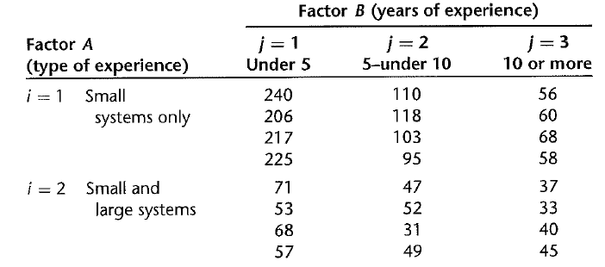

a) Prepare an estimated means plot. Does your graph suggest that any main factor or interaction effects are present? Explain.

b) Obtain the ANOVA table. Does any one source account for most of the total variability?

c) Test whether the two factors interact; use 0.01 significant level.

d) Test whether the main effects are present, use 0.01 significant level.

6. (10) Refer to question 5,

a) Estimate $μ_{23}$ with 99 percent confidence interval. Interpret your estimate.

b) Estimate $D=μ_{12}-μ_{13}$ with 99% confidence interval. Interpret your estimate.

c. The nature of the interaction effects is to be studied by comparing the effect of type of experience for each years-of-experience group. Specifically, the following comparisons are to be estimated:

$L_{1}=(μ_{11}-μ_{21})-(μ_{12}-μ_{22}$)

$L_{2}=(μ_{11}-μ_{21})-(μ_{13}-μ_{23}$)

$$L_{3}=(μ_{12}-μ_{22})-(μ_{13}-μ_{23})$$

Obtain a simultaneous confidence interval, with 95% level.

d) To examine whether a transformation of the data would make the interaction unimportant, plot separately the transformed estimated means for the reciprocal ( $1/Y)$ and logarithmic transformation (log(Y)). Would either of these transformations have made the interaction effects unimportant?