Naïve Bayes Classifier Confusion matrix

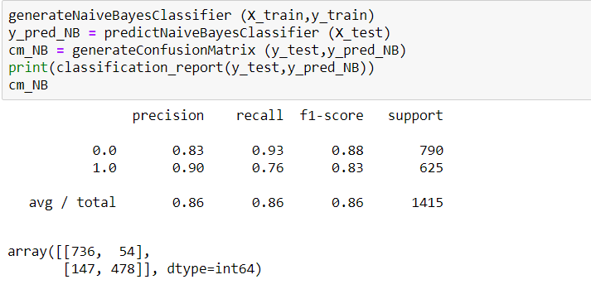

Decision Tree Classifier Confusion matrix

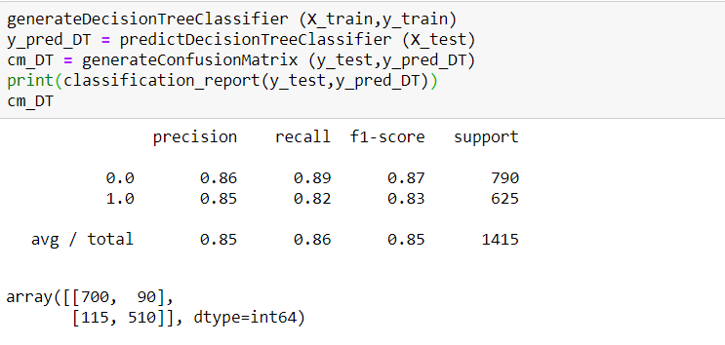

SVM Classifier Confusion matrix

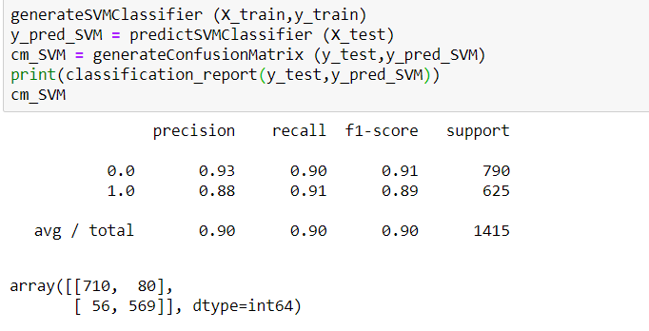

KNN Classifier Confusion matrix

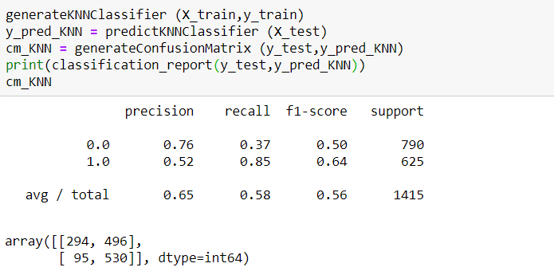

Random Forest Classifier Confusion matrix

