MAD and PWA Lab

**Name:** Abhishek Fatate **Class:** D15A **Roll no:** 15

**Aim:** Selecting features for application development, the features should comprise of:

1. Common widgets
2. Should include icons, images, charts etc.
3. Should have an interactive Form
4. Should apply navigation, routing and gestures
5. Should connect with FireBase database

|  |  |
| --- | --- |
| **Screen-shot** | **Features** |
|  | **Logo-screen**   1. Logo screen appears as soon as we open the oyo app. 2. Login details to be entered and login button at the bottom. 3. Firebase connectivity will be used for storing the user ID and password. |

|  |  |
| --- | --- |
|  | **Home-screen**   1. The home screen of the Oyo app. 2. A navigation bar at the bottom consisting of Home, bookings invite and earn, and need help. 3. Logo at the top and search bar below the logo. 4. Firebase connectivity will allow the search bar to be functional. |

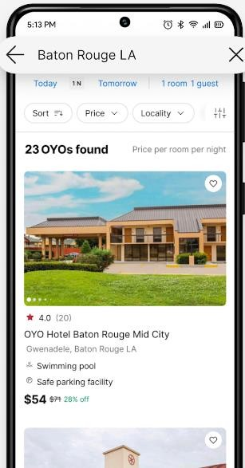

**Search-screen**

1. The search screen of the Oyo app.
2. It contains the search bar on top , various sort buttons such as price, locality etc

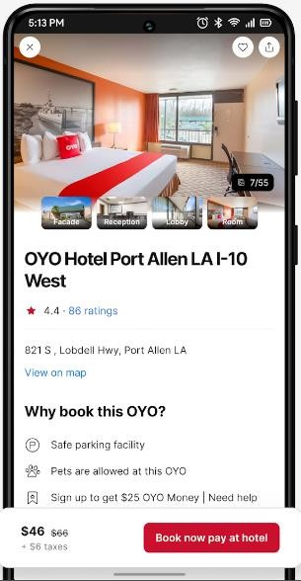

**Booking-screen**

1. The booking screen of the Oyo app.
2. It contains name of the hotel ratings, address, and various services offered by the particular hotel
3. It also contains the price and tax for that hotel.
4. After booking a confirmation e-mail is sent on the registered e-mail

|  |  |
| --- | --- |
|  | **Cancellation-screen**   1. Cancellation screen contains cancellation policy. 2. It states various rules and restrictions regarding cancellation. |