*Yefferson miranda josec*

*NUMERO 1.-*

*#include<iostream>*  
*#include<conio.h>*  
*#include<math.h>*  
  
**using** **namespace** std**;**  
*/*Funcion de la formula. */*  
**double** Formula**(double** a **,double** b**){**  
  
 **if** **(**a**>=30&&**b**!=0&&**a**!=0){**  
 **return** **(**sqrt**((**a**+30)/(2\***b**))\***a**+**b**/**a**);**  
 **}**  
   
**}**  
  
**int** main**(int** argc**,** **char** **const** **\***argv**[])**  
**{**  
 cout**<<**"El resultado es: "**<<**endl**;**  
 cout**<<**Formula**(32,5);**  
 getch**();**  
 **return** **0;**  
**}**

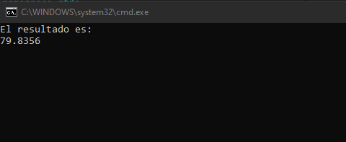

*NUMERO 2.-*

*#include<iostream>*  
*#include<conio.h>*  
  
**using** **namespace** std**;**  
  
**long** Sumatoria**(int** n**){**  
 **long** r**;**  
 **int** i**;**  
 **for** **(** r**=0,**i **=** **1;** i **<=**n**;** i**++)**  
 **{**  
 r**=**r**+10\***i**+2;**  
 **}**  
 **return** r**;**  
   
**}**  
  
**int** main**(int** argc**,** **char** **const** **\***argv**[])**  
**{**  
 cout**<<**Sumatoria**(3);**  
 getch**();**  
 **return** **0;**  
**}**

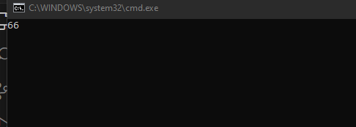

*NUMERO 3.-*

*#include<iostream>*  
*#include<conio.h>*  
  
**using** **namespace** std**;**  
  
**double** Sumatoria**(int** a**,int** b**){**  
 **long** r**;**  
 **int** i**;**  
 **int** X**[100];**  
 cout**<<**"Ingreso de datos a la matriz :"**<<**endl**;**  
 **for** **(** i **=** **0;** i **<** a**+**b**;** i**++)**  
 **{**  
 cout**<<**"X["**<<**i**+1<<**"]="**;**  
 cin**>>**X**[**i**];**  
  
 **}**  
 cout**<<**"La sumatoria es: "**;**  
 **for** **(** i **=** **0,**r**=0;**i **<** a**+**b**;**i**++)**  
 **{**  
 r**=**r**+**X**[**i**]+**a**\***b**;**  
 **}**  
 **return(**r**/(double)(**a**+**b**));**  
   
   
   
**}**  
  
**int** main**(int** argc**,** **char** **const** **\***argv**[])**  
**{**  
 **int** a**=4;**  
 **int** b**=6;**  
 cout**<<**Sumatoria**(**a**,**b**);**  
 **return** **0;**  
**}**

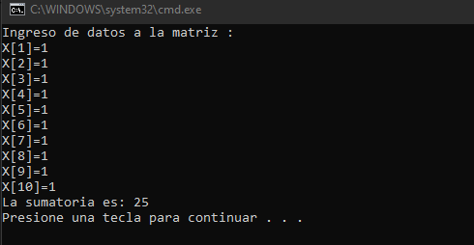

*NUMERO 4.-*

*#include<iostream>*  
*#include<conio.h>*  
*#define NOEXISTE -12345*  
  
**using** **namespace** std**;**  
*/* Funcion raiz */*  
**double** Raiz2**(double** num**){**  
 **double** raiz**=0;**  
  
 **if** **(**num**<0)**  
 **{**  
 **return** NOEXISTE**;**  
 **}**  
 **while(**raiz**\***raiz**<=**num**){**  
 raiz**+=0.00001;**  
 **}**  
 **return** raiz**;**   
**}**   
  
  
**int** main**(int** argc**,** **char** **const** **\***argv**[])**  
**{**  
 **double** n**=7;**  
 cout**<<**"La raiz de "**<<**n**<<**" es:"**;**  
 cout**<<**Raiz2**(**n**);**  
 getch**();**  
 **return** **0;**  
**}**

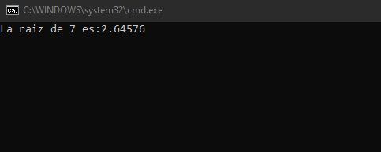

*NUMERO 5.-*

*#include<iostream>*  
*#include<conio.h>*  
  
  
**using** **namespace** std**;**  
  
**long** Factorial**(int** n**){**  
 **long** fact**=1;**  
 **for(int** i**=1;**i**<=**n**;**i**++){**  
 fact**\*=**i**;**  
 **}**  
 **return** fact**;**  
**}**  
  
**int** main**(int** argc**,** **char** **const** **\***argv**[])**  
**{**  
 **int** n**=10;**  
 cout**<<**"El factorial de "**<<**n**<<**"es: "**;**  
 cout**<<**Factorial**(**n**);**  
 getch**();**  
 **return** **0;**  
**}**

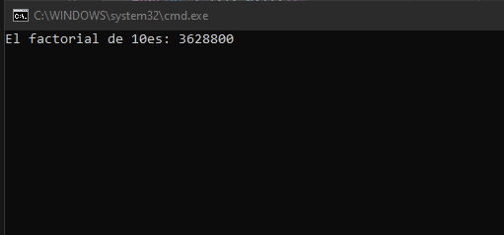

*NUMERO 6.-*

*#include<iostream>*  
*#include<conio.h>*  
*#include<math.h>*  
  
  
**using** **namespace** std**;**  
  
**double** Formula**(int** a**,int** b**){**  
 **double** x**;**  
 **if(**a**+20<0||**b**==0)**  
 **return** **-1;**  
 x**=(**sqrt**(**a**+20)/(2\***b**))\***a**;**  
 **return** x**;**  
**}**  
  
**int** main**(int** argc**,** **char** **const** **\***argv**[])**  
**{**  
 cout**<<**Formula**(5,8);**  
 getch**();**  
 **return** **0;**  
**}**

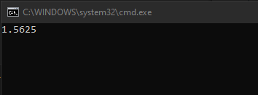

*NUMERO 7.-*

*#include<iostream>*  
*#include<conio.h>*  
*#include<math.h>*  
  
  
**using** **namespace** std**;**  
  
**long** Sumatoria**(int** n**){**  
   
 **long** s**=0;**  
  
 **for** **(int** i **=** **1;** i **<=**n **;** i**++)**  
 **{**  
 s**=**s**+(**n**+**i**\*10+2);**  
 **}**  
 **return** s**;**  
**}**  
  
**int** main**(int** argc**,** **char** **const** **\***argv**[])**  
**{**  
 **int** n**=3;**  
 cout**<<**"La suma es:"**<<**endl**;**  
 cout**<<**Sumatoria**(**n**);**  
 getch**();**  
 **return** **0;**  
**}**

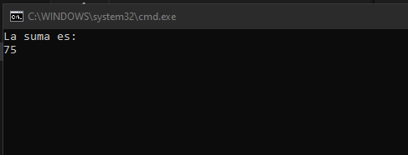

*NUMERO 8.-*

*#include<iostream>*  
*#include<conio.h>*  
*#include<math.h>*  
  
  
**using** **namespace** std**;**  
  
**long** Sumatoria**(int** a**,int** b**){**  
 **long** r1**,**r2**;**  
 **int** j**;**  
 **int** Y**[100];**  
 cout**<<**"ingreso de datos de matriz :"**<<**endl**;**  
  
 **for** **(** j **=** **0;** j **<** a**+**b**;** j**++)**  
 **{**  
 cout**<<**"Y["**<<**j**+1<<**"]="**;**  
 cin**>>**Y**[**j**];**  
 **}**  
 cout**<<**"La sumatoria es: "**;**  
 **for(**j**=0,**r1**=0;**j**<**a**;**j**++){**  
 r1**=**r1**+**Y**[**j**]+**a**\***b**;**  
 **}**  
 **for(**j**=0,**  
 r2**=0;**j**<**a**+**b**;**j**++){**  
 r2**=**r2**+**Y**[**j**];**  
 **}**  
 r2**=3\***r2**;**  
 **return** r1**+**r2**+**a**+**b**+100;**  
   
**}**  
  
**int** main**(int** argc**,** **char** **const** **\***argv**[])**  
**{**  
 **int** a**,**b**;**  
 a**=5;**  
 b**=9;**  
 cout**<<**Sumatoria**(**a**,**b**);**  
 getch**();**  
 **return** **0;**  
**}**

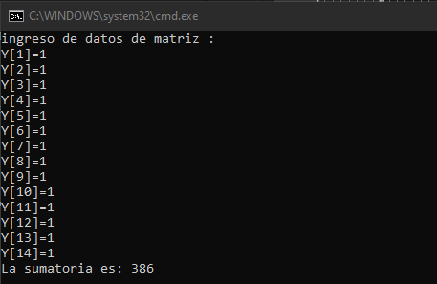

*NUMERO 9.-*

*#include<iostream>*  
*#include<conio.h>*  
  
**using** **namespace** std**;**  
  
**long** Cubo**(int** n**){**  
 **int** cubo**=0;**  
 **for(int** i**=0;**i**<**n**;**i**++){**  
 **for(int** j**=0;**j**<**n**;**j**++){**  
 cubo**+=**n**;**  
 **}**  
 **}**  
 **return** cubo**;**  
**}**  
  
**int** main**(){**  
 **int** n **=10;**  
 cout**<<**"El cubo de "**<<**n**<<**" es:"**;**  
 cout**<<**Cubo**(**n**);**  
 getch**();**  
  
 **return** **0;**  
**}**

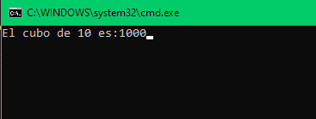

*NUMERO 10.-*

*#include<iostream>*  
*#include<conio.h>*  
  
**using** **namespace** std**;**  
**int** Division**(long** n1**,long** n2**){**  
 */* Ojo que n1 debe ser mayor o igual que n2 */*  
 **int** coc**=0;**  
 **while(**n2**<=**n1**){**  
 n1**=**n1**-**n2**;**  
 coc**++;**  
 **}**  
 *//cout<<"Resudio ="<<n1<<endl;*  
 **return** coc**;**  
**}**  
  
**int** main**(int** argc**,** **char** **const** **\***argv**[])**  
**{**  
 **long** num1**=100;**  
 **long** num2**=3;**  
 cout**<<**num1**<<**" entre "**<<**num2**<<**" ="**;**  
 cout**<<**Division**(**num1**,**num2**);**  
 getch**();**  
  
 **return** **0;**  
**}**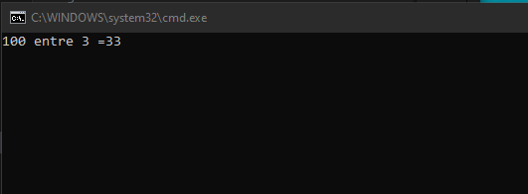

*NUMERO 11.-*

*#include<iostream>*  
*#include<conio.h>*  
  
**using** **namespace** std**;**  
  
**int** Pares**(long** n**){**  
 **int** pares**=0;**  
 **while(**n**>0){**  
 **if(**n**%2==0){**  
 pares**++;**  
   
 **}**  
 n**=**n**/10;**  
 **}**  
 **return** pares**;**  
**}**  
  
**int** main**(int** argc**,** **char** **const** **\***argv**[])**  
**{**  
 **long** num **=82423620;**  
 cout**<<**"El numero "**<<**num**<<**"tiene"**;**  
 cout**<<**Pares**(**num**)<<**"numeros pares"**;**  
 getch**();**   
 **return** **0;**  
**}**

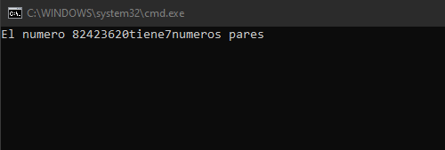

*NUMERO 12.-*

*#include<iostream>*  
*#include<conio.h>*  
  
**using** **namespace** std**;**  
  
**int** Primo**(long** num**){**  
 **int** lim**;**  
 **int** i**;**  
 **int** cont**=0;**  
 **for(**lim **=0;**lim**\***lim**<**num**;**lim**++);**  
 **for(**i**=2;**i**<**lim**;**i**++){**  
 **if** **(**num**%**i**==0)**  
 **{**  
 cont**++;**  
 **}**  
 **}**  
 **if(**cont **==0)**  
 **return** **1;**  
 **else**  
 **return** **-1;**  
  
**}**  
**int** main**(int** argc**,** **char** **const** **\***argv**[])**  
**{**  
 cout**<<**"Si imprime 1 es primo, si imprime -1 no es primo "**;**  
 **int** n**;**  
 cin**>>**n**;**  
 cout**<<**n**<<**endl**;**  
 cout**<<**Primo**(**n**);**  
 getch**();**  
 **return** **0;**  
**}**

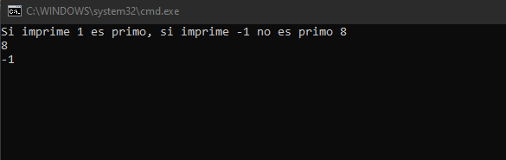

*NUMERO 13.-*

*#include<iostream>*  
*#include<conio.h>*  
  
**using** **namespace** std**;**  
  
**int** NTermino**(int** n**){**  
 **int** n1**=1;**  
 **int** n2**=1;**  
 **int** n3**=2;**  
 **int** n4**=**n1**+**n2**+**n3**;**  
 **int** cont**=0;**  
  
 **while(**cont**<**n**-1){**  
 n1**=**n2**;**  
 n2**=**n3**;**  
 n3**=**n4**;**  
 n4**=**n1**+**n2**+**n3**;**  
 cont**++;**  
 **}**  
 cout**<<**n1**;**  
 **return** n1**;**  
**}**  
  
**int** main**(int** argc**,** **char** **const** **\***argv**[])**  
**{**  
 NTermino**(5);**  
 **return** **0;**  
**}**

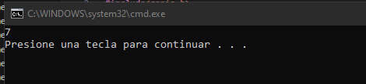

*NUMERO 14.-*

*#include<iostream>*  
*#include<conio.h>*  
  
**using** **namespace** std**;**  
  
**double** Raiz3**(double** num**){**  
 **double** raiz**=0;**  
 **while** **(**raiz**\***raiz**\***raiz**<**num**)**  
 **{**  
 raiz**+=0.1;**  
 **}**  
 **return** raiz**;**  
**}**  
  
**int** main**(int** argc**,** **char** **const** **\***argv**[])**  
**{**  
 **double** n**=8;**  
 cout**<<**"La raiz de "**<<**n**<<**" es:"**;**  
 cout**<<**Raiz3**(**n**);**  
 getch**();**  
 **return** **0;**  
**}**

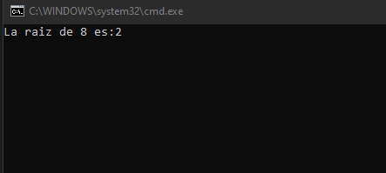

*NUMERO 15.-*

*#include<iostream>*  
*#include<conio.h>*  
  
**using** **namespace** std**;**  
  
**int** NTermino**(int** n**){**  
 **int** n1**=0;**  
 **int** n2**=1;**  
 **int** n3**=2;**  
 **int** n4**=**n1**+**n2**+**n3**;**  
 **int** cont**=0;**  
  
 **while(**cont**<**n**-1){**  
 n1**=**n2**;**  
 n2**=**n3**;**  
 n3**=**n4**;**  
 n4**=**n1**+**n2**+**n3**;**  
 cont**++;**  
 **}**  
 cout**<<**n1**;**  
 **return** n1**;**  
**}**  
  
  
  
**int** main**(int** argc**,** **char** **const** **\***argv**[])**  
**{**  
 NTermino**(7);**  
 getch**();**  
 **return** **0;**  
**}**

