1.Child process will become a zombie process when it is already terminated while its parent is sleeping. So in order to create zombie process i used sleep for its parent. In the following screenshot of table zombie process is stored with status Z until its parent is terminated using kill command by its pid

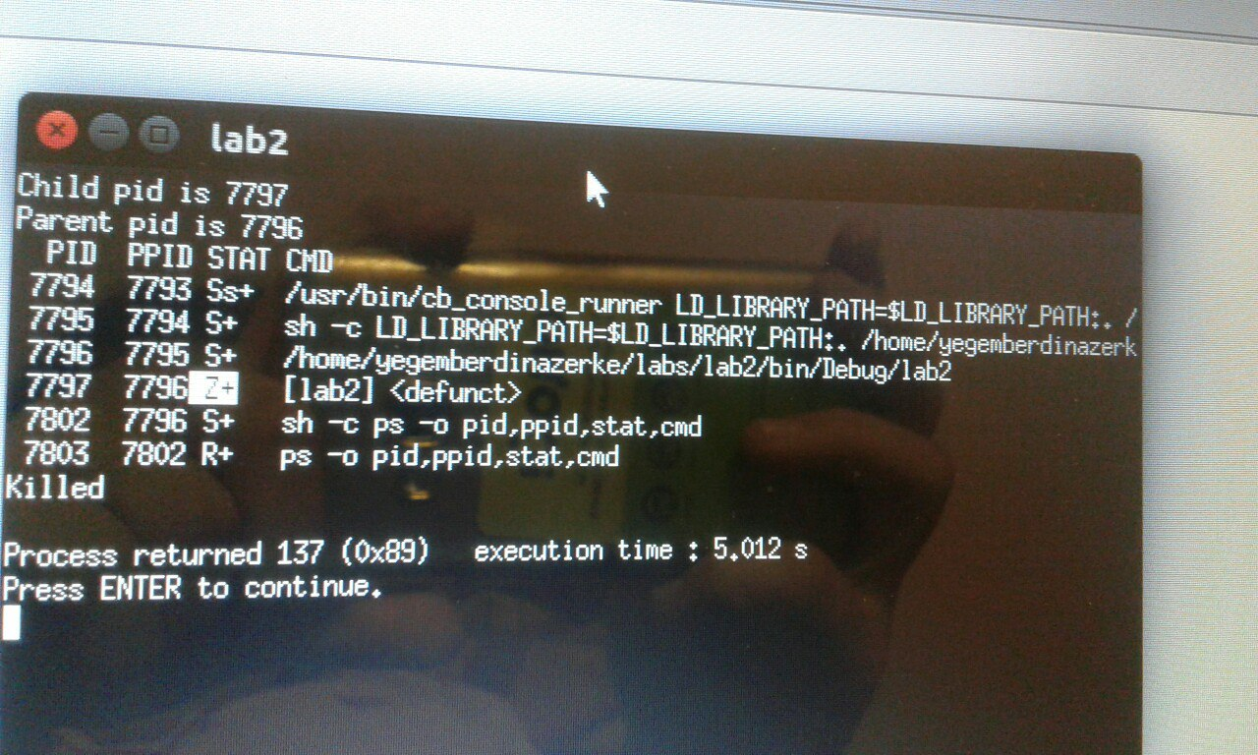

2.Orphan process means that its parent is already terminated when it is sleeping. So in order to create orphan process i used sleep for its child inversely. When it does not have parent its parent will be init process in my program case its pid is 1469. But later orphan process will be destroyed as init process will call wait().

Init process shortened from initialization is like core or ancestor process of all processes.

