**Operating Systems**

**Lab 3**

**Using threads**

1. Implement matrix multiplication using multithreading. Application should have pthread_create(), pthread_ exit(), pthread_join(). In the program, every thread must return the value and must be collected in pthread_join in the main function. Final sum of row-column multiplication must be done by main thread (main function).

**Hint**: We partition *A*, *B* and *C* into equally sized block matrices:



then

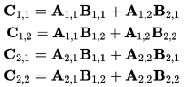

1. Write the same program using Windows threads.
2. Write the same program using Java threads.