Architecture Design Document
POC v2 — Gemini-Brain Robotic Inspection in MuJoCo / robosuite

Project path: C:\huminoid | POC v2 | June 2026

1. Executive Summary

POC v2 upgrades the humanoid inspection demo from a single-purpose YOLOv8 detector into a modern two-layer robot architecture that mirrors how leading humanoid companies build their systems: a hosted Vision-Language-Model (VLM) 'brain' for perception and decision-making, paired with a separate action layer for motor control. The operator types a natural-language instruction such as "throw all the defective parts into the reject bin"; a hosted Gemini 2.0 Flash brain looks at the simulated work cell, decides which parts are defective and what to do, and a reliable robosuite controller executes the pick-and-place inside MuJoCo.
The goal of this document is to define an architecture that produces a working, repeatable demo in MuJoCo on commodity hardware (AMD RX 580, no CUDA), while remaining honest about which components are reliable today versus which are best-effort showcases.

2. Why v2 — Limits of v1

v1 Limitation | Impact | v2 Resolution
YOLOv8 is the only 'intelligence' | Every decision is hardcoded in an FSM; no reasoning | Gemini VLM brain reasons over the scene and the instruction
Required ~2h CPU training on synthetic data | Slow iteration; brittle to scene changes | Zero-shot hosted brain — no training to change behaviour
Hardcoded keyframe motor layer | Not a real policy; no generalization | Reliable OSC controller + optional real VLA (Octo / GR00T)
Placeholder capsule scene | Looks like a prototype | robosuite PickPlace BinsArena — professional, ready-made
Behaviour fixed at code level | New rule = code edit + retrain | Behaviour changes by editing one English sentence

3. Industry Landscape — The VLM-Brain + Action-Model Pattern

Research into the most successful humanoid programs of 2025-2026 shows a single converging architecture: a VLM backbone for high-level reasoning, paired with a dedicated action model for low-level motor control. POC v2 deliberately adopts this same split. Notably, Gemini — our chosen brain — is the very model Google ships in Gemini Robotics.
Organization | Brain (VLM) | Action layer | Relevance to POC v2
Google DeepMind | Gemini Robotics (Gemini VLM) | Diffusion action decoder | Gemini is the same family we use as the brain
Figure AI | Helix (in-house VLM) | Onboard motor policy | Full-stack; drives Figure 02/03 hands+arms
NVIDIA | GR00T N1.5 VLM backbone | Diffusion Transformer | Open, customizable humanoid foundation model
Physical Intelligence | pi-0 VLM | Flow-matching action expert | General-purpose manipulation VLA
Tesla | In-house vision stack | In-house motor control | Optimus; 28-DOF full-body control

Sources: NVIDIA GR00T N1 / N1.5 announcements (Mar / May 2025); Google DeepMind Gemini Robotics; Figure AI Helix; Physical Intelligence pi-0. See evsint.com 'Top Robotics Foundation Model & Embodied AI Companies 2026' and the awesome-physical-ai survey.

4. System Architecture

The system is organized into four layers. Data flows down (camera -> brain -> decision -> action -> robot); the only operator input is a natural-language task instruction.
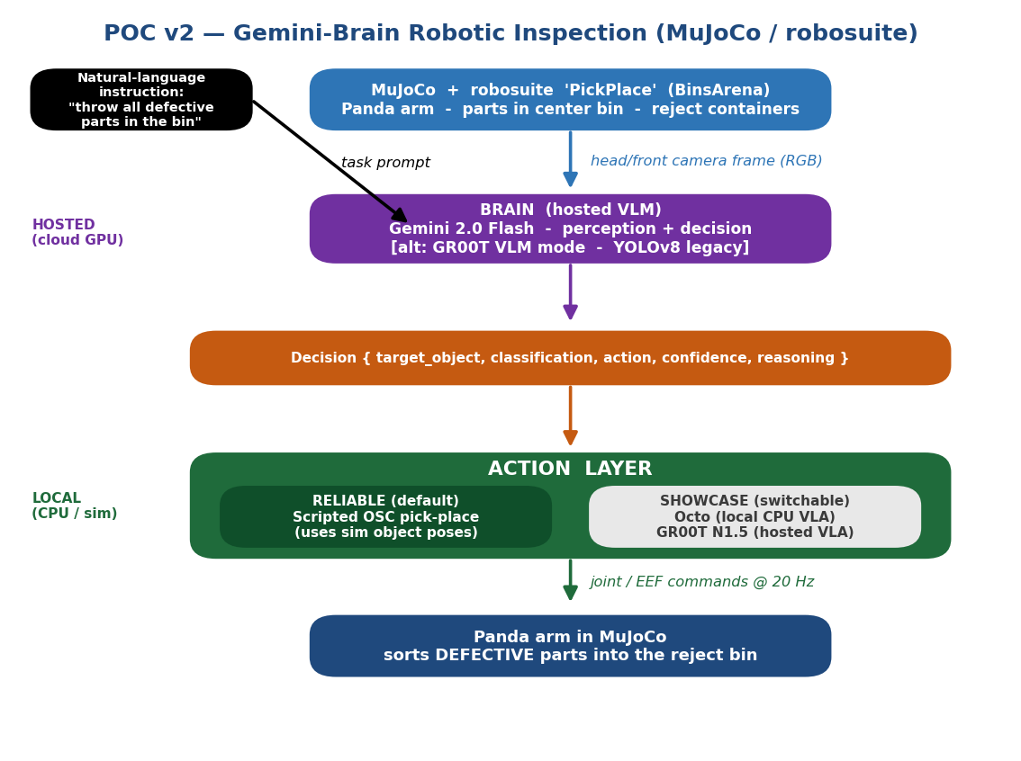
Figure 1 — POC v2 layered architecture

4.1 Layer responsibilities
Layer | Component | Responsibility | Hosting
Simulation | MuJoCo + robosuite PickPlace | Physics, rendering, ground-truth object poses | Local
Brain | Gemini 2.0 Flash | Perceive scene + decide (pixels -> JSON Decision) | Hosted (cloud)
Decision | Decision dataclass | Typed contract between brain and action | In-process
Action | Scripted OSC (default) | Reliable reach / grasp / place | Local
Action (showcase) | Octo / GR00T | Real VLA motor control (best-effort) | Local / Hosted
Robot | Panda arm | Executes the sort into the reject bin | Local (sim)

5. Component Specifications

5.1 Brain abstraction
All brains implement a common interface and return a typed Decision, so modes are fully interchangeable from the demo loop:
@dataclass
class Decision:
target_object: str # robosuite object name, e.g. 'Cereal'
classification: str # 'good' | 'defect'
action: str # 'pick_reject' | 'pass' | 'watch'
confidence: float
reasoning: str # plain-English 'why' (shown on the HUD)

class Brain(ABC):
def decide(self, frame_bgr, instruction, scene_context) -> list[Decision]: ...
Brain mode | Backing model | Hosting | Notes
gemini (default) | Gemini 2.0 Flash | Hosted | Free tier; video-capable; primary path
groot | NVIDIA GR00T N1.5 | Hosted* | VLA; endpoint must be verified (see 7)
yolo | v1 YOLOv8n detector | Local | Reuses vision/detector.py for comparison

5.2 Action abstraction
class ActionLayer(ABC):
def execute(self, env, decision: Decision) -> bool: ... # success?
def reset(self): ...
Action mode | Mechanism | Reliability | Role
scripted (default) | robosuite OSC_POSE waypoints | High | Backbone — demo always works
octo | Octo VLA (JAX, CPU) | Low (jittery) | Showcase: real generalist policy
groot | GR00T N1.5 action head | Unverified | Showcase: humanoid foundation model

The scripted OSC layer uses ground-truth object poses from the simulator for MOTION only; the brain still performs all PERCEPTION and DECISION-making from pixels. This cleanly separates 'where things are' (trivial in sim) from 'what to do' (the interesting part).

5.3 Scene mapping — PickPlace as inspection
robosuite element | Inspection meaning
Center bin with 4 objects (Can, Cereal, Milk, Bread) | Parts arriving for inspection
Gemini classification per object | good vs defect call
One target container | Reject bin for defective parts
Panda arm + gripper | The inspecting robot

6. Control Loop & Data Flow

env = suite.make('PickPlace', robots='Panda',
use_camera_obs=True, camera_names=['frontview'],
has_offscreen_renderer=True, control_freq=20)
obs = env.reset()

while not done:
frame = obs['frontview_image'] # RGB from MuJoCo
if time_to_replan(): # THROTTLED brain call
decisions = brain.decide(frame, instruction, scene_context)
for d in decisions if d.action == 'pick_reject':
action_layer.execute(env, d) # OSC reach->grasp->place
obs, _, done, _ = env.step(noop_or_action)
hud = draw_overlay(frame, status, reasoning=d.reasoning)
- Brain is called only at decision points (per re-plan), never per frame — respects Gemini free-tier rate limits.
- The Decision.reasoning string is rendered on the HUD so viewers see WHY the robot acted.
- Scripted OSC executes a fixed waypoint sequence: approach -> descend -> grasp -> lift -> move-to-reject -> release.

7. Hardware Limits & Hosting Strategy

Constraint | Consequence | Strategy
AMD RX 580, no CUDA | Cannot run 7B VLAs locally on GPU | Brain is hosted (Gemini / GR00T cloud)
16 GB RAM, CPU only | Octo runs but slowly (~seconds/step) | Octo is a showcase mode, throttled
Gemini free-tier limits | Rate caps on requests/min | Call brain per-decision, cache last plan
Windows + JAX | Octo/JAX install can be fragile | Octo isolated in optional requirements-octo.txt

8. Honest Reality Checks

- Octo zero-shot in robosuite grasps unreliably without fine-tuning (needs demo trajectories + GPU). It is a SHOWCASE only; the scripted OSC layer is what makes the demo reliable.
- GR00T is primarily open weights (nvidia/GR00T-N1.5-3B) on HuggingFace, not guaranteed to be a hosted NIM API. The build pass must VERIFY a hosted endpoint using NVIDIA_API_KEY; if absent, GR00T mode degrades gracefully and Gemini remains the working path.
- GR00T is technically a VLA action model, so it is wired alongside Octo as a foundation-model policy mode — it is NOT a drop-in replacement for the Gemini decision brain.
- The reliable, always-demoable path is: --brain gemini --action scripted.

9. Path to a Working MuJoCo Demo

Planned module layout for the build pass (kept parallel to v1; v1 stays intact):
C:\huminoid\
robosuite_demo.py # v2 main entry (env loop + HUD + CLI)
config.py # instruction, defect mapping, throttle, model IDs
brains\ base.py gemini_brain.py groot_brain.py yolo_brain.py
action\ base.py scripted_osc.py octo_policy.py groot_policy.py

9.1 Run modes
# Reliable path (recommended for any live demo)
python robosuite_demo.py --brain gemini --action scripted \
--instruction "throw all the defective parts into the reject bin"

# Headless (save annotated frames to output\)
python robosuite_demo.py --brain gemini --action scripted --no-viewer

# Showcase: real generalist VLA driving the arm
python robosuite_demo.py --brain gemini --action octo

# Comparison: original YOLO brain
python robosuite_demo.py --brain yolo --action scripted

9.2 Verification checklist
Check | Pass condition
Env smoke test | PickPlace creates, resets, renders one frame to output\env_smoke.jpg
Brain test | Gemini returns valid Decision list with classifications + reasoning
Action test | Scripted OSC places one known object inside the reject container
Full reliable demo | Runs to completion headless; prints inspected/defects/sorted metrics
Live viewer | robosuite window opens and the arm visibly sorts defects
Showcase modes | octo loads & steps without crashing; groot degrades cleanly if no endpoint

10. Environment Setup

cd C:\huminoid
.venv\Scripts\activate
pip install robosuite google-generativeai

# Gemini key (free at aistudio.google.com)
$env:GEMINI_API_KEY = "AIza..."

# NVIDIA key (already configured) — only for GR00T modes
$env:NVIDIA_API_KEY = "nvapi-..."

# Optional showcase only:
pip install -r requirements-octo.txt # octo, jax[cpu], flax

