Architecture Design Document
Humanoid Robot Industrial Inspection POC

Version 1.0 · June 2026 · C:\huminoid

1. System Overview

The Humanoid Robot Inspection POC is a closed-loop simulation system in which a Unitree G1 humanoid robot performs autonomous visual quality inspection at a work table. The system spans four architectural layers: simulation core, vision pipeline, control layer, and data/training pipeline. An optional cloud augmentation path connects to NVIDIA's Cosmos 3 NIM API to enrich synthetic training data with photorealistic industrial textures.
All compute runs locally on a Windows PC with an AMD RX 580 GPU (CPU physics + OpenGL rendering). No NVIDIA GPU is required at runtime — Cosmos 3 is accessed over HTTP only during the offline training phase.

2. Architecture Diagram

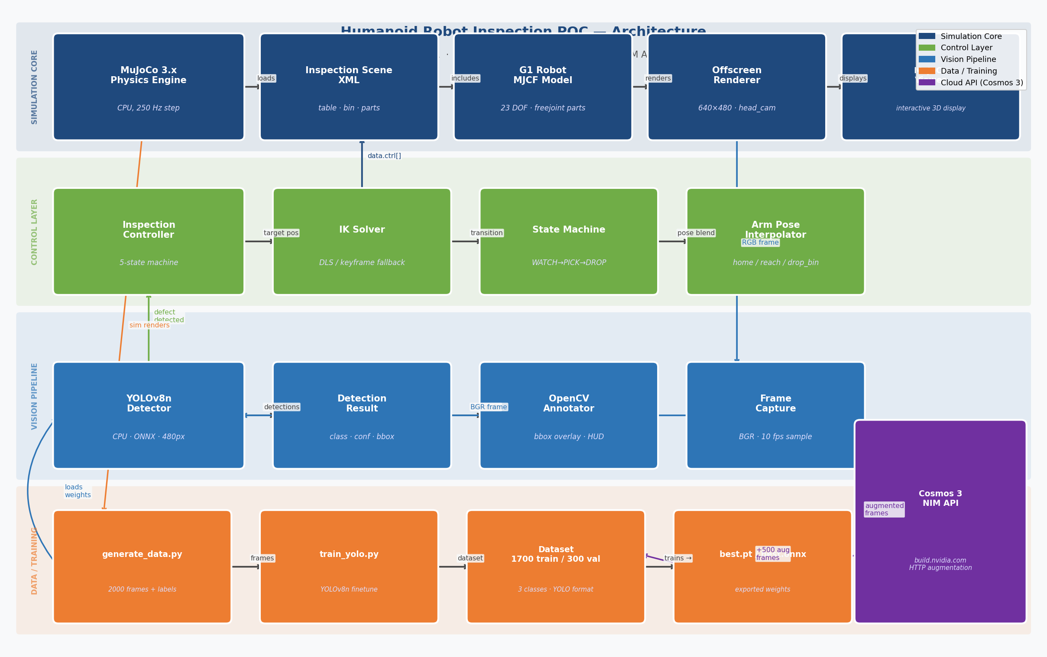
Figure 1 — Four-layer system architecture showing data flow between components

3. Architectural Layers

3.1 Simulation Core
MuJoCo 3.9 provides deterministic rigid-body physics at 250 Hz. The simulation scene is defined in two XML files: a standalone version (placeholder capsule robot) and a full version that includes the Unitree G1 MJCF. Both share the same world geometry: a work table, a reject bin, three part bodies with free joints, and a head-mounted camera.
Component | File | Role
MuJoCo Engine | mujoco 3.9.0 (pip) | Physics stepping, collision, rendering
Standalone scene | scene/inspection_scene_standalone.xml | Self-contained scene for testing without G1
Full scene | scene/inspection_scene.xml | Includes G1 MJCF via <include>
Offscreen render | mujoco.Renderer (640×480) | Generates head-cam frames for vision
Interactive view | mujoco.viewer.launch_passive | Real-time 3D display for demo

3.2 Vision Pipeline
YOLOv8n (Nano) runs on CPU at ~80 ms/frame. The Detector class wraps ultralytics, loads the best.onnx exported model, and returns DetectionResult objects containing class ID, confidence, and bounding box. Inference is throttled to every 5th simulation step (~10 fps) to avoid saturating the CPU.
Component | File | Notes
Detector | vision/detector.py | Wraps YOLO, returns DetectionResult
Model (train) | runs/train/weights/best.pt | PyTorch checkpoint
Model (runtime) | runs/train/weights/best.onnx | ONNX export — faster CPU inference
Annotator | vision/detector.py _draw() | Draws bboxes + HUD on BGR frame
OpenCV window | demo.py | Displays annotated head-cam feed

3.3 Control Layer
The inspection controller implements a 5-state finite state machine decoupled from the physics loop. Each call to step(sim_time, frame) advances the state machine and writes target joint angles to data.ctrl[] via the IK solver.
State | Trigger | Duration | Arm Action
WATCHING | Entry / return | Continuous | Home pose; YOLO runs every 200 ms
APPROACHING | Defect detected | 1.5 s | Blend to reach_table keyframe
PICKING | APPROACHING timeout | 1.0 s | Hold reach pose; remove part
DROPPING | PICKING timeout | 1.0 s | Blend to drop_bin keyframe
RETURNING | DROPPING timeout | 1.2 s | Blend back to home keyframe

The IK solver (robot/ik_solver.py) operates in one of two modes: Damped Least Squares (DLS) online IK when the G1 MJCF is loaded (7-DOF right arm, λ=0.05, 50 iterations), or keyframe interpolation fallback for the standalone scene. All three keyframe poses (home, reach_table, drop_bin) are smooth-step interpolated over the state duration.

3.4 Data / Training Pipeline
Training data is generated entirely from the MuJoCo offscreen renderer, eliminating the need for real-world images. Each frame is automatically labeled by projecting the known part position through the camera model.
Stage | Script | Output
Offscreen render | vision/generate_data.py | 2,000 JPEG frames + YOLO .txt labels
Cosmos augment | vision/augment_cosmos.py | 500 photorealistic variants (optional)
YOLO fine-tune | vision/train_yolo.py | best.pt + best.onnx (50 epochs, CPU)
Dataset config | data/dataset.yaml | 3 classes: good / defect_crack / defect_discolor

3.5 Cloud Augmentation (Cosmos 3 NIM)
NVIDIA's Cosmos 3 Diffusion model is accessed via the NIM HTTP API at ai.api.nvidia.com. Synthetic MuJoCo frames are encoded as base64 and sent with an industrial-context prompt. The returned image has photorealistic factory floor textures applied (image-to-image diffusion, strength=0.6). Bounding box labels are preserved unchanged since geometry is not altered. This step is optional but improves sim-to-real generalization.
POST ai.api.nvidia.com/v1/genai/nvidia/cosmos-1.0-diffusion
{"image": "<base64>", "prompt": "industrial factory floor...", "strength": 0.6}

4. Runtime Data Flow

Each simulation step (4 ms) executes the following sequence:
- 2. MuJoCo physics step (mj_step) — advances simulation by 4 ms
- 3. Every 25th step: Renderer.update_scene() + render() → BGR frame (10 fps)
- 4. InspectionController.step(sim_time, frame) called each step
- 5. If WATCHING and 200 ms elapsed: Detector.detect(frame) → DetectionResult
- 6. If defect found: state → APPROACHING; IKSolver.interpolate_to_pose() called
- 7. IKSolver.apply_pose() writes to data.ctrl[] → MuJoCo actuator targets
- 8. MuJoCo viewer synced via viewer.sync() — renders updated joint positions
- 9. OpenCV window updated with annotated frame + state HUD overlay

5. Module Interfaces

Module | Inputs | Outputs | Key Class/Function
vision/detector.py | BGR frame (np.ndarray) | DetectionResult | Detector.detect()
robot/ik_solver.py | target_pos (np.ndarray) | IKResult / pose dict | IKSolver.solve()
robot/inspection_controller.py | sim_time, BGR frame | ControllerStatus | InspectionController.step()
vision/generate_data.py | MuJoCo model + renderer | JPEG frames + .txt | render_dataset()
vision/train_yolo.py | dataset.yaml | best.pt + best.onnx | train()
vision/augment_cosmos.py | JPEG frames + API key | Augmented JPEGs | cosmos_augment()
demo.py | scene XML path | Viewer + OpenCV window | run_demo()

6. Dependency Graph

demo.py
├── vision/detector.py (ultralytics, opencv-python)
├── robot/inspection_controller.py
│ ├── robot/ik_solver.py (mujoco, numpy, scipy)
│ └── vision/detector.py
└── mujoco (physics + viewer + renderer)

vision/train_yolo.py
└── ultralytics (torch, torchvision)

vision/generate_data.py
└── mujoco, opencv-python, numpy

vision/augment_cosmos.py
└── requests, Pillow (NVIDIA NIM API — network only)

7. File Map

Path | Type | Description
scene/inspection_scene_standalone.xml | MuJoCo XML | Self-contained scene — placeholder robot, no G1 MJCF needed
scene/inspection_scene.xml | MuJoCo XML | Full scene — includes G1 MJCF via <include>
vision/generate_data.py | Python | Offscreen renderer loop; auto-projects YOLO labels
vision/augment_cosmos.py | Python | Calls Cosmos NIM HTTP API; polite rate limiting
vision/train_yolo.py | Python | YOLOv8n fine-tune; merges augmented images before train
vision/detector.py | Python | Detector class; prefers ONNX over .pt at runtime
robot/ik_solver.py | Python | DLS IK (G1) + keyframe fallback (standalone)
robot/inspection_controller.py | Python | 5-state FSM; spawns/removes parts; drives arm
demo.py | Python | Main entry; viewer + OpenCV cam window + spawn loop
verify_setup.py | Python | Pre-flight check: imports, scene load, model presence
data/dataset.yaml | YAML | YOLO dataset config — 3 classes, train/val split

8. Key Design Decisions

Decision | Chosen Approach | Alternative Considered | Rationale
Simulator | MuJoCo 3.x | Isaac Sim | Isaac Sim requires NVIDIA GPU — not available on AMD RX 580
Vision model | YOLOv8n (CPU) | YOLOv8s / MobileNet | Nano: ~80 ms/frame on i7; small enough for CPU real-time
IK method | DLS + keyframe fallback | ROS2 MoveIt | No ROS2 dependency; keyframes sufficient for POC pick-place
Training data | MuJoCo offscreen render | Real imagery | No real robot needed; 2,000 frames in ~5 min
Augmentation | Cosmos 3 NIM (cloud) | Local diffusion model | AMD GPU can't run Cosmos locally; cloud API costs ~$0.02/image
Project path | C:\huminoid | E:\huminoid | E:\ drive is full (0 bytes); short path avoids MuJoCo Windows bug

