**What are three conclusions we can make about Kickstarter campaigns given the provided data?**

1. People prefer to raise money for the projects related to Theater/Plays category on Kickstart. Because most of the projects on Kickstart are related to plays in theater.

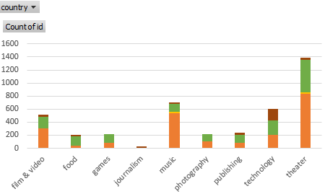

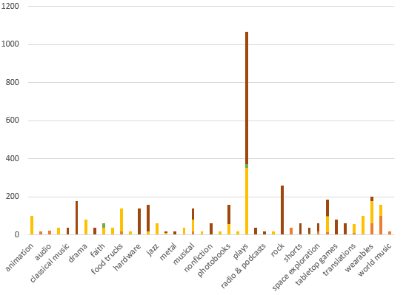

1. Kickstart is more popular in US than other countries. 74% of the projects raised on Kickstart are from US.
2. It’s easy to raise money for small projects with small goals on Kickstart. The percentage of successful is decreasing (The percentage of failed and the percentage of canceled are increasing ) when the goal of outcomes is getting bigger.

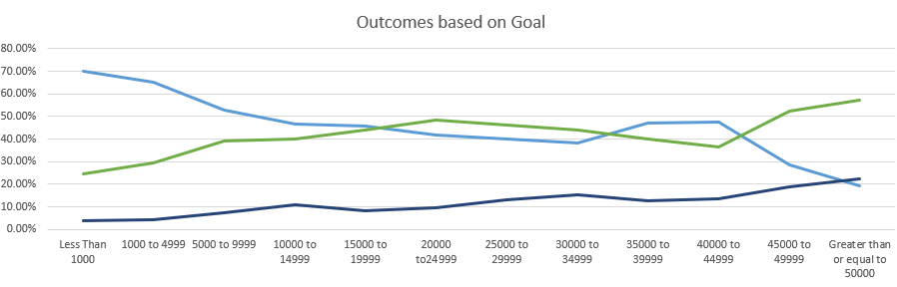

**What are some of the limitations of this dataset?**

There’s no backer’s profile in this data set, like their age, gender and income.

There’s no size of the project in this data set, like how many people will work on this project.

**What are some other possible tables/graphs that we could create?**

We can use scatter chart to compare the number of goals and number of pledged.