Process Synchronization using wait()
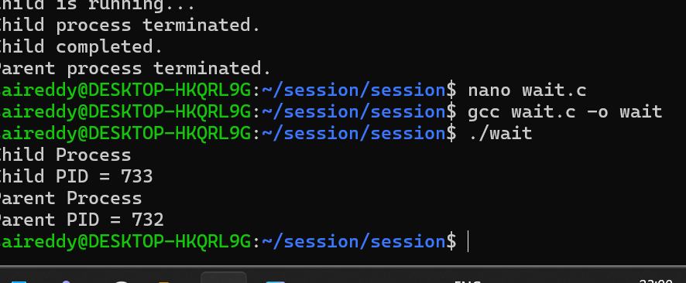

#include <stdio.h>
#include <unistd.h>
#include <sys/wait.h>

int main() {
int pid = fork();

if (pid == 0) {
printf("Child Process\n");
printf("Child PID = %d\n", getpid());
}
else {
wait(NULL);
printf("Parent Process\n");
printf("Parent PID = %d\n", getpid());
}

return 0;
}

