Create the C program using fork()
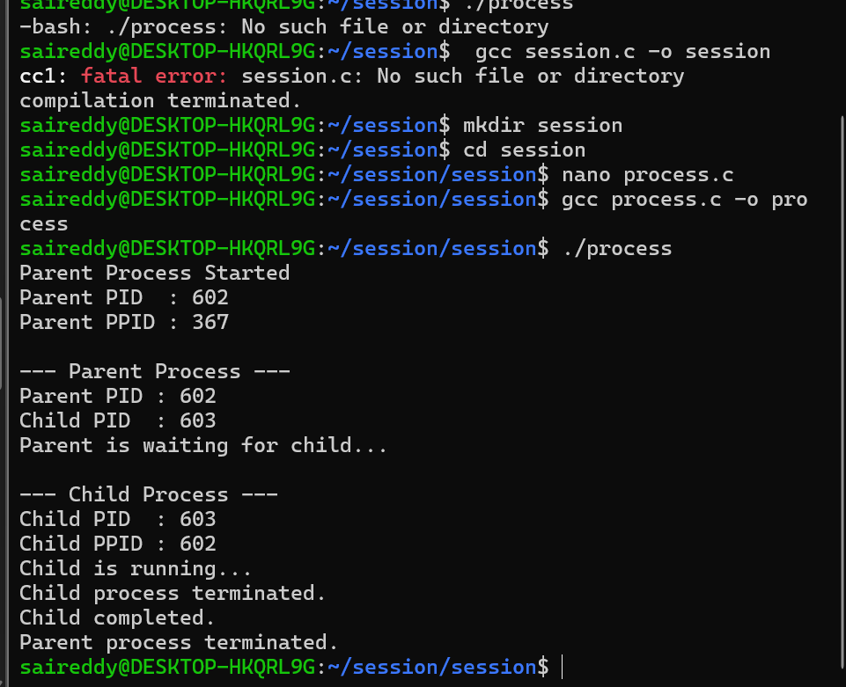

#include <stdio.h>
#include <unistd.h>
#include <sys/wait.h>
#include <stdlib.h>

int main() {
pid_t pid;

printf("Parent Process Started\n");
printf("Parent PID : %d\n", getpid());
printf("Parent PPID : %d\n", getppid());

pid = fork();

if (pid < 0) {
perror("fork failed");
return 1;
}

if (pid == 0) {
// Child process
printf("\n--- Child Process ---\n");
printf("Child PID : %d\n", getpid());
printf("Child PPID : %d\n", getppid());

printf("Child is running...\n");
sleep(10);

printf("Child process terminated.\n");
exit(0);
}
else {
// Parent process
printf("\n--- Parent Process ---\n");
printf("Parent PID : %d\n", getpid());
printf("Child PID : %d\n", pid);

printf("Parent is waiting for child...\n");
wait(NULL);

printf("Child completed.\n");
printf("Parent process terminated.\n");
}

return 0;
}

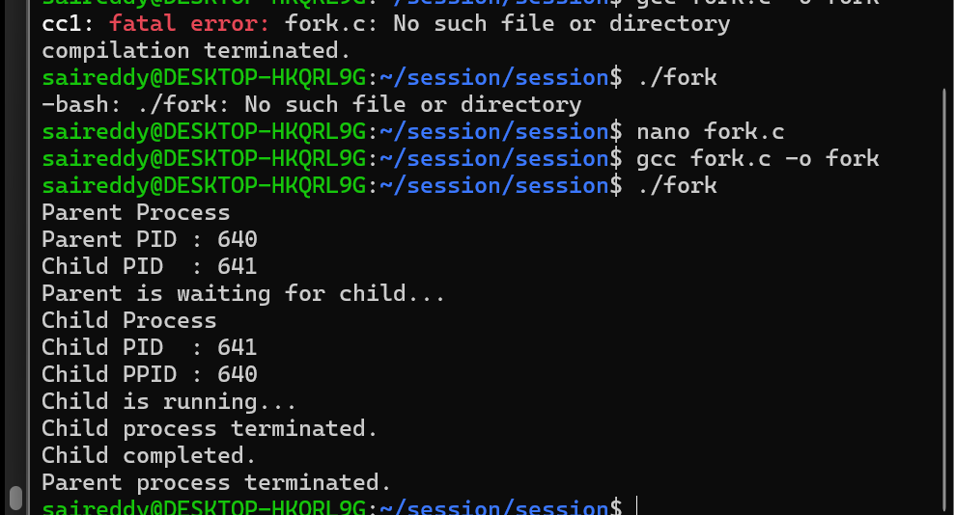

#include <stdio.h>
#include <unistd.h>
#include <sys/wait.h>
#include <stdlib.h>

int main()
{
pid_t pid = fork();

if (pid < 0)
{
printf("Fork failed\n");
}
else if (pid == 0)
{
printf("Child Process\n");
printf("Child PID : %d\n", getpid());
printf("Child PPID : %d\n", getppid());

printf("Child is running...\n");
sleep(5);

printf("Child process terminated.\n");
}
else
{
printf("Parent Process\n");
printf("Parent PID : %d\n", getpid());
printf("Child PID : %d\n", pid);

printf("Parent is waiting for child...\n");
wait(NULL);

printf("Child completed.\n");
printf("Parent process terminated.\n");
}

return 0;
}

