Sentinel Stage 2 Implementation Report
  - Yegor Sokolov | EECS 3311 Section A | Fall 2026
Implementation and publication snapshot 4 November 2026 | Submission due 10 November 2026

1 Project overview and implementation status
Sentinel is a single-user Java incident-triage application for students and junior analysts investigating synthetic local security events. Shared Swing and CLI workflows connect planning, allow-listed retrieval, provenance, deterministic severity and model-assisted interpretation. Sentinel does not scan networks or execute containment actions.
All twelve Stage 1 features have connected published GUI and CLI paths. The original implementation milestones and their applicable fixes are published, together with configurable model providers and setup tools. An October 29 real Qwen run completed a cited 7 HIGH assessment, follow-up, export and case reopen. Section 6 distinguishes earlier timeouts from a successful November 4 replay of the published GUI and CLI. Feature demonstrations are linked in Section 7.
The accepted baseline is Sentinel_Stage_1_Design_Report_V3.docx: F01-F12, UC01-UC08 and five patterns. This report follows the seven sections in Project-Stage2-Instruction.pdf; the full Project Instructions were also read. Setup instructions follow the demonstration index.

Architecture and scope
SentinelGUI and SentinelCLI submit Action values through ActionDispatcher and AgentController. AgentEngine coordinates bounded planning, retrieval and analysis. Investigation guards lifecycle, evidence and audit invariants. PlanningStrategy, ToolCommand, LLMGateway, SeverityPolicy and CaseRepository separate contracts from infrastructure. ApplicationSession injects one shared dataset, controller and executor.
The primary model remains local Qwen2.5 7B Instruct through Ollama. The optional OpenAI-compatible adapter uses the same LLMGateway boundary. Model drafts cannot choose arbitrary tools, alter fixed severity or execute response actions.

Submission status
All three weekly publication minima are satisfied. GUI and CLI recordings are linked for every feature; F01, F02 and F12 have two GUI parts. This report accompanies the published source and records actual verification rather than replacing analyst judgment. Full KUMA behavioral validation remains Stage 3 work.

2 Feature to implementation mapping
Every feature retains its original ID and user need. Status is implemented locally with refinements. No feature or original design pattern has been silently removed. The paths below identify the principal implementation files; collaboration explanations identify each responsibility.

F01 Natural language planning
Hybrid | Original Stage 1 F01 | UC01 / SD01 | Implemented and published
AgentController creates/clarifies the case; AgentEngine delegates to PlanningStrategy; LLMPlanningStrategy and RulePlanningStrategy generate plans; PlanValidator checks tools, scopes, dependencies and limits.
Methods: start, plan, createPlan, validate, acceptRulePlan. Patterns: MVC, Strategy, Adapter.
The analyst supplies a goal, dataset, target and UTC interval. Invalid model drafts receive one repair. Missing scope leaves DRAFT, and basic rule fallback requires explicit approval on the same case. Planning never executes tools.
Files: sentinel/application/AgentController.java; sentinel/application/AgentEngine.java; sentinel/domain/Plan.java; sentinel/planning/LLMPlanningStrategy.java; sentinel/planning/PlanningStrategy.java; sentinel/planning/PlanValidator.java; sentinel/planning/RulePlanningStrategy.java.
Demonstrate in New case or Generate model plan; CLI new / plan / rule. Include the relevant invalid-input, partial or alternative behavior.
Demonstration: GUI Part 1 | GUI Part 2 | CLI

F02 Validated dataset import
Deterministic | Original Stage 1 F02 | UC02 / SD02 | Implemented and published
AgentController preflights state; LogImporter validates a bounded UTF-8 event array; DatasetStore publishes durable immutable versions; Investigation records version, audit and staleness.
Methods: importLogs, importFile, ingest, recordImport. Patterns: MVC.
Conflicting event IDs reject atomically; identical duplicates count once. New versions retain historical evidence, clear the old plan, invalidate sessions and stale analysis. Invalid input and failed durable writes preserve the previous dataset.
Files: sentinel/application/AgentController.java; sentinel/data/DatasetStore.java; sentinel/data/LogImporter.java; sentinel/domain/Investigation.java.
Demonstrate in Import JSON; CLI import. Include the relevant invalid-input, partial or alternative behavior.
Demonstration: GUI Part 1 | GUI Part 2 | CLI

Feature mapping continued

F03 Filtered security log search
Deterministic | Original Stage 1 F03 | UC03 / SD03 | Implemented and published
ToolExecutor checks a case-bound session and dispatches LogSearchCommand to DatasetStore; ResultVerifier checks canonical source payloads before Investigation attaches evidence.
Methods: openSession, execute, query, search, addEvidence. Patterns: MVC, Command.
The view submits string-valued arguments pinned to a dataset/version, target and interval. Results are ordered and deduplicated with provenance and audit references. Empty, capped and failed retrieval are distinct outcomes.
Files: sentinel/data/DatasetStore.java; sentinel/data/ResultVerifier.java; sentinel/domain/Investigation.java; sentinel/domain/Result.java; sentinel/tools/LogSearchCommand.java; sentinel/tools/ToolExecutor.java.
Demonstrate in logSearch query; CLI query --tool logSearch. Include the relevant invalid-input, partial or alternative behavior.
Demonstration: GUI | CLI

F04 Threat indicator enrichment
Deterministic | Original Stage 1 F04 | UC03 / SD04 | Implemented and published
IndicatorFeedLoader validates source-dated records; IndicatorLookupCommand delegates to DatasetStore.lookup; AgentEngine accepts only the scoped target or indicators resolved from accepted events.
Methods: loadIndicatorFeed, lookup, query, acceptEvidenceIndicators. Patterns: MVC, Command.
Normalized IP/domain lookup preserves selected feed version, verdict, source and observation date. UNKNOWN is not SAFE; stale context remains visible. Observed indicators can extend the visible plan without resetting budgets or duplicate history.
Files: sentinel/application/AgentEngine.java; sentinel/data/DatasetStore.java; sentinel/data/IndicatorFeedLoader.java; sentinel/domain/Indicator.java; sentinel/tools/IndicatorLookupCommand.java.
Demonstrate in indicatorLookup query; CLI query --tool indicatorLookup. Include the relevant invalid-input, partial or alternative behavior.
Demonstration: GUI | CLI

Feature mapping continued

F05 Account activity investigation
Deterministic | Original Stage 1 F05 | UC03 / SD03 | Implemented and published
UserActivityCommand reuses LocalQueryCommand; DatasetStore computes ordered events/counts; ActivitySummary records full interval and returned coverage; Investigation attaches unique results.
Methods: activity, execute, query, addEvidence. Patterns: MVC, Command.
The shared retrieval path reports successes, failures, hosts and unknown values. Truncation retains total-versus-returned coverage; unknown accounts return empty results. Overlapping activity/search evidence attaches once.
Files: sentinel/data/DatasetStore.java; sentinel/domain/ActivitySummary.java; sentinel/domain/Investigation.java; sentinel/domain/Summary.java; sentinel/tools/LocalQueryCommand.java; sentinel/tools/UserActivityCommand.java.
Demonstrate in userActivity query; CLI query --tool userActivity. Include the relevant invalid-input, partial or alternative behavior.
Demonstration: GUI | CLI

F06 Timeline correlation
Deterministic | Original Stage 1 F06 | UC04 / SD05 | Implemented and published
CaseEvidence resolves canonical in-scope source events; TimelineBuilder orders/deduplicates and produces relationships; AnalysisService includes the timeline in Assessment.
Methods: events, build, correlate, analyze. Patterns: MVC.
UTC order is timestamp then event ID. Shared account/host within 15 minutes creates candidate related pairs, not causation. Missing optional fields do not block ordering; source-ID conflicts reject the standalone builder. Output is capped at 1000 pairs.
Files: sentinel/analysis/AnalysisService.java; sentinel/analysis/TimelineBuilder.java; sentinel/data/CaseEvidence.java; sentinel/domain/Assessment.java; sentinel/domain/Evidence.java.
Demonstrate in Timeline after Run; CLI run / exported report. Include the relevant invalid-input, partial or alternative behavior.
Demonstration: GUI | CLI

Feature mapping continued

F07 Grounded hypothesis analysis
Hybrid | Original Stage 1 F07 | UC04 / SD05 | Implemented and published
AnalysisService prompts through LLMGateway, resolves prompt-local refs to canonical UUIDs and validates structured synthesis; Investigation stores accepted Assessment values.
Methods: analyze, validateCitations, setAssessment. Patterns: MVC, Adapter.
The model receives at most 24 canonical evidence items, fixed severity and prior hypotheses. Unknown citations, invalid schema or confidence receive one repair. Persistent failure keeps deterministic results as PARTIAL with AI analysis unavailable. Citation validity is not semantic proof.
Files: sentinel/analysis/AnalysisService.java; sentinel/domain/Assessment.java; sentinel/domain/Investigation.java; sentinel/llm/LLMGateway.java.
Demonstrate in Hypotheses after Run; CLI run. Include the relevant invalid-input, partial or alternative behavior.
Demonstration: GUI | CLI

F08 Explainable severity
Hybrid | Original Stage 1 F08 | UC04 / SD05 | Implemented and published
RuleSeverityPolicy derives Facts from source events and accepted feed context; SeverityPolicy fixes scoring; AnalysisService preserves that result independently of model assertions.
Methods: derive, assess, analyze. Patterns: MVC, Strategy.
Each rule scores once: five failed logins in ten minutes +2; subsequent success within ten minutes +3; malicious login source +2; affected critical host +1. LOW 0-2, MEDIUM 3-5, HIGH 6-8; no usable authentication means UNDETERMINED. Unknown optional facts score zero and are disclosed.
Files: sentinel/analysis/AnalysisService.java; sentinel/analysis/RuleSeverityPolicy.java; sentinel/analysis/SeverityPolicy.java; sentinel/domain/Facts.java; sentinel/domain/Severity.java.
Demonstrate in Assessment after Run; CLI run. Include the relevant invalid-input, partial or alternative behavior.
Demonstration: GUI | CLI

Feature mapping continued

F09 Response recommendations
Hybrid | Original Stage 1 F09 | UC04 / SD05 | Implemented and published
AnalysisService validates Recommendation fields, references and categories; Assessment stores accepted rationale, priority and prerequisites; ReportService formats without inference.
Methods: analyze, validateCitations, export. Patterns: MVC, Adapter.
Only COLLECT, REVIEW and ESCALATE proposals are accepted. Every proposal cites evidence and is marked for analyst approval; no containment command exists. Invalid or unavailable synthesis produces no fabricated recommendation.
Files: sentinel/analysis/AnalysisService.java; sentinel/domain/Assessment.java; sentinel/reporting/ReportService.java.
Demonstrate in Assessment recommendations; CLI run. Include the relevant invalid-input, partial or alternative behavior.
Demonstration: GUI | CLI

F10 Contextual follow up
Hybrid | Original Stage 1 F10 | UC05 / SD06 | Implemented and published
AgentEngine optionally refreshes scoped tools through RulePlanningStrategy and ToolExecutor; AnalysisService answers; Investigation owns ConversationEntry history.
Methods: ask, answer, createPlan, query, recordConversation. Patterns: MVC, Strategy, Command, Adapter.
Questions use accepted evidence, fixed severity and prior hypotheses. A refresh: prefix requests bounded collection; scope widening requires an explicit revision. Answers resolve to existing UUIDs, with one repair for invalid citations. Failures are recorded and autosaved.
Files: sentinel/analysis/AnalysisService.java; sentinel/application/AgentEngine.java; sentinel/domain/ConversationEntry.java; sentinel/domain/Investigation.java; sentinel/domain/Plan.java; sentinel/planning/PlanningStrategy.java; sentinel/planning/RulePlanningStrategy.java; sentinel/tools/ToolExecutor.java.
Demonstrate in Ask and Conversation; CLI ask. Include the relevant invalid-input, partial or alternative behavior.
Demonstration: GUI | CLI

Feature mapping continued

F11 Persistent cases and history
Deterministic | Original Stage 1 F11 | UC06-UC07 / SD07 | Implemented and published
JsonCaseRepository validates closed JSON records and case revisions; AtomicFiles replaces files atomically; DatasetStore restores retained sources/feed provenance; Investigation restores aggregate state.
Methods: save, load, list, restore, snapshot, publish. Patterns: MVC, Observer.
Locks reject competing/stale case writes. Invalid schemas/references reject before restoration. RUNNING restores as PAUSED and needs revalidation. Unavailable source versions remain inspectable but block retrieval. Case/dataset files are separately atomic, not a cross-file transaction.
Files: sentinel/data/DatasetStore.java; sentinel/domain/Investigation.java; sentinel/persistence/AtomicFiles.java; sentinel/persistence/CaseRepository.java; sentinel/persistence/JsonCaseRepository.java.
Demonstrate in Save and Open case; CLI save / open / list. Include the relevant invalid-input, partial or alternative behavior.
Demonstration: GUI | CLI

F12 Report export
Deterministic | Original Stage 1 F12 | UC08 / SD08 | Implemented and published
ReportService formats immutable accepted case data; AtomicFiles protects output; AgentController exposes preview/export to both views.
Methods: preview, export, snapshot. Patterns: MVC.
Markdown includes scope, plan, provenance/payloads, timeline/relationships, severity, hypotheses, recommendations, conversation, failures, completeness and versions. Export makes no model calls. Existing destinations require GUI confirmation or explicit CLI --overwrite.
Files: sentinel/application/AgentController.java; sentinel/persistence/AtomicFiles.java; sentinel/reporting/ReportService.java.
Demonstrate in Report and Export Markdown; CLI preview / export. Include the relevant invalid-input, partial or alternative behavior.
Demonstration: GUI Part 1 | GUI Part 2 | CLI

3 Implemented design patterns

MVC
SentinelGUI and SentinelCLI are views; AgentController is controller; Investigation, Plan and Assessment are model values. Both views submit the same Action to ActionDispatcher, then use shared start/import/query/run/ask/save/export services. SwingWorker separates background work from EDT rendering. This preserves Stage 1 and avoids duplicate interface logic.

Strategy
AgentEngine is context and PlanningStrategy the interchangeable port. LLMPlanningStrategy and RulePlanningStrategy implement createPlan; explicit approval selects labeled rule fallback. AnalysisService also calls SeverityPolicy.assess on deterministic Facts. Model text cannot change policy output. This matches Stage 1.

Command
ToolExecutor is invoker; ToolCommand is contract; LogSearchCommand, UserActivityCommand and IndicatorLookupCommand extend LocalQueryCommand; DatasetStore is receiver. Session.execute validates schema, scope, keys and budgets before dispatch. AgentEngine.query then verifies canonical results before attachment. This matches Stage 1.

Observer
EventBus is publisher, ProgressListener the observer contract, and both views are listeners. publish delivers immutable ProgressEvent values and isolates listener failure. CLI writes progress to stderr; Swing schedules display on the EDT. Durable AuditEntry records remain separate. This matches Stage 1.

Adapter
LLMGateway is target; OllamaAdapter adapts local Ollama; OpenAICompatibleAdapter optionally adapts another compatible service. complete translates typed Prompt into bounded HTTP and ModelException failures. ModelGatewayFactory selects the adapter at composition. The optional second adapter refines the planned replaceable provider boundary.
Source packages: application/, presentation/, planning/, tools/, events/, llm/ and analysis/ under src/main/java/sentinel. The following diagram views summarize the implementation. docs/uml/implemented-system.puml is the detailed editable UML class model.

Implemented interaction class view
Current implementation relationships and key methods. The full PlantUML source includes the additional command, policy, persistence and observer inheritance relationships.
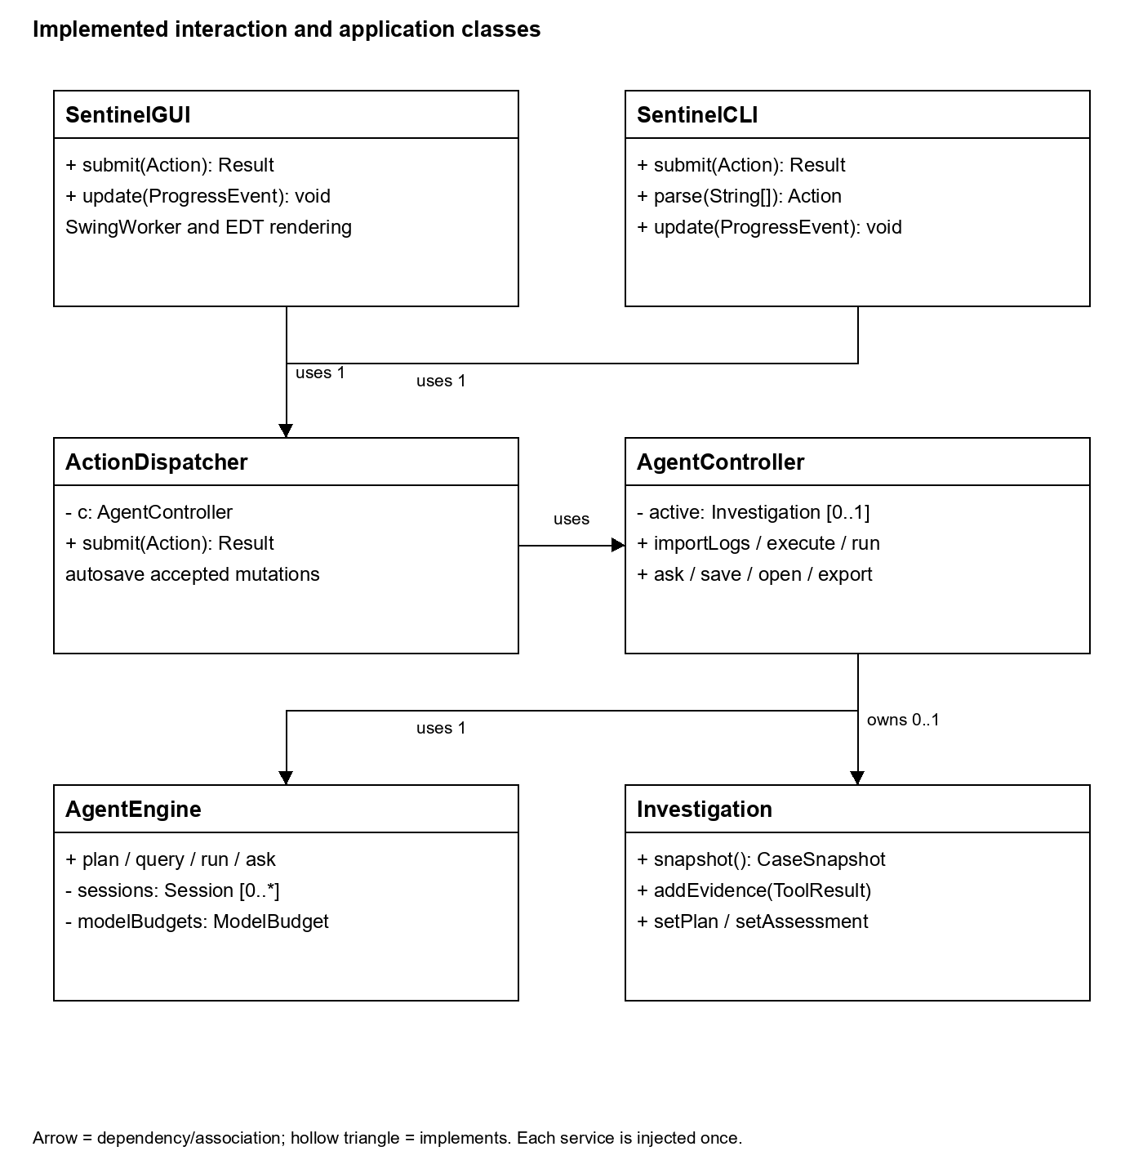
Current UML view interaction

Implemented planning and model class view
Current implementation relationships and key methods. The full PlantUML source includes the additional command, policy, persistence and observer inheritance relationships.
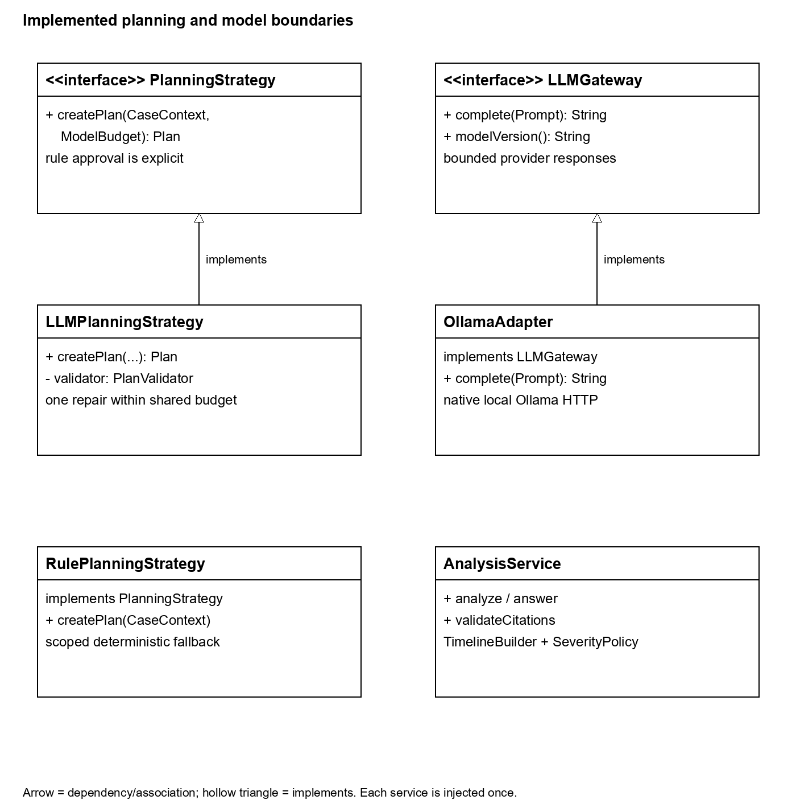
Current UML view analysis

Implemented data and progress class view
Current implementation relationships and key methods. The full PlantUML source includes the additional command, policy, persistence and observer inheritance relationships.
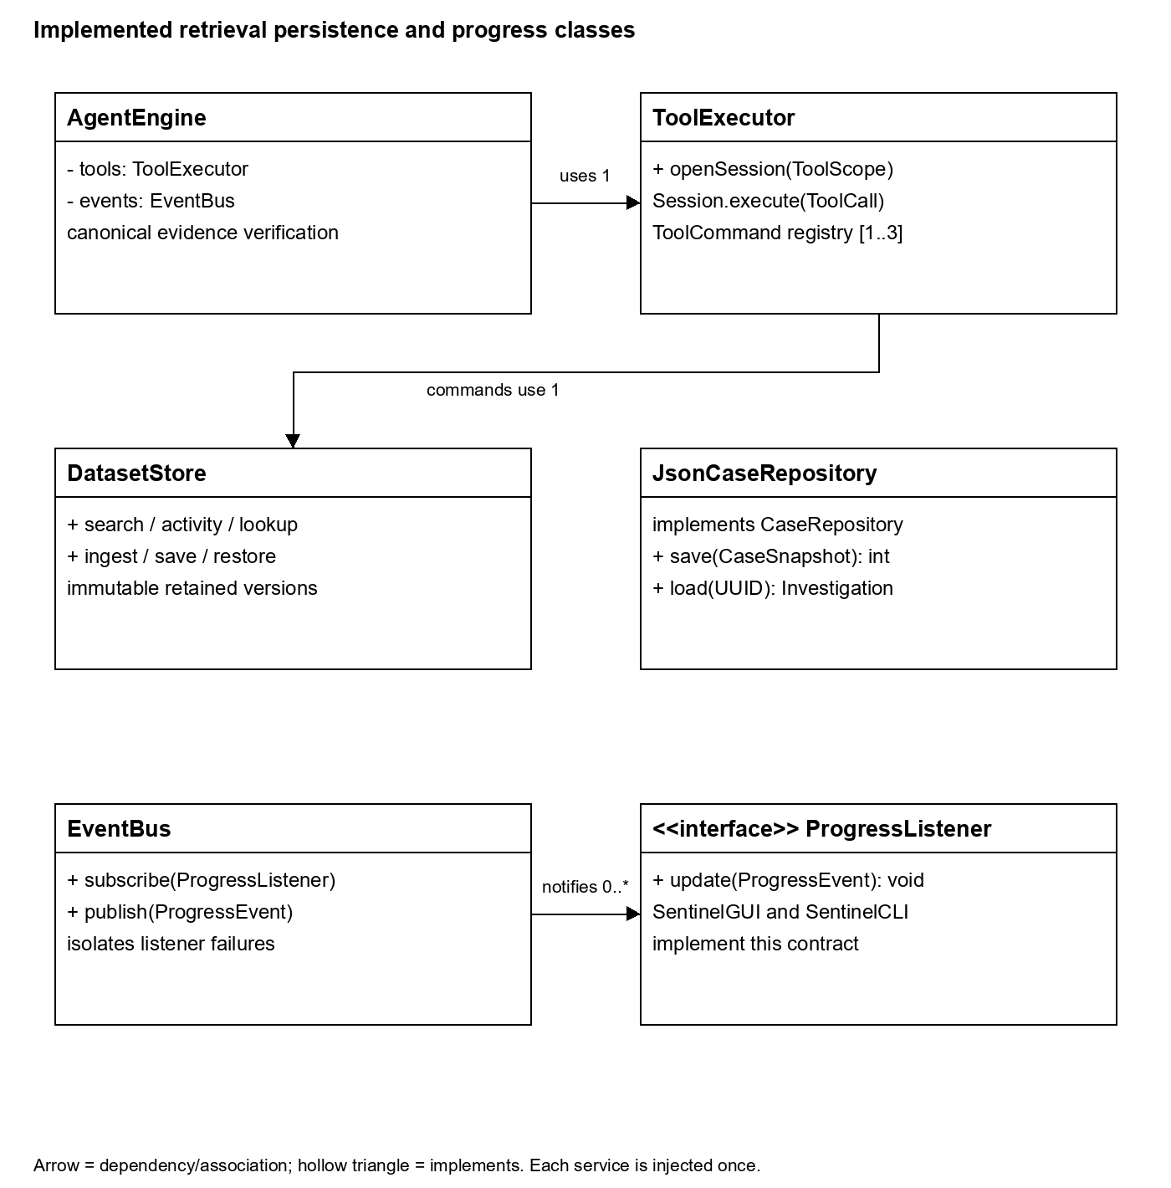
Current UML view data

4 Changes and rationale

Shared controller
Original design to implemented change: ActionDispatcher and ApplicationSession route and compose both views. Reason: Remove duplicate interface business routing. Impact: UC01-UC08; application/presentation packages; MVC unchanged.

Abstract evidence boundary
Original design to implemented change: Explicit target/feed metadata, canonical ResultVerifier and case-bound sessions. Reason: Prevent forged or historical evidence from authorizing enrichment; preserve counters/history. Impact: F02-F05; CaseEvidence, CaseSnapshot, AgentEngine and ToolExecutor; Command unchanged.

Plan act observe loop
Original design to implemented change: Accepted event indicators may extend the inspectable plan within two revisions. Reason: Use observations without restarting collection. Impact: UC04/SD04; AgentEngine.run, Plan, PlanValidator; eight tool attempts and six model calls.

Grounded model synthesis
Original design to implemented change: Compact short reference labels map back to full evidence UUIDs; one bounded repair and fixed severity. Reason: Reduce output latency without weakening source validation. Impact: F07/F09/F10; AnalysisService and LLMGateway. Citations do not establish semantic truth.

Ollama infrastructure
Original design to implemented change: Optional OpenAI-compatible connector and Windows/Linux setup scripts. Reason: Permit provider changes through the existing port; keep local Qwen primary. Impact: ModelSettings, ModelGatewayFactory, adapters and scripts; Adapter preserved, no replacement feature claimed.

JSON storage
Original design to implemented change: Closed record codec, bounded UTF-8, atomic replacement, case locks and retained dataset/feed versions. Reason: Restore provenance and reject malformed/stale case state. Impact: F11; JsonCaseRepository, AtomicFiles, JsonCodec and DatasetStore. Files are separately atomic.

Run and export alternatives
Original design to implemented change: Cooperative stop, explicit partial outcomes and confirmed overwrite. Reason: Preserve accepted evidence and avoid silent replacement. Impact: UC04/UC08; AgentEngine, SentinelGUI and ReportService. Auxiliary controls refine existing features.
No Stage 1 feature or selected pattern was removed. UC01-UC08 remain the analyst goals. docs/uml/runtime-sequences.puml updates orchestration and persistence interactions; scope and failure refinements leave the use-case actors unchanged.

5 AI tools and collaboration log
I directed incremental implementation, confirmed review/testing of Steps 1–21 and authorized their publication. I also authorized publication of the remaining provider/setup and submission changes. Codex generated and integrated code, prompts, tests and documentation; its later regression checks and corrections are distinguished from my own confirmed reviews.
Tool and model | Purpose and major tasks | Known usage and cost
Codex desktop  GPT-6 family | Architecture-guided implementation, setup, domain/data services, planners, tools, adapters, analysis, persistence, orchestration, CLI/Swing, tests and report drafting. Exact model variant for every earlier session is not established. | Three US$20 top-ups = US$60. I reported 1,200 credits above the included Codex allowance, plus additional included allowance of unknown amount. Token totals and remaining balance are unknown.
Ollama 0.40.13  Qwen2.5 7B Instruct Q4_K_M | Local planning, grounded synthesis and follow-up through LLMGateway. Installed tag qwen2.5:7b. Existing GTX 1650 4 GiB; CUDA 12 backend. | No hosted API fee for local inference. Hardware, electricity and subscription allocation are unmeasured. A prior direct diagnostic measured 37 prompt / 10 output tokens; total project usage is unknown.

Credits are not tokens. US$60 records reported purchases, not a measured token-consumption cost or full project cost. No paid hosted inference or fabricated zero-token total is claimed. Further details: docs/ai-tools-and-costs.md.

Representative interactions

Evidence integration
AI contribution: Codex connected the Command invoker, canonical source validation and atomic aggregate attachment, with domain/application tests. Human contribution: I reviewed/tested Step 9 and authorized publication. Outcome: Commit 707d502; isolated publication snapshot passed 245 tests.

Rule and model planning
AI contribution: Codex implemented scope/dependency checks, explicit fallback, bounded requests and fake-server tests. Human contribution: I confirmed review/testing of Steps 10–12 and approved publication. Subsequent regression corrections remain attributed to Codex. Outcome: Published rule/model planning with local Qwen observations recorded separately from deterministic tests.

Completion and failure handling
AI contribution: Codex implemented and integrated timelines, fixed rules, cited synthesis, persistence, orchestration and interfaces, and diagnosed layout, cancellation, validation and replay defects. Human contribution: I requested completion, confirmed review/testing through Step 21 and authorized publication. Outcome: Published connected workflows, regression checks and separately recorded real-model successes and limitations.

6 Development and verification summary
Verification layer | Recorded evidence
Java checks | 516 Java tests passed with zero failures/errors/skips on November 4 using JDK 17 and Maven Wrapper verify. Coverage includes provider settings, provenance, citations, budgets, cancellation, persistence, CLI processes and Swing.
Earlier setup and model work | 18 setup-helper and four replay-helper tests passed using deterministic fixtures. Earlier Ubuntu CPU checks passed 404 Java and 18 setup tests plus real Qwen workflows. No new Linux GPU or paid hosted test is claimed.
Packaged CLI | Separate CLI processes verified persisted creation, import, query, planning, run, follow-up, reopen and export with fake native HTTP. Current real observations are recorded below.
Actual Swing window | Seven automated Swing checks passed without skips on Windows: shared dispatch/saving, EDT progress/responsiveness, latest-query replacement, empty/rejected results and preflight. Earlier actual-window inspection remains separate; no new recording is claimed.
Stage 3 | Full coverage expansion and KUMA behavioral evaluation remain separate Stage 3 work. These Stage 2 checks are not broad agent-reliability evidence.

Historical October 29 Qwen checkpoint: COMPLETE / 7 HIGH with one hypothesis in 30.54 seconds; cited follow-up in 26.14 seconds. Times include JVM startup and are observations, not guarantees.
An earlier November 4 run fell back to CPU. Warm completion passed in 25.97 seconds, while planning and analysis hit the 60-second request limit. Replay helpers now reject incomplete assessments.
A later fresh Windows clone at 13329b5 passed cached setup and live Qwen planning. GUI and CLI both reached COMPLETE / 7 HIGH and verified cited follow-up, export and reopening. The full dependency download was stopped for slow transfer.

Important defects and limits
Regression fixes cover null/schema handling, context limits, cancellation, budgets, query classification and latest-query display. Case evidence remains accumulated; replay checks reject incomplete output. Automated checks are distinct from student review and videos.
Use one dataset writer per process. Case locks do not create a cross-file transaction. Model context is limited to 24 accepted items (larger cases are PARTIAL); related pairs stop at 1000. Resupply critical hosts per CLI process. Citation/scope checks do not prove meaning; language scope detection is incomplete.

Weekly published commit summary
Dates are Toronto local time. Counts include substantive implementation and functional regression-fix commits published to origin/main through November 4. Documentation-only and scaffold commits are excluded. Each listed hash links to its actual published commit.
Period | Toronto dates | Published count
1 | October 20-26 | 5 of 5
2 | October 27-November 2 | 8 of 5
3 | November 3-9 | 12 of 5

Period 1
8f19cb7 f99b454 d98fadf 3a720d4 d476e10

Period 2
8a8866e 49f1976 3125f77 707d502 cdd850f 3fdcc95 cde91a4 550c4ea

Period 3
9e1abd8 addcca1 8c70cc6 feb5dee 76f2200 65abd84 8a12f3e 81ad6fd 8cc0dea b886e58 57985b8 4ef15b1
Each of the three periods meets the five-commit minimum. Period 3 includes functional fixes with regression checks and the provider/setup implementation. Documentation and this report do not add to those code/test counts.

7 Demonstration index
Each feature has separate GUI and CLI recordings, with coverage beginning at 00:00 of the dedicated clip. For F01, F02 and F12, watch GUI Part 1 followed by GUI Part 2. The 27 existing Drive recording links are retained; access details are recorded in docs/demonstration-index.md.
Feature | Demonstration | Recording links
F01 Natural language planning | New case or Generate model plan; CLI new / plan / rule | GUI Part 1  GUI Part 2  CLI
F02 Validated dataset import | Import JSON; CLI import | GUI Part 1  GUI Part 2  CLI
F03 Filtered security log search | logSearch query; CLI query --tool logSearch | GUI  CLI
F04 Threat indicator enrichment | indicatorLookup query; CLI query --tool indicatorLookup | GUI  CLI
F05 Account activity investigation | userActivity query; CLI query --tool userActivity | GUI  CLI
F06 Timeline correlation | Timeline after Run; CLI run / exported report | GUI  CLI
F07 Grounded hypothesis analysis | Hypotheses after Run; CLI run | GUI  CLI
F08 Explainable severity | Assessment after Run; CLI run | GUI  CLI
F09 Response recommendations | Assessment recommendations; CLI run | GUI  CLI
F10 Contextual follow up | Ask and Conversation; CLI ask | GUI  CLI
F11 Persistent cases and history | Save and Open case; CLI save / open / list | GUI  CLI
F12 Report export | Report and Export Markdown; CLI preview / export | GUI Part 1  GUI Part 2  CLI

Setup and short review workflow
Use Python 3.10+ and a full JDK 17+. Windows setup is scripts/setup-qwen.ps1; Linux setup is scripts/setup-qwen.sh. Setup verifies runtime assets, reuses the model and checks Sentinel before optional GUI launch. Earlier native Ubuntu CPU checks passed; no fresh Linux or Linux GPU run is claimed here. Keep .env local and ignored; provider switching requires explicit replacement.
$env:JAVA_HOME = 'C:\Program Files\Java\jdk-17'
.\mvnw.cmd --batch-mode verify
java -jar target/sentinel-0.1.0-SNAPSHOT.jar --check-config
java -jar target/sentinel-0.1.0-SNAPSHOT.jar gui
CLI returns a JSON Result envelope with status and message; structured payloads inside message are JSON text. Progress is on stderr. Exit codes are 0 success, 2 invalid input, 3 operational failure. Supply --case UUID on later invocations. Successful mutations save automatically. A partial run is a successful operation with an explicit PARTIAL assessment. A restored PAUSED case uses resume --case UUID to revalidate its unchanged plan before Run; revision 2 remains revision 2 and no model request is spent.
java -jar target/sentinel-0.1.0-SNAPSHOT.jar new --dataset local --request "Investigate demo" --target demo-analyst --start 2026-10-22T12:00:00Z --end 2026-10-22T13:00:00Z --feed demo-feed-v1 --rule
java -jar target/sentinel-0.1.0-SNAPSHOT.jar import --case UUID --file data/scenarios/account-takeover.json
java -jar target/sentinel-0.1.0-SNAPSHOT.jar rule --case UUID
java -jar target/sentinel-0.1.0-SNAPSHOT.jar run --case UUID
java -jar target/sentinel-0.1.0-SNAPSHOT.jar ask --case UUID --question "Explain the accepted evidence"
java -jar target/sentinel-0.1.0-SNAPSHOT.jar export --case UUID --out runtime/exports/case.md
GUI review: create a case, import the takeover fixture, approve a rule plan or generate a model plan, Run, inspect every result tab, ask a follow-up, save/open, and export. The takeover fixture scores 7 HIGH or 8 when workstation-1 is explicitly declared critical. Model-offline behavior must remain partial; absent analysis never means benign.
References: README.md; docs/feature-implementation-mapping.md; docs/design-patterns.md; docs/implementation-architecture.md; docs/verification-log.md; docs/ai-collaboration-log.md; docs/ai-tools-and-costs.md; docs/uml/implemented-system.puml. Assignment sources: Project-Stage2-Instruction.pdf, Project-Instruction Full.pdf, and the accepted Stage 1 V3 report.

