Sentinel
  - AI Cybersecurity Incident Triage and Investigation Agent
  - Stage 1 Software and Agent Design Report
EECS 3311 Software Design
Section A | Fall 2026
Instructor Song Wang
Prepared by Yegor Sokolov
18 September 2026

Project purpose
Sentinel is a Java cybersecurity-triage agent for simulated incidents. Through equivalent GUI and CLI workflows, it plans investigations, uses approved read-only tools, correlates local evidence, applies deterministic severity rules, and produces cited assessments, follow-up answers, persistent cases, and Markdown reports.

Design coverage
Required area | Included design
Functionality | 12 meaningful features with inputs, outputs, workflows and alternatives
Interactions | 8 detailed use cases and 8 sequence diagrams
Structure | 5 coordinated UML class views with typed methods and multiplicities
Patterns | MVC, Strategy, Command, Observer and Adapter
Additional behavior | UML activity diagram and investigation state model
Traceability | Every feature mapped to use cases, classes, methods, diagrams and patterns
Design status: proposed Stage 1 architecture. Implementation and test results are outside this report.

Table of contents
The sections follow the Stage 1 deliverables. Stable feature, use-case, class-view, sequence, activity, and state identifiers support traceability.
Section | Contents | Page
1 | Project overview and scope | 3
2 | Architecture and interface design | 4
3 | Detailed feature specifications F01 to F12 | 5
4 | UML class model CD01 to CD05 | 9
5 | Design patterns and SOLID principles | 14
6 | Use case model and detailed use cases UC01 to UC08 | 16
7 | Runtime sequence diagrams SD01 to SD08 | 20
8 | Activity and state models | 30
9 | Feature to design traceability and realization | 32
10 | Data contracts and domain rules | 35
11 | Design decisions and disclosure | 36

1 Project overview and scope

Problem and target users
Students and junior security analysts must combine login records, network events, account activity, and indicator context before deciding whether an alert merits escalation. Manual filtering is slow, while a simple chatbot hides its evidence and process.
Sentinel serves a student or analyst in a simulated security operations centre. It makes each retrieval step and conclusion reviewable; the course assessor can also trace features to design artifacts. It is a single-user educational prototype, not a production response system.

Agent responsibilities
The agent scopes the analyst's request, proposes and validates a plan, invokes approved read-only tools, records evidence, builds hypotheses, applies deterministic severity rules, recommends next steps, and answers follow-up questions from saved case context. It exposes uncertainty and never executes containment actions.

Planned AI integration
Sentinel plans to use Qwen2.5 7B Instruct through local Ollama. LLMGateway isolates model-dependent communication, and OllamaAdapter translates typed prompts, responses, timeouts, and failures.
The model supports planning, hypotheses, recommendations, and cited answers. PlanValidator, ToolExecutor, and AnalysisService respectively validate plans, restrict tools, and verify evidence references. RulePlanningStrategy can produce a labelled basic plan when AI planning is unavailable; failed AI analysis remains explicitly unavailable.

Scope boundaries
Included: local JSON import, bundled indicators, natural-language planning, bounded read-only retrieval, timelines, hypotheses, rule-based severity, recommendations, follow-up questions, persistence, and Markdown export through GUI and CLI. Excluded: live enterprise integrations, scanning, exploit or containment execution, multi-user authorization, and cross-case semantic retrieval.
Success scenario. An analyst imports a synthetic account-takeover dataset, investigates a target and interval, reviews cited evidence, timeline, severity, and recommendations, asks a follow-up, saves and reopens the case, and exports the report from either interface.

2 Architecture and interface design

Layers and responsibility boundaries
Layer | Main components | Responsibility
Presentation | SentinelGUI, SentinelCLI | Collect actions; display structured results, progress and errors.
Application | AgentController, AgentEngine | Coordinate user actions and the bounded plan–act–observe loop.
Domain and analysis | Investigation, AnalysisService, TimelineBuilder, SeverityPolicy | Preserve case invariants; interpret evidence; construct repeatable timelines and scores.
Ports and tools | PlanningStrategy, LLMGateway, ToolCommand, CaseRepository | Define replaceable contracts for planning, inference, retrieval and persistence.
Infrastructure | OllamaAdapter, JsonCaseRepository, DatasetStore | Communicate with the local model, persist snapshots and query local data.

Graphical interface
A Java Swing window provides case selection, request and import controls, Plan, Evidence, Timeline, Hypotheses, Assessment, Conversation, and Report tabs, plus Run, Save, and Export actions. Evidence opens its source and provenance; progress and partial results remain visible while background work runs off the event-dispatch thread.

Command line parity
Command form | Corresponding GUI action
sentinel new --request "..." --dataset D | New case and Generate plan
sentinel import --case C --file logs.json | Import dataset
sentinel query --case C --tool T --args JSON | Search logs / Look up indicator / User activity
sentinel run --case C | Run investigation and build assessment
sentinel ask --case C --question "..." | Ask in Conversation tab
sentinel save --case C / open --case C | Save / Open case
sentinel export --case C --out report.md | Export report
The commands are interface contracts. Tool T is logSearch, indicatorLookup, or userActivity. Commands return JSON, write concise progress to stderr, and use exit codes 0 (success), 2 (invalid input), or 3 (operational failure). Each invocation loads the selected case and persists successful mutations.

3 Feature specifications

F01 Natural language investigation planning
Description and classification. Converts an analyst question into an inspectable, bounded evidence-gathering plan. Hybrid.
User interaction. New case -> enter request and dataset -> Generate plan; CLI new.
Input. Request, dataset identifier, target account or indicator, and UTC interval.
Output. A scoped case, validated ToolCalls, and any clarification request.
Expected workflow. AgentController.start creates Investigation or reuses the current DRAFT after accepted fallback. AgentEngine.plan delegates to PlanningStrategy; PlanValidator checks scope, tools, limits, and dependencies. AgentEngine stores the validated plan and records READY.
Errors and alternatives. Missing scope leaves DRAFT pending clarification. An invalid AI draft receives at most one budgeted repair. Model failure or persistent invalid output offers an analyst-approved, labelled rule plan; otherwise the case remains DRAFT.

F02 Validated dataset import
Description and classification. Validates and normalizes local records before atomic ingestion. Deterministic.
User interaction. Import -> choose JSON file -> review summary; CLI import.
Input. UTF-8 JSON event array and active case.
Output. Dataset version, accepted and duplicate counts, and validation errors.
Expected workflow. AgentController.importLogs calls LogImporter.importFile, which validates schema, IDs, types, and timestamps, normalizes UTC values, and stages the batch. DatasetStore.ingest commits it atomically and Investigation.record stores provenance.
Errors and alternatives. Unreadable, oversized, malformed, or conflicting input leaves the prior dataset unchanged. Identical duplicate events count once; conflicting IDs reject the batch.

F03 Filtered security log search
Description and classification. Retrieves scoped events without scanning the full dataset manually. Deterministic.
User interaction. Evidence -> Search -> choose filters; CLI query --tool logSearch.
Input. Filtered ToolCall, dataset version, and result limit.
Output. Matching records, evidence IDs, source locations, and truncation status.
Expected workflow. AgentController.execute delegates to AgentEngine.query; ToolExecutor validates the call and runs LogSearchCommand, which invokes DatasetStore.search. Investigation.addEvidence stores unique results and provenance.
Errors and alternatives. Invalid syntax, reversed times, or unknown datasets return typed errors. No matches is valid; capped results are labelled incomplete and suggest narrower filters.

F04 Threat indicator enrichment
Description and classification. Adds source-dated local threat context to an IP or domain. Deterministic.
User interaction. Evidence -> select indicator -> Look up indicator; CLI query --tool indicatorLookup.
Input. Normalized indicator and threat-feed version.
Output. Verdict, source, observation date, and match status.
Expected workflow. ToolExecutor invokes IndicatorLookupCommand; its select operation calls DatasetStore.lookup and returns a ToolResult that is attached as contextual evidence.
Errors and alternatives. No match is UNKNOWN, not SAFE. Stale dates remain visible, unavailable feeds return an explicit failure, and invalid indicators never reach the store.

F05 Account activity investigation
Description and classification. Summarizes an account's events across hosts and event types. Deterministic.
User interaction. Evidence -> User activity -> choose account and interval; CLI query --tool userActivity.
Input. Account ID, UTC interval, and dataset version.
Output. Ordered events and success, failure, and host counts.
Expected workflow. UserActivityCommand calls DatasetStore.activity and returns account events and source IDs. AgentEngine attaches the ToolResult through Investigation.addEvidence; autonomous plans use the same command.
Errors and alternatives. Unknown accounts return an empty result with coverage stated. Aliases require an explicit mapping, and missing host or location data remains unknown.

F06 Event correlation and timeline construction
Description and classification. Orders evidence and identifies candidate relationships for reconstruction. Deterministic.
User interaction. Timeline -> Build timeline, or Run investigation; CLI run.
Input. Case evidence and normalized events.
Output. UTC timeline with evidence links and related-event groups.
Expected workflow. AnalysisService.analyze calls TimelineBuilder.build, which deduplicates source IDs, sorts by time then event ID, and groups shared accounts or hosts within 15 minutes.
Errors and alternatives. Missing optional fields do not block ordering; conflicts are flagged, out-of-scope events are excluded, and sparse evidence produces a partial timeline. Correlation is not presented as causation.

F07 Evidence grounded hypothesis analysis
Description and classification. Compares candidate explanations against supporting and contradicting evidence. Hybrid.
User interaction. Hypotheses -> Analyze evidence, or Run investigation; CLI run.
Input. Goal, timeline, validated evidence, and prior hypotheses.
Output. Hypotheses with supporting and contradicting IDs, confidence, and limitations.
Expected workflow. AnalysisService prompts through LLMGateway, validates citations, and returns an Assessment containing accepted hypotheses. AgentEngine stores it through Investigation.setAssessment; new evidence marks prior results stale.
Errors and alternatives. Unsupported citations receive one correction attempt. Failure preserves deterministic results and marks AI analysis unavailable; insufficient evidence yields an inconclusive result.

F08 Explainable severity assessment
Description and classification. Applies reproducible severity rules and explains the fixed result. Hybrid.
User interaction. Assessment -> severity and rule breakdown; CLI run result.
Input. Evidence-derived Facts, asset context, and coverage flags.
Output. Score, matched rules, LOW/MEDIUM/HIGH explanation, or UNDETERMINED.
Expected workflow. RuleSeverityPolicy.assess fixes score and level. AnalysisService may ask the model to explain that result but cannot let it change the category; Assessment stores policy version and completeness.
Errors and alternatives. Missing authentication evidence yields UNDETERMINED. Unknown asset criticality scores zero and remains listed; duplicate evidence is not counted twice and partial coverage never implies safety.

F09 Response recommendation with rationale
Description and classification. Proposes evidence-linked next steps for analyst review. Hybrid.
User interaction. Assessment -> Recommended next steps; CLI run result.
Input. Accepted hypotheses, deterministic severity, and evidence gaps.
Output. Prioritized recommendations, reasons, prerequisites, and human decision points.
Expected workflow. AnalysisService requests recommendations in the grounded synthesis, validates their evidence IDs and schema, and includes accepted proposals in the returned Assessment.
Errors and alternatives. Unsupported or out-of-scope actions are rejected. Weak evidence shifts recommendations toward further collection; Sentinel has no command that executes containment.

F10 Contextual follow up investigation
Description and classification. Answers unresolved case questions without discarding established context. Hybrid.
User interaction. Conversation -> ask about the active case; CLI ask.
Input. Case ID, question, scope, and evidence snapshot.
Output. Cited answer, limitations, and any additional read-only evidence.
Expected workflow. AgentEngine.ask decides whether more evidence is needed, reuses validated planning and ToolExecutor when necessary, and calls AnalysisService.answer. The case records the question, answer, and evidence IDs.
Errors and alternatives. Out-of-scope questions require explicit scope revision. Model failure remains visible, and instructions found in retrieved text are treated only as evidence data.

F11 Persistent cases and investigation history
Description and classification. Saves versioned case evidence and decisions for review or resumption. Deterministic.
User interaction. Case list -> Save or Open -> History; CLI save/open.
Input. Active CaseSnapshot or saved case ID.
Output. Durable scope, plan, evidence, assessment, conversation, and audit history.
Expected workflow. AgentController.save obtains Investigation.snapshot and calls CaseRepository.save; JsonCaseRepository uses atomic replacement. On open, the repository validates and restores the aggregate; the controller checks dataset availability and publishes the restored case.
Errors and alternatives. Unsupported schemas and invalid references are rejected. Failed writes preserve the prior version; a reopened RUNNING case becomes PAUSED and requires explicit revalidation before resuming.

F12 Investigation report generation and export
Description and classification. Exports accepted case data and limitations as a shareable report. Deterministic.
User interaction. Report -> Preview and Export Markdown; CLI export.
Input. Case snapshot and destination path.
Output. Markdown scope, plan, evidence, timeline, hypotheses, severity, recommendations, failures, and completeness.
Expected workflow. AgentController.export calls ReportService.export, which formats the immutable snapshot with model, prompt, policy, and dataset versions and writes a stable layout.
Errors and alternatives. Interrupted or unassessed cases export as partial. Write failure does not mutate the case; overwrite requires confirmation, and export never generates new model claims.

4 Class model for interaction and orchestration
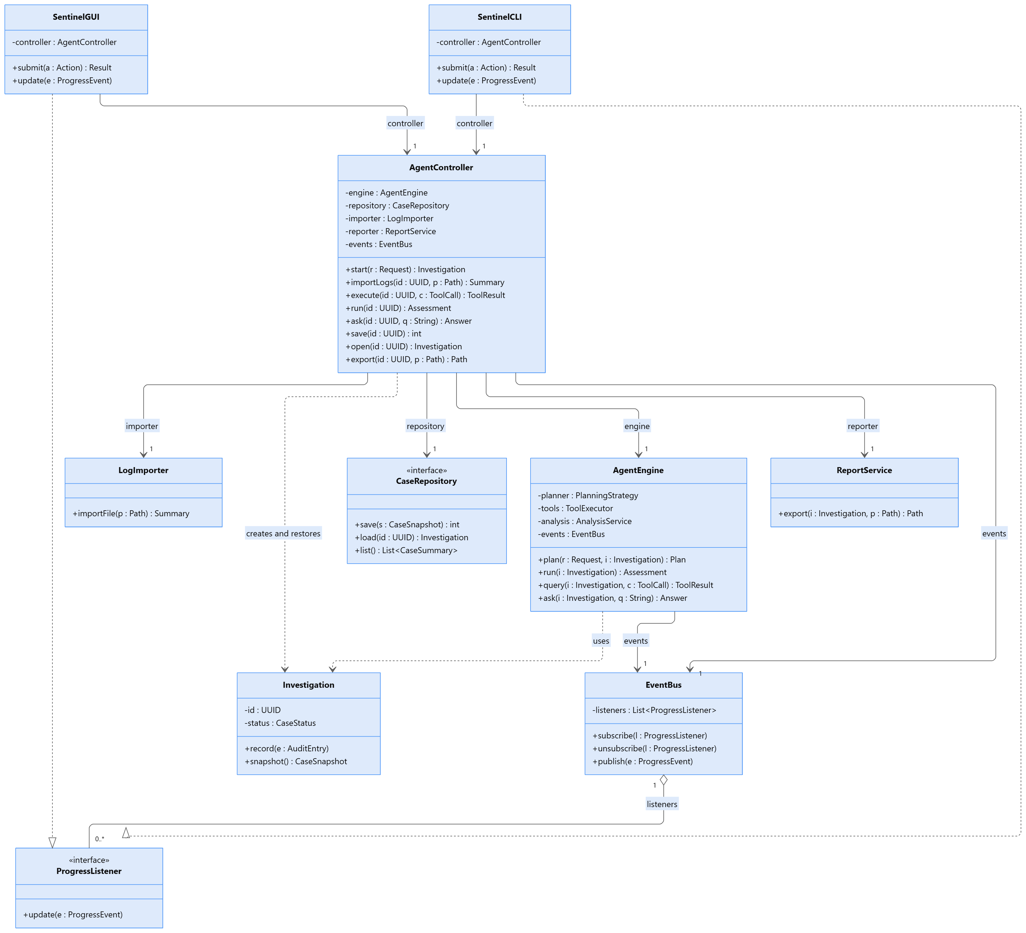
CD01. MVC interaction layer, application controller, engine and Observer roles.
SentinelGUI and SentinelCLI call the same AgentController operations and never access model or data services directly. Injected AgentEngine, repository, importer, and report services keep presentation separate; the prototype runs one investigation at a time.

4 Class model for planning and AI integration
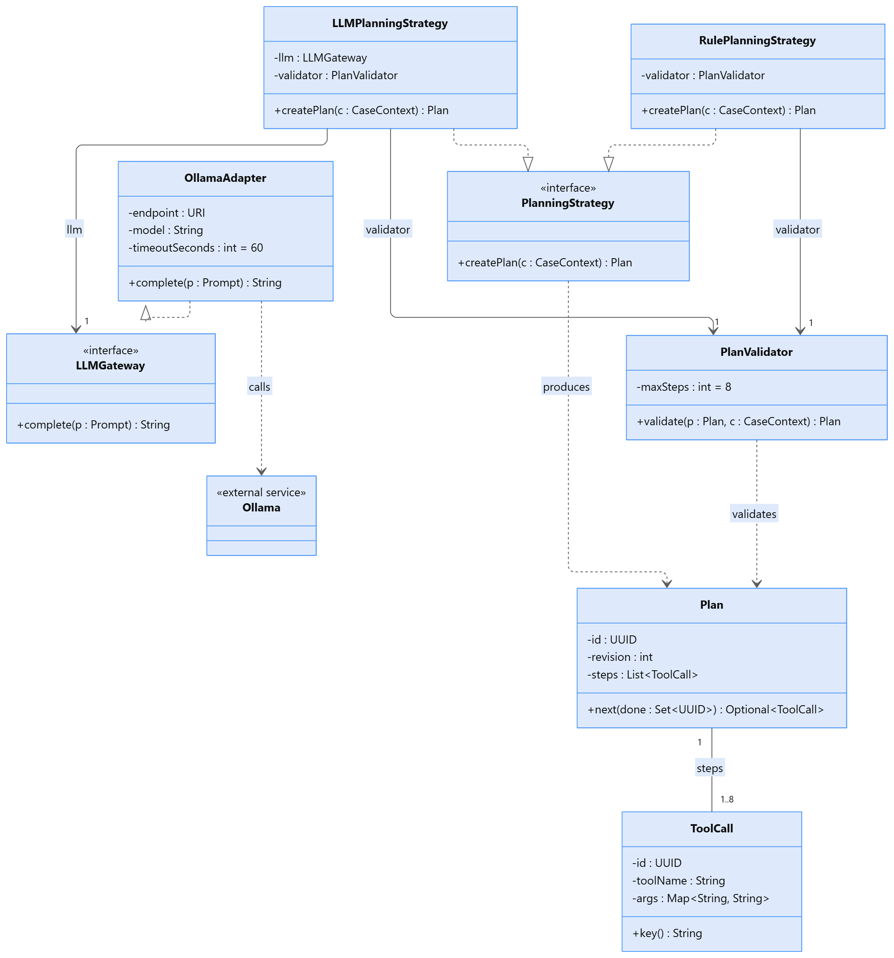
CD02. Strategy variants and Adapter boundary. Each Plan references 1 to 8 immutable ToolCalls.
Ollama is an external service, while immutable Plan and ToolCall values stay inside the application. AgentEngine receives a PlanningStrategy, so AI and rule planning remain interchangeable without changing clients; plans cannot contain arbitrary code or paths.

4 Class model for tools and imported data
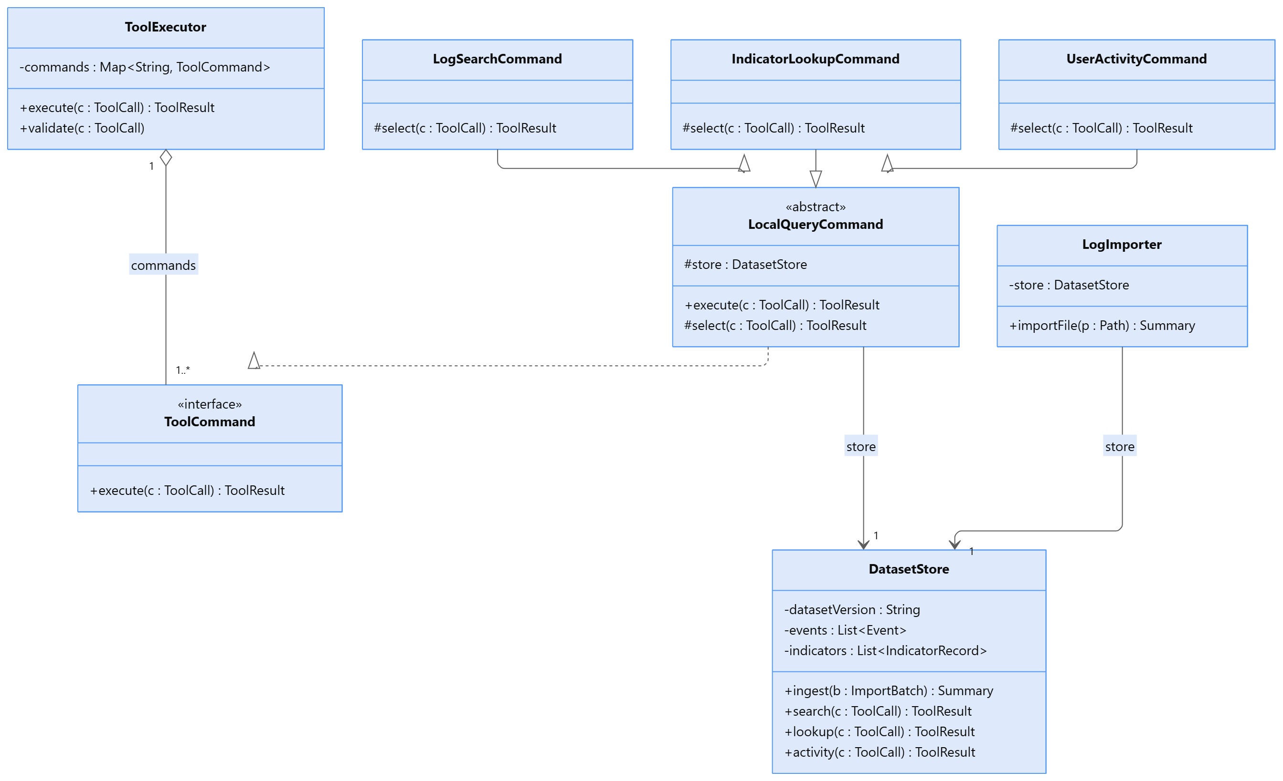
CD03. Command roles, abstract base class generalization and deterministic data access.
ToolExecutor validates registered calls. LocalQueryCommand delegates retrieval to protected select; its stateless subclasses query DatasetStore without UI or case-state logic.

4 Class model for analysis and reports
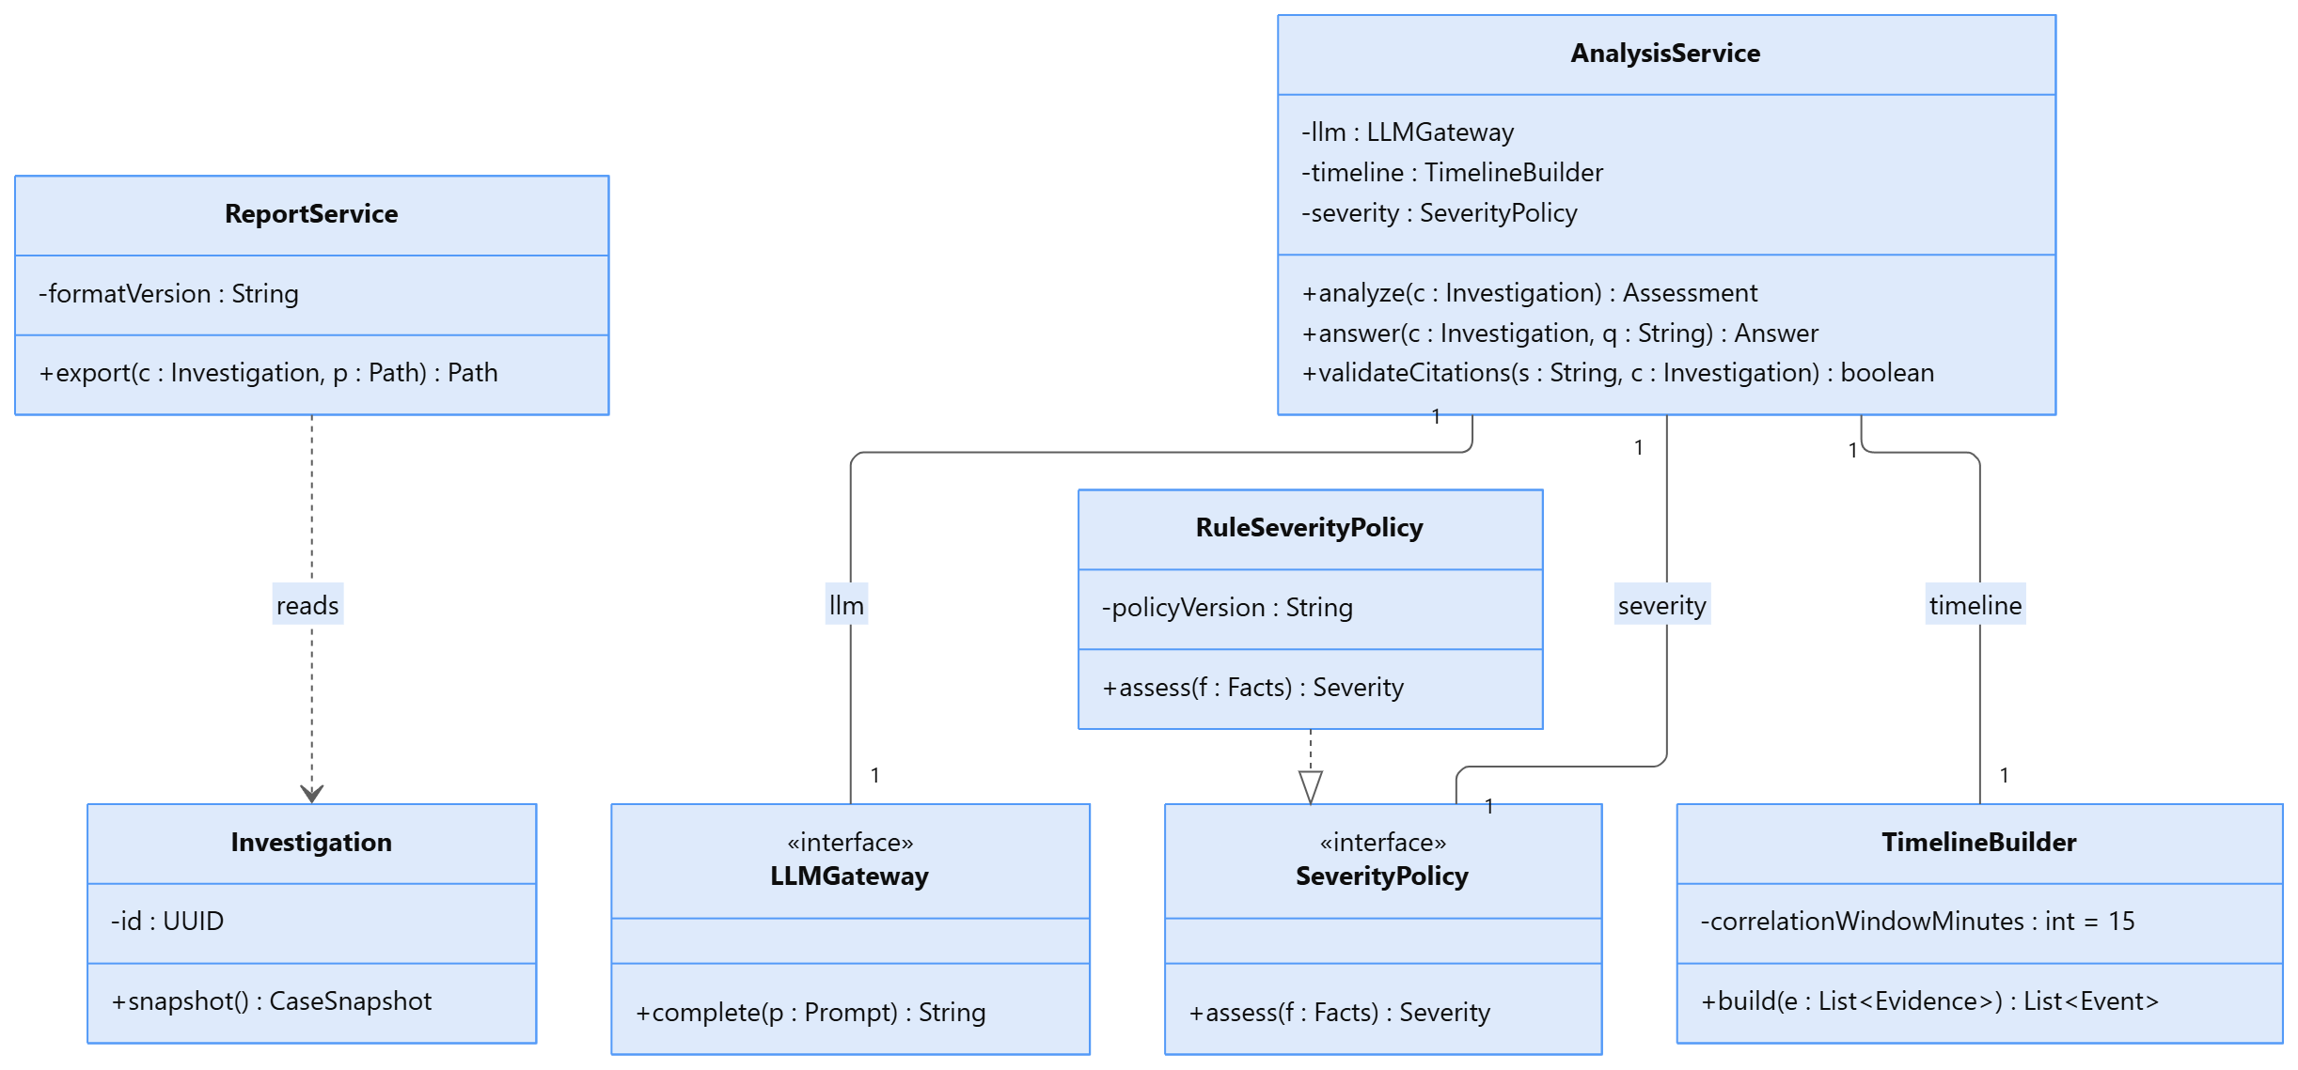
CD04. Analysis combines replaceable inference and severity contracts with deterministic timeline construction.
AnalysisService derives Facts before invoking SeverityPolicy, so model assertions cannot affect scoring. ReportService formats accepted values without an LLM; alternate policies must preserve the same score and completeness contract.

4 Class model for cases and persistence
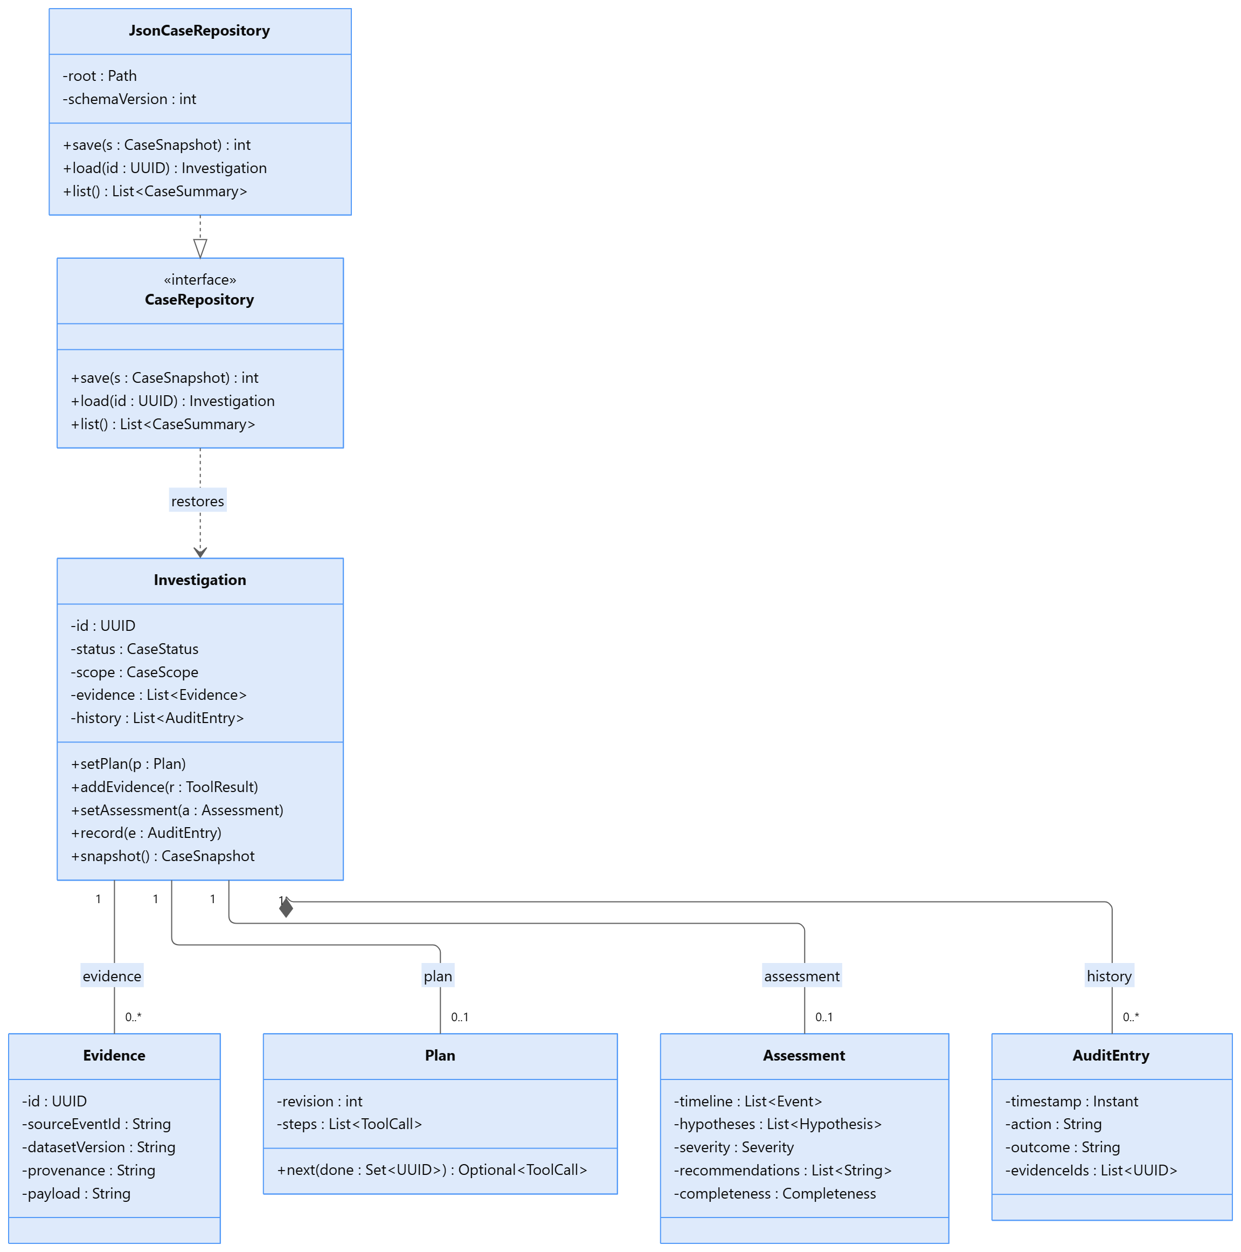
CD05. Investigation aggregate, evidence links, case-owned audit entries and Repository implementations.
Investigation owns AuditEntry lifetimes, while immutable Evidence may be referenced by multiple snapshots without owning source records. Plan and Assessment are replacement values, and CaseRepository restores the complete aggregate and its references.

5 Design patterns and rationale
Five patterns address distinct design needs: MVC separates interfaces from application logic, Strategy varies planning, Command encapsulates tool requests, Observer distributes progress, and Adapter isolates the model service.

MVC
Participants and roles. SentinelGUI and SentinelCLI are views, AgentController is the controller, and Investigation, Plan, Evidence, and Assessment form the model; AgentEngine and AnalysisService provide application services.
Problem and rationale. GUI and CLI require identical workflows without duplicated business logic. MVC keeps input/output in views and invariants in the domain; without it, Swing handlers and CLI parsing would duplicate search and assessment behavior. CD01 and SD01-SD08 show the roles.

Strategy
Participants and roles. AgentEngine is the context; PlanningStrategy is implemented by LLMPlanningStrategy and RulePlanningStrategy, each returning a validated Plan or defined error.
Problem and rationale. Planning must switch between AI and a labelled basic fallback without changing orchestration. Without Strategy, planner-specific conditionals would spread through AgentEngine and the interfaces. CD02 and SD01 show the contract.

Command
Participants and roles. ToolExecutor is the invoker, ToolCommand the contract, LogSearchCommand, IndicatorLookupCommand, and UserActivityCommand the concrete commands, and DatasetStore the receiver.
Problem and rationale. The agent proposes names and arguments, not Java calls. Command enables allow-listed dispatch, shared validation, provenance, and consistent failures for manual and agent retrieval; without it, dispatch and data access would be mixed into AgentEngine. CD03 and SD03-SD04 show the interaction.

5 Patterns and object oriented principles

Observer
Participants and roles. EventBus is the subject, ProgressListener the observer contract, SentinelGUI and SentinelCLI the observers, and AgentEngine or AgentController the publishers.
Problem and rationale. Long-running work must report progress without presentation dependencies. Observer lets either interface subscribe independently; without it, orchestration would depend on Swing or console output. CD01 and SD04 show publication.

Adapter
Participants and roles. LLMGateway is the target, OllamaAdapter the adapter, and local Ollama the external adaptee; planning and analysis depend only on LLMGateway.
Problem and rationale. Adapter contains protocol payloads, timeouts, and service errors behind Prompt and ModelException contracts. A provider can change without rewriting analysis or presentation. CD02, SD01, SD05, and SD06 show the calls.

SOLID and encapsulation
Principle | Application and consequence
Single responsibility | LogImporter validates imports; TimelineBuilder correlates events; ReportService formats output. A formatting change does not change case scoring.
Open closed | New ToolCommand implementations or planners can be registered without changing the engine loop. Registration changes remain in application setup.
Liskov substitution | Every PlanningStrategy returns a validated Plan or defined failure. Every ToolCommand returns ToolResult, including empty matches, or raises ToolException, while preserving read-only semantics.
Interface segregation | LLMGateway has only complete; ProgressListener has only update. Retrieval clients are not forced to implement export or storage methods.
Dependency inversion | The engine depends on PlanningStrategy; analysis on LLMGateway and SeverityPolicy; the controller on CaseRepository. Constructors receive these dependencies.
Encapsulation | Investigation owns status transitions and evidence updates. Collections are returned as immutable snapshots; external code cannot set arbitrary status or alter accepted evidence.
The table summarizes how the design applies SRP, OCP, LSP, ISP, and DIP. Investigation additionally encapsulates lifecycle transitions and exposes immutable snapshots. Inheritance is limited to LocalQueryCommand's safe shared workflow.

6 UML use case model
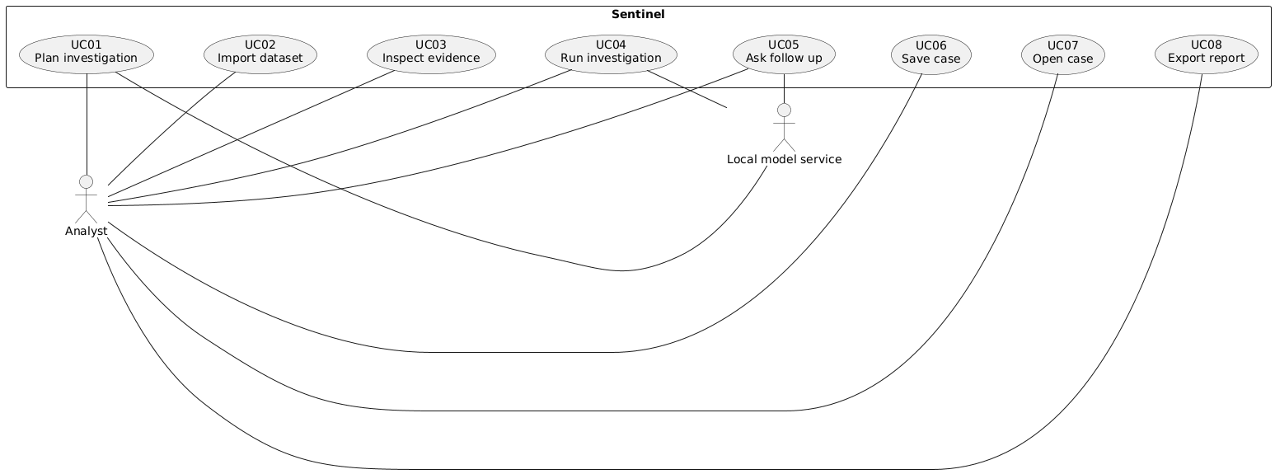
UC diagram. Analyst associations cover GUI and CLI. The local model is an external supporting actor.
UC03 covers F03-F05; UC04 covers bounded retrieval, timeline, hypotheses, severity, and recommendations; UC05 may reuse retrieval for new evidence. The diagram shows user goals, while shared runtime interactions appear in SD01-SD08.

UC01 Plan investigation
Actors and goal. Analyst; local model service supports AI processing. Goal: create a valid, scoped investigation plan.
Preconditions. The application and selected dataset are available.
Trigger. The analyst submits a new request.
Main success scenario. 1. Enter goal, target, interval, and dataset. 2. The interface calls AgentController.start. 3. AgentEngine.plan delegates to PlanningStrategy. 4. PlanValidator accepts scoped, registered steps. 5. Investigation.setPlan stores the plan and the interface shows READY.
Alternative and exception flows. Missing scope leaves DRAFT pending clarification. An invalid AI draft receives at most one budgeted repair. Model failure or persistent invalid output offers a labelled rule fallback. Acceptance replans the same DRAFT; rejection or invalid fallback preserves DRAFT. Planning never executes tools.
Postconditions. Success: READY with a validated plan. Failure: DRAFT with request and error preserved; source data is unchanged.
Related features and sequence. F01; SD01.

UC02 Import dataset
Primary actor and goal. Analyst - add validated local events to a case.
Preconditions. An active case and readable candidate file exist.
Trigger. The analyst chooses Import or runs the import command.
Main success scenario. 1. Supply case and path. 2. AgentController.importLogs calls LogImporter.importFile. 3. The importer validates and normalizes a staged batch. 4. DatasetStore.ingest commits it and versions the dataset. 5. The case records and displays the summary.
Alternative and exception flows. Unreadable, oversized, malformed, conflicting, or failed writes leave the prior dataset unchanged. Importing after assessment marks that assessment stale.
Postconditions. Success: versioned records with provenance. Failure: no partial batch is visible.
Related features and sequence. F02; SD02.

UC03 Inspect evidence
Primary actor and goal. Analyst - search logs, enrich an indicator, or inspect account activity.
Preconditions. The case has valid scope and a selected dataset version.
Trigger. The analyst submits an Evidence query or CLI query.
Main success scenario. 1. Choose a tool and arguments. 2. AgentController.execute calls AgentEngine.query. 3. ToolExecutor validates and selects a registered ToolCommand. 4. The command queries DatasetStore. 5. Investigation stores evidence and provenance; the interface displays completeness.
Alternative and exception flows. Invalid tools or arguments are refused. No match returns empty or UNKNOWN; failures preserve prior evidence; truncation warns and offers narrower filters.
Postconditions. Success: inspectable audit-linked evidence. Failure: no unsupported result is added; new evidence makes prior assessment stale.
Related features and sequences. F03-F05; SD03-SD04.

UC04 Run investigation
Actors and goal. Analyst; local model service supports AI processing. Goal: collect relevant evidence and produce justified triage.
Preconditions. The case has a valid plan and accessible dataset version.
Trigger. The analyst selects Run investigation.
Main success scenario. 1. AgentController.run invokes AgentEngine.run and records RUNNING. 2. ToolExecutor executes approved calls; AgentEngine records evidence and outcomes. 3. The planner may revise remaining steps within budget. 4. AnalysisService returns timeline, deterministic severity, and validated synthesis. 5. AgentEngine stores the assessment and records COMPLETED or PARTIAL.
Alternative and exception flows. A transient failure permits one budgeted retry. Duplicate or invalid calls are not repeated unchanged. Exhausted budgets or unavailable required AI output produce PARTIAL; fatal data failures produce FAILED with evidence preserved.
Postconditions. Evidence and an assessment or explicit partial/failure outcome are stored; datasets remain read-only.
Related features and sequences. F03-F09; SD04-SD05.

UC05 Ask follow up
Actors and goal. Analyst; local model service supports AI processing. Goal: answer a case-specific question from inspectable evidence.
Preconditions. An active case with established scope exists.
Trigger. The analyst sends a follow-up question.
Main success scenario. 1. The interface calls AgentController.ask. 2. AgentEngine.ask checks scope and prepares context. 3. It reuses bounded planning and retrieval if needed. 4. AnalysisService.answer returns a validated Answer. 5. AgentEngine records the question and outcome; the interface displays citations and limitations.
Alternative and exception flows. Out-of-scope questions require explicit scope revision without retrieval. Missing evidence is stated. Invalid drafts permit at most one budgeted repair; unavailable or unsupported output produces a recorded failure rather than an invented answer.
Postconditions. Success: grounded answer and any new evidence are recorded. Failure: the question and failure remain without an invented answer.
Related features and sequences. F10; SD06, reusing SD04 when necessary.

UC06 Save case
Primary actor and goal. Analyst - preserve a reproducible case and history.
Preconditions. An active Investigation exists.
Trigger. The analyst selects Save; successful CLI mutations also save.
Main success scenario. 1. AgentController.save requests Investigation.snapshot. 2. The snapshot captures scope, plan, evidence, conversation, versions, and audit history. 3. CaseRepository.save delegates serialization to JsonCaseRepository. 4. Atomic replacement writes the new version. 5. The interface confirms ID and version.
Alternative and exception flows. Serialization, permission, disk, or stale-version failures preserve in-memory state and the prior durable copy and leave the case marked unsaved.
Postconditions. Success: the new version is durable. Failure: the previous version remains available.
Related features and sequence. F11; SD07.

UC07 Open case
Primary actor and goal. Analyst - restore saved evidence and continue safely.
Preconditions. A saved case exists in the configured directory.
Trigger. The analyst selects or supplies its ID.
Main success scenario. 1. AgentController.open calls CaseRepository.load. 2. The repository validates schema, IDs, and references. 3. It restores Investigation, converting saved RUNNING to PAUSED. 4. The controller checks dataset availability. 5. The interface presents restored scope, evidence, history, and assessment.
Alternative and exception flows. Corrupt snapshots preserve the active case. A missing dataset permits viewing and export but disables retrieval until restored; Run explicitly revalidates unfinished calls.
Postconditions. Success: the case is active without automatic execution. Failure: no invalid case is loaded.
Related features and sequence. F11; SD07.

UC08 Export report
Primary actor and goal. Analyst - export an inspectable investigation report.
Preconditions. An active case and destination exist.
Trigger. The analyst chooses Export report.
Main success scenario. 1. The interface calls AgentController.export. 2. ReportService obtains an immutable snapshot. 3. It renders scope, plan, evidence, timeline, assessment, and limitations. 4. It writes Markdown with a completeness label. 5. The interface reports the path.
Alternative and exception flows. Missing assessment produces a partial evidence report. Existing files require overwrite approval; write failures preserve the case and prior destination. Export never calls the model.
Postconditions. Success: a report for a specific case version exists. Failure: no successful export is claimed.
Related features and sequence. F12; SD08.

7 SD01 Planning a new investigation
SD01. Planning a new investigation.
UC01 / F01. The next panel expands the AI createPlan call; fallback uses the same PlanValidator contract.

SD01.2 AI planning detail
SD01.2 AI planning detail. Expansion of the preceding sequence call.

7 SD02 Importing and validating local records
SD02. Importing and validating local records.
UC02 / F02. Validation completes before atomic DatasetStore ingestion.

7 SD03 Analyst driven evidence retrieval
SD03. Analyst driven evidence retrieval.
UC03 / F03-F05. Manual and agent retrieval share ToolCommand validation and provenance.

7 SD04 Bounded tool execution and observation
SD04. Bounded tool execution and observation.
UC04 / F03–F09. UC03 and UC05 reuse retrieval interactions. Retry, revision, and model-call limits are defined in Section 8; SD05 expands the assessment step.

7 SD05 Timeline and evidence based triage
SD05. Timeline and evidence based triage.
UC04 / F06-F09. Rules consume observed Facts; AI synthesis may explain but cannot replace deterministic severity.

7 SD06 Answering a follow up question
SD06. Answering a follow up question.
UC05 / F10. The next panel expands answer validation; AgentEngine records both accepted and failed outcomes.

SD06.2 Answer validation detail
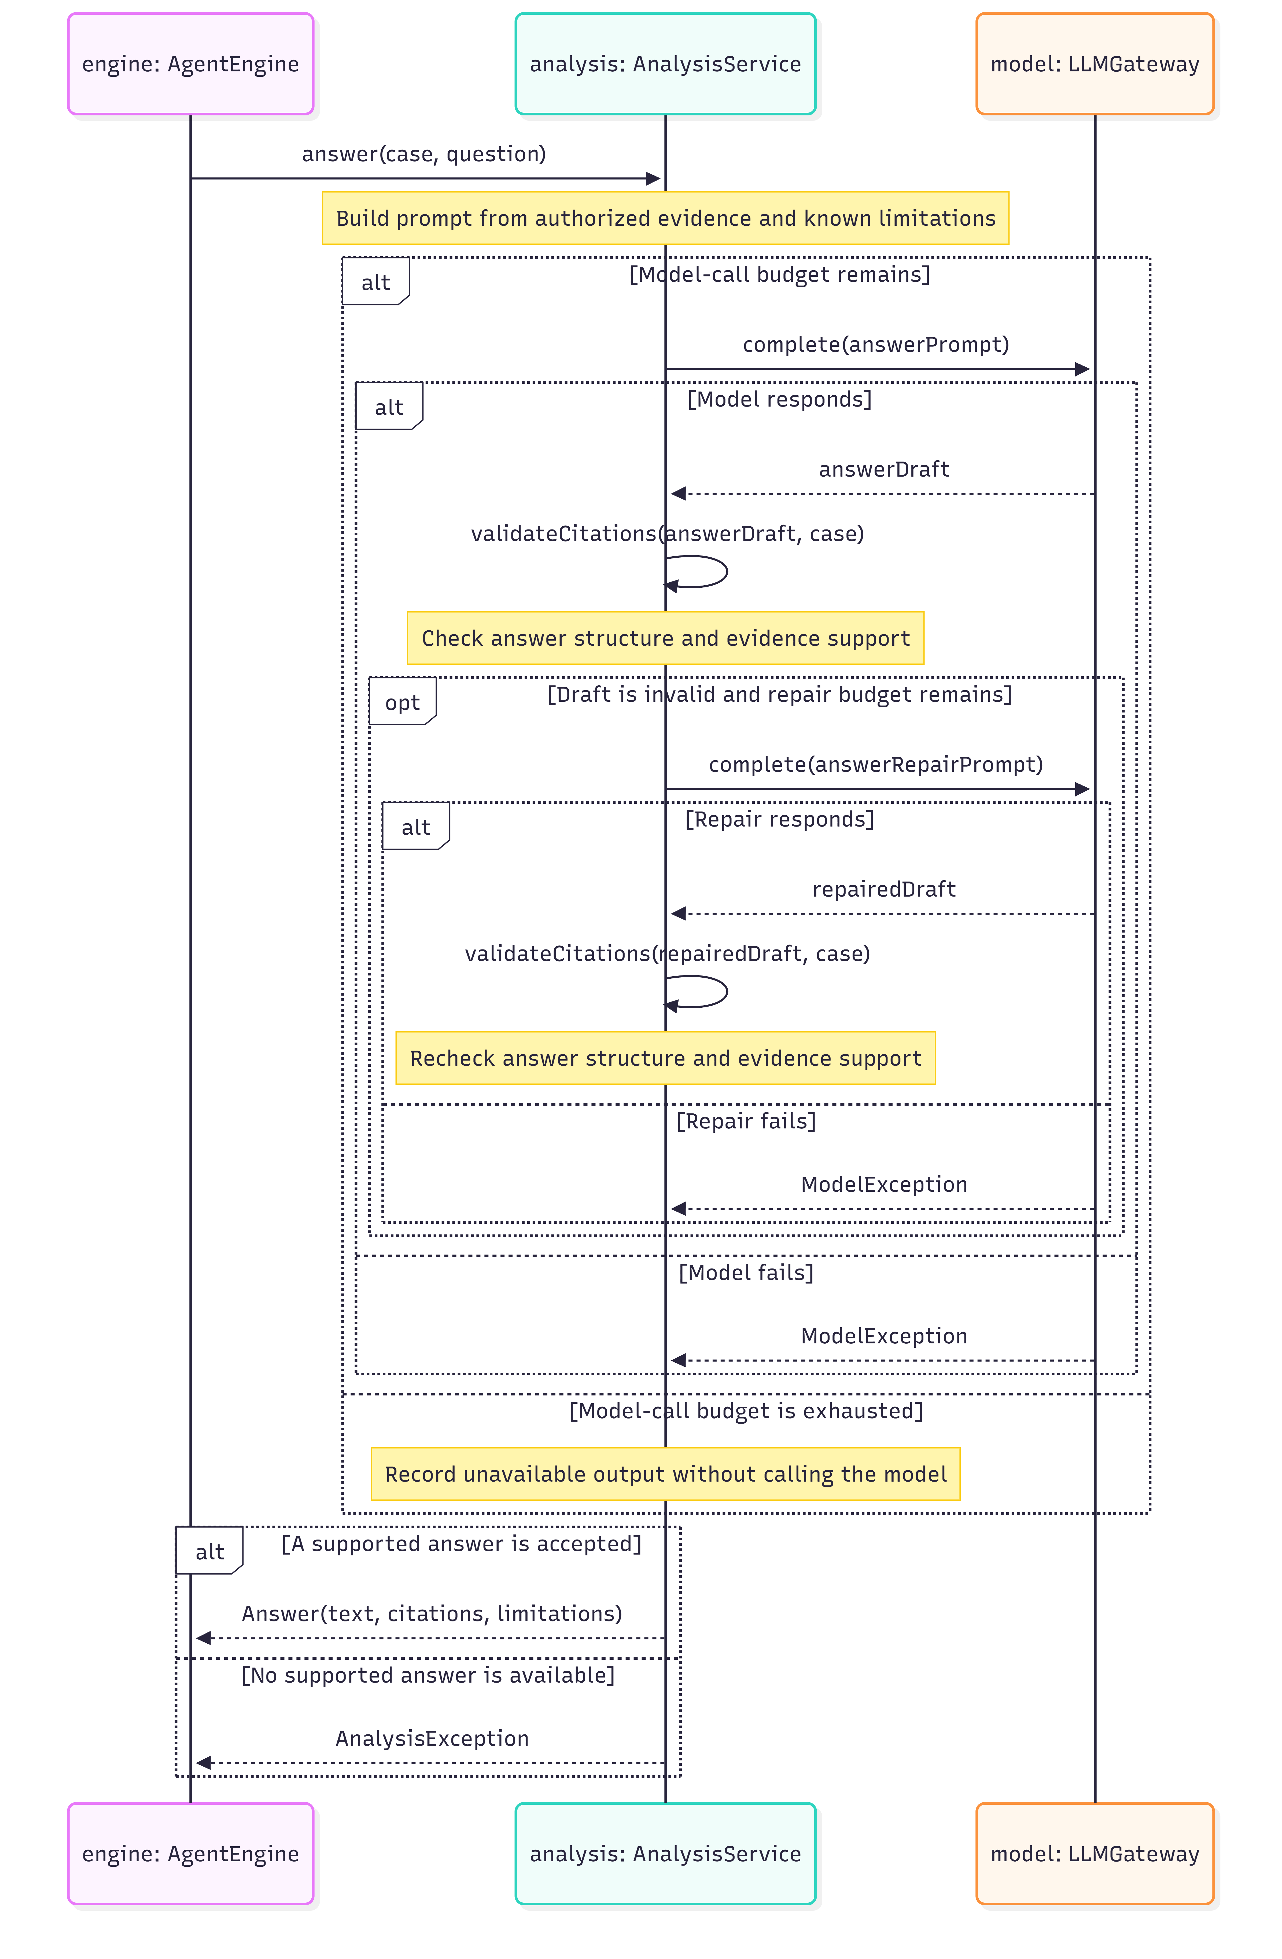
SD06.2 Answer validation detail. Expansion of the preceding sequence call.

7 SD07 Saving and restoring a case
SD07. Saving and restoring a case.
UC06-UC07 / F11. Repository failures preserve the prior case and never resume execution automatically.

7 SD08 Generating an investigation report
SD08. Generating an investigation report.
UC08 / F12. Export formats the snapshot deterministically and labels partial or stale assessments.

8 Investigation activity model
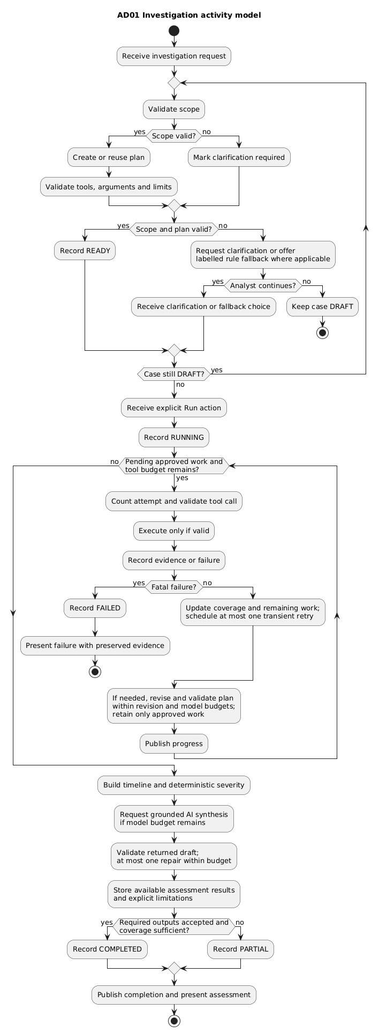
AD01. Activity model for UC01 and UC04. Guards control clarification, iteration and completion.
AD01 summarizes planning and explicit execution. The detailed interactions appear in SD01, SD04, and SD05.

8 Case state model and execution limits
SM01. Investigation lifecycle and guarded transitions.
Investigation.record applies guarded lifecycle transitions. Reopened RUNNING cases become PAUSED. Completed cases return to READY after successful revalidation, or DRAFT when revised scope or planning needs clarification. Viewing and export remain available in every state.

Bounded autonomy and recovery
Each run permits 8 tool attempts including retries, 2 plan revisions, and 6 model calls including repairs. All model requests share the budget; exhaustion skips further model work and preserves a partial result. Proposed timeouts are 10 seconds per tool and 60 seconds per model call. At most one transient retry is allowed; invalid or duplicate calls are not repeated unchanged. Progress exposes stages, outcomes, and evidence references.

9 Traceability F01 to F04
All GUI and CLI actions enter AgentController. The matrices identify each feature's use case, classes, methods, sequence diagram, and patterns; concrete commands may inherit execute from LocalQueryCommand.
Feature and type | Use case and sequence | Classes | Key methods and patterns
F01 Investigation planning  Hybrid | UC01  SD01 | AgentController  AgentEngine  PlanningStrategy  LLMPlanningStrategy  RulePlanningStrategy  LLMGateway  PlanValidator  Investigation | start, plan, createPlan, complete, validate, setPlan  Patterns: MVC; Strategy; Adapter
F02 Dataset import  Deterministic | UC02  SD02 | AgentController  LogImporter  DatasetStore  Investigation | importLogs, importFile, ingest, record  Patterns: MVC
F03 Log search  Deterministic | UC03; UC04  SD03; SD04 | AgentEngine  ToolExecutor  LogSearchCommand  DatasetStore  Investigation | query, execute, validate, select, search, addEvidence  Patterns: MVC; Command
F04 Indicator enrichment  Deterministic | UC03; UC04  SD03; SD04 | AgentEngine  ToolExecutor  IndicatorLookupCommand  DatasetStore  Investigation | query, execute, select, lookup, addEvidence  Patterns: MVC; Command

Feature realization
F01. AgentController creates or reuses the current DRAFT; AgentEngine selects the planner, validates the returned plan through its strategy, and stores it through Investigation.setPlan.
F02. LogImporter validates and normalizes, DatasetStore commits atomically, and Investigation records the dataset version and counts.
F03. ToolExecutor validates LogSearchCommand, DatasetStore.search returns provenance and completeness, and Investigation stores unique evidence.
F04. IndicatorLookupCommand returns a versioned DatasetStore verdict while preserving UNKNOWN, unavailable, and stale states.

9 Traceability F05 to F08
Feature and type | Use case and sequence | Classes | Key methods and patterns
F05 Account activity  Deterministic | UC03; UC04  SD03; SD04 | AgentEngine  ToolExecutor  UserActivityCommand  DatasetStore  Investigation | query, execute, select, activity, addEvidence  Patterns: MVC; Command
F06 Correlation and timeline  Deterministic | UC04  SD04; SD05 | AgentController  AgentEngine  AnalysisService  TimelineBuilder  Investigation | run, analyze, build, setAssessment  Patterns: MVC
F07 Hypothesis analysis  Hybrid | UC04  SD05 | AgentEngine  AnalysisService  LLMGateway  OllamaAdapter  Investigation | run, analyze, complete, validateCitations, setAssessment  Patterns: MVC; Adapter
F08 Severity assessment  Hybrid | UC04  SD05 | AnalysisService  SeverityPolicy  RuleSeverityPolicy  LLMGateway  Investigation | analyze, assess, complete, setAssessment  Patterns: MVC; Adapter

Feature realization
F05. UserActivityCommand queries DatasetStore.activity and returns account events and source IDs for display and correlation.
F06. AgentEngine invokes AnalysisService, whose TimelineBuilder produces the stable timeline stored in Assessment.
F07. AnalysisService uses LLMGateway and validates citations; AgentEngine stores the returned Assessment containing accepted hypotheses and limitations.
F08. RuleSeverityPolicy fixes score and level before optional AI explanation; Assessment preserves rule IDs and coverage.

9 Traceability F09 to F12
Feature and type | Use case and sequence | Classes | Key methods and patterns
F09 Response recommendation  Hybrid | UC04  SD05 | AnalysisService  LLMGateway  OllamaAdapter  Investigation | analyze, complete, validateCitations, setAssessment  Patterns: MVC; Adapter
F10 Follow up investigation  Hybrid | UC05  SD06; SD01; SD04 | AgentController  AgentEngine  PlanningStrategy  ToolExecutor  AnalysisService  LLMGateway  Investigation | ask, plan, createPlan, execute, answer, complete, record  Patterns: MVC; Strategy; Command; Adapter
F11 Case persistence and history  Deterministic | UC06; UC07  SD07 | AgentController  Investigation  CaseRepository  JsonCaseRepository  EventBus  ProgressListener | save, open, snapshot, load, record, publish, update  Patterns: MVC; Observer
F12 Report export  Deterministic | UC08  SD08 | AgentController  ReportService  Investigation | export, snapshot  Patterns: MVC

Feature realization
F09. AnalysisService includes validated recommendations in Assessment; AgentEngine stores the result. Recommendations never execute response actions.
F10. AgentEngine.ask reuses bounded planning and retrieval, calls AnalysisService.answer, and records the question and accepted answer or failure outcome.
F11. Investigation snapshots through CaseRepository; JsonCaseRepository validates, versions, and atomically saves or loads the aggregate.
F12. ReportService formats the immutable snapshot, versions, evidence IDs, and completeness without invoking the model.

10 Data contracts and domain rules

Core records
Value type | Required contract
Request and CaseScope | Goal, dataset ID/version, target account or indicator, UTC start/end. End must not precede start. Scope changes are explicit and audit-recorded.
Event | eventId, timestamp, eventType; nullable accountId, sourceIp, hostId and outcome where unavailable. Original source position and dataset version remain recoverable.
ToolCall and ToolResult | Call: registered tool name, typed arguments and stable ID. Result: status, data, evidence references, source version, duration and truncation flag. Empty is distinct from failed.
Facts and Severity | Facts contain deterministic predicates plus supporting event IDs. Severity contains score, level, contributing rule IDs, policy version and coverage limitations.
Hypothesis and Answer | Text, supporting/contradicting evidence IDs, qualitative confidence and limitations. Confidence is a model judgement, not a calibrated probability.
CaseSnapshot | Schema and case version, scope, plans, evidence, assessment, conversation, audit entries, model/prompt/policy versions and dataset reference. No API credentials.
AuditEntry and ProgressEvent | Audit entries persist case actions and outcomes. Progress events notify views and can be discarded after display; they are not the durable audit store.

Proposed severity policy version 1
Each rule contributes at most once per assessment, using unique source event IDs. Scores are educational heuristics for the simulated dataset, not an industry standard or a probability of compromise.
Rule | Observed condition | Points
R1 | At least 5 failed logins for one account within any 10-minute window. | +2
R2 | A successful login follows that qualifying burst within 10 minutes for the same account. | +3
R3 | A login source IP matches a malicious record in the selected local feed. | +2
R4 | A supplied inventory marks an affected host as critical. | +1
LOW = 0–2; MEDIUM = 3–5; HIGH = 6–8. No usable authentication evidence yields UNDETERMINED. Missing optional facts contribute zero and remain listed as unknown. A qualifying burst followed by success from a malicious IP scores 2 + 3 + 2 = 7, hence HIGH.

11 Design decisions and disclosure

Decisions and tradeoffs
Java and Swing support an object-oriented desktop design, while one controller preserves GUI/CLI parity. JSON snapshots keep course-scale persistence simple behind CaseRepository. Read-only local datasets provide repeatability and prevent the agent from changing a live environment.
Local Ollama avoids a required paid API but may require model substitution through LLMGateway. Citation checks establish that evidence exists and is in scope, not that every interpretation is correct; hypotheses and recommendations therefore remain analyst-reviewable. The five selected patterns solve specific variation and coupling problems without adding artificial hierarchies.

AI assistance disclosure
ChatGPT assisted with architecture design, report drafting, and consistency review. I have reviewed and revised all results. Diagrams were visualized with Mermaid and PlantUML.

