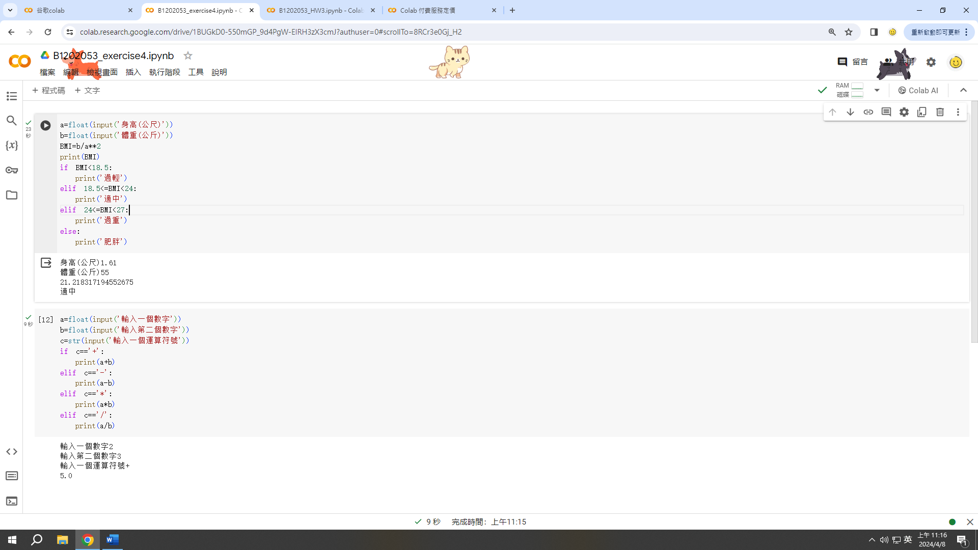

https://github.com/yeh-yan-jane/PLMA/upload/main