


A Double-Entry Accounting System

General Ledger, Accounts Payable & Receivable
LedgerCore


Name | Role | Responsibilities
Yehia --- | Team Lead / --- | ---
Eman Ibrahim | --- | --- / ERD Diagram/ Documentation
Ahmed Eman | --- | ---
Ahmed Mohammad | --- | ---
Ali Mohamed | --- | ---




Table of Contents
- Project Overview
  - Problem Statement
  - Proposed Solution
- System Analysis
  - Stakeholders
  - Target Users
  - Functional Requirements
  - Non-Functional Requirements
  - System Scope
- System Design
  - Use Case Diagram
  - Class Diagram
  - Entity Relationship Diagram (ERD)
- Technical Architecture
  - N-Tier Architecture Pattern
  - Design Patterns Used
  - Technology Stack & Libraries
- API Endpoints Specification
- Conclusion

Project Description & Problem Statement

Problem Statement
Small to medium-sized service-based businesses (consultancies, freelancers, legal firms) often rely on spreadsheets or disconnected software for financial tracking. This leads to several critical issues:
- Data Integrity Risks: Manual entry in Excel lacks double-entry validation, leading to unbalanced books and undetected errors.
- Inefficient Receivables/Payables Tracking: Businesses lose track of unpaid invoices or upcoming bills, impacting cash flow.
- Lack of Real-Time Reporting: Generating a Balance Sheet or Income Statement manually is time-consuming and prone to formula errors.
- Audit Difficulty: Tracking changes and maintaining a clear general ledger history is difficult without a proper transactional database.

Proposed Solution
LedgerCore is a secure, web-based accounting application built with ASP.NET Core. It automates the double-entry bookkeeping cycle, ensuring every financial transaction is balanced. The system focuses on core financial health by managing:
- General Ledger: The central repository of all financial transactions.
- Accounts Payable (AP): Tracking vendor bills and payments.
- Accounts Receivable (AR): Tracking customer invoices and collections.
The system guarantees data consistency using the Unit of Work pattern and provides management with instant access to standard financial reports (Trial Balance, Income Statement, Balance Sheet).

System Analysis

1. Stakeholders
- Business Owners/Management: Require accurate financial reports for decision-making.
- Accountants/Bookkeepers: Daily users who enter invoices, payments, and reconcile accounts.
- Auditors: Require read-only access to the general ledger and transaction history.
- Developers: The technical team maintaining the codebase (benefits from N-Tier separation).

2. Target Users
- Accountant Role: Full permissions to create, edit, and post journal entries.
- Manager Role: View permissions for all reports and dashboards; ability to close financial periods.
- Auditor Role: Read-only access to all financial data.

3. Functional Requirements
- FR-01: The system shall allow the creation of a Chart of Accounts (Assets, Liabilities, Equity, Revenue, Expenses).
- FR-02: The system must enforce Double-Entry validation (Debits must equal Credits) before saving any Journal Entry.
- FR-03: Users shall be able to create Vendor Bills (AP) and Customer Invoices (AR).
- FR-04: Users shall be able to record payments against open AP Bills and AR Invoices.
- FR-05: The system shall generate a Trial Balance report for any specified date.
- FR-06: The system shall generate an Income Statement (Profit & Loss) for a date range.
- FR-07: The system shall generate a Balance Sheet as of a specific date.
- FR-08: Admin shall have access to a dashboard displaying Aged Payables and Aged Receivables.

4. Non-Functional Requirements
- NFR-01 (Security): Authentication and role-based authorization shall be managed by ASP.NET Core Identity.
- NFR-02 (Data Integrity): All financial postings must be atomic using the Unit of Work pattern to prevent partial updates.
- NFR-03 (Performance): General Ledger queries shall load within 2 seconds for up to 10,000 records via server-side pagination (DataTables).
- NFR-04 (Usability): The interface shall be responsive and accessible on desktop and tablet browsers using Bootstrap.

5. System Scope
In Scope:
- Double-Entry General Ledger.
- Accounts Payable (Vendor Bills, Payments).
- Accounts Receivable (Customer Invoices, Receipts).
- Financial Reporting (Trial Balance, P&L, Balance Sheet).
Out of Scope (for this version):
- Inventory Management / Stock Tracking (per project requirement change).
- Payroll Processing.
- Multi-Currency Transactions.

6. Use Cases
Use Case ID | Name | Actor | Description
UC-01 | Create Journal Entry | Accountant | User enters a transaction with equal debits and credits. System posts to GL.
UC-02 | Enter Vendor Bill | Accountant | User records a bill from a vendor. System credits AP and debits Expense.
UC-03 | Pay Bills | Accountant | User selects outstanding bills and records a payment. System debits AP and credits Cash.
UC-04 | View Balance Sheet | Manager | User selects a date and views the organization's Assets, Liabilities, and Equity.

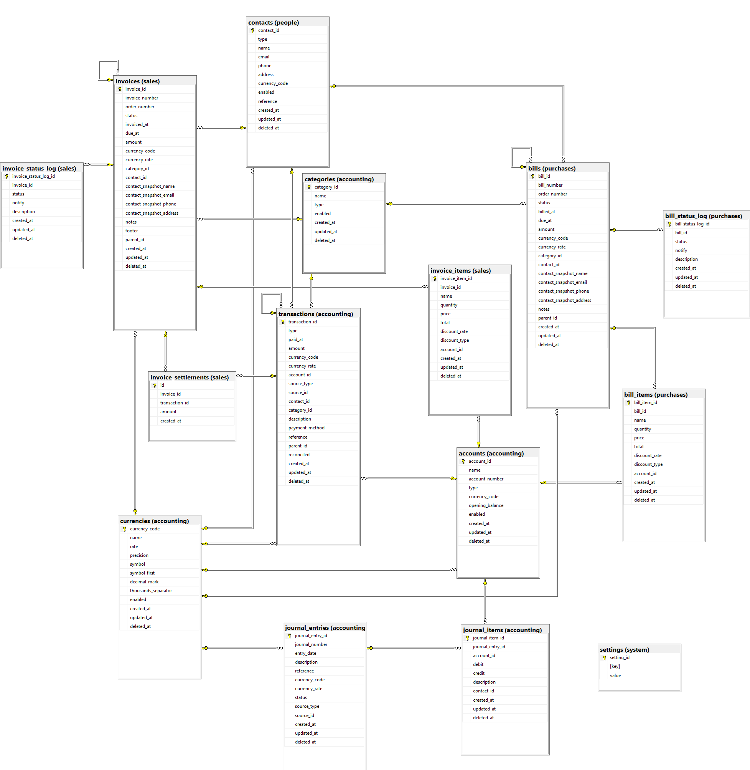
8. Entity Relationship Diagram (ERD)
Architecture & Design Patterns (Page ...)
N-Tier Architecture
The project strictly follows a 3-Layer N-Tier Architecture to separate concerns:
- Presentation Layer (LedgerCore.Web):
  - ASP.NET Core MVC Controllers and Razor Views.
  - Handles user input, displays data, and manages client-side logic (jQuery, DataTables).
  - No direct database access.
- Business Logic Layer (LedgerCore.Services):
  - Contains all accounting rules (e.g., JournalService.ValidateBalance(), FinancialReportService.CalculateNetIncome()).
  - Orchestrates data access through repositories.
- Data Access Layer (LedgerCore.Data):
  - Contains ApplicationDbContext (EF Core).
  - Contains Generic Repository (Repository<T>) and Specific Repositories (IAccountRepository).
Design Patterns Used
- Repository Pattern: Abstracts CRUD operations. For example, IJournalEntryRepository.GetLedger(accountId) hides complex SQL joins behind a simple method call.
- Unit of Work: The ApplicationDbContext acts as the Unit of Work. When a customer payment is recorded, the PaymentService updates the Invoice Status, creates a Journal Entry, and updates the Account Balances. If any step fails, SaveChangesAsync() rolls back everything, ensuring the ledger remains balanced.
- Dependency Injection: Services and Repositories are registered in Program.cs and injected into Controllers, making the code testable and modular.
Technology Stack & Libraries
- Framework: ASP.NET Core MVC (.NET 10)
- Database: SQL Server / Entity Framework Core (Code-First Migrations)
- Authentication: ASP.NET Core Identity
API Endpoints Specification (Sample)
HTTP Method | Endpoint | Description | Authorization
GET | /api/accounts | Returns list of all Chart of Accounts | Accountant
POST | /api/journalentries | Creates a new balanced Journal Entry | Accountant
GET | /api/reports/trialbalance | Returns Trial Balance data for a given date | Manager
GET | /api/reports/agedpayables | Returns list of overdue vendor bills | Manager
POST | /api/invoices/{id}/pay | Applies a payment to a specific AP/AR invoice | Accountant

Thank You

We extend our gratitude to
Ashraf Sadek and
The Digital Egypt Builders Initiative and
YAT Learning Solutions
for their guidance and support throughout this project.

