ES_SR_ST_r0.r

yehai

Tue Apr 25 12:22:47 2017

#Shortterm Retention and shortterm Transfer effect sizes  
library(readr)  
library(metaSEM)

## Loading required package: OpenMx

## OpenMx is not compiled to take advantage of computers with multiple cores.

## "SLSQP" is set as the default optimizer in OpenMx.

## mxOption(NULL, "Gradient algorithm") is set at "central".

## mxOption(NULL, "Optimality tolerance") is set at "6.3e-14".

## mxOption(NULL, "Gradient iterations") is set at "2".

library(metafor)

## Loading required package: Matrix

##   
## Attaching package: 'Matrix'

## The following objects are masked from 'package:OpenMx':  
##   
## %&%, expm

## Loading 'metafor' package (version 1.9-9). For an overview   
## and introduction to the package please type: help(metafor).

library(MVN)

## sROC 0.1-2 loaded

library(nortest)  
  
##Read data from csv  
SRSTd <- read_csv("SRd_STd_CLd_r0.csv")

## Parsed with column specification:  
## cols(  
## Authors = col_character(),  
## Year = col_integer(),  
## Experiment = col_character(),  
## CGn = col_double(),  
## EGn = col_double(),  
## PP = col_integer(),  
## LVS = col_integer(),  
## ToV = col_integer(),  
## SRd = col_double(),  
## STd = col_double(),  
## SRv = col_double(),  
## STv = col_double(),  
## CLd = col_double(),  
## CLv = col_double(),  
## SRSTcov = col_integer(),  
## SRSTcov1 = col_double(),  
## SRSTcovC = col_double()  
## )

##QQPlot test using metaFor  
#Normality test for short term retention  
srd<-SRSTd[["SRd"]]  
lillie.test(srd)#Kolmogorov-Smirnov normality test

##   
## Lilliefors (Kolmogorov-Smirnov) normality test  
##   
## data: srd  
## D = 0.11087, p-value = 0.04579

sf.test(srd)#Shapiro-Francia normality test

##   
## Shapiro-Francia normality test  
##   
## data: srd  
## W = 0.96925, p-value = 0.09589

#Generate QQ plot for retention  
resSR<-rma(measure="SMD",SRd,SRv,data=SRSTd)

## Warning in rma(measure = "SMD", SRd, SRv, data = SRSTd): Studies with NAs  
## omitted from model fitting.

qqnorm(resSR,label="out", main="Normal Q-Q Plot of Retention")

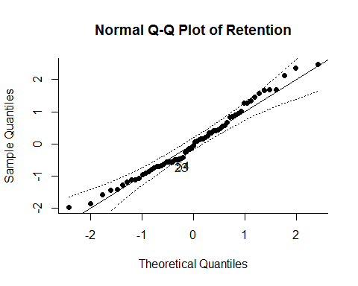

#generate QQ plot for retention with moderators  
resSR1M<-rma(measure="SMD",SRd,SRv,mods=cbind(PP,LVS,ToV),data=SRSTd)

## Warning in rma(measure = "SMD", SRd, SRv, mods = cbind(PP, LVS, ToV), data  
## = SRSTd): Studies with NAs omitted from model fitting.

qqnorm(resSR1M,label="out", main="Normal Q-Q Plot of Retention with Moderators")

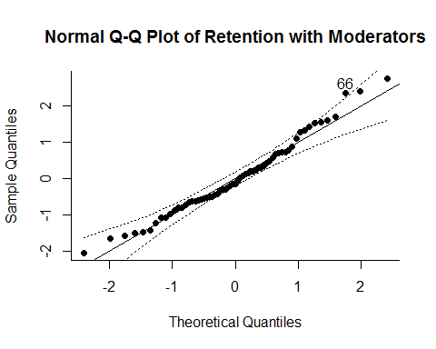

##Normality test for short term transfer  
std<-SRSTd[["STd"]]  
lillie.test(std)#Kolmogorov-Smirnov normality test

##   
## Lilliefors (Kolmogorov-Smirnov) normality test  
##   
## data: std  
## D = 0.11239, p-value = 0.09229

sf.test(std)#Shapiro-Francia normality test

##   
## Shapiro-Francia normality test  
##   
## data: std  
## W = 0.95696, p-value = 0.05271

#generate QQ plot for retention  
resST<-rma(measure="SMD",STd,STv,data=SRSTd)

## Warning in rma(measure = "SMD", STd, STv, data = SRSTd): Studies with NAs  
## omitted from model fitting.

qqnorm(resST,label="out",main="Normal Q-Q Plot of Transfer")

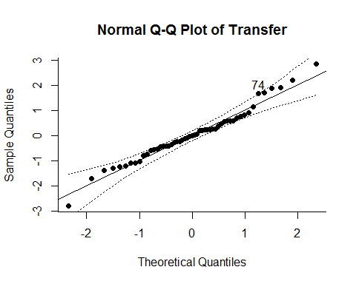

#generate QQ plot for transfer  
resST1M<-rma(measure="SMD",STd,STv,mods=cbind(PP,LVS,ToV),data=SRSTd)

## Warning in rma(measure = "SMD", STd, STv, mods = cbind(PP, LVS, ToV), data  
## = SRSTd): Studies with NAs omitted from model fitting.

qqnorm(resST1M,label="out",main="Normal Q-Q Plot of Trasnfer with Moderators")

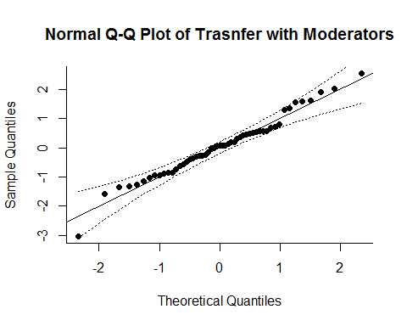

##Normality test for cognitive load  
cld<-SRSTd[["CLd"]]  
lillie.test(cld)#Kolmogorov-Smirnov normality test

##   
## Lilliefors (Kolmogorov-Smirnov) normality test  
##   
## data: cld  
## D = 0.14256, p-value = 0.1707

sf.test(cld)#Shapiro-Francia normality test

##   
## Shapiro-Francia normality test  
##   
## data: cld  
## W = 0.9412, p-value = 0.1177

#generate QQ plot for cognitive load  
resCL<-rma(measure="SMD",CLd,CLv,data=SRSTd)

## Warning in rma(measure = "SMD", CLd, CLv, data = SRSTd): Studies with NAs  
## omitted from model fitting.

qqnorm(resCL, label="out", main="Normal Q-Q Plot of Cognitive Load")

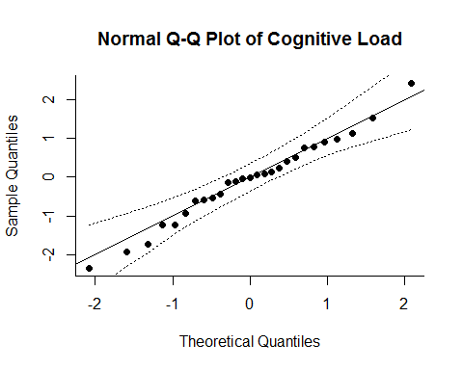

#generate QQ plot for cognitive load with moderatoers  
resSR1M<-rma(measure="SMD",CLd,CLv,mods=cbind(PP,LVS,ToV),data=SRSTd)

## Warning in rma(measure = "SMD", CLd, CLv, mods = cbind(PP, LVS, ToV), data  
## = SRSTd): Studies with NAs omitted from model fitting.

qqnorm(resCL, label="out", main="Normal Q-Q Plot of Cognitive Load with Moderators")

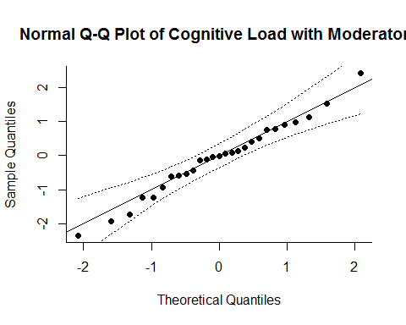

##Normality test using Maridia's MVN for multivariate  
nmtres<-mardiaTest(SRSTd[,c(9:10)],qqplot=TRUE)

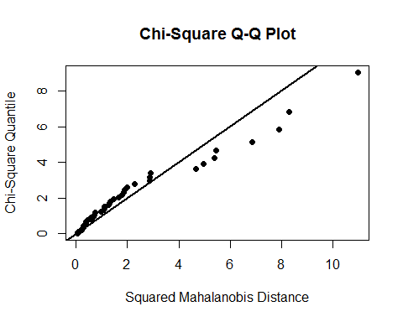

nmtres

## Mardia's Multivariate Normality Test   
## ---------------------------------------   
## data : SRSTd[, c(9:10)]   
##   
## g1p : 0.595379   
## chi.skew : 4.564573   
## p.value.skew : 0.3349594   
##   
## g2p : 10.1602   
## z.kurtosis : 1.831402   
## p.value.kurt : 0.06704062   
##   
## chi.small.skew : 5.078363   
## p.value.small : 0.2793511   
##   
## Result : Data are multivariate normal.   
## ---------------------------------------

##r=0  
##Multivariance meta analysis with metaSEM  
##SRd-short term retention effect size, STd-short tem transfer effect size, v-variance,cov-covariance  
result<-meta(y=cbind(SRd,STd),v=cbind(SRv,SRSTcov,STv),data=SRSTd, model.name="Random Effects Model Analysis for Retention and Transfer")  
summary(result)

##   
## Call:  
## meta(y = cbind(SRd, STd), v = cbind(SRv, SRSTcov, STv), data = SRSTd,   
## model.name = "Random Effects Model Analysis for Retention and Transfer")  
##   
## 95% confidence intervals: z statistic approximation  
## Coefficients:  
## Estimate Std.Error lbound ubound z value Pr(>|z|)   
## Intercept1 0.150827 0.062070 0.029172 0.272483 2.4299 0.0151011 *   
## Intercept2 0.357995 0.090027 0.181545 0.534444 3.9765 6.993e-05 ***  
## Tau2_1_1 0.159527 0.044492 0.072323 0.246730 3.5855 0.0003365 ***  
## Tau2_2_1 0.175481 0.052772 0.072049 0.278913 3.3252 0.0008834 ***  
## Tau2_2_2 0.341926 0.092268 0.161083 0.522769 3.7058 0.0002107 ***  
## ---  
## Signif. codes: 0 '***' 0.001 '**' 0.01 '*' 0.05 '.' 0.1 ' ' 1  
##   
## Q statistic on the homogeneity of effect sizes: 424.3674  
## Degrees of freedom of the Q statistic: 116  
## P value of the Q statistic: 0  
##   
## Heterogeneity indices (based on the estimated Tau2):  
## Estimate  
## Intercept1: I2 (Q statistic) 0.6662  
## Intercept2: I2 (Q statistic) 0.7911  
##   
## Number of studies (or clusters): 75  
## Number of observed statistics: 118  
## Number of estimated parameters: 5  
## Degrees of freedom: 113  
## -2 log likelihood: 192.4032   
## OpenMx status1: 0 ("0" or "1": The optimization is considered fine.  
## Other values may indicate problems.)

##extract the variance component of the random effects  
T2<-vec2symMat(coef(result,select="random"))  
T2

## [,1] [,2]  
## [1,] 0.1595269 0.1754814  
## [2,] 0.1754814 0.3419261

##Convert the covariance matrix to a correlation matrix  
cov2cor(T2)

## [,1] [,2]  
## [1,] 1.00000 0.75136  
## [2,] 0.75136 1.00000

##plot the effect sizes and their confidence ellipses  
plot(result, axis.labels = c("Retention","Transfer"))

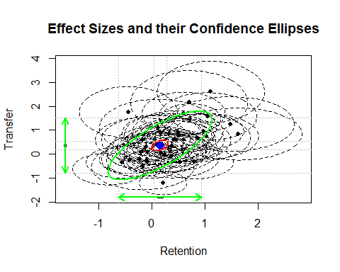

##Plot the effect sizes with the forest plots  
##create extra panels for the forest plots  
##plot(result,diag.panel = TRUE,   
# main="Learning Performance Analysis",   
# axis.labels = c("Retention","Transfer"))  
##forest plot for retention  
forest(rma(yi=SRd,vi=SRv,data=SRSTd))

## Warning in rma(yi = SRd, vi = SRv, data = SRSTd): Studies with NAs omitted  
## from model fitting.

title("Forest plot of retention")

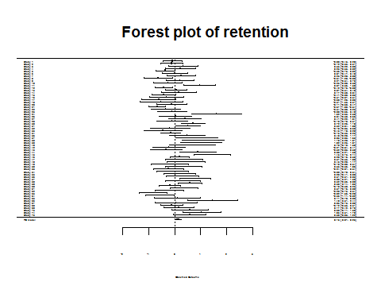

##forest plot for transfer  
forest(rma(yi=STd,vi=STv,data=SRSTd))

## Warning in rma(yi = STd, vi = STv, data = SRSTd): Studies with NAs omitted  
## from model fitting.

title("Forest plot of transfer")

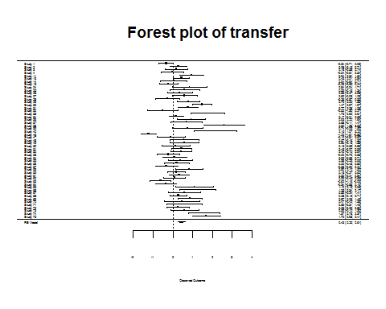

##r=1  
result1<-meta(y=cbind(SRd,STd),v=cbind(SRv,SRSTcov1,STv),data=SRSTd, model.name="Random effects model")  
summary(result1)

##   
## Call:  
## meta(y = cbind(SRd, STd), v = cbind(SRv, SRSTcov1, STv), data = SRSTd,   
## model.name = "Random effects model")  
##   
## 95% confidence intervals: z statistic approximation  
## Coefficients:  
## Estimate Std.Error lbound ubound z value Pr(>|z|)  
## Intercept1 0.1246408 0.0606205 0.0058267 0.2434548 2.0561 0.0397746  
## Intercept2 0.3419621 0.0862918 0.1728333 0.5110909 3.9629 7.406e-05  
## Tau2_1_1 0.1458683 0.0423182 0.0629261 0.2288105 3.4469 0.0005670  
## Tau2_2_1 0.0695933 0.0500828 -0.0285671 0.1677538 1.3896 0.1646607  
## Tau2_2_2 0.3065275 0.0852740 0.1393936 0.4736614 3.5946 0.0003249  
##   
## Intercept1 *   
## Intercept2 ***  
## Tau2_1_1 ***  
## Tau2_2_1   
## Tau2_2_2 ***  
## ---  
## Signif. codes: 0 '***' 0.001 '**' 0.01 '*' 0.05 '.' 0.1 ' ' 1  
##   
## Q statistic on the homogeneity of effect sizes: 3853.11  
## Degrees of freedom of the Q statistic: 116  
## P value of the Q statistic: 0  
##   
## Heterogeneity indices (based on the estimated Tau2):  
## Estimate  
## Intercept1: I2 (Q statistic) 0.6460  
## Intercept2: I2 (Q statistic) 0.7725  
##   
## Number of studies (or clusters): 75  
## Number of observed statistics: 118  
## Number of estimated parameters: 5  
## Degrees of freedom: 113  
## -2 log likelihood: 189.788   
## OpenMx status1: 0 ("0" or "1": The optimization is considered fine.  
## Other values may indicate problems.)

##extract the variance component of the random effects  
T21<-vec2symMat(coef(result1,select="random"))  
T21

## [,1] [,2]  
## [1,] 0.14586830 0.06959334  
## [2,] 0.06959334 0.30652747

##Convert the covariance matrix to a correlation matrix  
cov2cor(T21)

## [,1] [,2]  
## [1,] 1.0000000 0.3291187  
## [2,] 0.3291187 1.0000000

##three moderators  
resultpp<-meta(y=cbind(SRd,STd),v=cbind(SRv,SRSTcov,STv),data=SRSTd, model.name="Random effects model",x=cbind(PP))  
summary(resultpp)

##   
## Call:  
## meta(y = cbind(SRd, STd), v = cbind(SRv, SRSTcov, STv), x = cbind(PP),   
## data = SRSTd, model.name = "Random effects model")  
##   
## 95% confidence intervals: z statistic approximation  
## Coefficients:  
## Estimate Std.Error lbound ubound z value Pr(>|z|)   
## Intercept1 0.081038 0.087767 -0.090983 0.253059 0.9233 0.3558359   
## Intercept2 0.424745 0.123864 0.181977 0.667513 3.4291 0.0006055 ***  
## Slope1_1 0.128735 0.120304 -0.107056 0.364526 1.0701 0.2845814   
## Slope2_1 -0.156528 0.175992 -0.501466 0.188410 -0.8894 0.3737869   
## Tau2_1_1 0.146061 0.043174 0.061440 0.230681 3.3830 0.0007169 ***  
## Tau2_2_1 0.177302 0.051394 0.076572 0.278032 3.4499 0.0005608 ***  
## Tau2_2_2 0.339798 0.091421 0.160617 0.518979 3.7169 0.0002017 ***  
## ---  
## Signif. codes: 0 '***' 0.001 '**' 0.01 '*' 0.05 '.' 0.1 ' ' 1  
##   
## Q statistic on the homogeneity of effect sizes: 424.3674  
## Degrees of freedom of the Q statistic: 116  
## P value of the Q statistic: 0  
##   
## Explained variances (R2):  
## y1 y2  
## Tau2 (no predictor) 0.159527 0.3419  
## Tau2 (with predictors) 0.146061 0.3398  
## R2 0.084414 0.0062  
##   
## Number of studies (or clusters): 75  
## Number of observed statistics: 118  
## Number of estimated parameters: 7  
## Degrees of freedom: 111  
## -2 log likelihood: 189.0226   
## OpenMx status1: 0 ("0" or "1": The optimization is considered fine.  
## Other values may indicate problems.)

resultlvs<-meta(y=cbind(SRd,STd),v=cbind(SRv,SRSTcov,STv),data=SRSTd, model.name="Random effects model",x=cbind(LVS))  
summary(resultlvs)

##   
## Call:  
## meta(y = cbind(SRd, STd), v = cbind(SRv, SRSTcov, STv), x = cbind(LVS),   
## data = SRSTd, model.name = "Random effects model")  
##   
## 95% confidence intervals: z statistic approximation  
## Coefficients:  
## Estimate Std.Error lbound ubound z value Pr(>|z|)  
## Intercept1 0.0386515 0.0881477 -0.1341148 0.2114177 0.4385 0.6610344  
## Intercept2 0.2451688 0.1302939 -0.0102025 0.5005402 1.8817 0.0598822  
## Slope1_1 0.2435670 0.1220741 0.0043061 0.4828278 1.9952 0.0460168  
## Slope2_1 0.2307165 0.1759290 -0.1140979 0.5755309 1.3114 0.1897164  
## Tau2_1_1 0.1465246 0.0429492 0.0623457 0.2307035 3.4116 0.0006459  
## Tau2_2_1 0.1614818 0.0513816 0.0607757 0.2621879 3.1428 0.0016734  
## Tau2_2_2 0.3259044 0.0899884 0.1495304 0.5022783 3.6216 0.0002928  
##   
## Intercept1   
## Intercept2 .   
## Slope1_1 *   
## Slope2_1   
## Tau2_1_1 ***  
## Tau2_2_1 **   
## Tau2_2_2 ***  
## ---  
## Signif. codes: 0 '***' 0.001 '**' 0.01 '*' 0.05 '.' 0.1 ' ' 1  
##   
## Q statistic on the homogeneity of effect sizes: 418.2773  
## Degrees of freedom of the Q statistic: 114  
## P value of the Q statistic: 0  
##   
## Explained variances (R2):  
## y1 y2  
## Tau2 (no predictor) 0.159527 0.3419  
## Tau2 (with predictors) 0.146525 0.3259  
## R2 0.081505 0.0469  
##   
## Number of studies (or clusters): 73  
## Number of observed statistics: 116  
## Number of estimated parameters: 7  
## Degrees of freedom: 109  
## -2 log likelihood: 185.9312   
## OpenMx status1: 0 ("0" or "1": The optimization is considered fine.  
## Other values may indicate problems.)

resulttov<-meta(y=cbind(SRd,STd),v=cbind(SRv,SRSTcov,STv),data=SRSTd, model.name="Random effects model",x=cbind(ToV))  
summary(resulttov)

##   
## Call:  
## meta(y = cbind(SRd, STd), v = cbind(SRv, SRSTcov, STv), x = cbind(ToV),   
## data = SRSTd, model.name = "Random effects model")  
##   
## 95% confidence intervals: z statistic approximation  
## Coefficients:  
## Estimate Std.Error lbound ubound z value Pr(>|z|)  
## Intercept1 0.0489920 0.0877653 -0.1230249 0.2210088 0.5582 0.5766973  
## Intercept2 0.2479927 0.1250893 0.0028221 0.4931633 1.9825 0.0474205  
## Slope1_1 0.1911714 0.1199867 -0.0439981 0.4263410 1.5933 0.1110992  
## Slope2_1 0.2234931 0.1748775 -0.1192606 0.5662467 1.2780 0.2012503  
## Tau2_1_1 0.1449927 0.0430936 0.0605308 0.2294546 3.3646 0.0007665  
## Tau2_2_1 0.1588797 0.0511823 0.0585642 0.2591952 3.1042 0.0019080  
## Tau2_2_2 0.3253748 0.0893484 0.1502551 0.5004945 3.6416 0.0002709  
##   
## Intercept1   
## Intercept2 *   
## Slope1_1   
## Slope2_1   
## Tau2_1_1 ***  
## Tau2_2_1 **   
## Tau2_2_2 ***  
## ---  
## Signif. codes: 0 '***' 0.001 '**' 0.01 '*' 0.05 '.' 0.1 ' ' 1  
##   
## Q statistic on the homogeneity of effect sizes: 424.3674  
## Degrees of freedom of the Q statistic: 116  
## P value of the Q statistic: 0  
##   
## Explained variances (R2):  
## y1 y2  
## Tau2 (no predictor) 0.159527 0.3419  
## Tau2 (with predictors) 0.144993 0.3254  
## R2 0.091108 0.0484  
##   
## Number of studies (or clusters): 75  
## Number of observed statistics: 118  
## Number of estimated parameters: 7  
## Degrees of freedom: 111  
## -2 log likelihood: 189.5238   
## OpenMx status1: 0 ("0" or "1": The optimization is considered fine.  
## Other values may indicate problems.)

resultall<-meta(y=cbind(SRd,STd),v=cbind(SRv,SRSTcov,STv),data=SRSTd, model.name="Random effects model",x=cbind(PP,LVS,ToV))  
summary(resultall)

##   
## Call:  
## meta(y = cbind(SRd, STd), v = cbind(SRv, SRSTcov, STv), x = cbind(PP,   
## LVS, ToV), data = SRSTd, model.name = "Random effects model")  
##   
## 95% confidence intervals: z statistic approximation  
## Coefficients:  
## Estimate Std.Error lbound ubound z value Pr(>|z|)   
## Intercept1 -0.032975 0.112820 -0.254098 0.188148 -0.2923 0.7700720   
## Intercept2 0.290863 0.166859 -0.036175 0.617901 1.7432 0.0813052 .   
## Slope1_1 0.098379 0.123327 -0.143338 0.340096 0.7977 0.4250410   
## Slope2_1 -0.198786 0.183064 -0.557584 0.160012 -1.0859 0.2775298   
## Slope1_2 0.204563 0.134825 -0.059689 0.468814 1.5172 0.1292046   
## Slope2_2 0.103554 0.196853 -0.282271 0.489379 0.5260 0.5988552   
## Slope1_3 0.074227 0.137502 -0.195272 0.343725 0.5398 0.5893195   
## Slope2_3 0.219319 0.196156 -0.165140 0.603778 1.1181 0.2635312   
## Tau2_1_1 0.134703 0.042214 0.051966 0.217440 3.1910 0.0014179 **   
## Tau2_2_1 0.161317 0.050369 0.062595 0.260039 3.2027 0.0013615 **   
## Tau2_2_2 0.317195 0.088296 0.144139 0.490251 3.5924 0.0003276 ***  
## ---  
## Signif. codes: 0 '***' 0.001 '**' 0.01 '*' 0.05 '.' 0.1 ' ' 1  
##   
## Q statistic on the homogeneity of effect sizes: 418.2773  
## Degrees of freedom of the Q statistic: 114  
## P value of the Q statistic: 0  
##   
## Explained variances (R2):  
## y1 y2  
## Tau2 (no predictor) 0.15953 0.3419  
## Tau2 (with predictors) 0.13470 0.3172  
## R2 0.15561 0.0723  
##   
## Number of studies (or clusters): 73  
## Number of observed statistics: 116  
## Number of estimated parameters: 11  
## Degrees of freedom: 105  
## -2 log likelihood: 182.0358   
## OpenMx status1: 0 ("0" or "1": The optimization is considered fine.  
## Other values may indicate problems.)

T2all<-vec2symMat(coef(resultall,select="random"))  
T2all

## [,1] [,2]  
## [1,] 0.1347026 0.1613170  
## [2,] 0.1613170 0.3171949

cov2cor(T2all)

## [,1] [,2]  
## [1,] 1.0000000 0.7804213  
## [2,] 0.7804213 1.0000000

plot(resultall)

## Warning in plot.meta(resultall): There are predictors in the model.  
## The plot is based on the intercepts.

